**geom_bar() Function Assignment**

**Problem Statement:**

Sam’s next exam is on ‘geom_bar()’ function from the ggplot2 package. The questions will be asked on the basis of what you’ve learnt in the respective module.

Questions:

1. Build a bar-plot for the ‘PhoneService’ column

a. Assign the fill color to be ‘pink’

b. Assign the boundary color to be ‘peru’

> ggplot(data=customer_churn, aes(x=PhoneService))+geom_bar(fill='pink', col='peru')

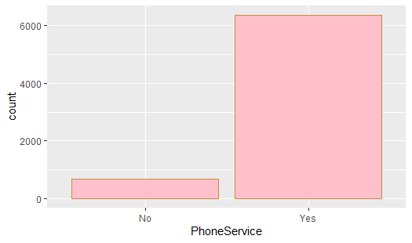

2. Build a bar-plot for the ’InternetService’ column

a. Assign ‘InternetService’ to the fill aesthetic

b. Assign ‘Contract’ to the fill aesthetic

c. Change the position of bars to ‘identity’

> ggplot(data=customer_churn, aes(x=InternetService, fill=InternetService))+geom_bar()

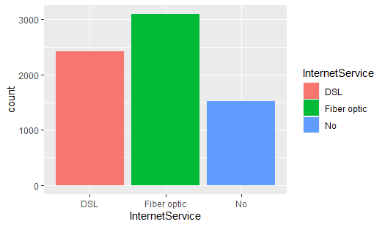

> ggplot(data=customer_churn, aes(x=InternetService, fill=Contract))+geom_bar()

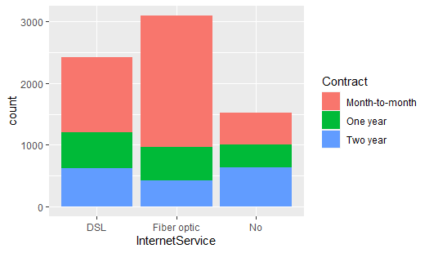

> ggplot(data=customer_churn, aes(x=InternetService))+geom_bar(position = "identity")

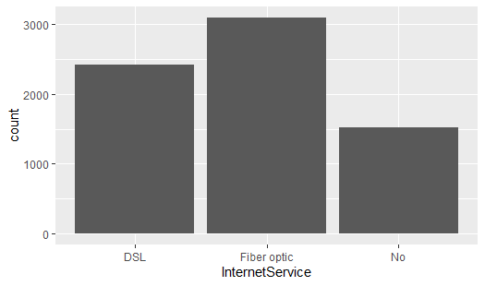

3. Build a bar-plot for ‘TechSupport’ column

a. Assign ‘Churn’ to the fill aesthetic

> ggplot(data=customer_churn, aes(x=TechSupport, fill=Churn))+geom_bar()

