**geom_point() Function Assignment**

**Problem Statement:**

Sam’s next exam is on ‘geom_point()’ function from the ggplot2 package. The questions will be asked on the basis of what you’ve learnt in the respective module.

Questions:

1. Build a scatter-plot between ‘TotalCharges’ & ‘tenure’. Map ‘TotalCharges’ to the y-axis &

‘tenure’ to the ‘x-axis’

1. Assign it the color ‘wheat3’
2. > ggplot(data=customer_churn, aes(y=TotalCharges, x=tenure))+geom_point(col='wheat3')
3. Warning message:
4. Removed 11 rows containing missing values (geom_point).

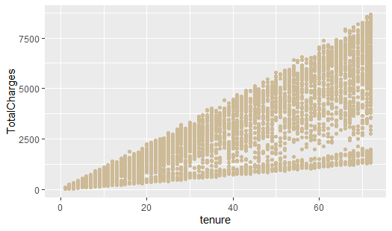

b. Use ‘col’ as an aesthetic and Map ‘PaymentMethod’ to col

> ggplot(data=customer_churn, aes(y=TotalCharges, x=tenure, col=PaymentMethod))+geom_point()

Warning message:

Removed 11 rows containing missing values (geom_point).

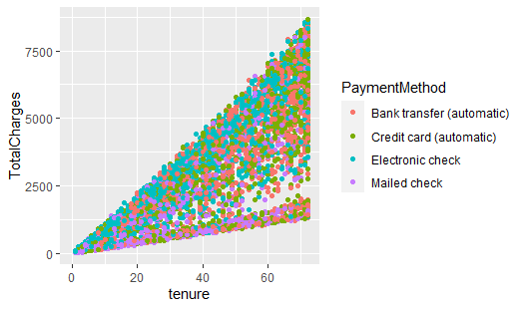

c. Use ‘col’ as an aesthetic and Map ‘gender’ to col

> ggplot(data=customer_churn, aes(y=TotalCharges, x=tenure, col=gender))+geom_point()

Warning message:

Removed 11 rows containing missing values (geom_point).

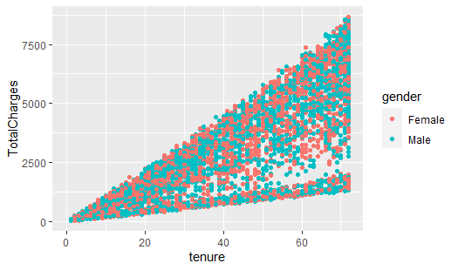

1. Map ‘Dependents’ to both ‘col’ & ‘shape’ aesthetics
2. > ggplot(data=customer_churn, aes(y=TotalCharges, x=tenure, col=Dependents, shape=Dependents))+geom_point()
3. Warning message:
4. Removed 11 rows containing missing values (geom_point).

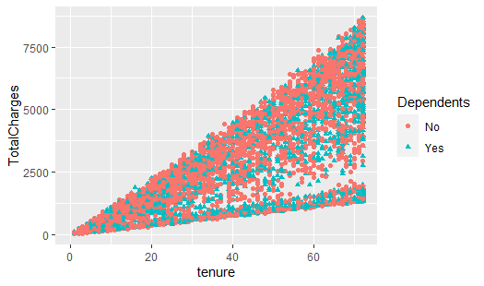

2. Build a scatter-plot between ‘tenure’ & ‘MonthlyCharges’. Map ‘tenure’ to the y-axis &

‘MonthlyCharges’ to the ‘x-axis’

1. Assign it the color ‘yellowgreen’
2. > ggplot(data=customer_churn, aes(y=tenure, x=MonthlyCharges))+geom_point(col='yellowgreen')

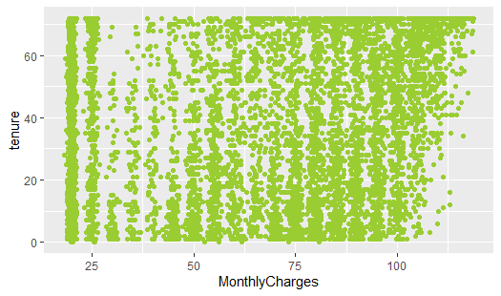

1. Use ‘col’ as an aesthetic and Map ‘InternetService’ to col
2. > ggplot(data=customer_churn, aes(y=tenure, x=MonthlyCharges, col=InternetService))+geom_point()

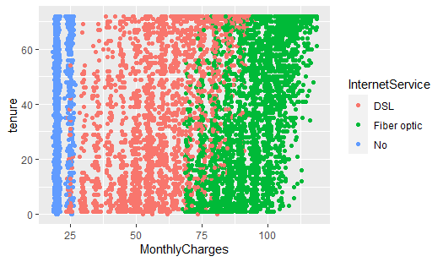

c. Use ‘col’ as an aesthetic and Map ‘Contract’ to col

> ggplot(data=customer_churn, aes(y=tenure, x=MonthlyCharges, col=Contract))+geom_point()

