**geom_boxplot() Function Assignment**

**Problem Statement:**

Sam’s next exam is on ‘geom_boxplot()’ function from the ggplot2 package. The questions will be asked on the basis of what you’ve learnt in the respective module.

Questions:

1. Build a box-plot between ‘tenure’ & ‘Partner’. Map ‘tenure’ to the y-axis & ‘Partner’ to the ‘xaxis’

a. Assign it a fill color of ‘violet’

b. Assign it a boundary color of ‘snow3’

> ggplot(data=customer_churn, aes(y=tenure, x=Partner))+geom_boxplot(fill='violet',outlier.color = 'snow3')

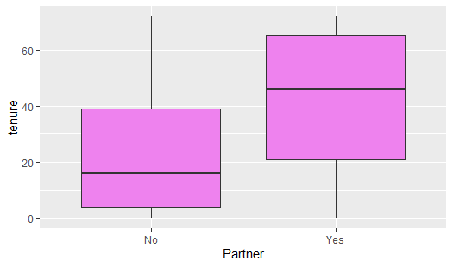

2. Build a box-plot between ‘tenure’ & ‘MultipleLines’. Map ‘tenure’ to the y-axis & ‘MultipleLines’ to the ‘x-axis’

a. Assign ‘Partner’ to the fill aesthetic

> ggplot(data=customer_churn, aes(y=tenure, x=MultipleLines, fill=Partner))+geom_boxplot()

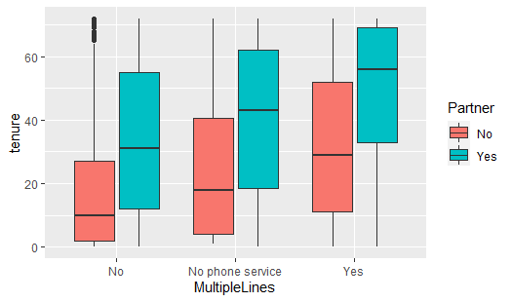

b. Assign ‘PhoneService’ to the fill aesthetic

> ggplot(data=customer_churn, aes(y=tenure, x=MultipleLines, fill=PhoneService))+geom_boxplot()

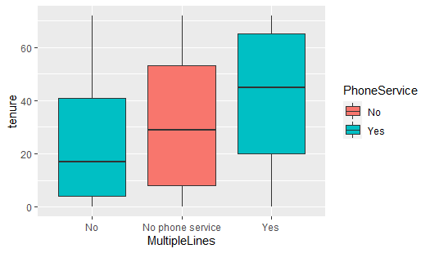

3. Build a box-plot between ‘tenure’ & ‘Contract’

a. Assign ‘InternetService’ to the fill aesthetic

> ggplot(data=customer_churn, aes(y=tenure, x=Contract, fill=InternetService))+geom_boxplot()

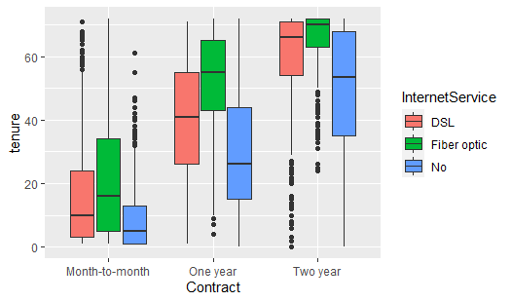

b. Assign ‘PaymentMethod’ to the fill aesthetic

> ggplot(data=customer_churn, aes(y=tenure, x=Contract, fill=PaymentMethod))+geom_boxplot()

