**Facet Grid Assignment**

**Problem Statement:**

Sam’s next exam is on ‘Facet Grid’ from the ggplot2 package. The questions will be asked on the basis of what you’ve learnt in the respective module.

**Questions:**

1. Build a box-plot between ‘tenure’ & ‘MultipleLines’. Map ‘tenure’ on the y-axis & ‘MultipleLines’ on the x-axis. Map ‘InternetService’ to the fill aesthetic

a. Facet the plot w.r.t ‘InternetService’ column

> ggplot(data=customer_churn, aes(x=tenure, y=MultipleLines, fill=Contract))+geom_boxplot()->g1

> g1+facet_grid(~InternetService)

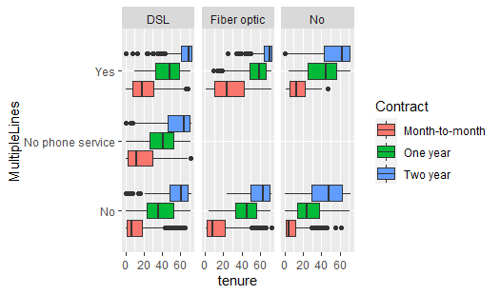

2. Build a scatter-plot between ‘TotalCharges’ & ‘tenure’. Map ‘TotalCharges’ on the y-axis &

‘tenure’ on the x-axis. Map ‘Contract’ onto col aesthetic

1. Facet the plot w.r.t ‘Contract’ column
2. > ggplot(data=customer_churn, aes(x=tenure, y=TotalCharges, fill=Contract))+geom_point()->g2
3. > g2+facet_grid()
4. Warning message:
5. Removed 11 rows containing missing values (geom_point).

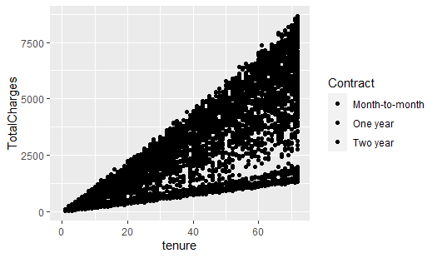

3. Build a histogram for the ‘MonthlyCharges’ column. Map ‘PaymentMethod’ onto fill aesthetic.

a. Facet the plot w.r.t ‘PaymentMethod’ column

> ggplot(data=customer_churn, aes(x=MonthlyCharges, fill=PaymentMethod))+geom_histogram()->g3

> g3+facet_grid()

`stat_bin()` using `bins = 30`. Pick better value with `binwidth`.

