**Theme Layer Assignment**

**Problem Statement:**

Sam’s next exam is on ‘Theme’ layer from the ggplot2 package. The questions will be asked on the basis of what you’ve learnt in the respective module.

**Questions:**

1. Build a bar-plot for the ‘gender’ column. Give it a fill color of ‘blue4’
2. > ggplot(data=customer_churn, aes(x=gender))+geom_bar(fill='blue4')
3. > ggplot(data=customer_churn, aes(x=gender))+geom_bar(fill='blue4')->g1

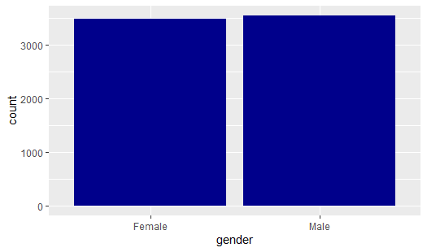

1. Give the panel a background color of ‘chartreuse4’
2. > g1+theme(panel.background = element_rect(fill='chartreuse4'))
3. > g1+theme(panel.background = element_rect(fill='chartreuse4'))->g2

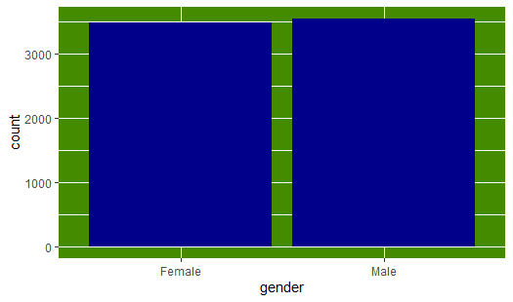

b. Give the plot a background color of ‘cornsilk4’

> g2+theme(plot.background = element_rect(fill = 'cornsilk4'))

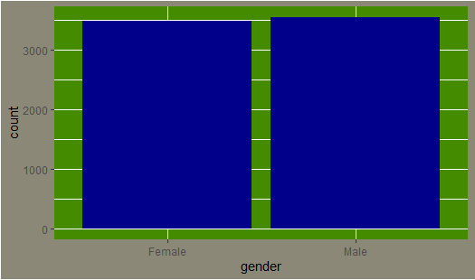

2. Build a scatter-plot between ‘tenure’ & ‘MonthlyCharges’. Map ‘tenure’ on the y-axis & ‘MonthlyCharges’ on the x-axis. Assign a color of ‘yellowgreen’ to the points.

> ggplot(data=customer_churn, aes(y=tenure, x=MonthlyCharges))+geom_point(col='yellowgreen')

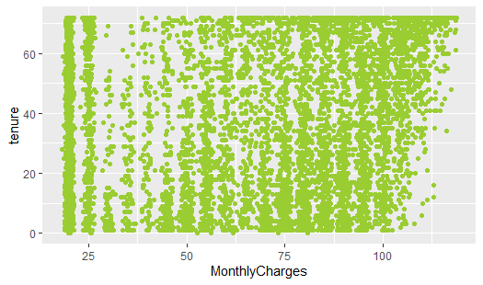

1. Add a title to the plot ‘Tenure vs Monthly Charges’
2. > g1+labs(title="Tenure Vs MonthlyCharges")
3. > g1+labs(title="Tenure Vs MonthlyCharges")->g2

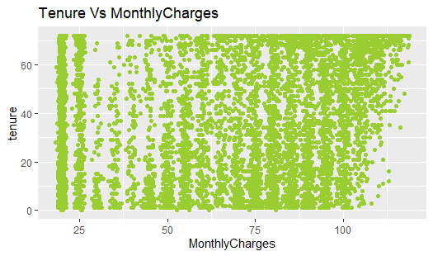

b. Give the panel a background color of ‘coral2’

> g2+theme(panel.background = element_rect(fill='coral2'))

> g2+theme(panel.background = element_rect(fill='coral2'))->g3

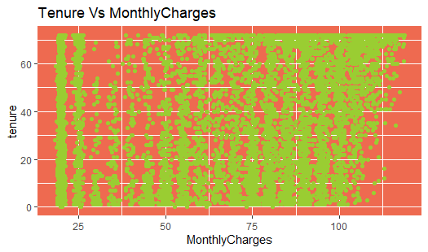

c.Give the plot a background color of ‘beige’

> g3+theme(plot.background = element_rect(fill='beige'))

> g3+theme(plot.background = element_rect(fill='beige'))->g4

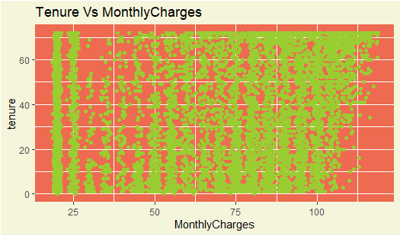

1. Center align the title & make the color of the title to be red
2. > g4+theme(plot.title = element_text(hjust = 0.5, color = 'red'))

