Plotly Assignment

### **Problem Statement:**

Sam’s next exam is on the plotly package. The questions will be asked on the basis of what you’ve learnt in the respective module.

## Questions:

1. Build a histogram for the ‘tenure’ column.

> plot_ly(data=customer_churn, x=~tenure, type = "histogram")

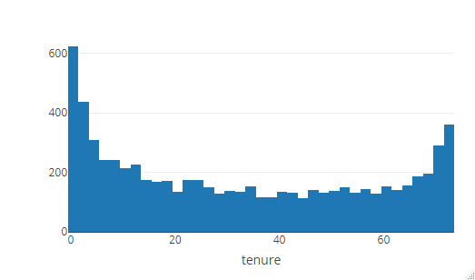

* 1. Color should be determined by ‘gender’ column

1. > plot_ly(data=customer_churn, x=~tenure, type = "histogram", color=~gender)
2. Warning messages:
3. 1: In RColorBrewer::brewer.pal(N, "Set2") :
4. minimal value for n is 3, returning requested palette with 3 different levels
5. 2: In RColorBrewer::brewer.pal(N, "Set2") :
6. minimal value for n is 3, returning requested palette with 3 different levels

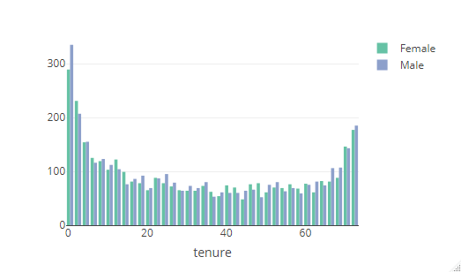

b.Color should be determined by ‘PaymentMethod’ column

> plot_ly(data=customer_churn, x=~tenure, type = "histogram", color=~PaymentMethod)

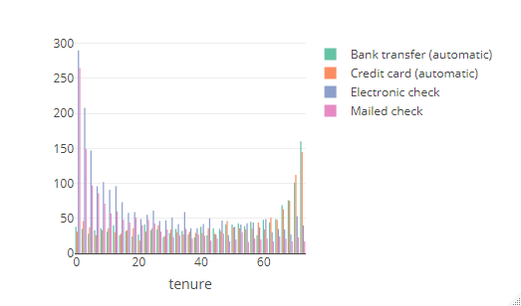

1. Create a scatter plot between ‘tenure’ & ‘MonthlyCharges’. Map ‘tenure’ on the y-axis & ‘MonthlyCharges’ on the ‘x-axis’
   1. Color should be determined by ‘InternetService’ column
2. > plot_ly(data=customer_churn, y=~tenure, x=~MonthlyCharges, mode="marker", color=~InternetService )
3. No trace type specified:
4. Based on info supplied, a 'scatter' trace seems appropriate.
5. Read more about this trace type -> https://plot.ly/r/reference/#scatter

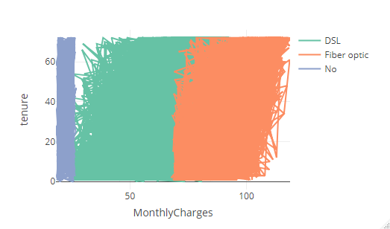

1. Color should be determined by ‘Contract’ column
2. > plot_ly(data=customer_churn, y=~tenure, x=~MonthlyCharges, mode="marker", color=~Contract)
3. No trace type specified:
4. Based on info supplied, a 'scatter' trace seems appropriate.
5. Read more about this trace type -> https://plot.ly/r/reference/#scatter

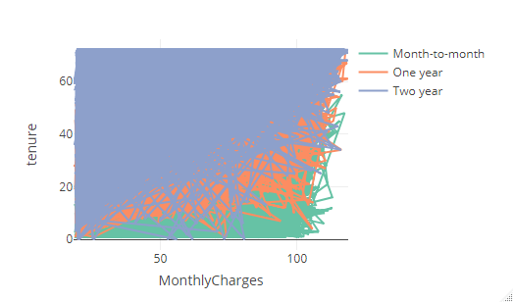

1. Create a box-plot between ‘tenure’ & ‘MultipleLines’. Map ‘tenure’ on the y-axis & ‘MultipleLines’ on the x-axis
   1. Color should be determined by ‘Dependents’ column
2. > plot_ly(data=customer_churn, y=~tenure, x=~MultipleLines, type="box", color = ~Dependents)
3. Warning messages:
4. 1: In RColorBrewer::brewer.pal(N, "Set2") :
5. minimal value for n is 3, returning requested palette with 3 different levels
6. 2: In RColorBrewer::brewer.pal(N, "Set2") :
7. minimal value for n is 3, returning requested palette with 3 different levels

