

**CSCI 5308: Advanced Topics In Software Development**

**GROUP 11**

| **HEMANTH NADIPINENI** | **B00899473** |
| --- | --- |
| **SANGRAMSINH MORE** | **B00903585** |
| **TRUSHITA MAURYA** | **B00913134** |
| **NISHIT MISTRY** | **B00911296** |
| **SUBASH NARAYANAN** | **B00899481** |

**TA :** MANJINDER SINGH

**PROFESSOR :** TUSHAR SHARMA

**DEPENDENCIES**

**1) High Charts:**

For a graphical representation of ratings for a particular series across seasons and episodes we are displaying the visualization in terms of ratings chart. For this feature, we have used HighCharts to represent ratings.

More info on High Charts can be found here:

1. High Charts wrapper for ReactJS: <https://www.highcharts.com/blog/tutorials/highcharts-wrapper-for-react-101/>.
2. <https://yarnpkg.com/package/react-jsx-highcharts>.
3. <https://github.com/highcharts/highcharts-react>.

High Charts are used to build chart components in our Ratings Visualizer Module. Below is a chart that shows the ratings of each season of a particular show.

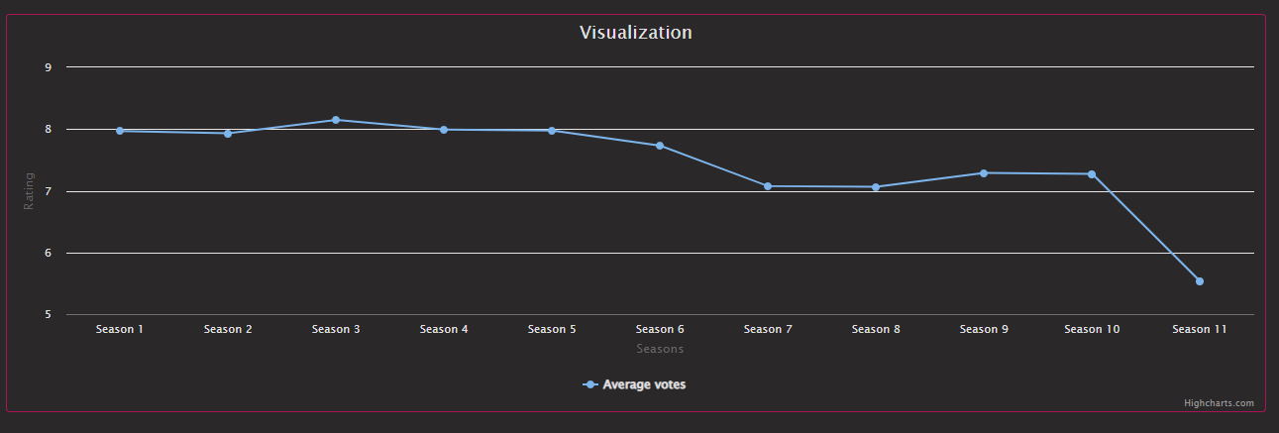

**2) TMDB API:**

TMDB API is the place from where we get all the movie and TV series information. It is called “The Movie Database”. Below is a sample of data fetched and rendered from API.

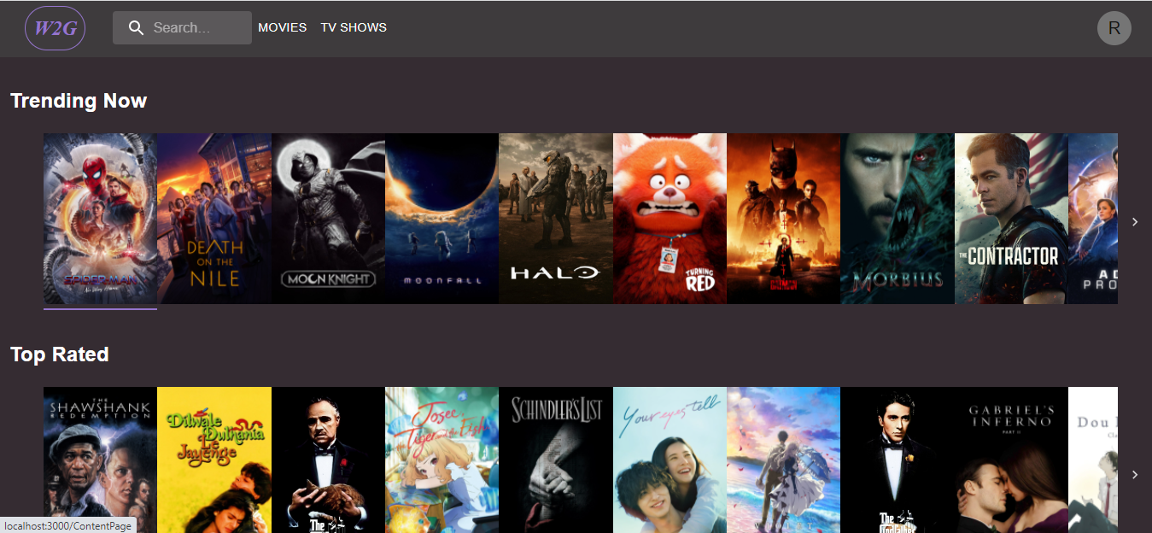

**For information on TMDB API:** <https://www.themoviedb.org/documentation/api>.

**More info on getting movie details**: <https://developers.themoviedb.org/3/movies/get-movie-details>

**3) Jest:** The project is built on JavaScript frameworks that are ReactJS for the frontend and ExpressJS, NodeJS for the backend. Therefore, we have chosen Jest as our testing framework.

Jest is a JavaScript test runner, that is, a JavaScript library for creating, running, and structuring tests [1]. Jest is one of the most popular testing frameworks these days. Jest is installed as an NPM package, you can install it in any JavaScript project.

Sample testing scenario[2]:

Consider a function in a file named *sum.js:*

function sum (a, b){

return a + b;

}

module.exports = sum;

Tests for the above code snippet can be written in *sum.test.js* like below:

const sum = require (‘. /sum');

test ('adds 1 + 2 to equal 3', () => {

expect (sum (1, 2)). toBe (3);

});

**Reference:**

a) <https://www.valentinog.com/blog/jest/>

b) <https://jestjs.io/docs/getting-started>

**4) Material UI:**

Material UI is an open-source, front-end framework for React components, MUI provides a simple, customizable, and accessible library of React components. Follow your own design system, or start with Material Design.

We have used Material UI in ReactJS for the front end designing and maintaining styling consistency and uniformity across the system, it helps us customize a component.

How to install:

// with npm

npm install @mui/material @emotion/react @emotion/styled

// with yarn

yarn add @mui/material @emotion/react @emotion/styled

**Reference:**

<https://mui.com/getting-started/usage/>.

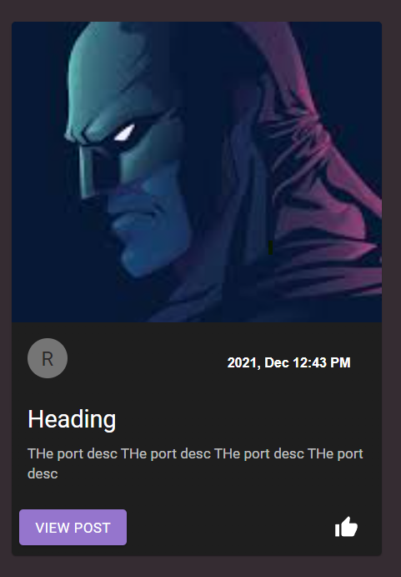

We have built components like Buttons, Avatar, Icon Buttons, Cards, and other components are all designed using Material UI.

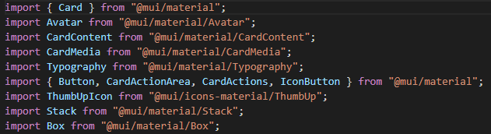

**5) Cors plugin for chrome:**

Access-Control-Allow-Origin lets you easily perform cross-domain Ajax requests in web applications.

CORS or Cross Origin Resource Sharing is blocked in modern browsers by default.

**Reference:** <https://chrome.google.com/webstore/detail/allow-cors-access-control/lhobafahddgcelffkeicbaginigeejlf?hl=en>.

Why we used CORS: <https://medium.com/geekculture/bypassing-cors-with-a-google-chrome-extension-7f95fd953612>

**6) Moment.js**

MomentJS is a JavaScript library which helps in parsing, validating, manipulating and displaying date/time in JavaScript in a very easy way. This chapter will provide an overview of MomentJS and discusses its features in detail. Moment JS allows displaying of date as per localization and in human readable format.

In MomentJS, you can find many easy-to-use methods to add, subtract, validate date, get the maximum, minimum date etc. It is an open-source project and you can easily contribute to the library and add features in the form of plugins and make it available on GitHub and in Node.js.