**Analysis of Activation Test MEA (standard protocol data set)**

**Na’il Mitchell**

**data set description:**Data set of activation test runs of fuel cells with Nafion 112 membranes. MEA structure, operation conditions, activation procedure, and operation conditions after activation can be found at the url below.

**data set url**[: https://github.com/ECSIM/pem-dataset1/tree/master/Activation%20Test%20MEA%20Standard%20Protocol](:%20https:/github.com/ECSIM/pem-dataset1/tree/master/Activation%20Test%20MEA%20Standard%20Protocol)

**data set source**: S. Hamidi, S. Haghighi, K. Askari, Dataset of Standard Tests of Nafion 112 Membrane and Membrane Electrode Assembly (MEA) Activation Tests of Proton Exchange Membrane (PEM) Fuel Cell, ChemRxiv, (2020). doi:10.26434/chemrxiv.11902023.

**data set dimensions:** 5139 rows, 4 columns



Table 1. *Data dictionary*

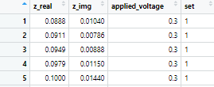

Table 2. *First five rows in data set.*

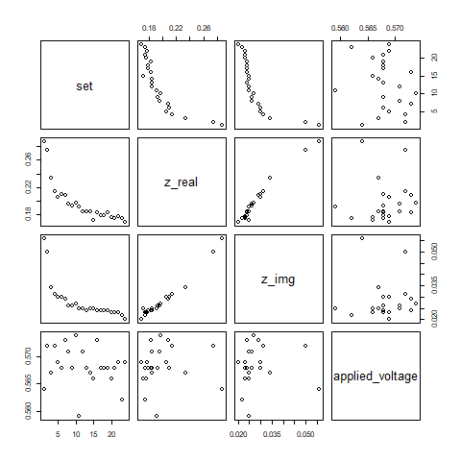

Figure 1. *Scatter plot matrix of mean values (for impedance (real, imaginary) and applied voltage) per activation set. Impendence appears to be strongly associated with set number. Most of the other pair wise plots do not exhibit low correlation between the variables.*

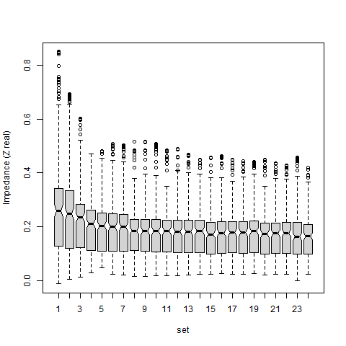

Figure 2. *Box plots of impedance for the 24 activation sets. A steep drop in median independence occurs for the first few runs, then appears to be gradually approaching a convergence. The black notches represent confidence intervals for median impedance; non-overlap of notches for different box plots is strong evidence that there is a significant difference in median impedances. The spread of impedance, in terms of interquartile range, for a given set is quite wide, as can be seen by the lower and upper whiskers.*



Table 3*. Analysis of variance (ANOVA) was performed to test for significant differences in mean impedance values for the activation sets. Notice that the p-value (Pr(>F)) is very low, significant at even the 1% significance level, meaning significant statistical differences exist in mean impedance amongst the activation sets.*