Q1.

2. TEMPLATE.fmb and TEMPLATE.fmb are added from

<root>/appltop/apps/apps_st/appl/au/12.0.0/forms/US to local machine

D:\ABHISHIKTH\Module_3\forms

1. All pll files are added from

<root>/appltop/apps/apps_st/appl/au/12.0.0/resource to local machine

D:\ABHISHIKTH\Module_3\forms

1. Add the forms path by typing “regedit” in RUN

Press CTRL+F then find FORMS_PATH and add pll’s path D:\ABHISHIKTH\Module_3\forms to it.

1. Open AppStand and Template, save the template as EMPLOYEE_TABLE
2. Navigate to property palette of EMPLOYEE_TABLE and change the name to EMPLOYEE_TABLE
3. Delete the BLOCKNAME in DataBlock, Canvas and Window.
4. Create a new DataBlock by selecting DataBlock using wizard
5. Connect to the server providing the credentials as

User Name: apps

Password: apps

Database: EG30518

1. Select the EMP table
2. Rename the Data Block Name as EMPLOYEE_TABLE.
3. Now the data Block is successfully created.
4. In layout wizard select a new canvas here
5. Select all columns to the display Items
6. Select Form
7. Frame Title Name as EMPLOYEE_TABLE, the number of record to be displayed are 5 and the scroll bar is activated.
8. Layout is created
9. Form is created
10. Select the frame and navigate to frame properties. There change the frame name to EMPLOYEE_TABLE

Sub Class Information: Property class to FRAME_RECT

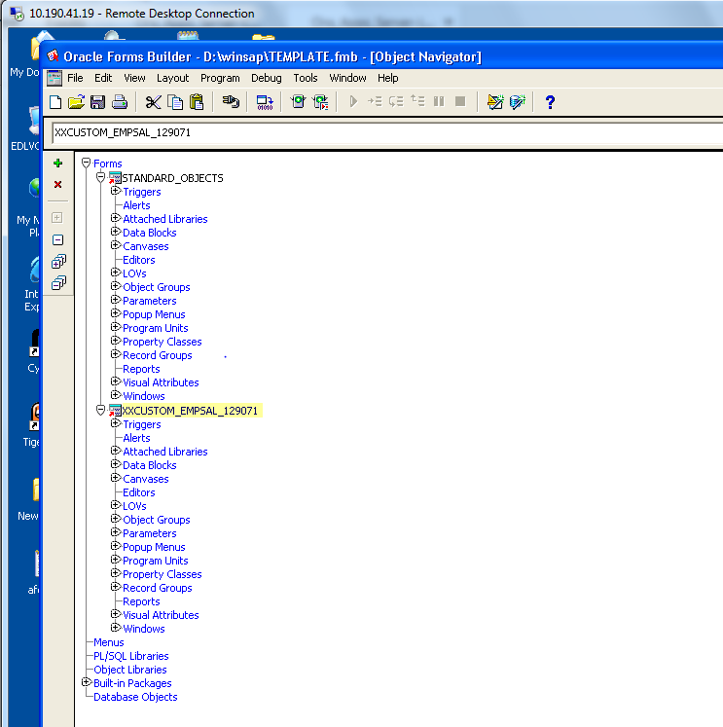

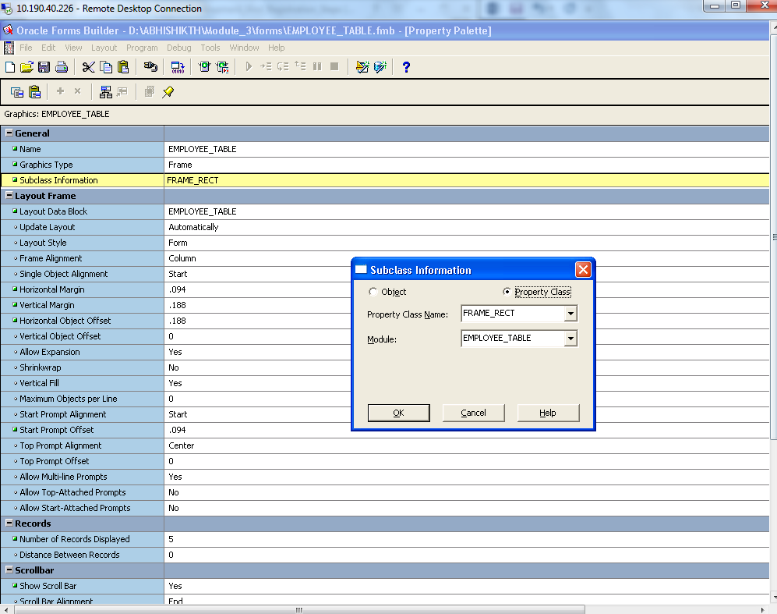

1. Save and exit the form
2. Create new window. Navigate to property palette and change the subclass information property class to WINDOW and change name to EMPLOYEE_TABLE.

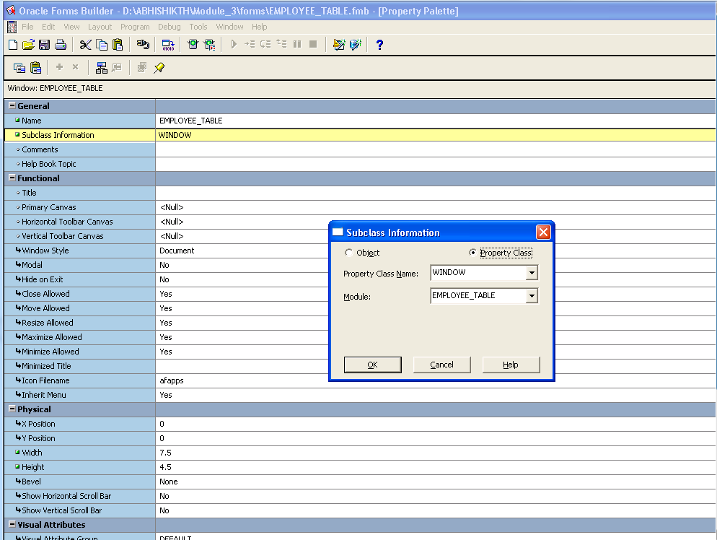

1. Now switch to canvas

Change the canvas name to EMPLOYEE_TABLE

Subclass to CANVAS

Window to EMPLOYEE_TABLE

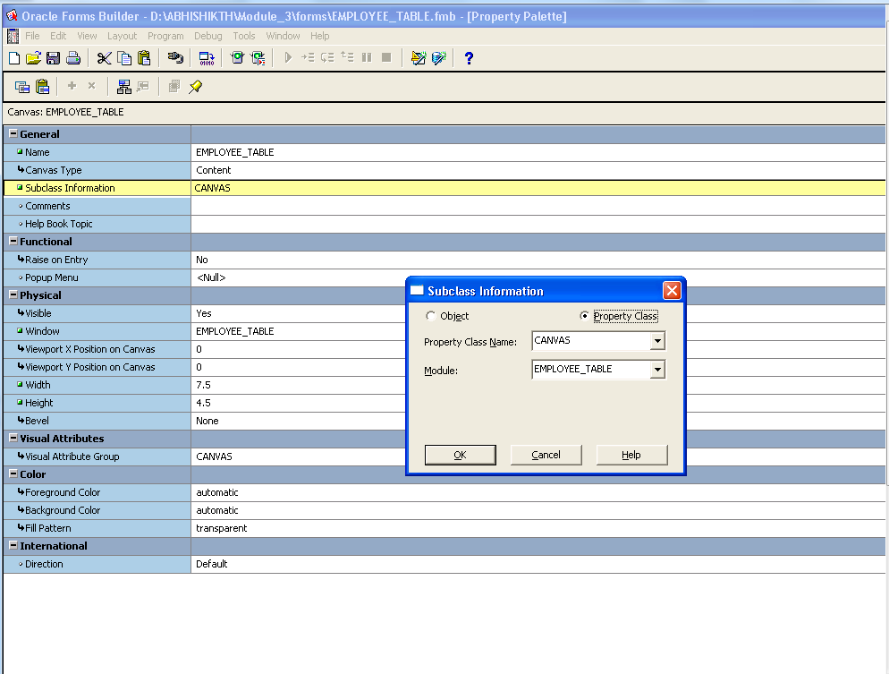

1. Now EMPLOYEE_TABLE in the canvas is dragged on to the top of the window
2. Navigate to block and change the block name to EMPLOYEE_TABLE and 4the Subclass to BLOCK

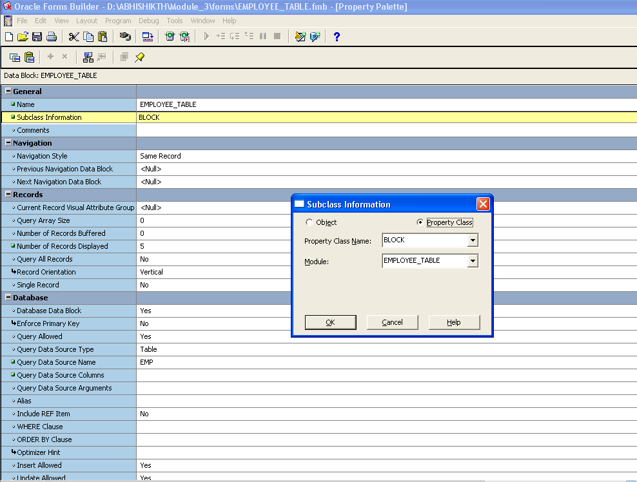

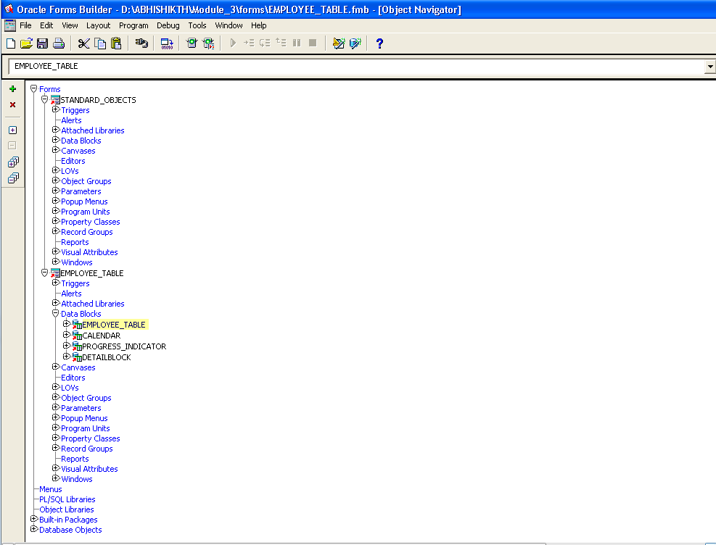

1. Now PRE-FORM triggers are to be set and changes are to be made as

FND_STANDARD.FORM_INFO('$Revision:120.0$', 'EMPLOYEE_TABLE', 'CUSTOM',

'$Date: 2005/05/06 23:25 $', '$Author: TEST_USER_VVB $');

app_standard.event('PRE-FORM');

app_window.set_window_position('EMPLOYEE_TABLE', 'FIRST_WINDOW');

1. Now it is saved and compiled.

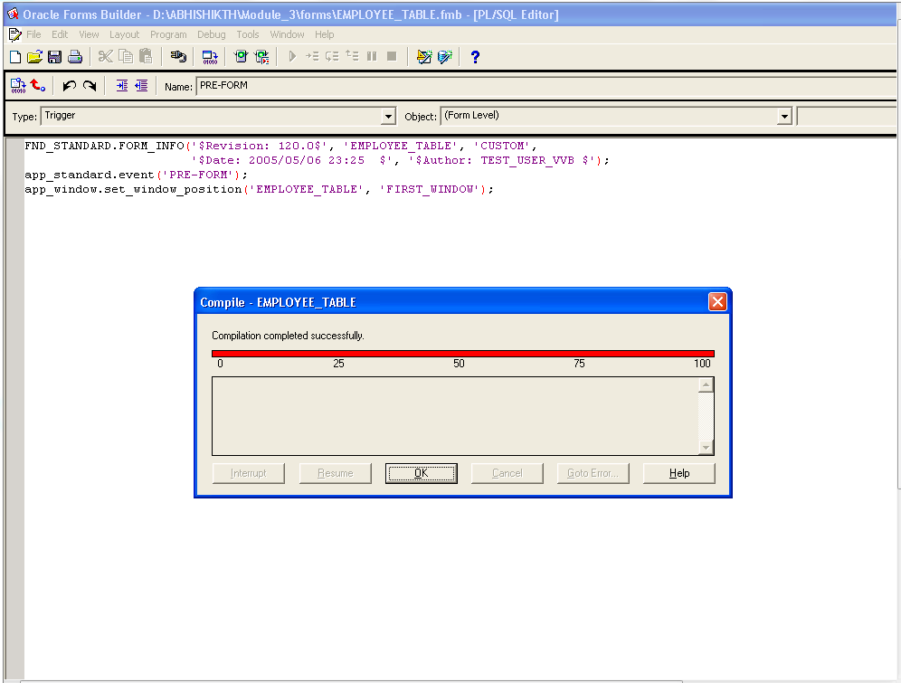

1. Switch to program unit and navigate to BODY and change the assigned window name “EMPLOYEE_TABLE” and save it.

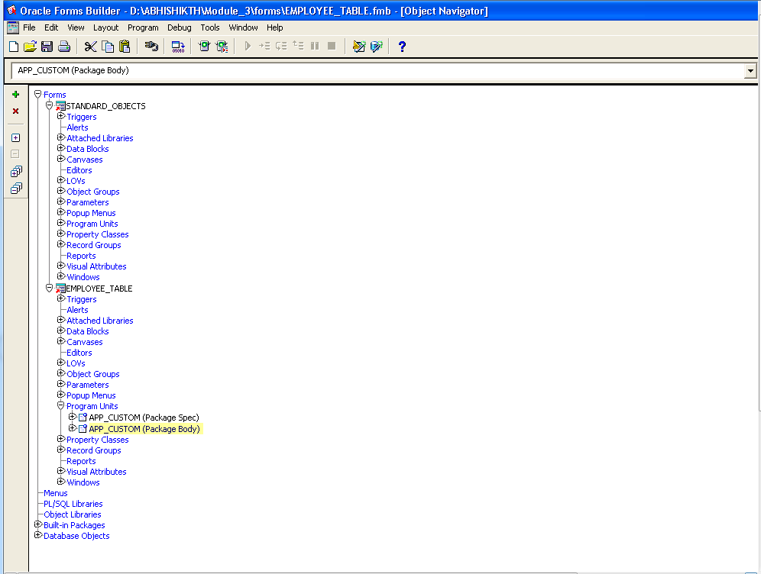

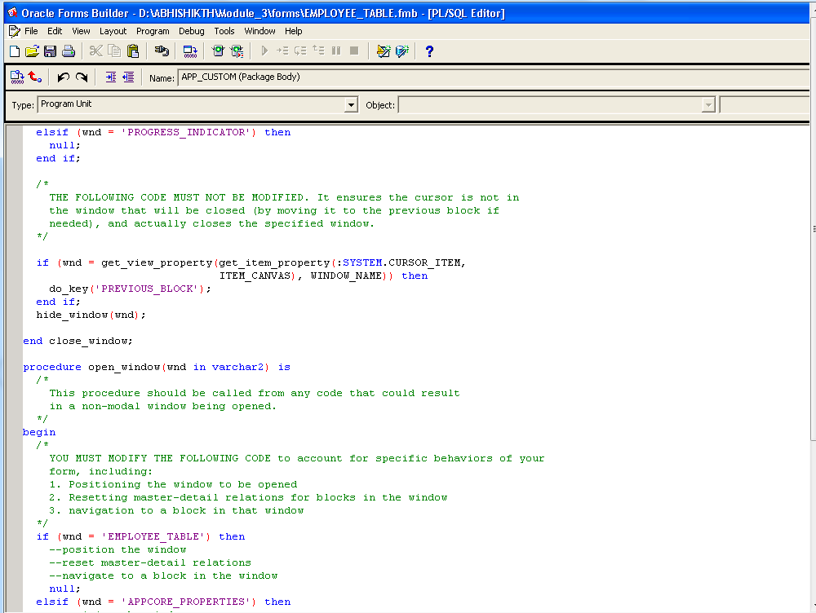

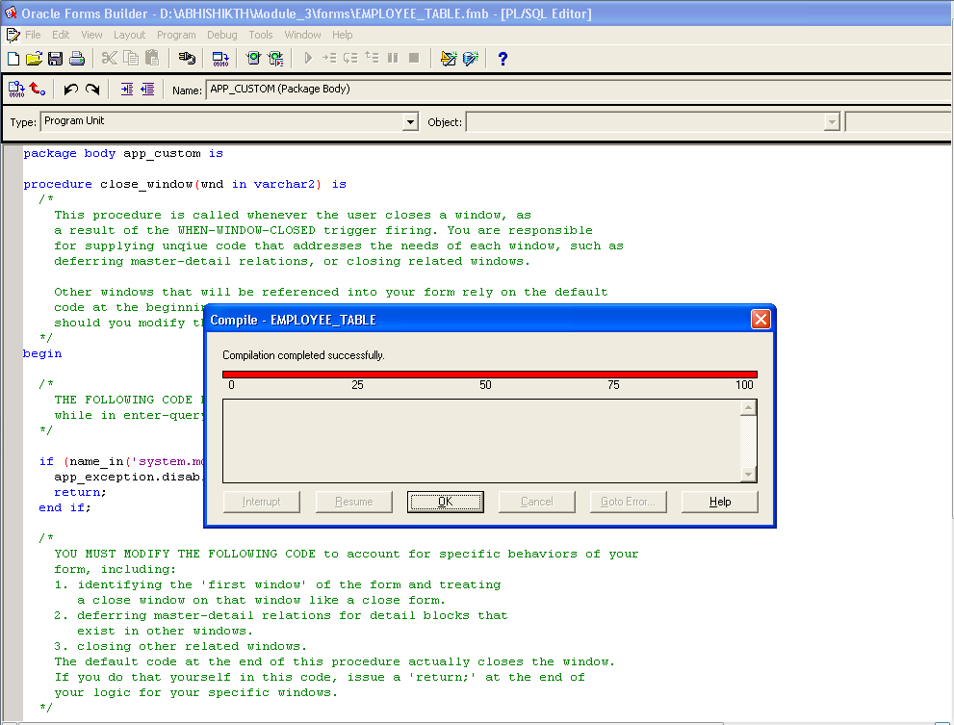

1. Now entire form is compiled and successfully.
2. The for is created.
3. The “EMPLOYEE_TABLE “ form is copied from local directory D:\ABHISHIKTH\Module_3\forms to

<root./dbfiles/applcsf/cust/forms/US

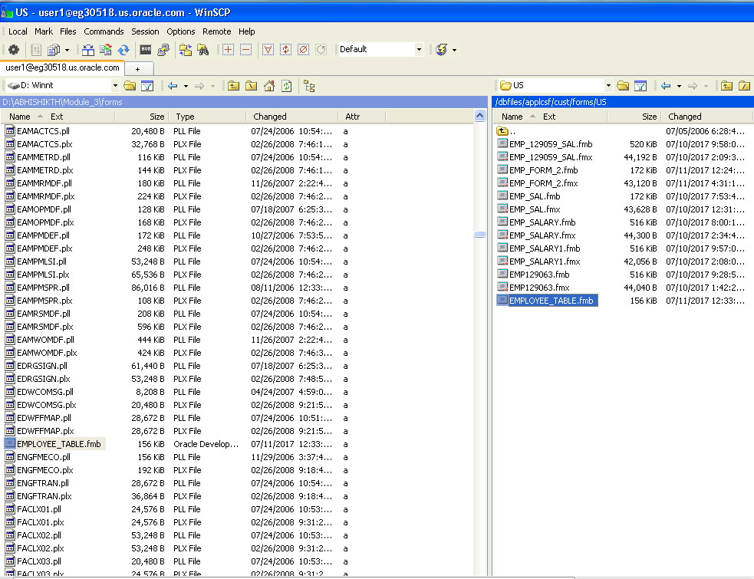

1. To create a fmx file, go to PUTTY

IP address: EG30518.US.ORACLE.COM

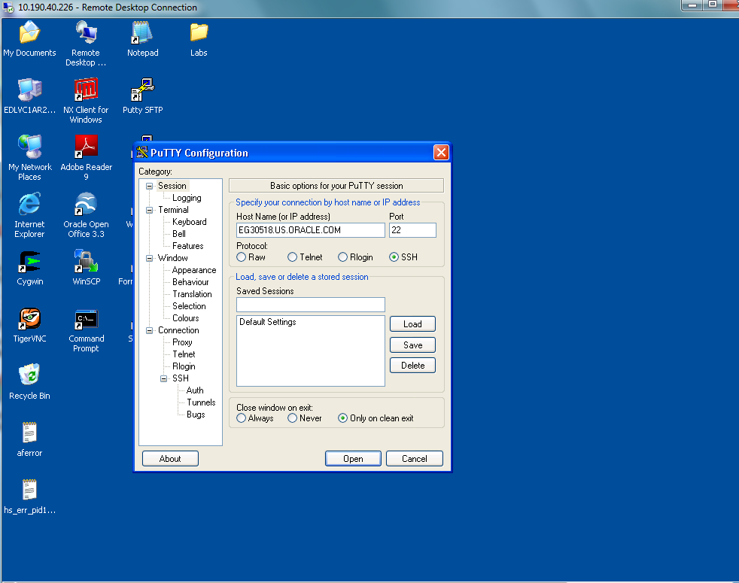

1. Login as

Login: user1

Password: oracle

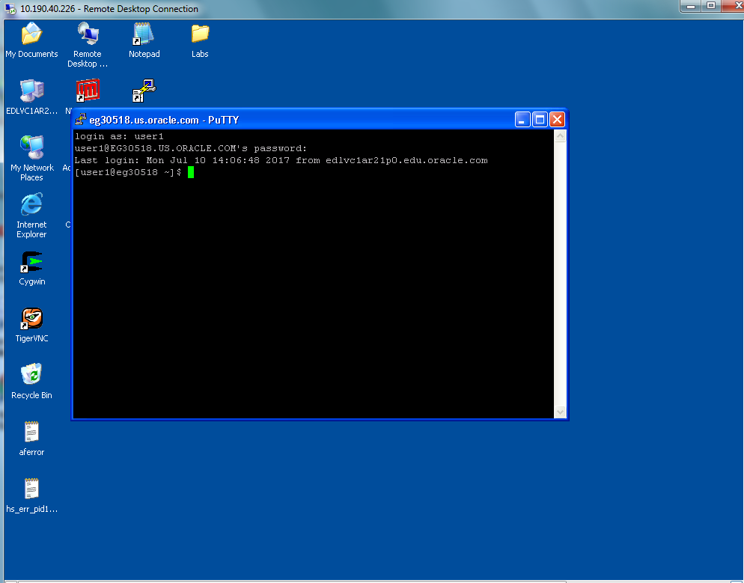

1. Go to root directory by typing

$ cd /

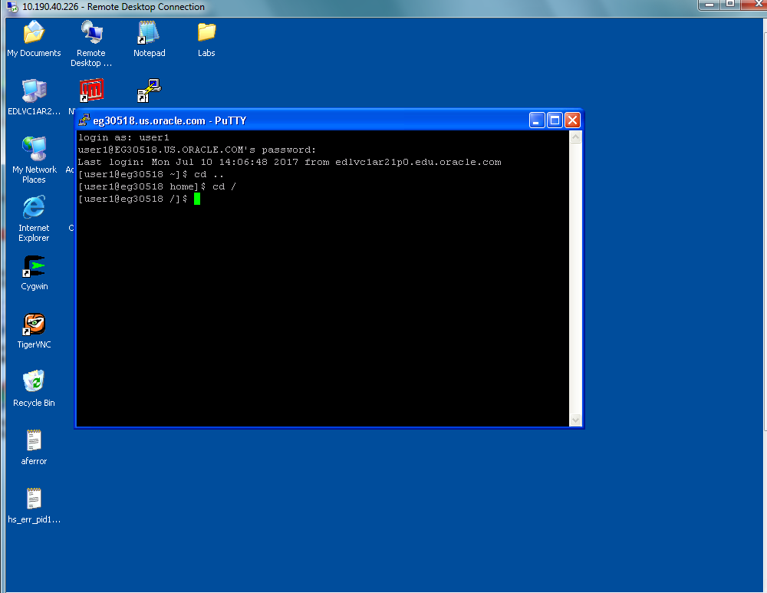

1. Go to form directory by typing

$ cd dbfiles/applcsf/cust/forms/US

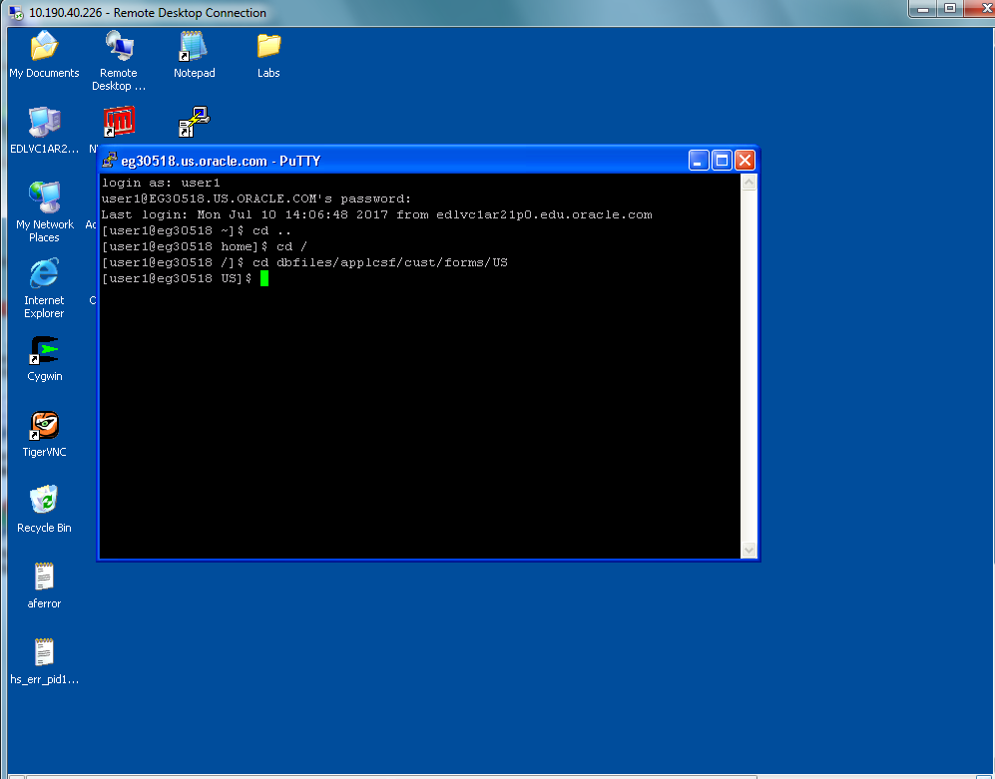

1. Type

frmcmp_batch Userid=apps/apps Module=EMPLOYEE_TABLE.fmb

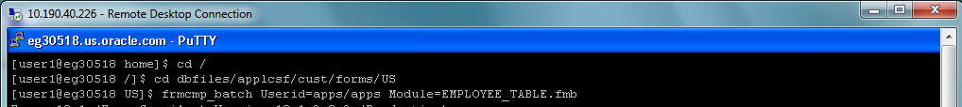

1. Now the fmx file is created.

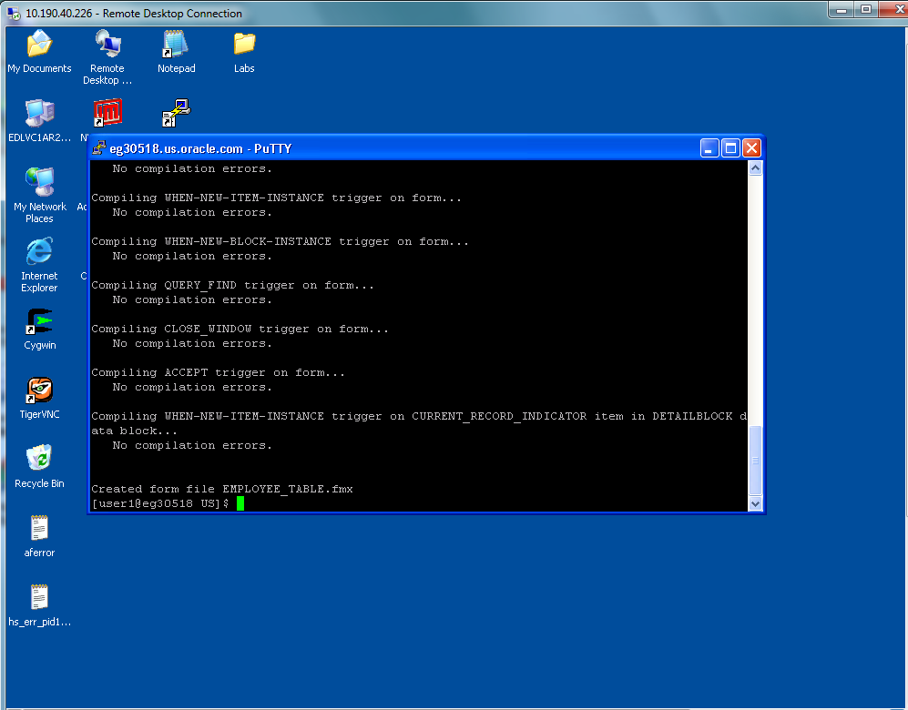

1. Switch to Oracle Application Server:

Login as

User Name: operations_1

Password: welcome

1. Switch to Application developer
2. Navigate to Application and form, here create a new form as shown

FORM: EMPLOYEE_TABLE

Application: Custom Development

USER FORM NAME: EMPLOYEE TABLE FORM

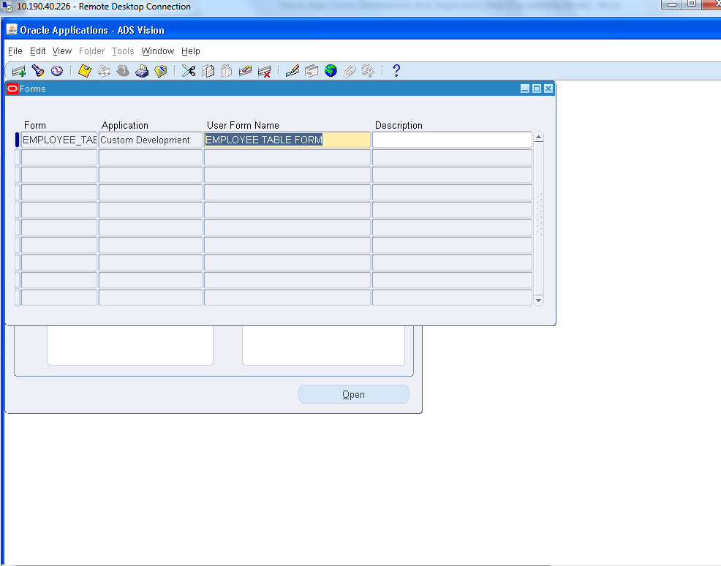

1. Now create a function

In description tab:-

Function Name: EMPLOYEE_TABLE_FUNC

User Function Name: EMPLOYEE TABLE FUNC

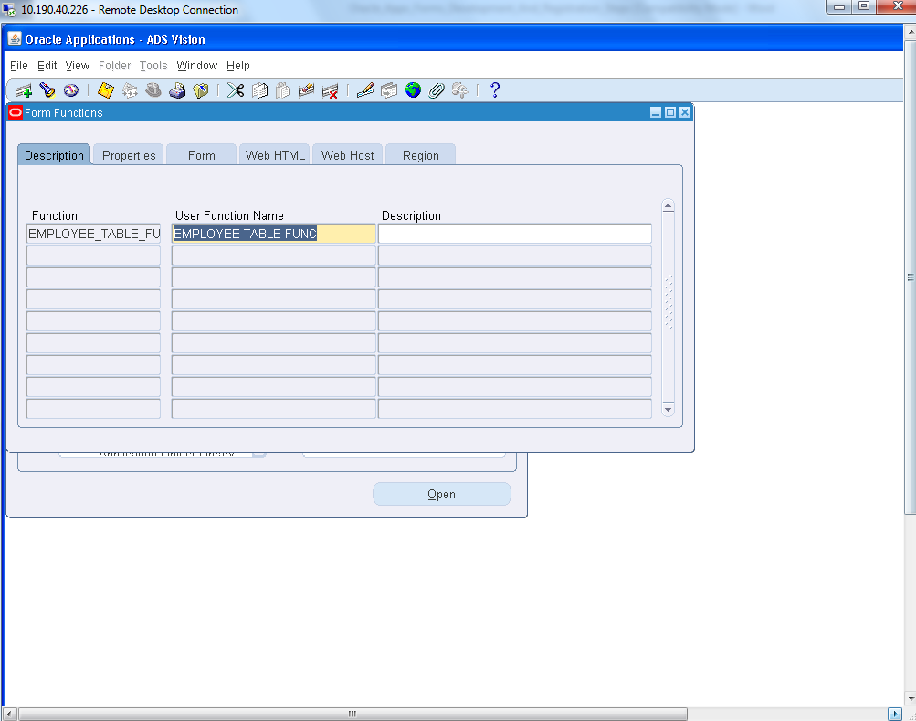

1. In properties tab:-

FORM: form

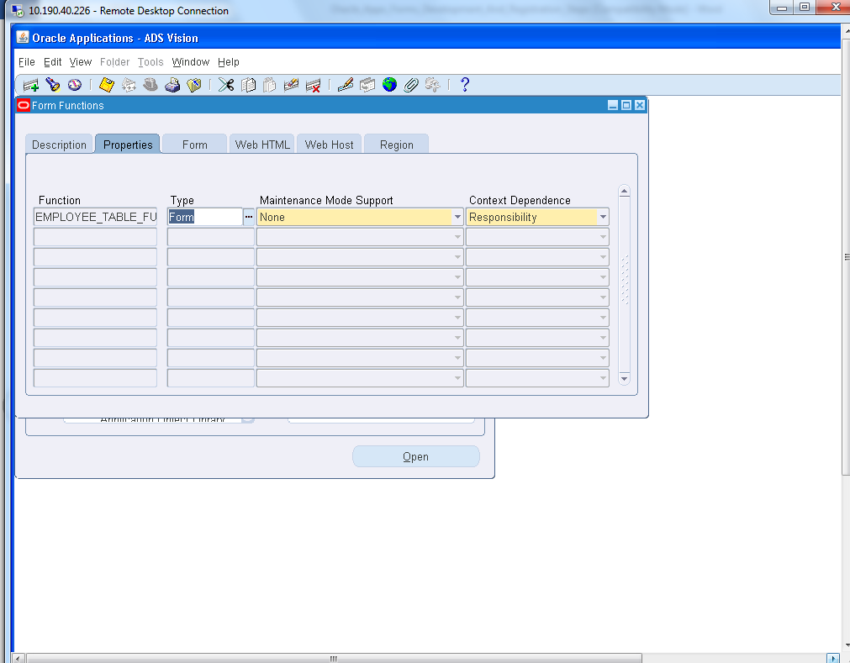

1. In Form tab:-

Form: EMPLOYEE_TABLE

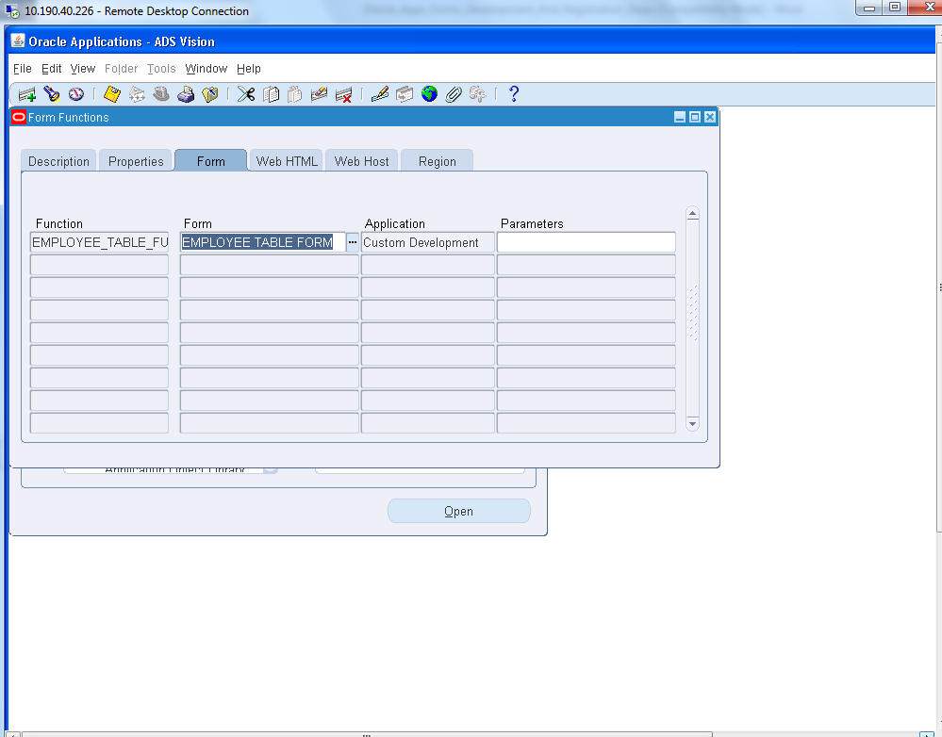

1. Now the form is to be attached to the custom menu

Navigate to menu

1. Query the menu with the name and add the created function

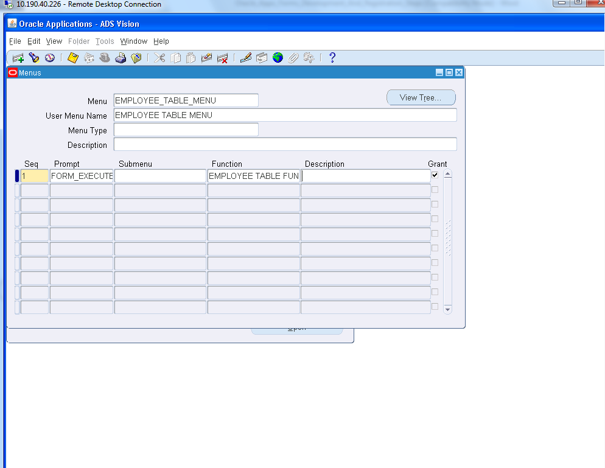

1. Now save and exit the menu. A request id is created.

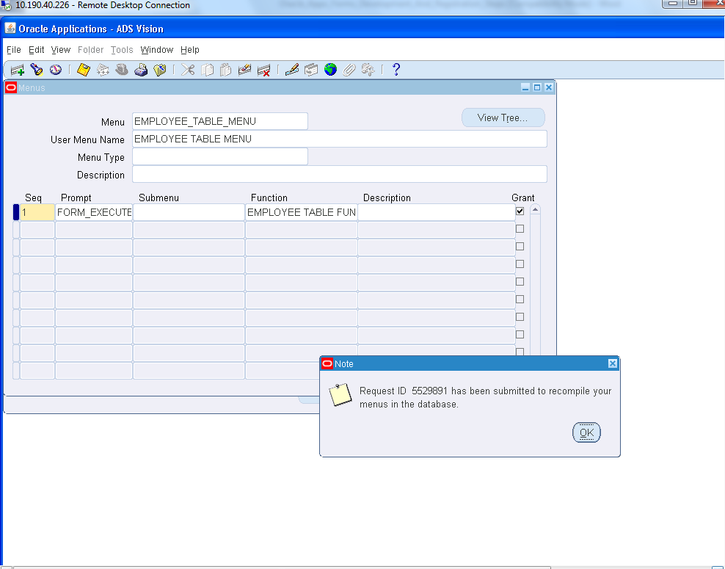

1. Now Create a new responsibility

Switch to System Administrator -> Security -> Responsibility -> Define

Application: Custom Development

Data group:-

Name: STANDARD

Application: Custom Development

Receiver Group:-

Name: Application Developer Reports

Application: Application Object Library

Menu: EMPLOYEE TABLE MENU

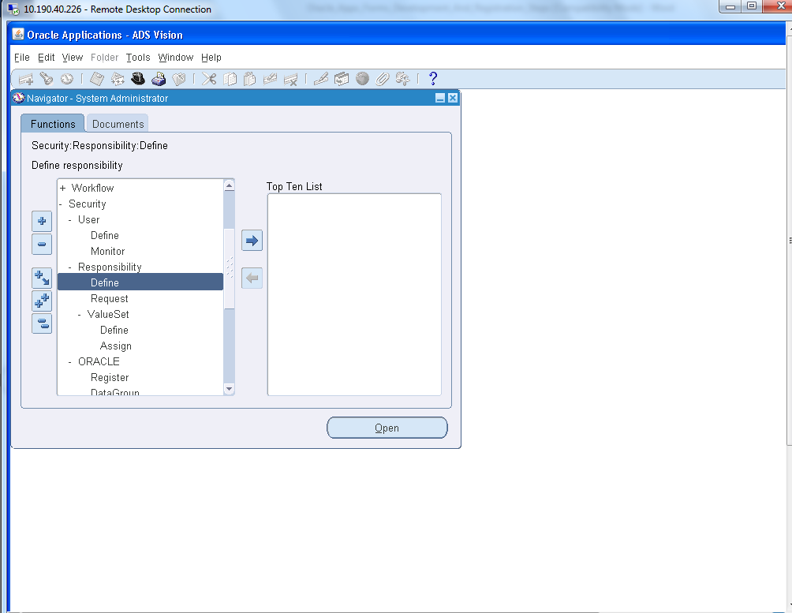

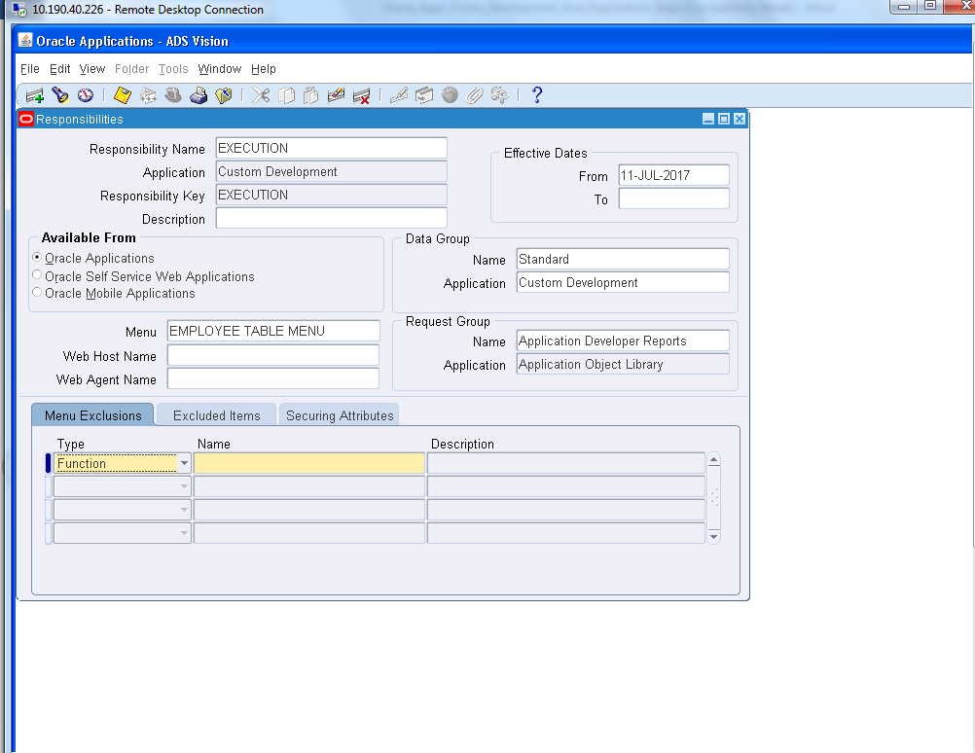

1. Add this created responsibility to the user as

System Administrator -> Security -> User -> Define

Press F11

Enter the user name: operations_1

Press CTRL+F11

Add the created responsibility in the list

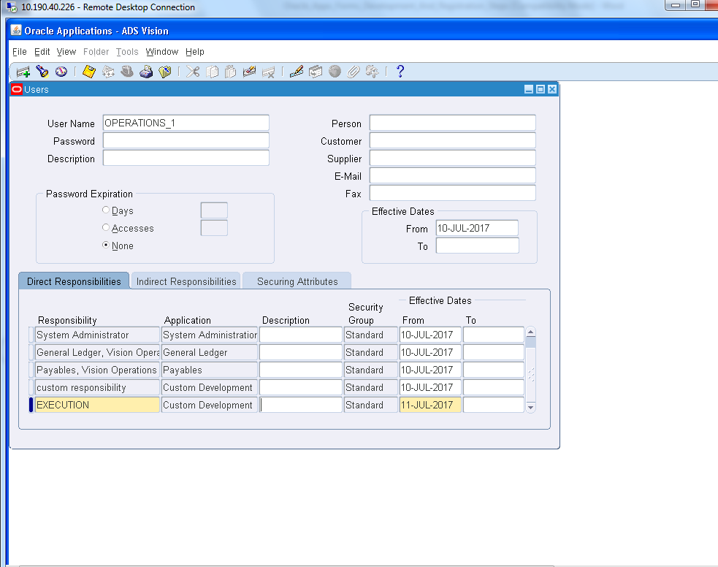

1. Switch to the created responsibility “EXECUTION”

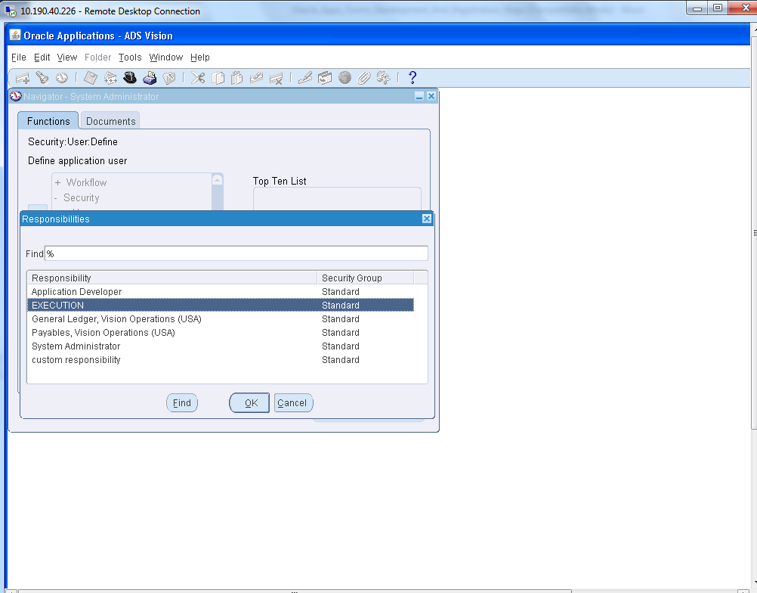

1. Double click on the FORM_EXECUTE

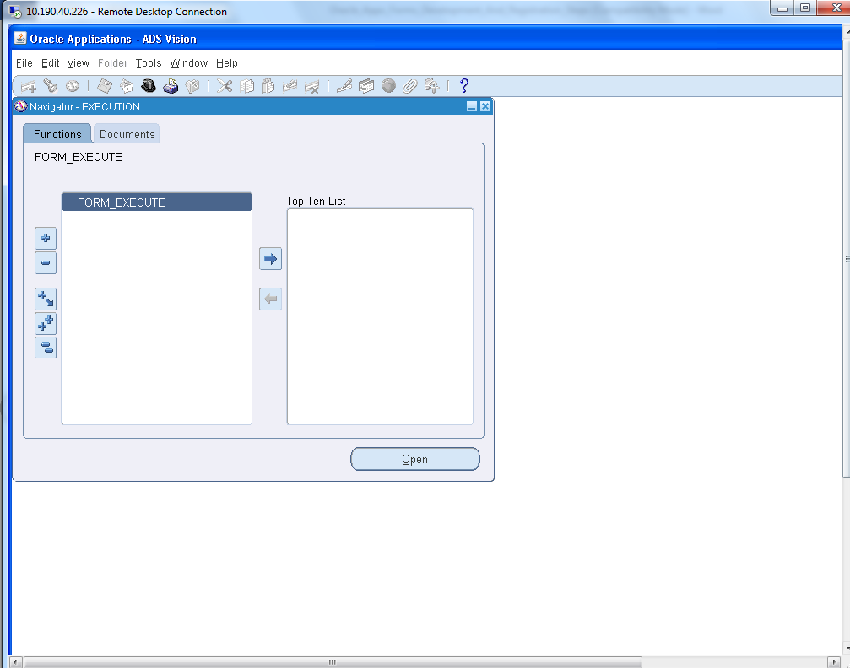

1. Form page is opened.

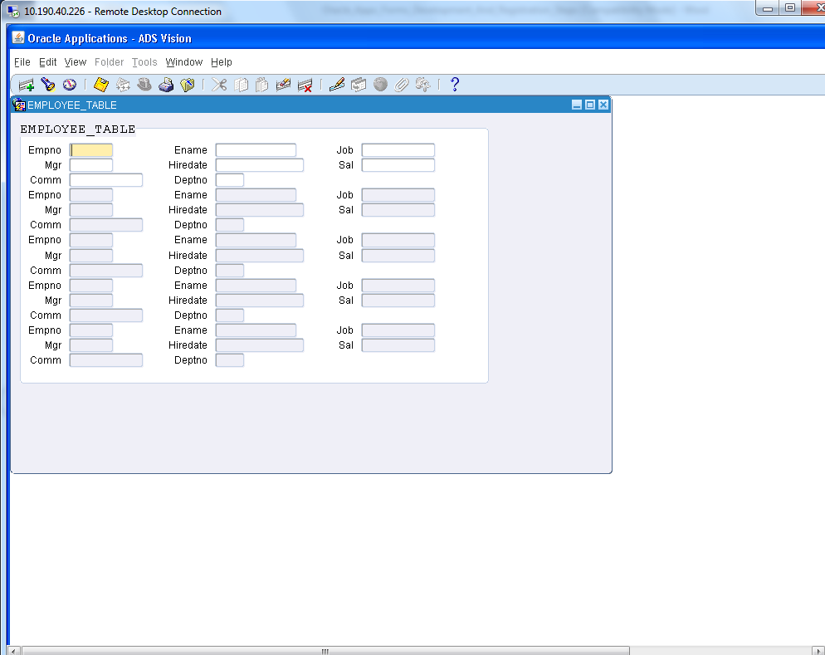

1. Press CTRL+F11. The form is executed.

