1. **Registration and Running a PL/SQL Program in Oracle Application : package**

**Step 1**: Login to the Oracle Apps Database. And compile the package mention below

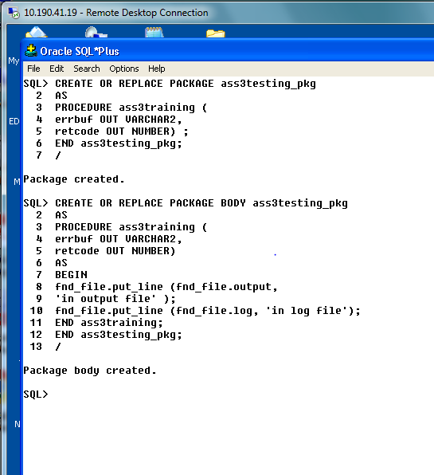

**Step 2:** Make a program and attach executable

Now Login to Oracle Application.

Go to Responsibility Application developer->Concurrent, Executable

Fill the details and save.

Register an executable in oracle applications, as follows

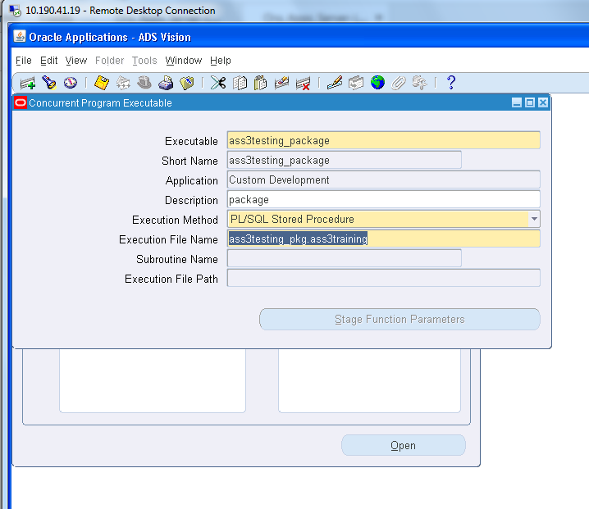

**Step 3:** Now Follow lab 2 (Steps 2 to 4), and to run the program follow steps mention in Lab 3 and

see/analyze output.

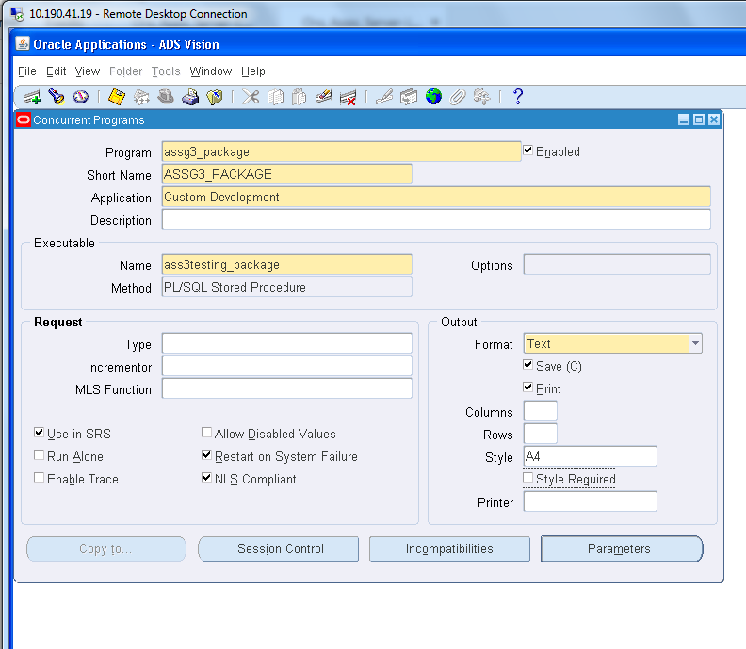

**Step 4:** Attach the program name to a responsibility

Go to Responsibility System Administrator->Security, Responsibility Request

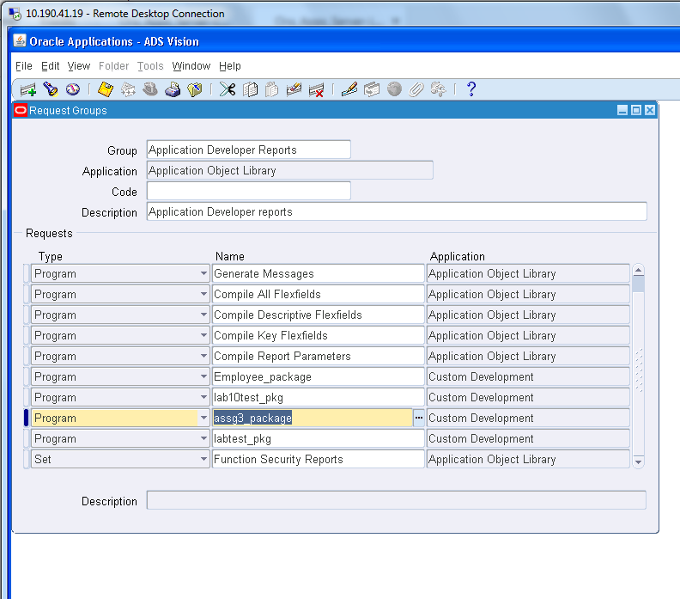

**Run a request**

Go to Respective Responsibility /(M) view/ submit a new request

