1. Retrieve the details (Name, Salary and dept code) of the employees

who are working in department 20, 30 and 40

QUERY:

SELECT ENAME,SAL,DEPTNO FROM EMP WHERE DEPTNO IN (20,30,40)

RESULT:

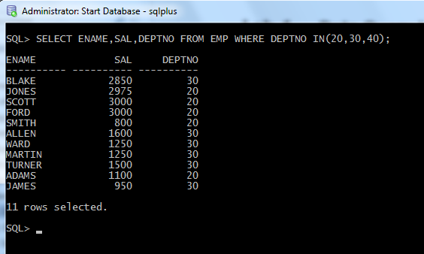

**2.** List the details of the employees with user defined Column headers.

QUERY

SELECT STAFF_NAME “NAME”,SATFF_CODE “CODE” FROM STAFF_MASTERS;

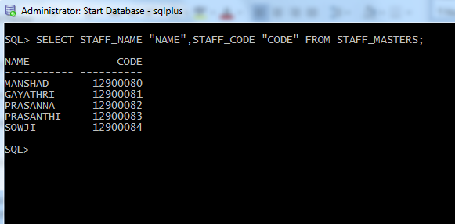

**3.** Display the code, subjects and total marks for every student. Total Marks will be calculated as Subject1+Subject2+Subject3. (Refer Student_Marks table)

QUERY:

SELECT STUDENT_CODE,SUBJECT1,SUBJECT2,SUBJECT3,

(SUBJECT1+SUBJECT2+SUBJECT3) “TOTAL_MARKS” FROM STUDENT_MARKS;

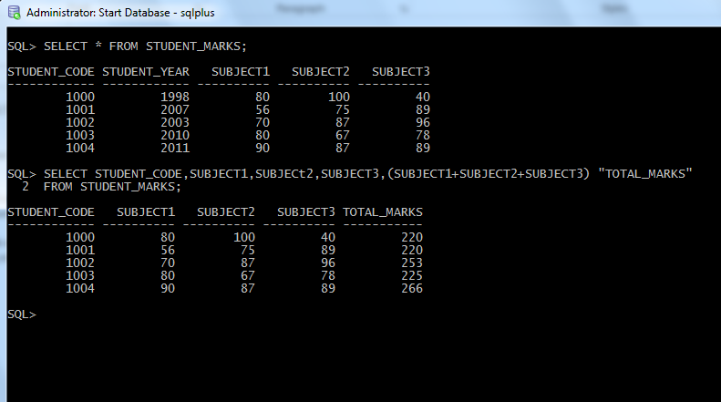

**4.** List the details of the staff whose designations are either PROFESSOR or LECTURER.

QUERY:

SELECT S.STAFF_NAME,S.STAFF_SAL,S.STAFF_ADRESS,D.DESIGN_NAME,

D.DESIGN_CODE FROM STAFF_MASTERS S,DESIGNATION_MASTERS D WHERE

S.DESIGN_CODE = D.DESIGN_CODE AND D.DESIGN_NAME IN(‘PROFESSOR,’LECTURER’);

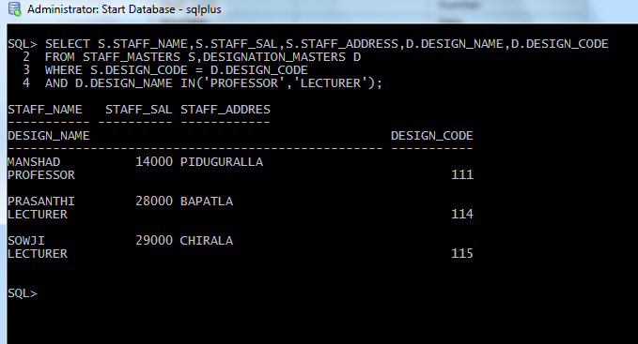

**5.** List the code, name, and department number of the employees who have experience of more than 18 years.

QUERY:

SELECT STAFF_CODE,STAFF_NAME,DEPT_CODE FROM STAFF_MASTERS

WHERE ((SYSDATE-HIREDATE)/365) > 18;

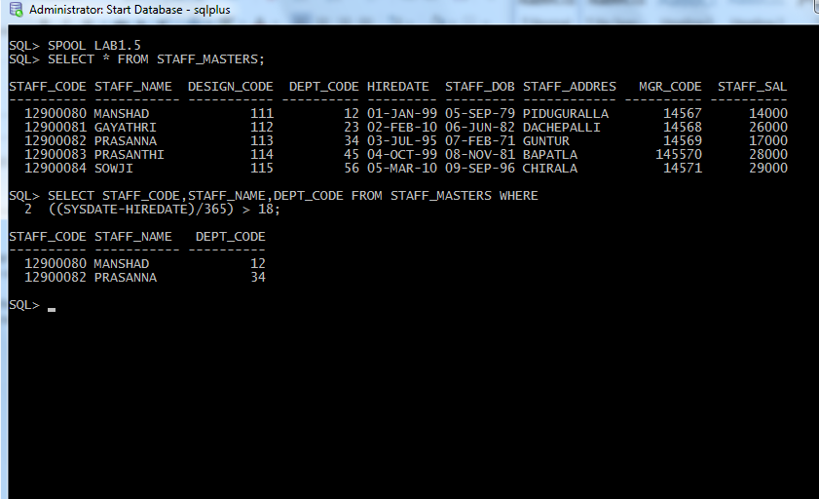

**6.** List the name and Designations of the staff who have joined before Jan 2003.

QUERY:

SELECT S.STAFF_NAME,D.DESIGN_NAME,S.HIREDATE FROM STAFF_MASTERS S, DESIGNATION_MASTERS D WHERE S.DESIGN_CODE=D.DESIGN_CODE AND S.HIREDATE < ’01-JAN-2003’;

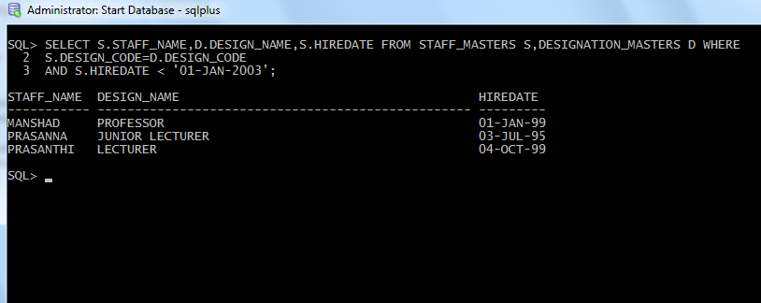

**7.** List the name, designation, and income for 10 years of the employees who are working in departments 10 and 30.

QUERY:

SELECT S.STAFF_NAME,D.DESIGN_NAME,S.STAFF_SAL *120 FROM STAFF_MASTERS S, DESIGNATION_MASTERS D WHERE S.DESIGN_CODE=D.DESIGN_CODE AND S.DEPT_CODE IN(10,30);

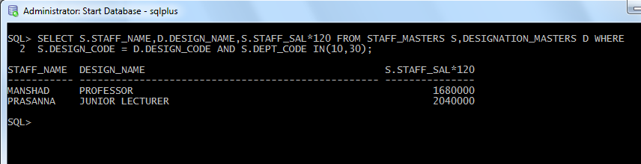

**8.** List the name and experience (in years) of employees who are working as LECTURER.

QUERY:

SELECT S.STAFF_NAME, (SYSDATE-S.HIREDATE)/365 “EXPERIENCE” FROM STAFF_MASTERS S,DESIGNATION_MASTERS D WHERE D.DESIGN_NAME=’LECTURER’;

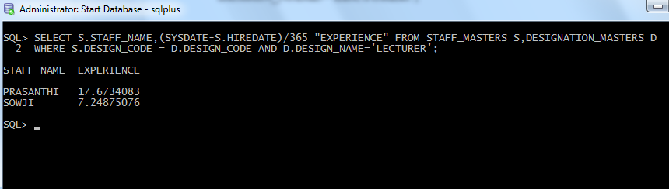

**9.** Display name concatenated with dept code separated by comma and space. Name the column as ‘Student Info’.

QUERY:

SELECT STAFF_NAME|| ’, ‘|| DEPT_CODE “STUDENT_INFO” FROM STAFF_MASTERS;

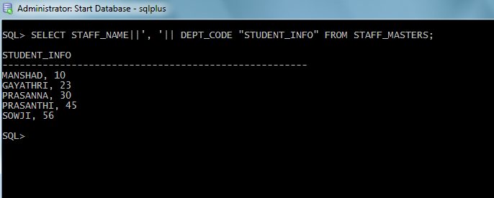

**10.** List the Name and Salary of the staff who are earning between 12000 and 25000. Sort them based on their salaries and name.

QUERY

SELECT STAFF_NAME,STAFF_SAL FROM STAFF_MASTERS WHERE STAFF_SAL BETWEEN 12000 AND 25000 ORDER BY STAFF_SAL,STAFF_NAME;

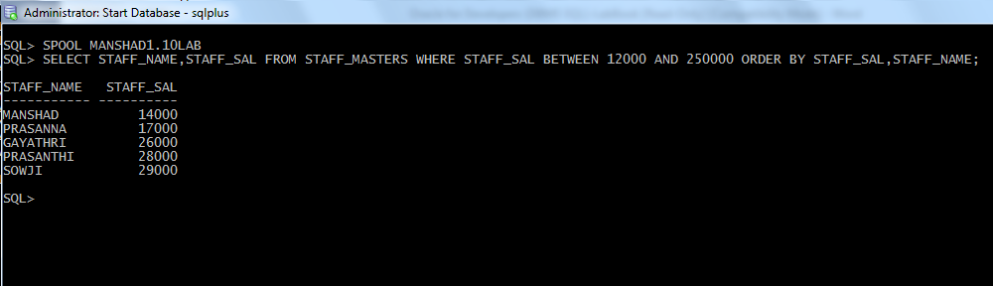

**11.** Display employees who do not have manager.

QUERY:

SELECT STAFF_NAME FROM STAFF_MASTERS WHERE MGR_CODE IS NULL;

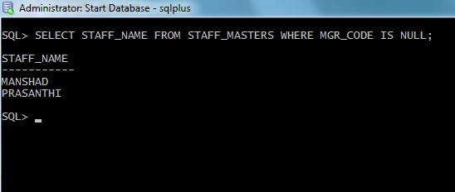

**12.** Write a query which will display name, department code and date of birth of all students who were born between January 1, 1981 and March 31, 1983. Sort it based on date of birth (ascending).

QUERY:

SELECT STAFF_NAME,DEPT_CODE ,STAFF_DOB FROM STAFF_MASTERS WHERE STAFF_DOB BETWEEN ’01-JAN-1981’ AND ’31-MAR-1983 ORDER BY STAFF_DOB;

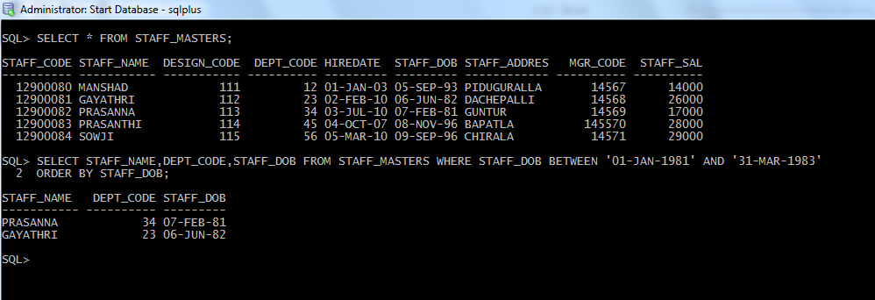

**13.** Get the Department number, and sum of Salary of all non managers where the sum is greater than 2000.

QUERY:

SELECT DEPTNO,SUM(SAL) FROM EMP GROUP BY DEPTNO HAVING SUM(SAL)>2000 AND JOB NOT LIKE ‘MANAGER’;

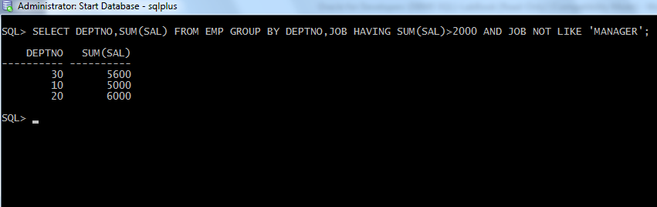

**14.** Display the details of books that have not been returned and expected return date was last Monday.

QUERY;

SELECT * FROM BOOK_TRANSACTIONS WHERE BOOKS_ACTUAL_RETUTN_DATE IS NULL AND BOOKS_EXPECTED_RETURN_DATE = ’29-MAY-2017’;

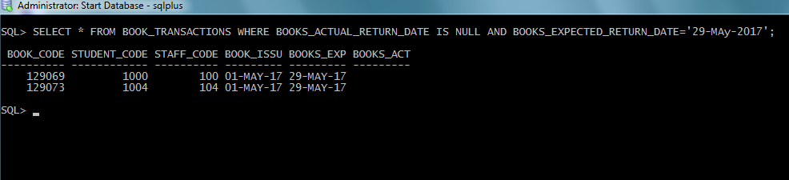

15. Display the name and department code of students. If student does not belong to any department, display “No Department”. Label the column as “Department”. (Hint: Use NVL function)

QUERY:

SELECT STUDENT_NAME,NVL(D.DEPT_NAME,’NO_DEPARTMENT’) “DEPARTMENT” FROM STUDENT_MASTERS S LEFT OUTER JOIN DEPARTMENT_MASTERS D ON S.DEPT_CODE= D.DEPT_CODE;

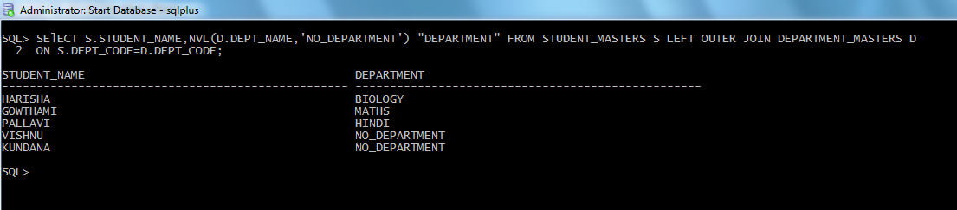

16. Display the name and salary of the staff. Salary should be represented as X. Each X represents a 1000 in salary.

QUERY:

SELECT STAFF_NAME,RPAD(STAFF_SAL/1000+LENTH(STAFF_SAL)),’X’) “SALARY” FROM STAFF_MASTERS;

