1.Display name and date of birth of students where date of birth must be displayed in the format similar to “January, 12 1981” for those who were born on Saturday or Sunday.

QUERY:

SELECT STUDENT_NAME,TO_CHAR(STUDENT_DOB,’MONTH, DD YYYY’) AS STUDENT_DATE_OF_BIRTH, TO_CHAR(STUDENT_DOB,’DAY’) AS DAY FROM STUDENT_MASTERS WHERE TO_NUMBER(TO_CHAR(STUDENT_DOB,’D’),’9’) IN (7,1);

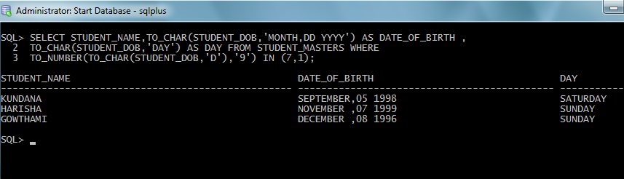

**2.** Display each staff name and number of months they worked for the organization. Label the column as ‘Months Worked’. Order your result by number of months employed. Round the number of months to closest whole number.

QUERY:

SELECT STAFF_NAME,ROUND(MONTHS_BETWEEN(SYSDATE,HIREDATE) “MONTHS_WORKED” FROM STAFF_MASTERS ORDER BY (MONTHS_BETWEEN(SYSDATE,HIREDATE));

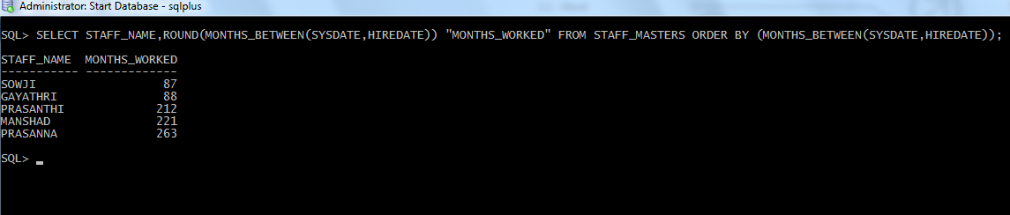

**3.** List the details of the employees, whose names start with ‘A’ and end with ‘S’.

QUERY:

SELECT * FROM STAFF_MASTERS WHERE STAFF_NAME LIKE ‘A%S’;

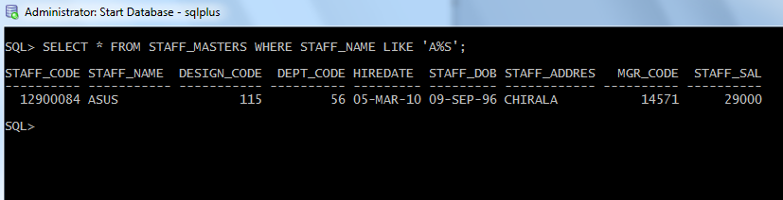

**4.** List the name and job of the employees whose names should contain N as the second or third character, and ending with either ‘N’ or ‘S’.

QUERY:

SELECT ENAME,JOB FROM EMP WHERE( ENAME LIKE ‘_N%’ OR ENAME LIKE ‘__N%’) AND ENAME LIKE ‘%N’ OR ENAME LIKE ‘%S’);

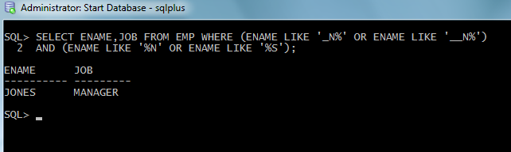

**5.** Create a query which will display Staff Name, Salary of each staff. Format the salary to be 15 character long and left padded with ‘$’.

QUERY:

SELECT STAFF_NAME,LPAD(STAFF_SAL,15,’$’) AS SALARY FROM STAFF_MASTERS;

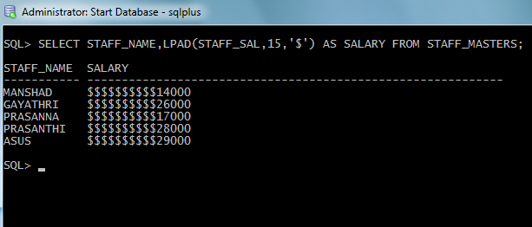

**6.** List the names of the Employees having ‘_’ character in their name.

QUERY:

SELECT ENAME,JOB FROM EMP WHERE ENAME LIKE ‘%\_%’ ESCAPE ‘\’;

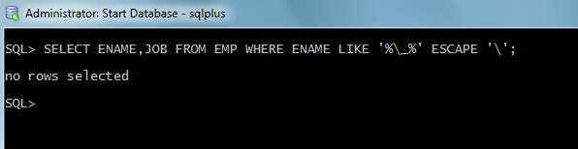

**7.** List the details of the employees who have joined in December (irrespective of the year).

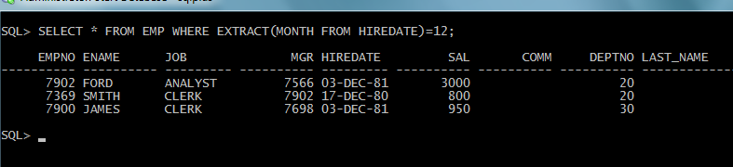

**8.** Write a query that displays Staff Name, Salary, and Grade of all staff. Grade depends on the following table.

|  |  |
| --- | --- |
| Salary | Grade |
| Salary >=50000 | A |
| Salary >= 25000 < 50000 | B |
| Salary>=10000 < 25000 | C |
| OTHERS | D |

QUERY:

SELECT STAFF_NAME,STAFF_SAL,CASE WHEN (STAFF_SAL >= 50000) THEN ‘a’

WHEN (STAFF_SAL>=25000) AND STAFF_SAL<50000) THEN ‘b’

WHEN (STAFF_SAL >= 10000 AND STAFF_SAL<250000) THEN ‘c’

ELSE ‘d’

END CASE

FROM STAFF_MASTERS;

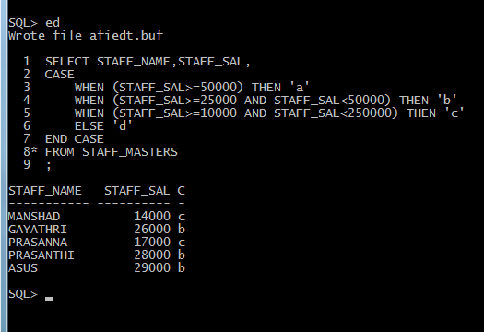

**9.** Display the Staff Name, Hire date and day of the week on which staff was hired. Label the column as DAY. Order the result by the day of the week starting with Monday.

QUERY:

SELECT ENAME,HIREDATE,TO_CHAR(HIREDATE,’DAY’) FROM EMP;

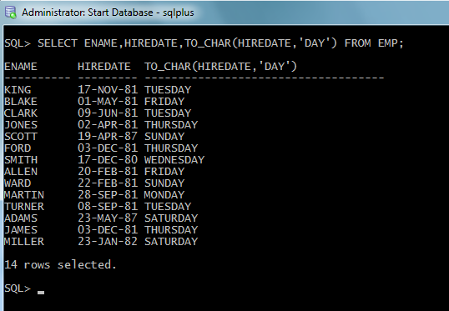

**10.** Show staff names with the respective numbers of asterisk from Staff table.

QUERY:

SELECT LPAD(‘*’,LENGTH(STAFF_NAME_,’*’) AS ANMES FROM STAFF_MASTERS;

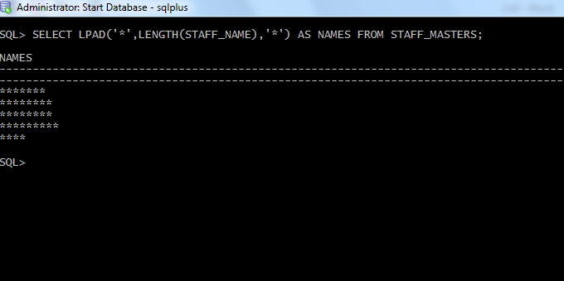

**11.** Show staff names with the respective numbers of asterisk from Staff table except first and last characters. For example: KING will be replaced with K**G.

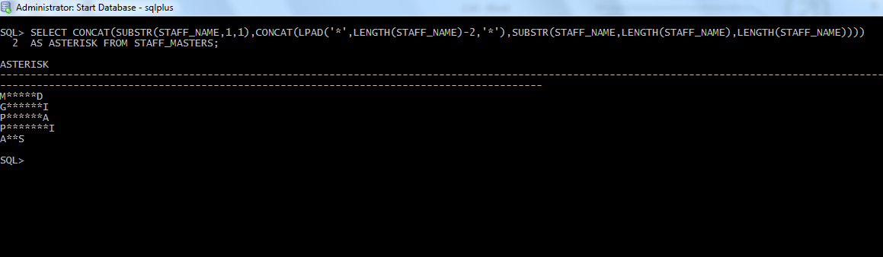

**12.** Show all staffs who were hired in the first half of the month.

QUERY:

SELECT * FROM STAFF_MASTERS WHERE EXTRACT(DAY FROM HIREDATE)<15;

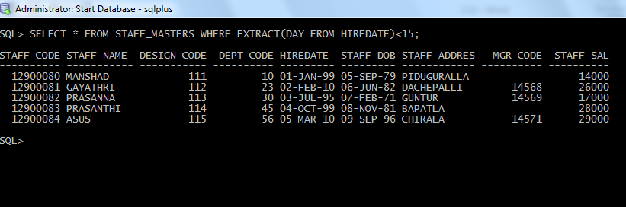

**13.** Display the staff name, hire date and day of the week on which the staff joined. Order the results by the day of the week starting with Monday.

QUERY:

SELECT ENAME,HIREDATE,TO_CHAR(HIREDATE,’DAY’) FROM EMP ORDER BY

MOD((TO_NUMBER(TO_CHAR(HIREDATE,’d’),’9’)+5),7);

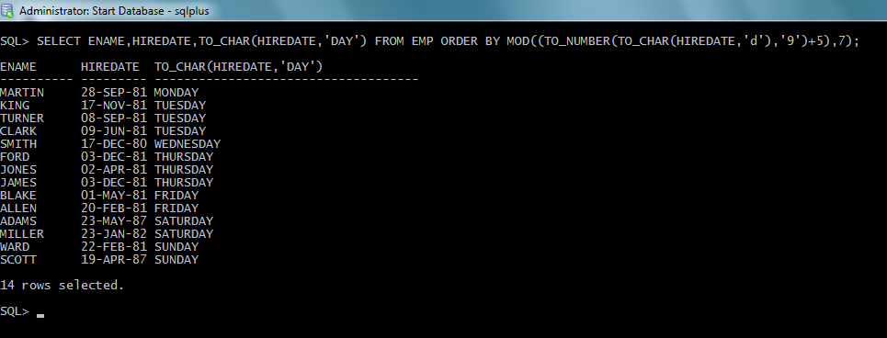

**14.** Write a query to find the position of third occurrence of ‘i’ in the given word ‘Mississippi’.

QUERY:

SELECT INSTR(‘MISSISSIPI’,’I’1,3) FROM DUAL;

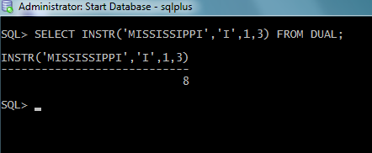

**15.** Write a query to find the pay date for the month. Pay date is the last Friday of the month. Display the date in the format “Twenty Eighth of January, 2002”. Label the heading as PAY DATE.

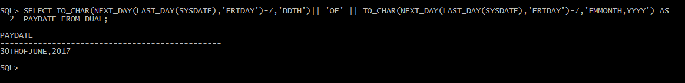

**16.** Display the Highest, Lowest, Total & Average salary of all staff. Label the columns Maximum, Minimum, Total and Average respectively. Round the result to nearest whole number.

QUERY:

SELECT ROUND(MAX(STAFF_SAL),0) AS MAXIMUM,ROUND(MIN(STAFF_SAL),0) AS MINIMUM,ROUND(SUM(STAFF_SAL),0) AS TOTAL,ROUND(AVG(STAFF_SAL),0) AS AVERAGE FROM STAFF_MASTERS;

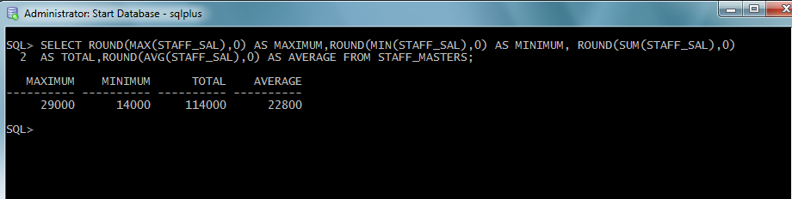

**17.** Edit the above query and display the same for each Department Name.

QUERY:

SELECT D.DEPT_NAME,ROUND(MAX(S.STAFF_SAL),0) AS MAXIMUM,ROUND(MIN(S.STAFF_SAL),0) AS MINIMUM, ROUND(SUM(S.STAFF_SAL),0) AS TOTAL,ROUND(AVG(S.STAFF_SAL),0) AS AVERAGE

FROM STAFF_MASTERS S,DEPARTMENT_MASTERS D WHERE

S.DEPT_CODE=D.DEPT_CODE GROUP BY D.DEPT_NAME;

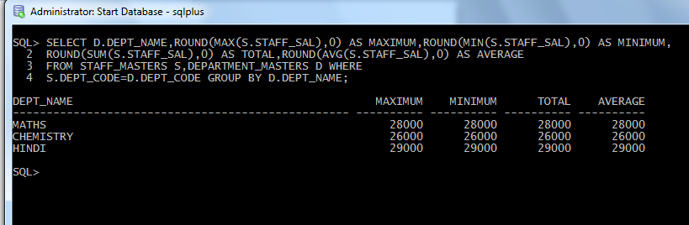

**18.** Write a query to display number of people in each Department. Output should display Department Code, Department Name and Number of People.

QUERY: SELECT D.DEPT_CODE AS DEPARTMENT_CODE,D.DEPT_NAME DEPARTMENT_NAME, COUNT(*) AS NUMBER_OF_PEOPLEFROM STAFF_MASTERS E,DEPARTMENT_MASTERS D WHERE

E.DEPT_CODE = D.DEPT_CODE GROUP BY D.DEPT_CODE,D.DEPT_NAME;

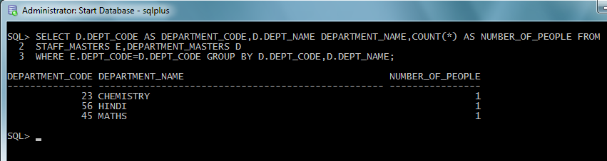

**19.** Determine the number of managers without listing them. Label the column as ‘Total Number of Managers’.

QUERY:

SELECT COUNT(*) FROM EMP WHERE EMPNO=ANY(SELECT MGR FROM EMP);

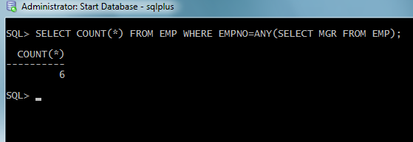

**20.** Display Manager Code, Manager Name and salary of lowest paid staff in that manager’s team. Exclude any group where minimum salary is less than 10000. Order the result on descending order of salary

QUERY:

SELECT E1.MGR,E2.ENAME,MIN(E1.SAL) AS mIN_SAL FROM EMP E1,EMP E2 WHERE E1.MGR IS NOT NULL AND E1.MGR = E2.EMPNO GROUP BY E1.MGR,E2.ENAME HAVING MIN(E1.SAL)>1000 ORDER BY MIN_SAL;

