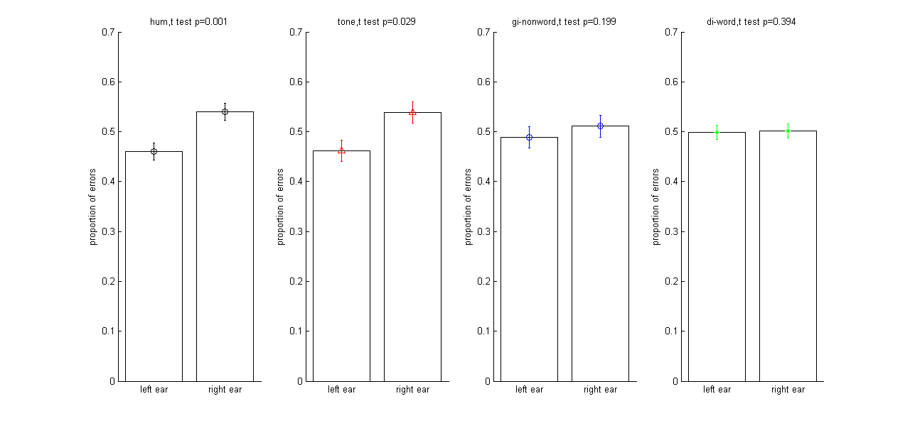

Error is calculated by:

Given a tone from left/right ear, and a response does not match to the tone. Lower bar means better performance. Percentage of error from the left/right / (percentage of error from the left + percentage of error from the right)

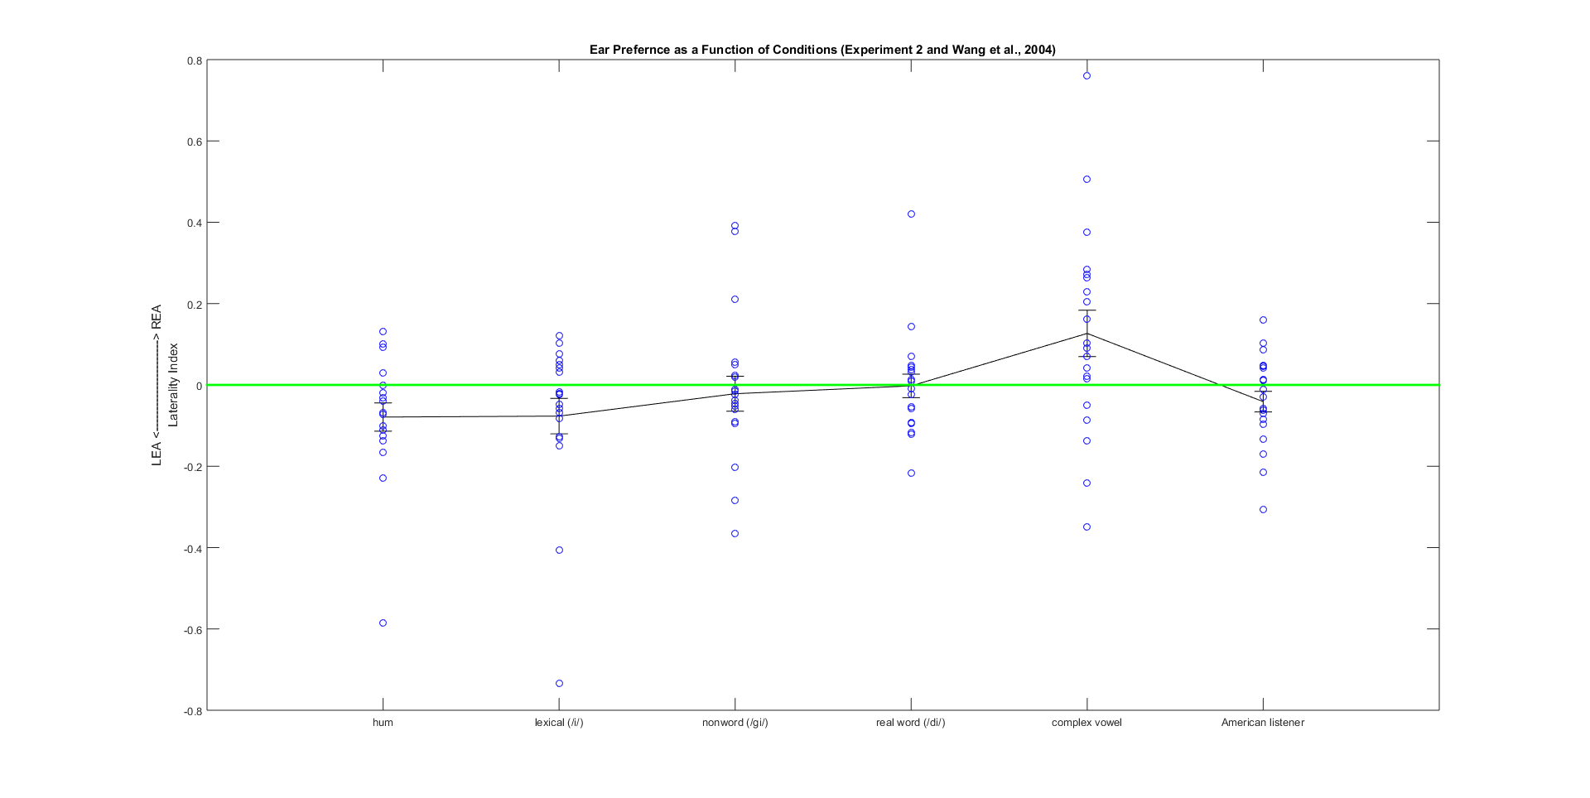

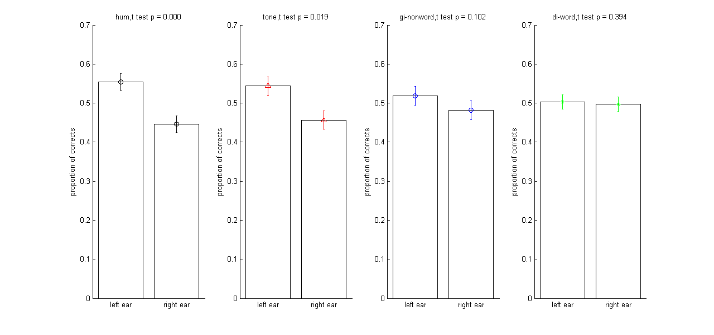Graph above shows Strong LEA for hum, weaker LEA for lexical (simple) tone, very weak LEA for gi-nonword, and no ear preference for di-word.  
Correct is calculated by:

Given a tone from left/right ear, a responses matches the tone. Higher bar means better performance.

Graph above shows Strong LEA for hum, weaker LEA for lexical (simple) tone, very weak LEA for gi-nonword, and no ear preference for di-word.

Since percentage of error is similar to percentage of correct, I will use POE in the rest of report.

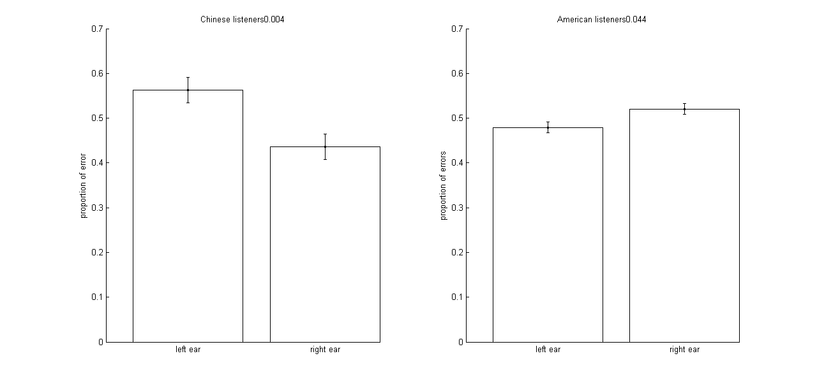A study of Wang et al. 2001. Wang et al. (2001) used Consonant – Complex Vowels (4 tokens) to investigate asymmetric tone perception. They found REA for Chinese speakers and LEA for American students.

The graph is showed by percentage of error, therefore, lower bar means better performance.

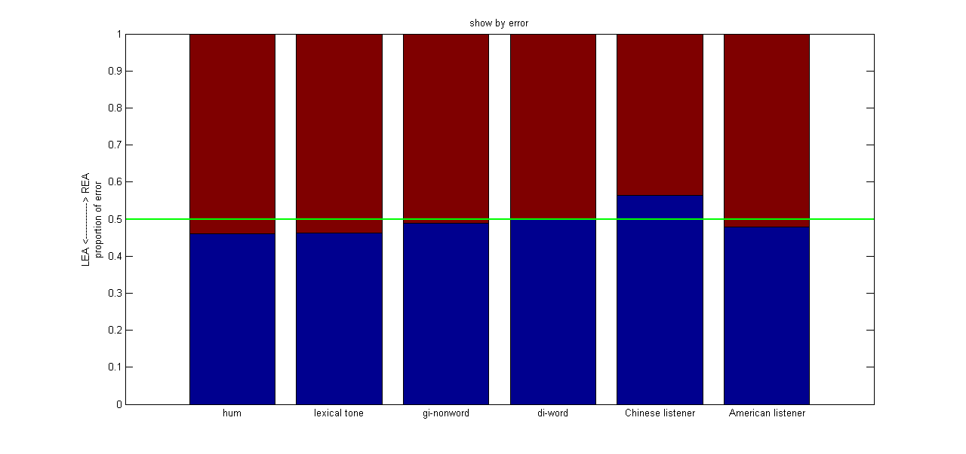Stacked bar graph presents percentage of error as a function of conditions, including Wang et al. (2001) study. A boundary below the green line means LEA, and a boundary above the green line means REA.

The graph shows LEA for hum and lexical (simple) tones, and no ear preference for gi-nonword and di-word. The graph also shows REA for Consonant-complex vowels.

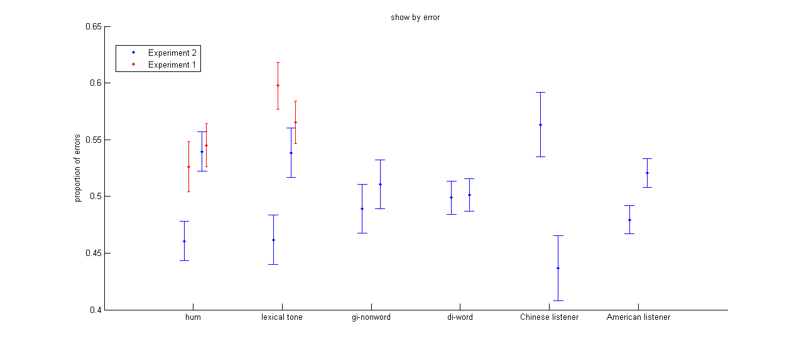The graph shows percentage of error as a function of tokens, including experiment 1, experiment 2, and Wang et al. (2001) study.

LEA is greater in experiment 2 than in experiment 1 for hums, and effect size of experiment 2 is -0.9149. Wang et al. (2001) had a large effect size for REA in Chinese listener, which is 0.4592. effect size is calculated by:

[mean(left) – mean(right)] / pooled standard deviation

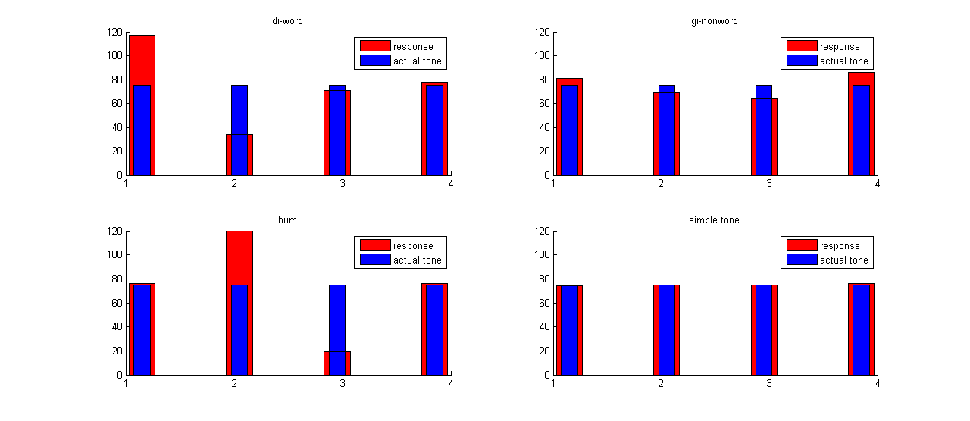The graph shows overall tone recognition. Lexical (simple) tones are the most stable. Subjects usually confuse di2 by di1 and hum3 by hum2.

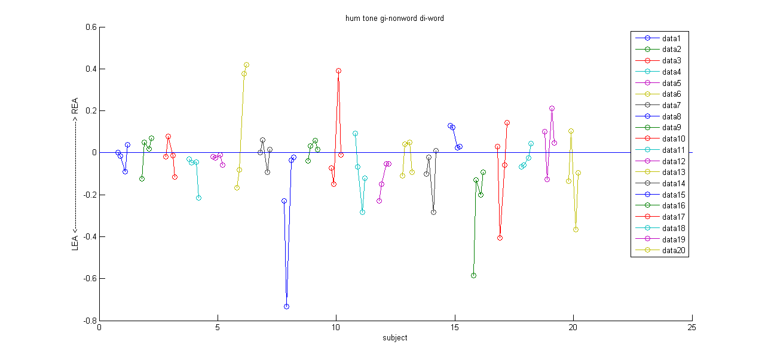Each dot is calculated by:

(percentage of error from left – percentage of error from right) / (percentage of error from left + percentage of error from right)

Therefore, above zero means REA, and below zero means LEA.

Only subject 6 and 18 match our original hypotheses.

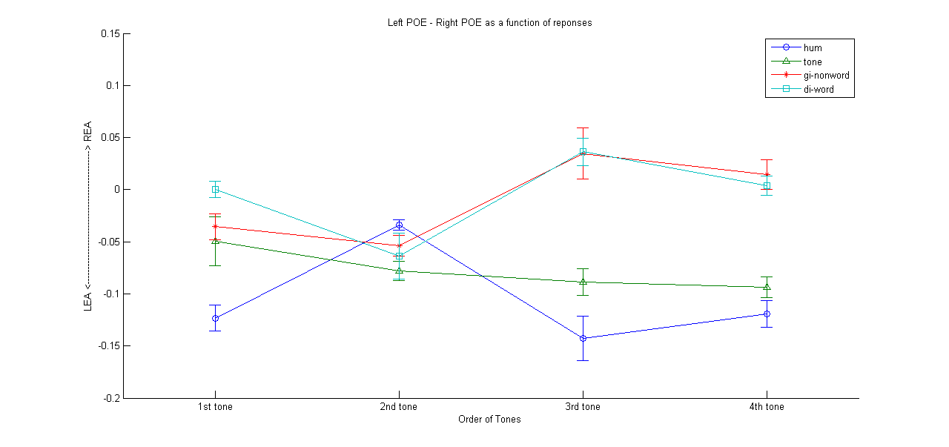

For each condition (hum, tone, di, gi), I take the data of all the subjects and divide the matrix of [left, response, right] into 4 matrices by the response. Within each subject, I calculate an index: (Left percentage of error – Right percentage of error) / (Left percentage of error + Right percentage of error). But, because some of the subjects did not respond all 4 tones, some of the calculated indexes are empty. The mean showed above is the mean of the indexes, and the error bar is the standard error.

We can see that the biggest discrepancy is at 3rd tone, which also has lots of empty calculated indexes. However, because it is the most difficult one, it fits our hypotheses. With more semantic-like structure added to the hum, the tone perception becomes more and more left hemisphere driven.