**Optimisation – Nafih Mohammed**

Task 1)

Task 2)

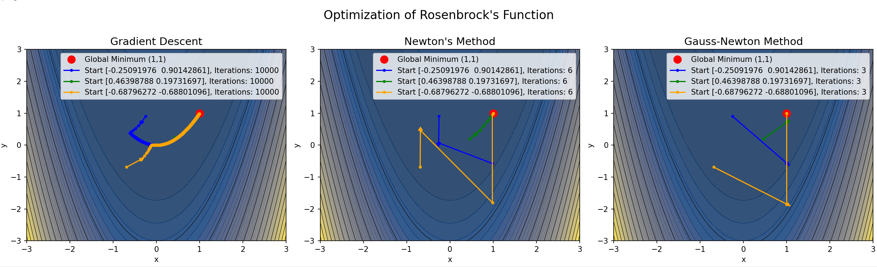

Task 3)

