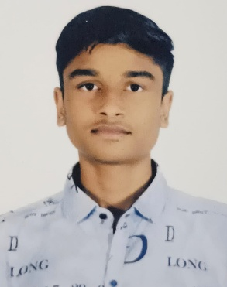
Curriculum Vitae

Name: Agrawal Sahil Sunil Bhai

Phone: 9714665120

Email: sahillagrawal2612@gmail.com
Location: Vadodara, Gujarat
Career Objective
Motivated and creative BCA 2nd-year student with a commerce background, strong problem-solving skills and have some projects. Seeking an opportunity to enhance technical skills, contribute to innovative solutions, and grow in the IT field.
Education
Bachelor of Computer Applications (BCA), 2nd Year – Ongoing Higher Secondary Education (12th – Commerce), Completed
Technical Projects
- Student Result Management (Python + FileHandling)
- Personal Expense Tracker (Python +JSON)
- Simple Portfolio Website (HTML+CSS+ Basic JS)
- 0nline Form Registration System (HTML +CSS+JS +Python Flask OPTIONAL)
Technical Skills
Programming: Python, C/C++ (as applicable)
Web Development: HTML, CSS, JavaScript
Database: SQL,
Tools: Git/GitHub, UI/UX Basics
Soft Skills
Communication, Creativity, Problem Solving, Adaptability, Teamwork, Time Management
Personal Skills & Interests
Sketching, Sports, Exploring new concepts, Creative thinking
Strengths
Fast learner, Curious, Self-motivated, Analytical mindset
Declaration
I hereby declare that the above information is true and correct to the best of my knowledge.

