**Canada**

We chose Canada because it has free trade with United-States and Mexico under NAFTA agreements, education system with an excellent international reputation of Canadian Universities, excellent healthcare system and generous network of social assistance programs and one of the nicest countries in the world with excellent business opportunities. Not to forget that canada's population has over 36 million people who reflect a cultural, ethnic and linguistic mix that is unique in the world. Canadian multiculturalism is based on the belief that all citizens are equal and that diversity makes us stronger as a country.

The 5 foods:

**Poutine** - Warm, gooey, and indulgent, the famous Canadian snack of fries, cheese curds and gravy are now adored the world over. It debuted in rural Quebec snack bars in the 1950s and found its way onto Canada-wide fast-food menus by the late 1980s.

**Bannock** - A satisfying quick bread steeped in Canadian history, basic Bannock is flour, water, and butter (or lard) that is shaped into a disc and baked, fried, or cooked over a fire until golden.

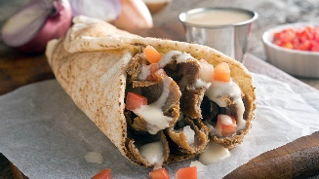**Donairs** - It doesn’t matter if you’re enjoying it as a late-night nosh or a Tuesday-night dinner—a good Canadian donair is all about gobs of sauce. A Nova Scotian twist on traditional gyros, donairs feature spiced ground beef, onions, tomatoes, and a tangy-sweet, condensed milk sauce.

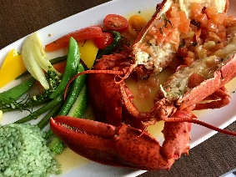**Lobster** - Sweet, succulent lobster from our Atlantic waters is loved across the globe. Once a cheap food source for servants and prisoners, Canadian lobster is now the ultimate delicacy. But don’t let its fancy status intimidate you—lobster is meant to be enjoyed!

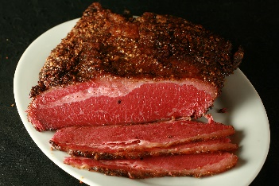**Montreal Smoked Meat -** This salty, smoky deli beef is a Canadian sandwich superstar, best slathered with mustard and sandwiched in rye bread. Montreal smoked meat is dry rubbed with more garlic and savoury spices than its sweeter deli cousin, pastrami, before being smoked, steamed, and sliced.