|  |
| --- |
| GuPS |
| Guitar Pitch Shifter (GuPS) Program Plan (PP) |
| Statement of Work/Work Structure Overview/Work Breakdown Structure |
|  |
| **GuPS1 Team** |
| **November 7th, 2014** |

|  |
| --- |
|  |

# bcIntroduction

This Statement of Work (SOW) identifies and describes the tasks that Guitar Pitch Shifter Team 1 (GuPS1) will perform on the ACME GuPS project. The team will research, design, and deliver a functional GuPS device, and test said device, to ensure fulfillment of the functionality, stability, and performance requirements for the project’s various phases.

Under this SOW, GuPS1, with possible support from other ACME contractual development teams, will design and deliver a GuPS device. The development cycle has been divided into three phases:

**Phase I** will deliver requirements and specification documentation, as well as implement simulations to verify various algorithms and designs before hardware implementation.

**Phase II** will implement Phase I algorithms and designs on pre-configured hardware in order to deliver a hardware implementation of the device and locate any hardware issues.

**Phase III** will use Phase II hardware designs to implement a custom hardware device, removing any unnecessary components included in Phase II pre-configured hardware.

The period of performance for this project will be three months (est. September 11, 2014 – December 5, 2014) for Phase I, with a two month follow-on for Phase II (January 31, 2015), and a second two month follow-on for Phase III (April 1, 2015). Final project design and demonstration is scheduled for May 1, 2015.

# System Approach

GuPS1 has established three phases of design and development in order to more efficiently validate progress throughout project duration. Phase I focuses heavily on theory and design development, while Phase II builds upon validated design to implement a hardware manifestation of Phase I theories. Finally, Phase III allows for further size and unit optimization, in order to create a smaller more portable final product. Phase III also allows for system optimization, modification, or additional optional features.

## Phase I

**Task 0.1: Create a System Boundary Diagram.** The System Boundary Diagram task will ensure that the system is well-defined and that external pre-existing systems that interface with the GuPS system are also well-defined. The GuPS1 Team will produce an understandable System Boundary Diagram that clearly defines what systems and inputs will be external to the developed platform and interface with the GuPS device.

**Task 0.2: Create a Mission Scenario.** The Mission Scenario task will ensure that the device usage is well-defined and that all use cases/modes are accounted for. The GuPS1 Team will produce a comprehensive Mission Scenario that clearly outlines system usage and steps, including those of optional features, for the customer and end user.

**Task 0.3: Create Project Chart and Network Flow Diagram.** The Project Chart/Network Flow Diagram task will ensure development and delivery in the intended timeframe, and allow for development status checks throughout the process. The GuPS1 Team will produce an organized and understandable Project Chart/Network Flow Diagram which clearly outlines the development process and steps involved, with chronological ordering to more clearly track progress.

**Task 0.4: Recommendation Report.** The Recommendation Report task will allow for greater system robustness and flexibility. The GuPS1 Team may produce a coherent Recommendation Report outlining possible improvements to the GuPS project as described by ACME Corporation, if any. This report would allow for optional luxury features to be developed in any remaining time once primary functionality has been developed and tested.

**Task 0.5: Program Plan (SOW and WBS).** The Program Plan task (including Statement of Work and Work Breakdown Structure) will ensure all work tasks necessary for each stage are identified and documented, as well as scheduled along with all other project tasks. The Program Plan will allow for smoother development workflow, and also allow for more efficient timekeeping.

**Task 0.6: Requirement Documents.** The Requirement Document task will ensure that the proposed system, its functions, its interfaces, as well as any physical unit requirements, are well defined and fulfill ACME Corporations expectations. GuPS1 Team will produce this document to assist in project planning and design, as well as a reference for test cases.

**Task 0.7: System Requirements Review.** The System Requirements Review (SRR) task involves a brief presentation to ACME Corporation of the proposed system design, the functions supported, and the interfaces proposed. The SRR also will address any foreseen project risks, and present a development schedule for the GuPS project. GuPS1 Team shall produce and present these components at the SRR, and while all design choices are intended to remain constant, the preliminary review allows for possible modification as development carries on.

**Task 1.4: Create Audio Samples.** The GuPS1 Team will record and store various audio samples from a pre-existing guitar representative of the most common electric guitar configuration. These audio samples will be used during the early stages of simulation to verify shifting algorithm accuracy across various modes before simulations are run on real-time input.

**Task 1.5: Research Pitch Shifting Algorithms.** GuPS1 Team will find, study, and compare various existing pitch shifting algorithms for use in the project design. For each algorithm, multiple metrics will be taken into consideration and compared across algorithms to determine the most beneficial solution. Relevant metrics include performance/latency, accuracy, resulting noise, and finally power demands.

**Task 2.0: Implement Single String Retuning Simulation.** The Single String Retuning Simulation task will verify the models and algorithms chosen to implement the Single String Retuning mode, allowing for strings, even played together, to be shifted separately. GuPS1 Team will implement single-string pitch shifting using these algorithms in a simulation environment, and carefully study results to determine if implementation meets metric requirements determined in Task 1.5.

**Task 2.1: Implement Electronic Capo Mode Simulation.** The Electronic Capo Mode Simulation task will verify the models and algorithms chosen to implement the Electronic Capo Retuning mode, allowing for strings to be shifted together by a decided amount. GuPS1 Team will implement electronic capo pitch shifting using these algorithms in a simulation environment, and carefully study results to determine if implementation meets metric requirements determined in Task 1.5.

## Phase II

**Task 1.1: Determine Input Interface.** The Determine Input Interface task will define the interface through which an input device (typically a guitar) will connect and communicate with the GuPS device. GuPS1 Team will research various interface options and adopt an input interface which will be compatible with most, if not all, pre-existing standard electric guitars.

**Task 1.2: Determine Output Interface.** The Determine Output Interface task will define the interface through which the GuPS device will connect and communicate with an output device (typically a guitar amplifier or effects module). GuPS1 Team will research various interface options and adopt an output interface which will be compatible with most, if not all, pre-existing standard electric guitar amplifiers or effect modules.

**Task 1.3: Determine Development Platform.** The Determine Development Platform task will define a hardware development/prototyping platform to utilize for implementing and testing the standalone unit design. GuPS1 Team will research various hardware options and adopt a platform which will best fit the project specifications. Relevant metrics to be considered are: performance/latency, size, power consumption, cost, and robustness.

**Task 3.0: Implement Single String Retuning in Hardware.** The Single String Mode Hardware task will verify the simulations and data produced in Task 2.0, moving the design onto hardware in order to develop a standalone device. GuPS1 Team will implement single-string pitch shifting using the algorithms from the simulation environment, and carefully study results to determine if implementation meets metric requirements determined in Task 1.5.

**Task 3.1: Implement Electronic Capo in Hardware.** The Electronic Capo Mode Hardware task will verify the simulations and data produced in Task 2.1, moving the design onto hardware in order to develop a standalone device. GuPS1 Team will implement electronic capo pitch shifting using the algorithms from the simulation environment, and carefully study results to determine if implementation meets metric requirements determined in Task 1.5.

## Phase III

**Task 3.2: PCB/Production Unit Design.** The PCB/Production Unit Design task will further minimize and optimize the Phase II project design, in order to make a final device design that is ready for full-scale production. GuPS1 Team will analyze Phase II hardware implementation, and remove any unnecessary components from design that may be included on the prototyping hardware platform. A custom PCB will then be designed (but not fabricated) that would interface all necessary components in an optimized fashion, therefore driving down unit power consumption and production cost.

## Milestone Gantt Chart

A Gantt chart showing the project timeline, featuring all of the necessary tasks and milestones through project completion in May, 2015 is shown below in Figure 1.

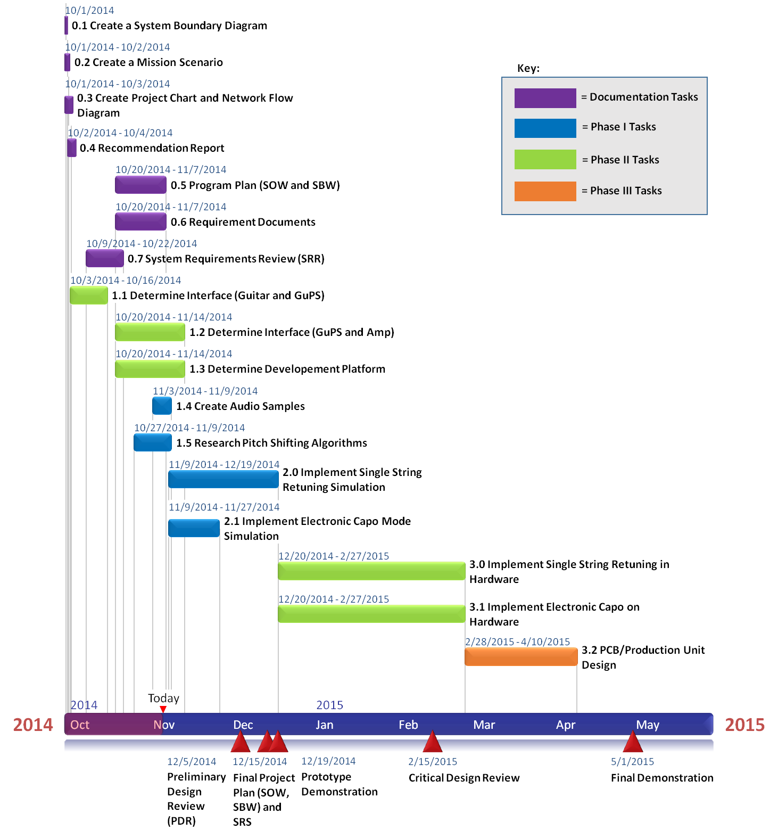

**Figure 1: GuPS Gantt Chart Through May, 2015**

# Work Breakdown Structure

The Work Breakdown Structure of the Guitar Pitch Shifter accurately shows how the smaller jobs will come together to accomplish the larger task. There are three major levels.

Level 1 is the project’s overall objective, to create a device that can pitch shift a guitar without the user having to use the tuning pegs. Level 2 shows the three parts that will make up the guitar pitch shifter: the pitch shifter pedal, the mobile app, and the guitar/amp that the pitch shifter will be connected with.

Level 3 shows the individual parts that will make up these three pieces of the design in level 2. Under the pitch shifter there is the power supply to power the device, the PCB design that will be used to make the standalone device, the user interface for the user to set a tuning, and also the four modes: single string, electronic capo, dynamic tuning, and auto tune. Under the mobile app there is the system software to run the app, the utilities data that will be displayed to the user, wireless Bluetooth to communicate between the device and a phone, retuning options for the user to select, and the user interface for the user to interact with the pitch shifter. Under the guitar/amp connection there is simply ¼” cables to connect the guitar to the pitch shifter and the pitch shifter to the amp. Figure 2 shows the described work breakdown structure by levels.

**Level 1**

* Power Supply
* PCB Design
* Standalone Device
* User Interface
* Single String
* Electronic Capo
* Dynamic Tuning
* Auto-tune
* System Software
* Utilities Data
* BTLE
* Retuning Options
* User Interface
* ¼” Cables
* Guitar to Pitch Shifter Connection
* Pitch Shifter to Amplifier Connection

**Guitar Pitch Shifter (GuPS)**

**Pitch shifter**

**Mobile App**

**Guitar/Amp**

**Level 2**

**Level 3**

**Figure 2: Work Breakdown Structure Diagram**