|  |
| --- |
| GuPS |
| Guitar Pitch Shifter (GuPS) Program Plan (PP) |
| Statement of Work/Work Structure Overview/Work Breakdown Structure |
|  |
| **Prepared by: GuPS1 Team** |
| **February 16 h, 2015** |

|  |
| --- |
|  |

# bcIntroduction

This Statement of Work (SOW) identifies and describes the tasks that Guitar Pitch Shifter Team 1 (GuPS1) are performing on the ACME GuPS project. The objectives of the team are to research, design, and deliver a functional GuPS device, and test said device, to ensure fulfillment of the functionality, stability, and performance requirements for the project’s various phases.

Under this SOW, GuPS1, with possible support from other ACME contractual development teams, are planning to design and deliver a GuPS device. The development cycle is divided into three phases:

**Phase I:** Deliver requirements and specification documentation, as well as implement simulations to verify various algorithms and designs before hardware implementation.

**Phase II:** Implement Phase I algorithms and designs on pre-configured hardware in order to deliver a hardware implementation of the device and locate any hardware issues.

**Phase III:** Design a user interface that allows the user to turn on and off the device, select the mode of operation and the amount of pitch shift.

**Phase IV:** Use the user interface and hardware designs to implement a custom hardware device, removing any unnecessary components included in Phase II pre-configured hardware.

# System Approach

GuPS1 has four phases of design and development to more efficiently validate progress throughout project duration. Phase I focuses heavily on theory and design development, while Phase II builds upon the simulation design to implement a hardware manifestation of Phase I theories. Phase III brings the device to full functionality allowing the user to interact with the different modes and the pitch selection feature. Phase IV allows for further size and unit optimization, in order to create a smaller more portable final product. Phase III also allows for system optimization, modification, or additional optional features.

## Phase I - Software Simulation

**Task 0.1: Create a System Boundary Diagram.** The System Boundary Diagram task ensures that the system is well-defined and that external pre-existing systems that interface with the GuPS system are also well-defined. The GuPS1 Team is producing an understandable System Boundary Diagram that clearly defines what systems and inputs will be external to the developed platform and interface with the GuPS device.

**Task 0.2: Create a Mission Scenario.** The Mission Scenario task ensures that the device usage is well-defined and that all use cases/modes are accounted for. The GuPS1 Team is producing a comprehensive Mission Scenario that clearly outlines system usage and steps, including those of optional features, for the customer and end user.

**Task 0.3: Create Project Chart and Network Flow Diagram.** The Project Chart/Network Flow Diagram task ensures development and delivery in the intended timeframe, and allows for development status checks throughout the process. The GuPS1 Team are producing an organized and understandable Project Chart/Network Flow Diagram which clearly outlines the development process and steps involved, with chronological ordering to more clearly track progress.

**Task 0.4: Recommendation Report.** The Recommendation Report task allows for greater system robustness and flexibility. The GuPS1 Team may produce a coherent Recommendation Report outlining possible improvements to the GuPS project as described by ACME Corporation, if any. This report allows for optional luxury features to be developed in any remaining time once primary functionality has been developed and tested.

**Task 0.5: Program Plan (SOW and WBS).** The Program Plan task (including Statement of Work and Work Breakdown Structure) ensures all work tasks necessary for each stage are identified and documented, as well as scheduled along with all other project tasks. The Program Plan allows for smoother development workflow, and also allows for more efficient timekeeping.

**Task 0.6: Requirement Documents.** The Requirement Document task ensures that the proposed system, its functions, its interfaces, as well as any physical unit requirements, are well defined and fulfill ACME Corporations expectations. GuPS1 Team is producing this document to assist in project planning and design, as well as a reference for test cases.

**Task 0.7: System Requirements Review.** The System Requirements Review (SRR) task involves a brief presentation to ACME Corporation of the proposed system design, the functions supported, and the interfaces proposed. The SRR also addresses any foreseen project risks, and presents a development schedule for the GuPS project. GuPS1 Team shall produce and present these components at the SRR, and while all design choices are intended to remain constant, the preliminary review allows for possible modification as development carries on.

**Task 1.4: Create Audio Samples.** The GuPS1 Team is recording and storing various audio samples from a pre-existing guitar representative of the most common electric guitar configuration. These audio samples are used during the early stages of simulation to verify shifting algorithm accuracy across various modes before simulations are run on real-time input.

**Task 1.5: Research Pitch Shifting Algorithms.** GuPS1 Team is finding, studying, and comparing various existing pitch shifting algorithms for use in the project design. For each algorithm, multiple metrics are taken into consideration and compared across algorithms to determine the most beneficial solution. Relevant metrics include performance/latency, accuracy, resulting noise, and finally power demands.

**Task 2.0: Implement Single String Retuning Simulation.** The Single String Retuning Simulation task will verify the models and algorithms chosen to implement the Single String Retuning mode, allowing for strings, even played together, to be shifted separately. GuPS1 Team will implement single-string pitch shifting using these algorithms in a simulation environment, and carefully study results to determine if implementation meets metric requirements determined in Task 1.5.

**Task 2.1: Implement Electronic Capo Mode Simulation.** The Electronic Capo Mode Simulation task verifies the models and algorithms chosen to implement the Electronic Capo Retuning mode, allowing for strings to be shifted together by a decided amount. GuPS1 Team is implementing electronic capo pitch shifting using these algorithms in a simulation environment, and carefully studying results to determine if implementation meets metric requirements determined in Task 1.5.

## Phase II - Hardware Implementation

**Task 1.1: Determine Input Interface.** The Determine Input Interface task defines the interface through which an input device (typically a guitar) will connect and communicate with the GuPS device. GuPS1 Team will research various interface options and adopt an input interface which is compatible with most, if not all, pre-existing standard electric guitars.

**Task 1.2: Determine Output Interface.** The Determine Output Interface task defines the interface through which the GuPS device is connecting and communicating with an output device (typically a guitar amplifier or effects module). GuPS1 Team is researching various interface options and adopting an output interface which is compatible with most, if not all, pre-existing standard electric guitar amplifiers or effect modules.

**Task 1.3: Determine Development Platform.** The Determine Development Platform task defines a hardware development/prototyping platform to utilize for implementing and testing the standalone unit design. GuPS1 Team is researching various hardware options and adopting a platform which will best fit the project specifications. Relevant metrics to be considered are: performance/latency, size, power consumption, cost, and robustness.

**Task 3.0: Implement Single String Retuning in Hardware.** The Single String Mode Hardware task will verify the simulations and data produced in Task 2.0, moving the design onto hardware in order to develop a standalone device. GuPS1 Team will implement single-string pitch shifting using the algorithms from the simulation environment, and carefully study results to determine if implementation meets metric requirements determined in Task 1.5.

**Task 3.1: Implement Electronic Capo in Hardware.** The Electronic Capo Mode Hardware task verifies the simulations and data produced in Task 2.1, moving the design onto hardware in order to develop a standalone device. GuPS1 Team is implementing electronic capo pitch shifting using the algorithms from the simulation environment, and carefully studying results to determine if implementation meets metric requirements determined in Task 1.5.

**Task 3.3 Implement ADC/DAC in Hardware:** Configure the device's audio codecs to convert analog to digital and digital to analog signals. This includes programming the bit depth, resolution and quantization factors.

## Phase III - User Interface

**Task 4.0: Design User Interface:** In this task the user interface allows the user to power on and off the device, select a mode of operation and select a pitch shift.

## Phase IV: Production Unit Testing

**Task 3.2: Production Unit Design:** The Production Unit Design task is further minimizing and optimizing the Phase II project design, in order to make a final device design that is ready for small-batch production. GuPS1 Team is analyzing Phase II hardware implementation, and removing any unnecessary components from design that may be included in the interface or hardware platform. A custom housing is then designed to protect sensitive hardware and provide interface buttons.

## Milestone Gantt Chart

A Gantt chart showing the project timeline, featuring all of the necessary tasks and milestones through project completion in May, 2015 is shown below in Figure 1.

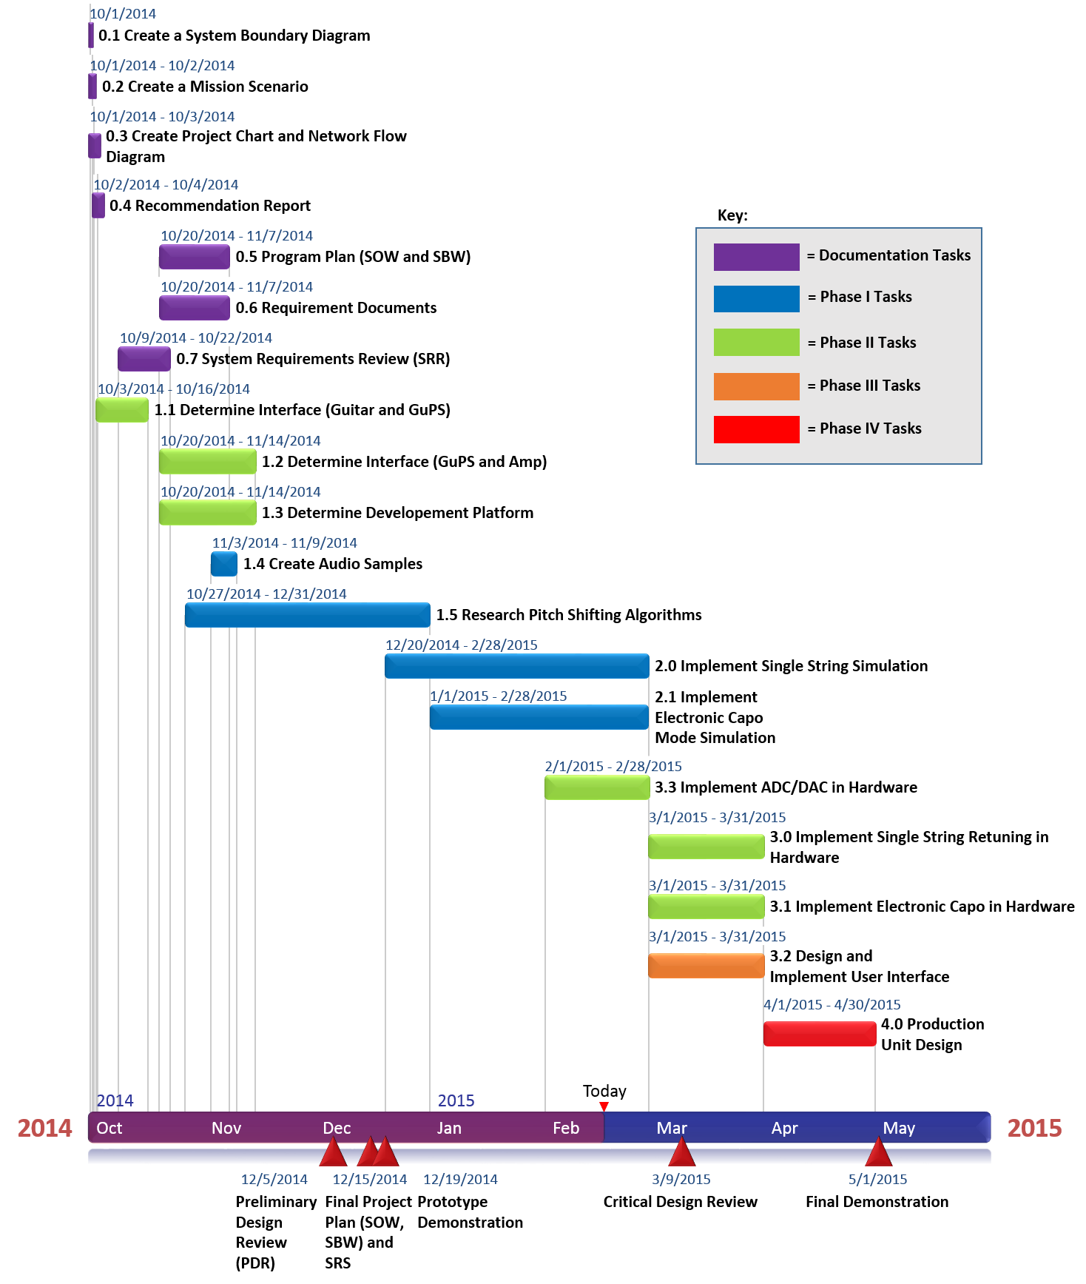

**Figure 1: GuPS Gantt Chart Through May, 2015**

# Work Breakdown Structure

The Work Breakdown Structure of the Guitar Pitch Shifter accurately shows how the smaller jobs will come together to accomplish the larger task. There are three major levels.

Level 1 is the project’s overall objective, to create a device that can pitch shift a guitar without the user having to use the tuning pegs. Level 2 shows the three parts that will make up the guitar pitch shifter: the pitch shifter pedal, the optional tuner mode capability, and the guitar/amp that the pitch shifter will be connected with.

Level 3 shows the individual parts that will make up these three pieces of the design in level 2. Under the pitch shifter there is the power supply to power the device, the housing design that will be used to make the standalone device, the user interface for the user to set a tuning, and also the electronic capo mode shifting. Under the guitar/amp connection there is simply ¼” cables to connect the guitar to the pitch shifter and the pitch shifter to the amp. Figure 2 shows the described work breakdown structure by levels.

**Level 1**

* Power Supply
* Housing Design
* Standalone Device
* User Interface
* Electronic Capo
* ¼” Cables
* Guitar to Pitch Shifter Connection
* Pitch Shifter to Amplifier Connection

**Guitar Pitch Shifter (GuPS)**

**Pitch shifter**

**Guitar/Amp**

**Level 2**

**Level 3**

**Tuner Mode**

**Figure 2: Work Breakdown Structure Diagram**