|  |
| --- |
| GuPS1 |
| Guitar Pitch Shifter (GuPS) System Requirements Specification (SRS) |
|  |
|  |
| **Prepared by: GuPS1 Team** |
| **February 16th, 2015** |

|  |
| --- |
|  |

# bcIntroduction

## Objective and Scope

This document contains the minimum system performance standards for the Guitar Pitch Shifter (GuPS). The performance defined in this document is intended to provide reliable sound quality to the user as well as seamless pitch correction on the order of milliseconds. Given that the user is in standard tuning, the device will ensure that the pitch changes will be all-electronic with the user never having to use the tuning pegs of the guitar.

This document anticipates that the user will run the guitar through the pitch shifter and output the shifted signal to an amplifier or other processing effects pedal. The pitch shifter will have two distinct modes that the user can select: single string retuning and electronic capo. These modes will satisfy different functionalities ranging from electronic tuning to creative pitch shifting effects. Figure 1 shows the System Boundary Diagram (SBD) which indicates the external interfaces to the GuPS system.

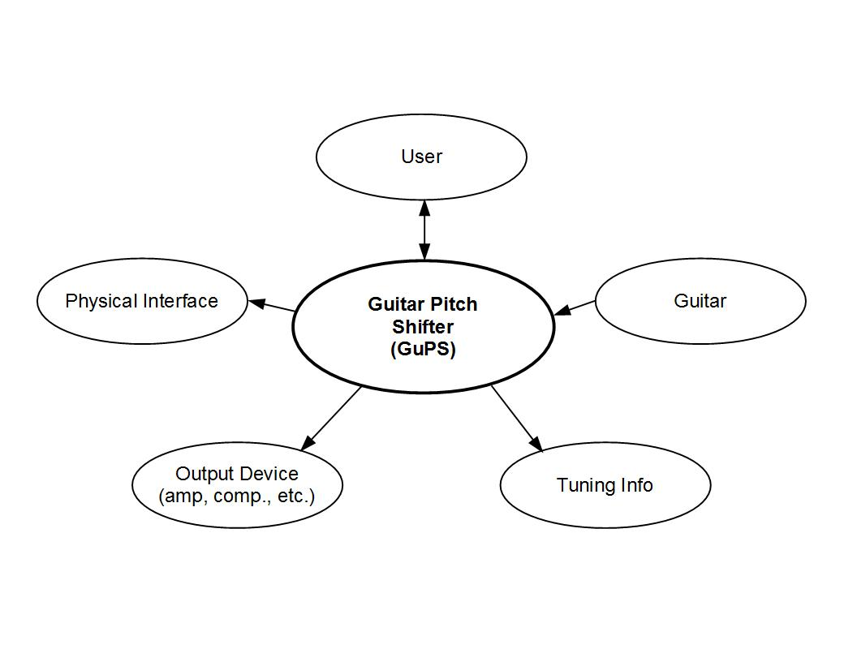

**Figure 1: GuPS System Boundary Diagram**

This document anticipates four distinct phases to the project. Phase 1 will consist of developing the pitch shifting algorithms in MATLAB. Phase 2 will consist of implementing the algorithms on an FPGA. Phase 3 will consist of the user interface design. Phase 4 will consist of the production unit testing.

# System Requirements

## General Requirements

The GuPS system shall interface with a standard electric guitar and amplifier using 1/4" connections and will perform retuning of the guitar without mechanical adjustment of the tuning pegs. The system shall support user configuration through an interactive display and control interface. This interface may allow initial calibration of the unit and will allow operational mode selection. Additionally, the system shall be a standalone unit which provides its own power either through a [9V] battery or DC power supply.

## Operational Modes

The GuPS pitch shift unit will offer several operational modes that satisfy different user demands. The system shall provide a single string retuning mode for basic drop tunings, and an electronic capo mode for full-signal pitch scaling. All processing should be performed such that latency is minimized below an audibly detectable level of [50ms].

### Definition of Terms

This section provides explicit definitions for terms used in this document pertaining to the specified modes of operation. Table 1 below provides an outline of the terminology that will be used throughout this document.

**Table 1: Operational Mode Terminology**

|  |  |
| --- | --- |
| **Term** | **Definition** |
| **Electronic Capo** | This mode will take in the full signal of the guitar with all six strings. It will be able to shift the whole signal by a selected amount of the users choosing. |
| **Single String Retuning** | This is a mode that will take in the full signal of the guitar with all six strings. It will be able to pick out one string that the user selects, and tune it to the desired pitch. It will leave all other strings unaffected. |

### Electronic Capo

This operation mode shall take in a single polyphonic analog signal from the guitar and shall shift the entire waveform up or down by a desired amount, specified by the user. This feature will allow pitch shifting in either direction up to five semitones. This mode shall accomplish pitch shifting without truncating the duration of the incoming signal.

### Single String Retuning

In this mode, the GuPS system should take in a polyphonic analog signal and should have the capability of isolating the frequency content of a single string. Based on the user selected tuning, the system should be able to shift only the appropriately isolated string to the desired frequency. The shifted signal and the remaining unaltered signal shall be recombined into a single output signal.

## Design Requirements

Where required, all code referenced or used shall be properly sited. All workspaces should utilize revision control applications to maintain all code.

Both a developer’s manual and a user’s manual shall be created. The developer’s manual shall include all modules, inputs and outputs. The developer’s manual should include a brief functional description for all functions or modules and block diagrams for each module. The user manual shall include instructions on how to power, connect and run a live demo. The user manual shall include figures and tables where needed.

# System Verification

## Verification Techniques

In this section several verification requirements have been defined to assist in testing whether the system requirements for the Guitar Pitch Shifter have been met. The development timeline has been broken up into four phases:

1. Software Simulation
2. Hardware Simulation
3. User Interface Design
4. Production Unit Testing

## Phase I - Software Simulation

Phase 1 will assist in verifying that each system requirement works in theory through software simulation. Inputs shall be prerecorded and shall not be processed in real time.

## Phase 2 - Hardware Implementation

Phase 2 will assist in verifying that each system requirement works realistically through hardware simulation.

There shall be an interface between the guitar and device model and also between the amplifier and the device model. There shall be an algorithm that can behave similar to the software simulation, but modified as needed for any hardware devices. There shall be a method for verifying that the hardware implementation is correctly functioning. Inputs should be processed in real-time and any delay should be minimal.

The hardware algorithm may be developed on a simulation hardware package and the completed program should contain a library of modules, that support all programs as needed. All relevant data should be plotted on waveform tools to verify each algorithm meets the system requirements.

## Phase 3 - User Interface

In Phase 3 the user interface prototype shall include power on/off capability, mode operation and pitch shift selection. The final user interface should be redesigned to fit within the production unit specifications listed in section 3.5.

## Phase 4 - Production Unit Testing

Phase 4 can be broken into two major components: production quantity and cost. The product design should be no more than twice the final volume of the prototype. There will be a limited production phase to build 100 units, if the functionality of the limited production devices goes well, the design will be expanded to run lots of 1000, 3000, and 6000 units. And the cost per unit should be no more the $500.