Business Requirements Document(BRD) Template
Project/Initiative
Month 20YY
Version X.XX

Company Information

Document Revisions
Date | Version Number | Document Changes
05/02/20xx | 0.1 | Initial Draft

Approvals
Role | Name | Title | Signature | Date

Introduction

Project Summary
The project aims to enhance the existing hotel search and filtering module to simplify and speed up the process of finding a hotel that best meets users' needs.
The primary business objective is to maximize the conversion rate from search to booking by improving search usability, ensuring the accuracy and timeliness of hotel availability data, and better addressing user preferences. Additionally, the module will provide data for analyzing user search behavior and supporting the further expansion of the hotel offering.

Objectives
- Increase the number of bookings by improving the hotel search and filtering functionality.
- Make hotel search easier and faster by helping users find suitable hotels based on their preferences.
- Collect and analyze user search behavior, popular search criteria, and searches with no results to identify unmet user needs.
- Ensure timely updates of room availability through synchronization with external booking systems to reduce the risk of offering rooms that are no longer available.

Background
The need to enhance the existing hotel search and filtering module was identified through user feedback, which highlighted the demand for more convenient search options and better access to hotel information. The project aims to improve the search experience through features such as destination autocomplete, advanced filtering, total price display, and map-based hotel viewing. The expected benefits include increased search-to-booking conversion, improved user satisfaction, more accurate hotel availability information, and valuable insights into user search behavior.

Business Drivers

Project Scope

In Scope Functionality
- Implement hotel search with destination autocomplete, date selection, and the ability to specify the number of guests and children's ages.
- Implement hotel filtering based on user-selected criteria.
- Display key hotel information in search results, including the total accommodation cost, main room photo, and distance to key locations.
- Provide a map view showing hotel locations directly from the search results.
- Display recommended hotels according to business-defined criteria and sort other available offers by ascending price.
- Synchronize room availability information with external booking systems.
- Display marketing badges based on current and accurate hotel offer data.
- Collect search data and provide business users with tools to analyze search behavior and searches returning no results.
- Support multiple languages across the search interface and results.
- Support displaying prices in different currencies and currency conversion using current exchange rates.
- Ensure the usability of the search form, filters, search results, and map view on mobile devices.
3.2. Out of Scope Functionality
- Redesigning the complete hotel booking and payment processes is not included in the project.
- Changes are limited to the hotel search module and search results page. Other website sections are not included.
- The project includes analyzing searches with no results but does not include adding new hotels or onboarding new hotel partners.
- The project uses existing external booking systems to synchronize room availability. Developing a new hotel management system is not included.

System Perspective
[Provide a complete description of the factors that could prevent successful implementation or accelerate the projects, particularly factors related to legal and regulatory compliance, existing technical or operational limitations in the environment, and budget/resource constraints.]

Assumptions

Constraints

Risks

- .

Issues

Business Process Overview
[Describe how the current process(es) work, including the interactions between systems and various business units. Include visual process flow diagrams to further illustrate the processes the new product will replace or enhance.
Use case documentation and accompanying activity or process flow diagrams can be used to create the description(s) of the proposed or “To-Be” processes.]

Current Business Process (As-Is)
At any point during or after deployment of web apps or web sites (internal or external) to support business activities, development/support teams may create and deploy widgets.
- CMS / database administrators for the employee portal use the CMS tool to create widgets. They can test widgets in the designated staging environment, then register them and deploy to production.
- Development teams may deploy widgets to development and testing environments set up for their development projects. They must check widget code into and out of the source code repository according to their projects’ development schedule.
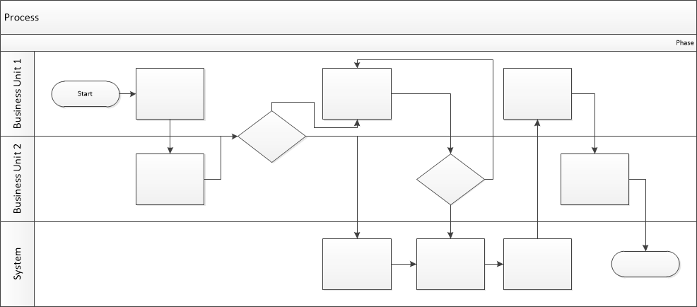

Proposed Business Process (To-Be)
- Technical Lead searches repository
- If widget is not found, user creates a new widget name record.
- WINS validates that all fields have been completed.
- WINS confirms that no similar widgets exist
- User confirms record to be created.
- User searches repository to locate existing widget description.
- WINS displays record
- User selects Edit to open and modify record
- WINS validates all fields completed correctly
- User confirms changes.
- WINS confirms changes and updates Audit table.

Stakeholder Requirements

ID | Requirement
SR-001 | The traveler shall be able to search for hotels by destination, travel dates, number of adults and children, and children's ages.
SR-002 | The traveler shall be able to filter hotels by price per night, guest rating, cancellation policy, and available amenities.
SR-003 | The traveler shall be able to view the total accommodation cost for the entire stay, the main room photo, the distance to the city center or another key location, and hotel locations on a map.
SR-004 | The business owner wants recommended hotels to be displayed in search results according to business priorities, including profitability and partnership agreements, to increase the conversion rate from search to booking.
SR-005 | The business owner shall receive up-to-date room availability information in real time based on data from external booking systems.
SR-006 | The traveler shall be able to use the website in different languages and view prices in different currencies.
SR-007 | The traveler shall receive search results within 1–2 seconds and be able to conveniently use hotel search, filters, and results on mobile devices.
SR-008 | The business owner shall be able to analyze search queries, applied filters, and searches with no results to identify unmet demand and plan the expansion of the hotel database.

The requirements in this document are prioritized as follows:
Value | Rating | Description
1 | Critical | This requirement is critical to the success of the project. The project will not be possible without this requirement.
2 | High | This requirement is high priority, but the project can be implemented at a bare minimum without this requirement.
3 | Medium | This requirement is somewhat important, as it provides some value but the project can proceed without it.
4 | Low | This is a low priority requirement, or a “nice to have” feature, if time and cost allow it.
5 | Future | This requirement is out of scope for this project, and has been included here for a possible future release.

Functional Requirements
Req# | Priority | Description | Rationale | Use Case Reference | Impacted Stakeholders
General / Base Functionality
FR-G-001 | 2 | The system shall suggest matching cities as the user types in the destination search field. | To simplify destination entry and help users find the required city faster. | UC-001  User Survey | Website Users
FR-G-002 | 3 | The system shall visually highlight weekends in the date selection calendar. | To help users identify weekends when planning their trips. | UC-001  User Survey | Website Users
FR-G-003 | 1 | The system shall allow users to specify the number of adults, the number of children, and the age of each child. | To calculate accommodation prices accurately based on the composition of the traveling party. | UC-001  User Survey | Website Users
FR-G-004 | 2 | The system shall allow users to filter hotels by price per night using a price range slider. | To help users find hotels within their budget. | UC-002  User Survey | Website Users
FR-G-005 | 2 | The system shall allow users to filter hotels by guest rating, with a minimum rating of 8. | To help users identify hotels that meet their quality expectations. | UC-002  User Survey | Website Users
FR-G-006 | 2 | The system shall allow users to filter hotels that offer free cancellation. | To help users find accommodation options with flexible cancellation conditions. | UC-002  User Survey | Website Users
FR-G-007 | 2 | The system shall allow users to filter hotels by amenities, including Wi-Fi, parking, and breakfast. | To help users find hotels that meet their accommodation needs. | UC-002  User Survey | Website Users
FR-G-008 | 1 | The system shall display the total accommodation price for the entire selected stay. | To help users compare the full cost of accommodation rather than only the nightly rate. | UC-002  User Survey | Website Users
FR-G-009 | 2 | The system shall display the main room photo on each hotel result card. | To help users assess accommodation options visually. | UC-002  User Survey | Website Users
FR-G-010 | 2 | The system shall display the distance from each hotel to the city center or another relevant location. | To help users evaluate hotel locations in relation to places of interest. | UC-002  User Survey | Website Users
FR-G-011 | 3 | The system shall allow users to switch from the hotel results list to a map view showing hotel locations. | To help users compare hotel locations geographically. | UC-002  User Survey | Website Users
FR-G-012 | 2 | The system shall display recommended hotels at the top of the search results based on business-defined criteria, including margin and partner agreements. | To prioritize offers according to business objectives and partnership conditions. | UC-003  Business Owner | Business Owner
FR-G-013 | 2 | The system shall display an “Only 1 room left” label when only one room is available for the selected search criteria. | To inform users about limited room availability. | UC-003  Business Owner | Business Owner
FR-G-014 | 3 | The system shall display a “Best Price” label for offers that meet business-defined pricing criteria. | To help users identify offers that meet the business's best-price conditions. | UC-003  Business Owner | Business Owner
FR-G-015 | 1 | The system shall synchronize room availability with external booking systems and shall not display unavailable rooms as available. | To ensure that users receive accurate availability information. | UC-003  Business Owner | Business Owner
FR-G-016 | 2 | The system shall support multiple languages for the search form, search results, and related interface messages | To allow users to interact with the website in a supported language. | UC-001, UC-002  Business Owner | , Business Owner
FR-G-017 | 2 | The system shall allow users to view accommodation prices in multiple supported currencies. | To help users understand prices in their preferred currency. | UC-002  Business Owner | Business Owner
FR-G-018 | 2 | The system shall convert accommodation prices into the selected currency using the current exchange rate. | To provide consistent and up-to-date price information across supported currencies. | UC-002  Business Owner | Business Owner
FR-G-019 | 3 | The system shall allow users to sort hotel offers, excluding recommended offers, by ascending price. | To help users compare eligible offers from the lowest price upward. | UC-002  Business Owner | Business Owner
Security Requirements
FR-S-001 | 1 | The system shall restrict access to business analytics and reports to users with administrator privileges. | To prevent unauthorized access to business analytics and reports. | UC-003  Proposed Requirement — To Be Confirmed | Business Owner
Reporting Requirements
FR-R-001 | 2 | The system shall collect data on search queries, applied filters, hotel availability, and searches that return no results, and make this data available for business analysis. | To identify popular search criteria, unmet demand, and potential reasons for searches returning no results. | UC-003  Business Owner | Business Owner
Usability Requirements
FR-U-001 | 2 | The system shall support hotel search, filtering, and results viewing on mobile devices. | To provide a convenient search experience on mobile devices. | UC-002  Proposed Requirement — To Be Confirmed | Website Users
FR-U-002 | 4 | The system shall retain the selected filters when the user returns to the search results from a hotel details page. | To reduce the need to reapply filters and make hotel comparison easier. | UC-002  Proposed Requirement — To Be Confirmed | Website Users
Audit Requirements
FR-A-001 | 3 | The system shall record changes to room availability, including the time of the update and the source system. | To support investigation of availability discrepancies and synchronization issues. | UC-003  Business Owner | Business Owner

Non-Functional Requirements
[Include technical and operational requirements that are not specific to a function. This typically includes requirements such as processing time, concurrent users, availability, etc.]

ID | Requirement
NFR-001 | The system shall display updated hotel search results within 1–2 seconds after the user applies or changes a filter.
NFR-002 | The system interface shall adapt to mobile devices and remain usable on supported mobile screen sizes.
NFR-003 | The system shall update hotel room availability in real time based on information received from external booking systems.

Appendices

List of Acronyms
[If needed, create a list of acronyms used throughout the BRD document to aid in comprehension.]

Glossary of Terms
[If needed, identify and define any terms that may be unfamiliar to readers, including terms that are unique to the organization, the technology to be employed, or the standards in use.]

Related Documents
[Provide a list of documents or web pages, including links, which are referenced in the BRD.]

