Hello students,

Please do the following before coming to the recitation. (Mac users or students with linux on their systems can skip this)

* Search for an email in your Colorado email ID from [noreply@kivuto.com](mailto:noreply@kivuto.com) with subject as “An account has been created for you”.

It should look like this:

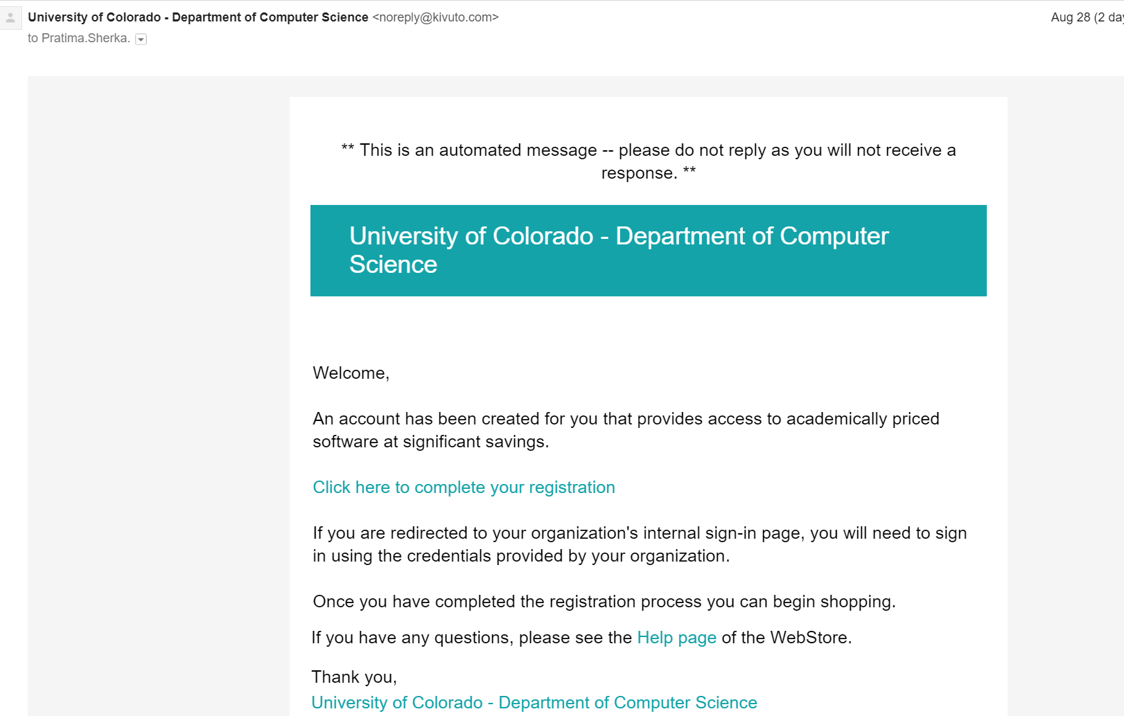

* Complete the registration
* Install VMware workstation 12 – Windows user ;
* Add to cart and check out
* Download the software; note down the product key
* Run it and enter the product key to finish installation.
* Once this is done, we can continue installing the VM using flash drive during the recitation.