**REQUIREMENTS**

**SWP391 - SE1819 - TEAM 1**

**PC BUILD & GEAR WEBSITE**

1. **TARGET**

* An online shopping website of PC equipment and accessories retailer company for people to buy their products.
* Targeted users: For the PC equipment and accessories retailer company and every customer.

1. **USER REQUIREMENTS**

* Guest:
* Guests should be able to visit the homepage and see details about each product without having to log in.
* User:
* Users should be able to easily browse products by category, brand, or price range to find what they need.
* Users should be able to find products using a search bar.
* Users should be able to add items to a shopping cart, proceed to checkout, and complete their purchases.
* Users want to see the current status of their orders.
* Users should be able to look at a list of all their past orders.
* Users should be able to update their personal details and account information, such as their address and payment methods.
* Users should be able to leave reviews and rate the products they have purchased.
* Marketing:
* Marketing team members need to write and publish advertising articles and news related to products.
* Manager:
* Managers need to access detailed statistics on product performance, such as sales trends and revenue.
* Managers should be able to oversee and update product listings and handle order statuses.
* Managers should be able to track and manage inventory levels to ensure product availability.
* Managers should be able to oversee and manage customer service interactions and resolutions.
* Admin:
* Admins should be able to manage user accounts, including creating, updating, and deleting accounts.
* Admins should be able to manage user roles and permissions to ensure appropriate access levels.

1. **SYSTEM REQUIREMENTS**

* Guest:
* The system must allow guests to access the homepage and product detail pages without requiring authentication.
* The system must enable guests to view all products.
* The system must provide a search feature that allows guests to find products using keywords.
* The system must display detailed product information, including user comments and likes.
* The system must allow guests to view blog posts and news articles.
* User:
* The system must authenticate users and provide access to user-specific features upon login.
* The system must allow users to leave comments on product detail pages.
* The system must provide enhanced search functionalities for users to find products efficiently.
* The system must support adding items to a cart, viewing the cart, updating item quantities, and removing items.
* The system must facilitate the checkout process, allowing users to complete their purchases and create new orders.
* The system must provide real-time updates on the status of user orders.
* The system must allow users to view a history of all completed orders.
* The system must allow users to securely update their personal and account information.
* The system must enable users to leave reviews and rate the products they have purchased.
* Marketing:
* The system must provide tools for the marketing team to create, edit, and publish advertising articles and news posts.
* Manager:
* The system must enable managers to add, edit, and delete product listings and moderate user comments.
* The system must allow managers to update order statuses and manage order details.
* The system must provide a dashboard with detailed analytics on product performance, including sales trends and revenue.
* The system must track and manage inventory levels and provide alerts for low stock.
* The system must provide tools for managing customer service interactions and tracking resolution status.
* Admin:
* The system must provide tools for admins to manage user accounts, including creation, modification, and deletion of user profiles.
* The system must allow admins to manage user roles and permissions to ensure appropriate access levels.

USE-CASE: Authenticate Users, Authorise Users

Guest, User:

DÙNG TỪ CHƯA CHUẨN: CẦN 100% ĐỘNG TỪ

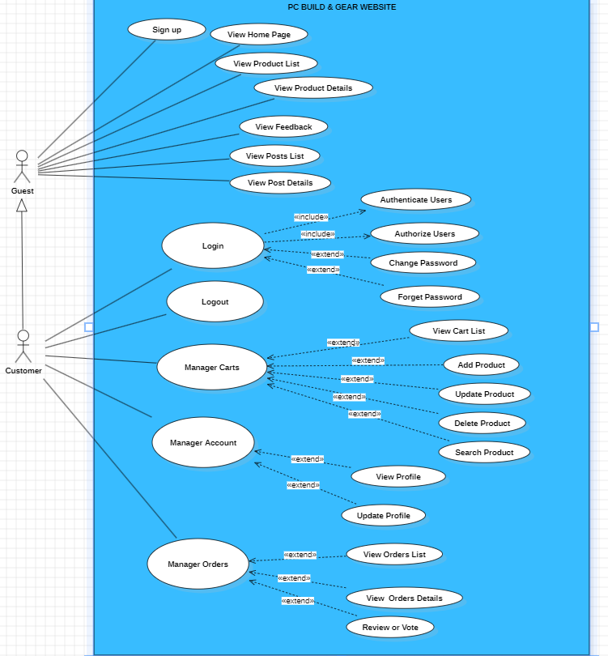

Marketing:

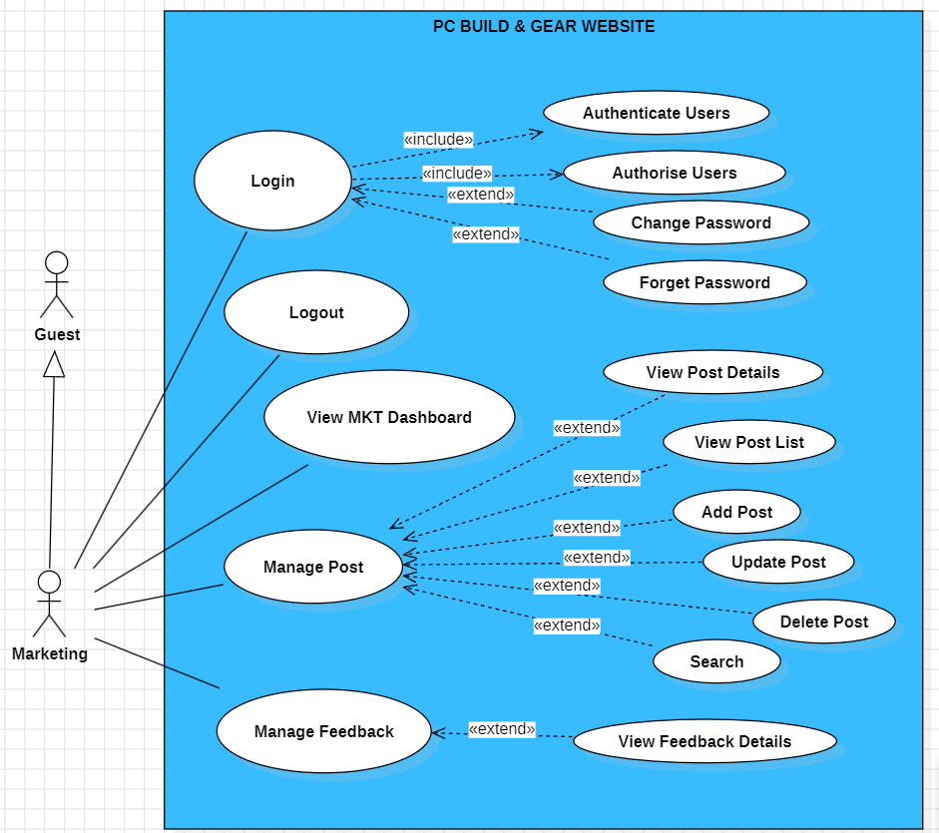

Manager:

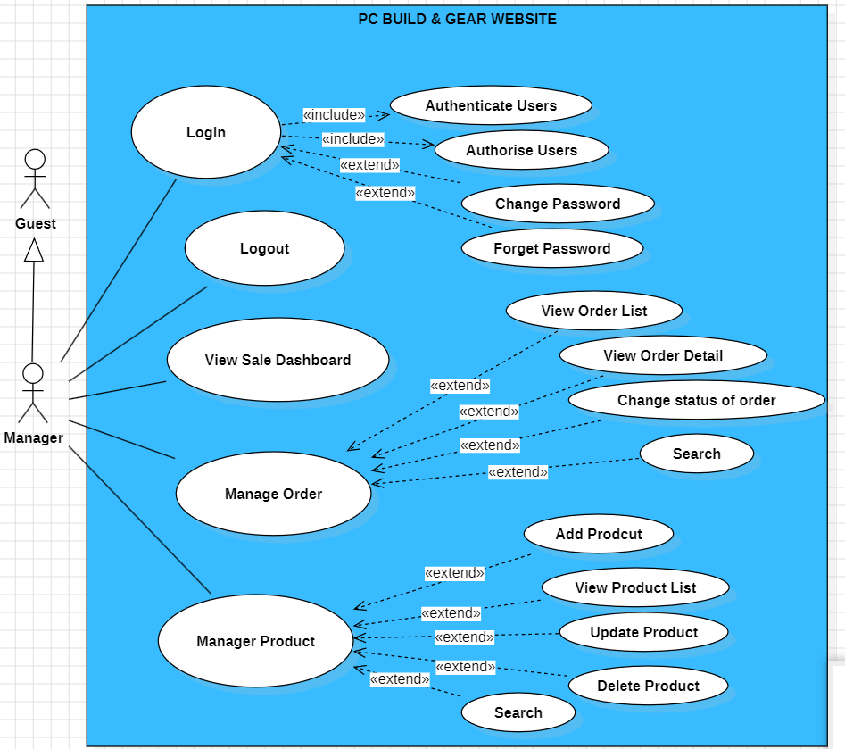

Admin:

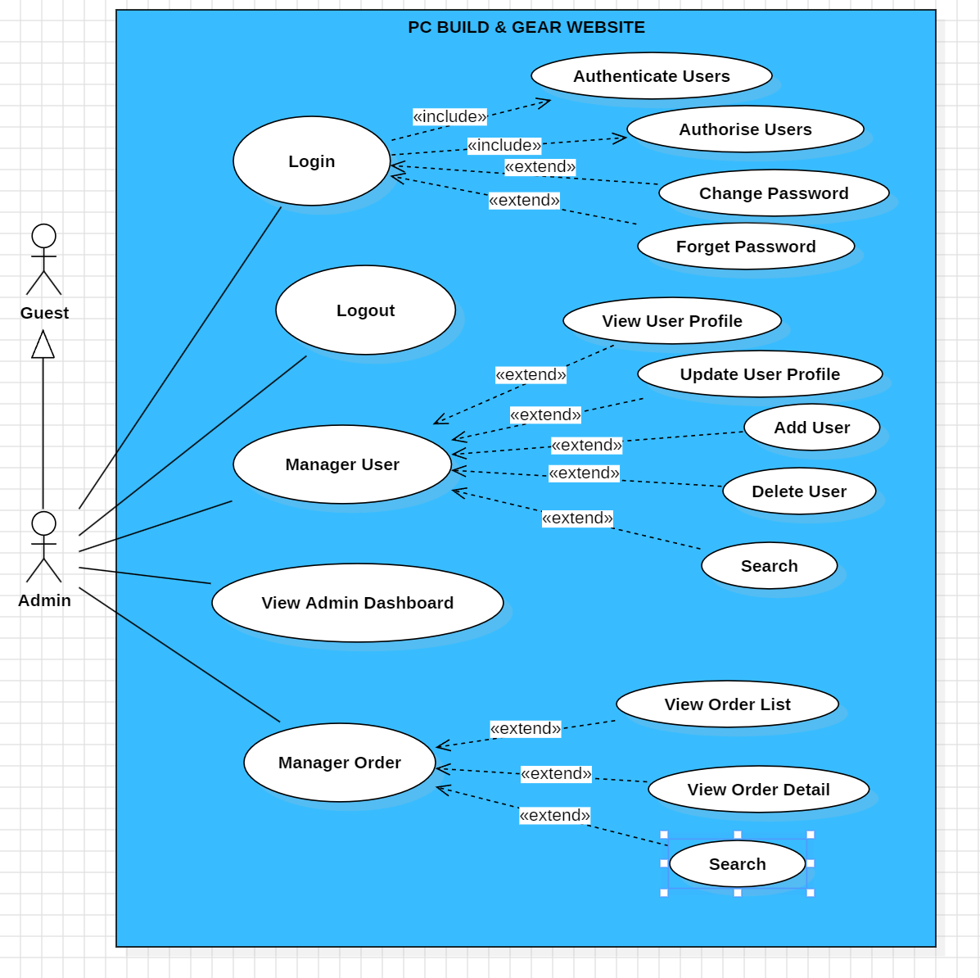

Use Case description:

| ID | Feature | Use Case | Use Case Description |
| --- | --- | --- | --- |
| 1 | Public | Sign up | - Create a new account for users who don't have account. |
| 2 | Public | View Home Page | - Show contact information with social links of the company.  - Show product information including its thumbnail, price. |
| 3 | Public | View Product List | - Show the list of products that are sold |
| 4 | Public | View Product details | - Show the information of products |
| 5 | Public | View feedback | - Below the product, customer can see the "feedback" of this product |
| 6 | Public | View Post List | - Show the newest posts list such as discount, new product, events |
| 7 | Public | View Post details | - Show the exact information about the post after choosing to view it |
| 8 | Public | Login | - Log in to the system by providing username and password or via Google login page, as long as the input email's domain is listed in the predefined domain list |
| 9 | Public | Change password | - Show the change password option for security and private reasons |
| 10 | Public | Forget password | - Show the forget password option for people who forgot their current password |
| 11 | Public | Logout | - Logs out of the system |
| 12 | Customer | Manage Cart | - Show the cart interface for customer to use and manage |
| 13 | Customer | View Cart List | - Show the list of products have added into the cart |
| 14 | Customer | Add product | - Add new products into the cart list |
| 15 | Customer | Delete product | - Remove products from the cart list |
| 16 | Customer | Update product | - Update details of products in the cart list such as number, color of products |
| 17 | Customer | Search product | - Search for any product that is in the cart list |
| 18 | Customer | Manage Account | - Show the detail of the account to view and update |
| 19 | Customer | View profile | - Show the infomation of the profile |
| 20 | Customer | Update profile | - Update the information of the profile such as password, phone number |
| 21 | Customer | Manage Orders | - View and manage the detail of the order list |
| 22 | Customer | View Orders List | - Show the list of orders |
| 23 | Customer | View Orders detail | - Show the detail of the specific order in the Orders List |
| 24 | Customer | Review or vote | - Leave comments and reviews about the product |
| 25 | Marketing | View MKT Dashboard | - Show the detail of the marketing proccess onto the Dashboard |
| 26 | Marketing | Manage Post | -View and update the content, status the posts that are posted onto the system |
| 27 | Marketing | View Post Details | - Show the information of the posts such as posted time, number of view |
| 28 | Marketing | View Post List | - Show the list of posts |
| 29 | Marketing | Add Post | - Create a new post and post onto the system |
| 30 | Marketing | Update Post | - Change the detail of the post such as content, image |
| 31 | Marketing | Delete product | - Remove the post from the system |
| 32 | Marketing | Search Post | - Search for the post to find the specific one |
| 33 | Marketing | Manage Feedback | - Show the feedback from customers |
| 34 | Manager | View Sale Dashboard | -Show the detail of sale on the Dashboard |
| 35 | Manager | Manage Order | -Show all of the detail about order |
| 36 | Manager | View Order List | - Show the Order List from customers |
| 37 | Manager | View Order detail | -Show the detail of order such as name, order time, address of the receivers |
| 38 | Manager | Change status of order | - Update the status of the order such as completed or failed |
| 39 | Manager | Search Order | - Search for the order to find the specific one |
| 40 | Manager | Manage Product | - Show the detail about product to manage |
| 41 | Manager | Add Product | - Create a new product and post to start selling |
| 42 | Manager | View Product List | - Show the list of products that are sold |
| 43 | Manager | Update Product | - Change the information of the product such as name, number, price |
| 44 | Manager | Delete product | - Remove the product from the Product List |
| 45 | Manager | Search Product | - Search for the product to find the specific one |
| 46 | Admin | Manage User | - Show all of the information about users |
| 47 | Admin | View User Profile | - Show basic information, account details, user activity, roles. |
| 48 | Admin | Update User Profile | - Change the information in the profile of the user |
| 49 | Admin | Add User | - Add new user into the system |
| 50 | Admin | Delete User | - Remove user from the system |
| 51 | Admin | Search User | - Search for the user in the system |
| 52 | Admin | View Admin Dashboard | - Show various aspects of a system on the Dashboard |
| 53 | Admin | Manage Order | -Show all of the detail about order of all users in the system |
| 54 | Admin | View Order List | - Show the list of orders of users in the system |
| 55 | Admin | Search Order | - Search for the order to find the specific one |