**UC1: Identify Business Processes Manually**

|  |  |
| --- | --- |
| **Actor: User** | **System: RAT** |
|  | 0.The RAT displays the description in the input textarea. |
| 1. TUCBW the user identifies the verb -noun phrases. | 2.The system shows the identified verb-noun phrases. |
| 3.The user right clicks the identified verb-noun phrase. | 4. The system displays a popup menu which includes business process option. |
| 5.The user clicks the add business process option to add business process. | 6. The system stores the business process and highlights it. |
| 7. TUCEW the user sees the  business processes are successfully identified. |  |

**Scenario**

|  |  |
| --- | --- |
| 6.  6.1  6.2  6.2.1  6.2.2  6.2.3  6.2.4  6.2.5  6.2.6  6.3 | The user clicks the add business process option to add business process.  The GUI sends the selected business processes to Indexer.  **For each** *business process,*  The indexer creates BusinessProcess object using *business process*  The Indexer sends the BusinessProcess object to StoreMgr.  The StoreMgr saves the BusinessProcess object in List.  The StoreMgr returns the msg to Indexer successfully stored.  The Indexer sends the index location of the text to be highlighted  to GUI.  GUI highlights the selected business process.  GUI displays the highlighted business processes. |
|  |  |

**Scenario Table**

|  |  |  |  |  |
| --- | --- | --- | --- | --- |
| **#** | **Subject** | **Subject action** | **Other data/Objects** | **Object Acted Upon** |
| 5. | User | clicks option | business process | GUI |
| 6.1 | GUI | sends | business process | Indexer |
| 6.2 | For each business process | | | |
| 6.2.1 | Indexer | creates | busineess process | Business process object |
| 6.2.2 | Indexer | sends | Business Process object | StoreMgr |
| 6.2.3 | StoreMgr | saves | List | Business Process Object |
| 6.2.4 | StoreMgr | returns | msg object | Indexer |
| 6.2.5 | Indexer | sends | index location | GUI |
| 6.2.6 | GUI | highlights |  | bsiness process |
| 6.3 | GUI | displays | highlighted business processes | User |

**Sequence diagram:**

**1 informal:**

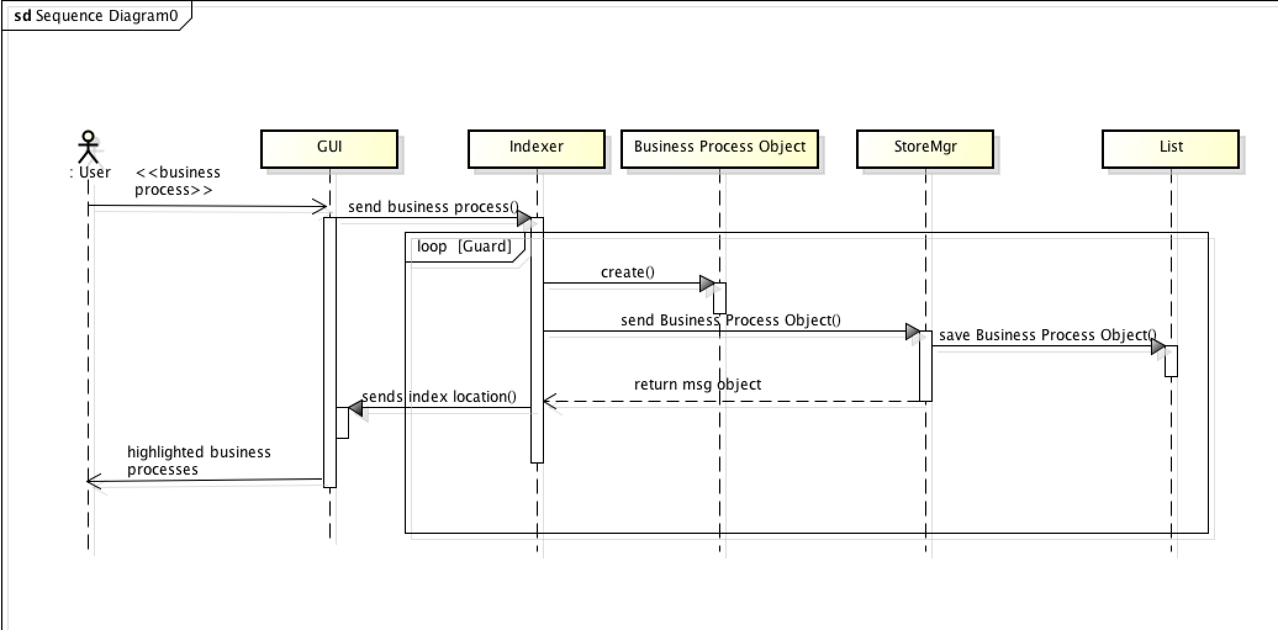

**2 formal:**

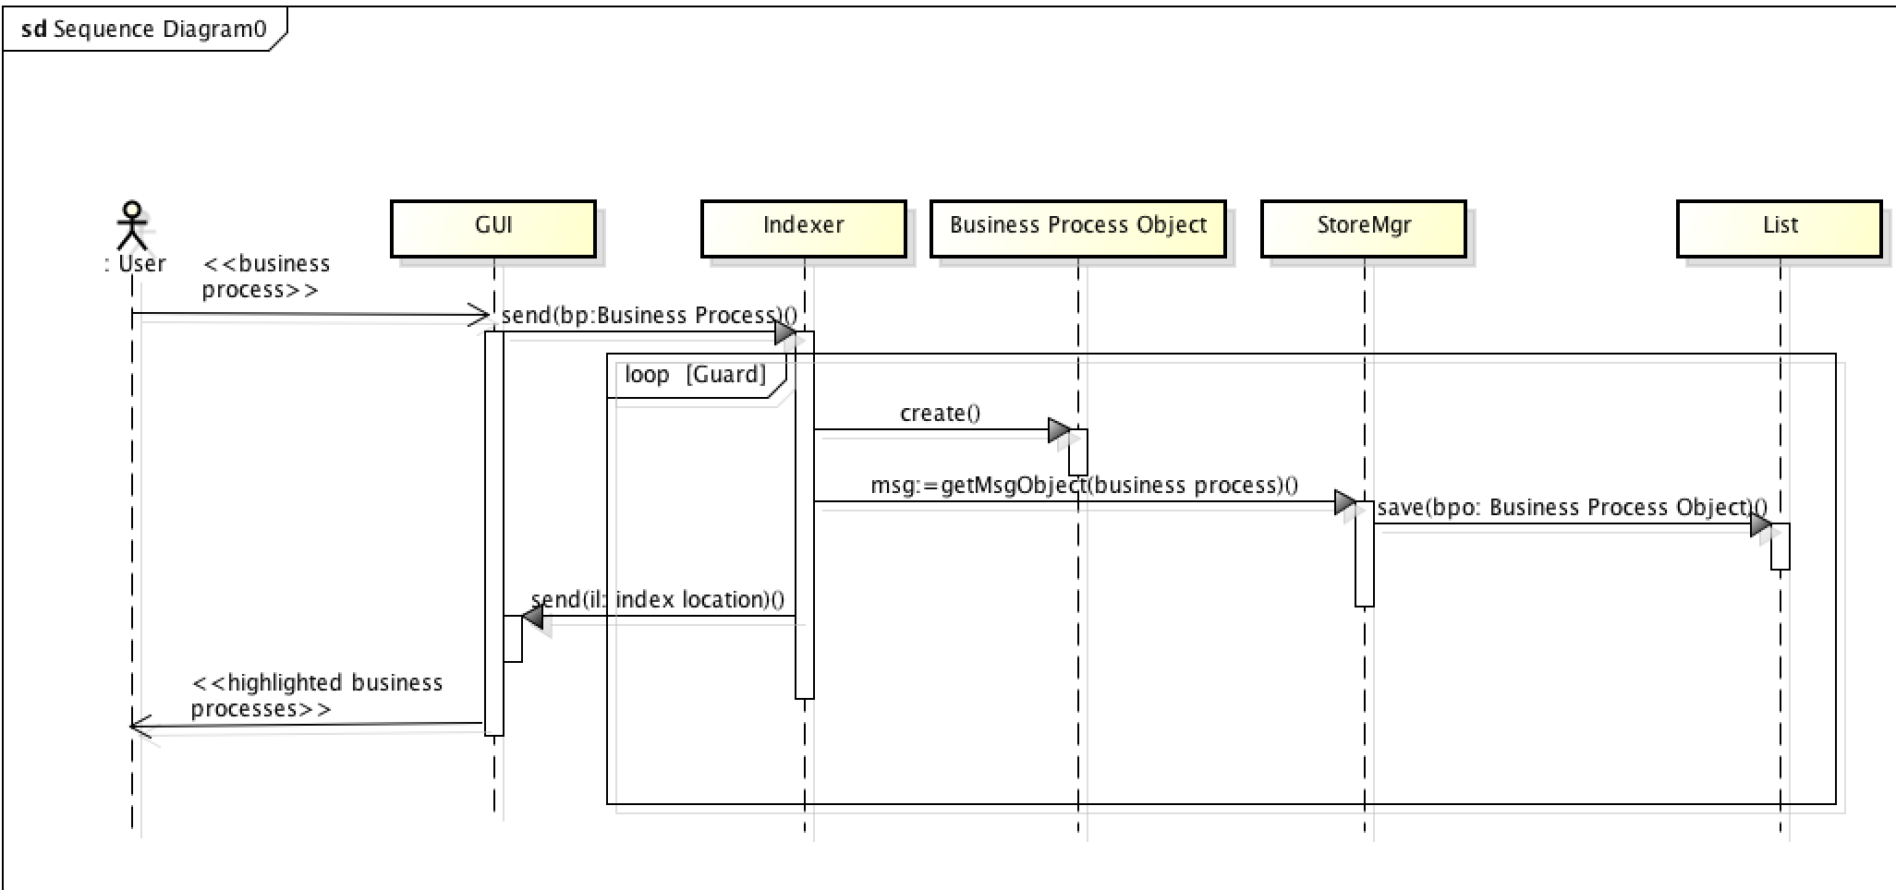

**Class Diagram:**

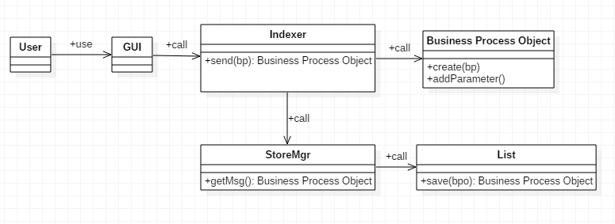

**UC2: Edit Business Processes**

|  |  |
| --- | --- |
| **Actor: User** | **System: RAT** |
|  | 0.The RAT displays the highlighted business processes. |
| 1.TUCBW the user right-clicks on the highlighted business processes. | 2.The system opens a dialog box. |
| 3.The user adds or deletes the business processes and edits the priorities, the steps and actions for that business process. | 4. The system displays the business processes in the output area. |
| 5.TUCEW the user sees the  business process is successfully edited. |  |

**Scenario**

|  |  |
| --- | --- |
| 3.  4.1  4.2  4.2.1  4.2.1.1  4.2.2  4.2.2.1  4.2.3  4.2.3.1  4.2.4  4.2.4.1  4.2.5  4.2.5.1  4.2.6  4.3 | The User edits the parameteres in the dialog box.  The GUI sends the parameters to the Indexer.  **For each** *parameter*,  **If** the *parameter* is a subject  the Indexer adds subject to BusinessProcess object  **else If** the *parameter* is a predicate  the Indexer adds predicate to BusinessProcess object.  **else If** the *parameter* is a verb  the Indexer adds verb to BusinessProcess object.  **else If** the *parameter* is a priority  the Indexer adds priority to BusinessProcess object.  **else**  the Indexer adds unkown to BusinessProcess object.  The Indexer sends the BusinessProject object in string format to  the GUI.  GUI displays the business processes in the output area. |

**Scenario Table**

|  |  |  |  |  |
| --- | --- | --- | --- | --- |
| **#** | **Subject** | **Subject action** | **Other data/Objects** | **Object Acted Upon** |
| 4. | User | edits | dialog box | parameters |
| 4.1 | GUI | sends | parameters | Indexer |
| 4.2 | For each parameter | | | |
| 4.2.1 | If the parameter is a subject | | | |
| 4.2.1.1 | Indexer | adds | Business Process object | subject |
| 4.2.2 | If the parameter is a predicate | | | |
| 4.2.2.1 | Indexer | adds | Business Process object | predicate |
| 4.2.3 | If the parameter is a verb | | | |
| 4.2.3.1 | Indexer | adds | Business Process object | verb |
| 4.2.4 | If the parameter is a priority | | | |
| 4.2.4.1 | Indexer | adds | Business Process object | priority |
| 4.2.5 | else | | | |
| 4.2.5.1 | Indexer | adds | Business Process object | unknown |
| 4.2.6 | Indexer | sends | string format of object | GUI |
| 4.3 | GUI | displays | business process | Output area |

**Sequence diagram:**

**1 informal:**

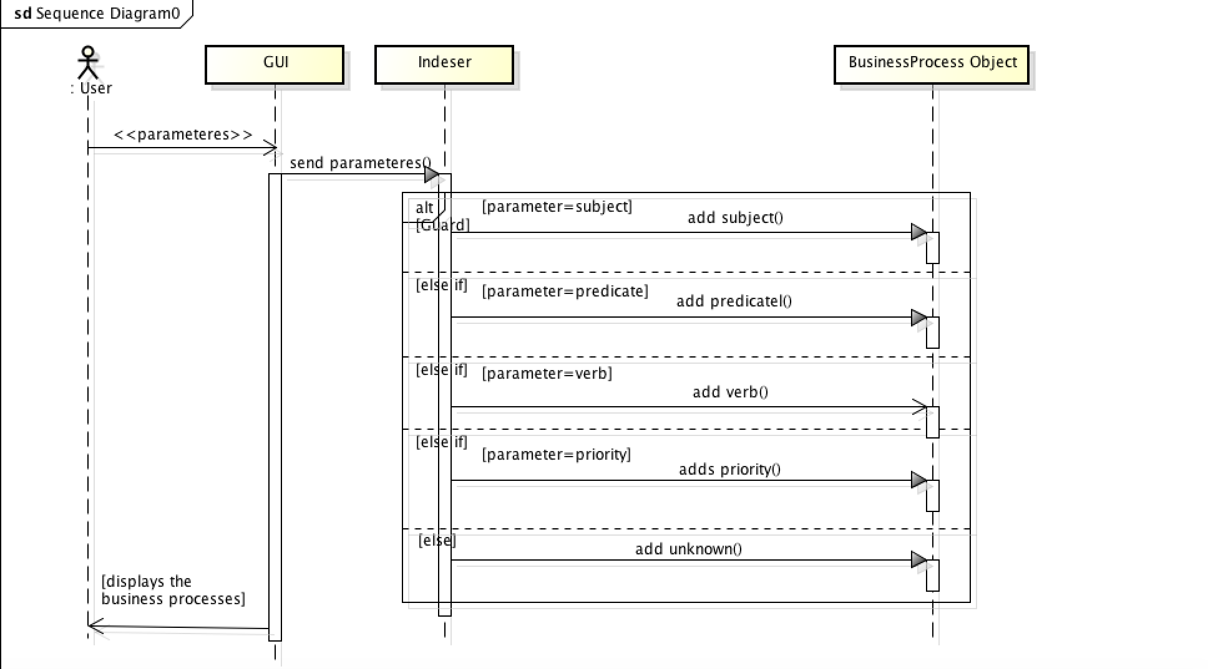

**2 formal:**

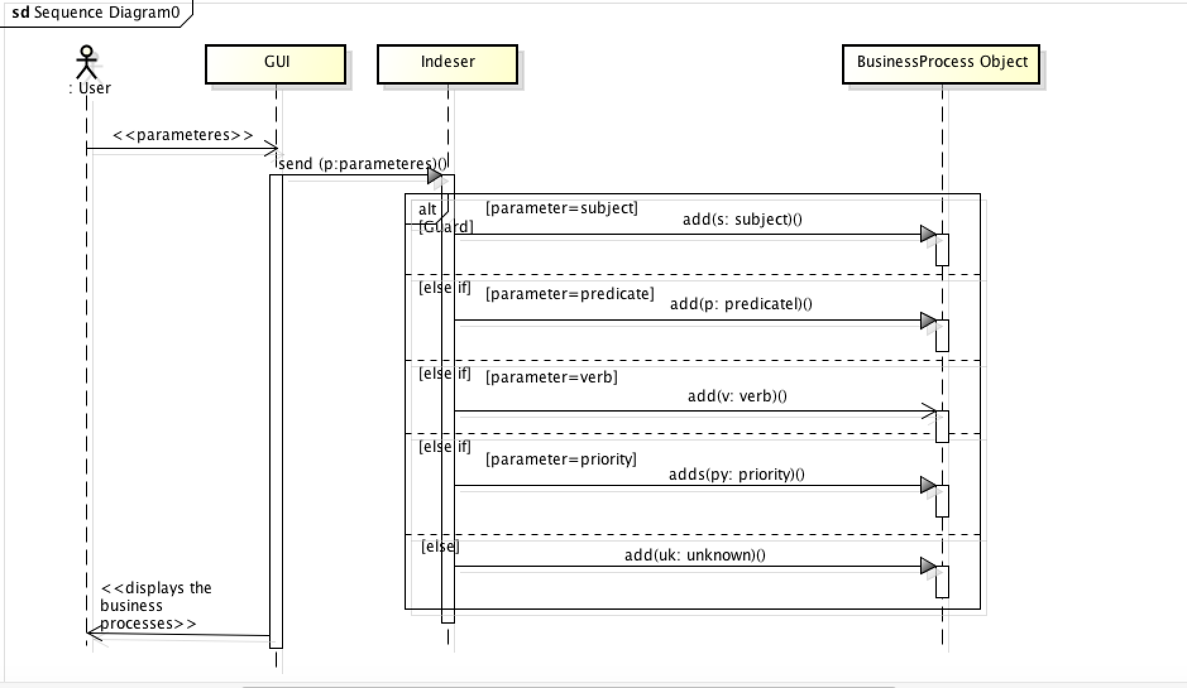

**Class Diagram:**

