**UC1: Identify Business Processes Manually**

|  |  |
| --- | --- |
| **Actor: User** | **System: RAT** |
|  | 0. System displays the GUI. |
| 1. TUCBW user inputs the description. | 2. System shows the description in the input text-area. |
| 3. User repeatedly selects verb-noun phrases and identifies as business process. | 4. System pops-up the corresponding dialog-box. |
| 5. User inputs the business process, steps, actions and priorities into the dialog-box. | 6. System stores business processes in list and displays in the output text-area. |
| 7. TUCEW user sees the identified business processes. |  |

**Scenario**

|  |  |
| --- | --- |
| 5.  6.  6.1  6.1.1  6.1.2  6.1.3  6.1.3.1  6.1.3.2  6.1.4  6.1.5  6.1.6  6.2 | User inputs the business processes, steps, actions and priorities from the dialog-box.  The GUI sends the business processes and the parameters including steps, actions, priorities to BPController.  **For each**  *business process,*  The BPController creates BusinessProcess object using *business*  *process*  **For each** *parameter*,  BPController creates the Object or attribute of corresponding  *Parameter*  BPController adds parameter Object or attribute into  BusinessProcess Object.  The BPController sends the BusinessProcess object to StoreMgr.  The StoreMgr saves the BusinessProcess object in List.  The BPController sends the BusinessProcess object in string  format to the GUI.  GUI displays the business processes in the output text-area. |

**Scenario Table**

|  |  |  |  |  |
| --- | --- | --- | --- | --- |
| **#** | **Subject** | **Subject action** | **Other data/Objects** | **Object Acted Upon** |
| 5. | User | inputs | business processes,steps,actions and priorities | GUI |
| 6 | GUI | sends | business processes and parameters | BPController |
| 6.1 | For each business process | | | |
| 6.1.1 | BPController | creates | busineess process | Business process object |
| 6.1.3 | For each parameter | | | |
| 6.1.3.1 | BPController | creates | parameter | Object or attribute |
| 6.1.3.2 | BPController | adds | Object or attribute | BusinessProcess Object |
| 6.1.4 | BPController | sends | Business Process Object | StoreMgr |
| 6.1.5 | StoreMgr | saves | Business Process Object | List |
| 6.1.6 | BPController | sends | Business Process Object | GUI |
| 6.2 | GUI | displays | business process | output text-area |

**Sequence diagram:**

**1 informal:**

**Sequence Diagram : informal**

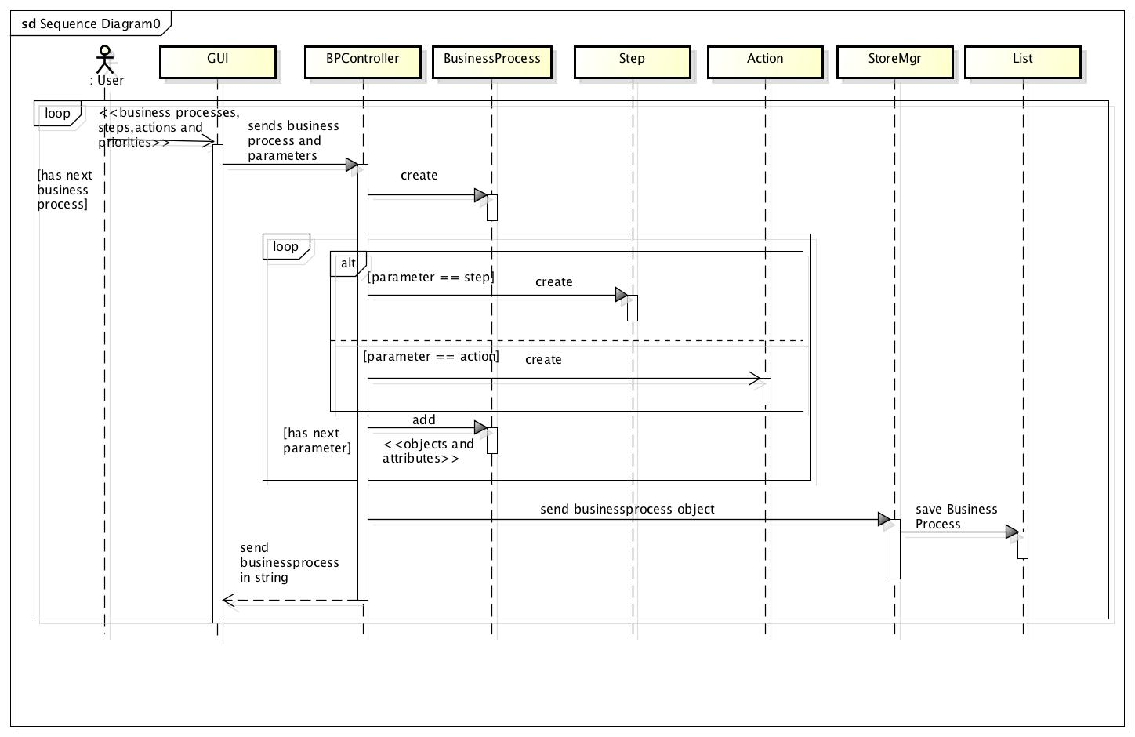

**2 formal:**

**Sequence Diagram : informal**

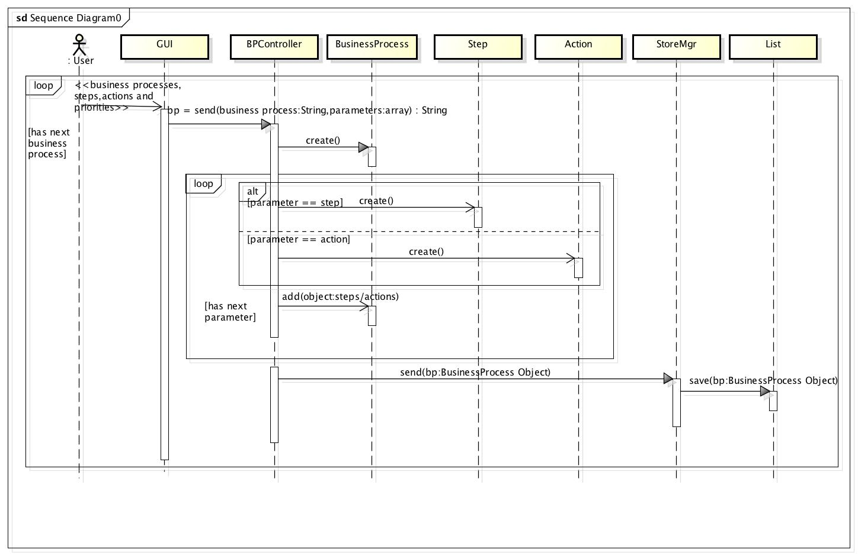

**UC2: Edit Business Processes**

|  |  |
| --- | --- |
| **Actor: User** | **System: RAT** |
|  | 0. The System displays the identified business processes in the output text-area. |
| 1. TUCBW user right clicks on the identified business process. | 2. The system pops-up menu. |
| 3. The user selects the edit or delete option from the menu. | 4. The system pops-up the dialog-box for corresponding business process. |
| 5. The user repeatedly edits business processes of output text-area. | 6. System makes relevant changes into the list and output text-area. |
| 7. TUCEW the user sees business process is successfully edited. |  |

**Scenario**

|  |  |
| --- | --- |
| 3.  4.1  4.2  4.2.1  4.2.2  4.2.2.1  4.2.3  4.2.3.1  4.2.3.2  4.2.3.1.1  4.2.3.1.2  4.2.3.3  4.2.3.4  4.2.3.5  4.3 | The User edits the business processes of output text-area.  The GUI sends the business processes and the parameters including steps, actions, priorities to the BPController.  **For each**  *business process,*  The BPController sends the *business process* and *action to*  StoreMgr.  If *action* is delete,  StoreMgr removes BusinessProcess object for *business*  *process.*  If *action* is edit,  StoreMgr sends BusinessProcess object for *business process*  to BPController.  **For each** *parameter*,  BPController edits the Object or attribute of  corresponding *Parameter*  BPController edits parameter Object or attribute into  BusinessProcess Object.  The BPController sends the BusinessProcess object to  StoreMgr.  The StoreMgr saves the BusinessProcess object in List.  The BPController sends the BusinessProcess object in  string format to the GUI.  GUI displays the edited business processes in the output text-area. |

**Scenario Table**

|  |  |  |  |  |
| --- | --- | --- | --- | --- |
| **#** | **Subject** | **Subject action** | **Other data/Objects** | **Object Acted Upon** |
| 4. | User | edits | output text-area | Business processes |
| 4.1 | GUI | sends | business processes and parameters | BPController |
| 4.2 | For each business process | | | |
| 4.2.1 | BPController | sends | Business processes, action | StoreMgr |
| 4.2.2 | If the action is delete | | | |
| 4.2.2.1 | StoreMgr | removes | Business Process object | List |
| 4.2.3 | If the action is a edit | | | |
| 4.2.3.1 | StoreMgr | sends | Business Process object | BPController |
| 4.2.3.2 | For each parameter | | | |
| 4.2.3.2.1 | BPController | edits | parameter | Object or attribute |
| 4.2.3.2.2 | BPController | edits | Object or attribute | BusinessProcess Object |
| 4.2.3.2 | BPController | sends | Business Process Object | StoreMgr |
| 4.2.3.4 | StoreMgr | saves | Business Process Object | List |
| 4.2.3.5 | BPController | sends | Business Process Object | GUI |
| 4.3 | GUI | displays | business process | output text-area |

**Sequence diagram:**

**1 informal:**

**Sequence diagram: Informal**

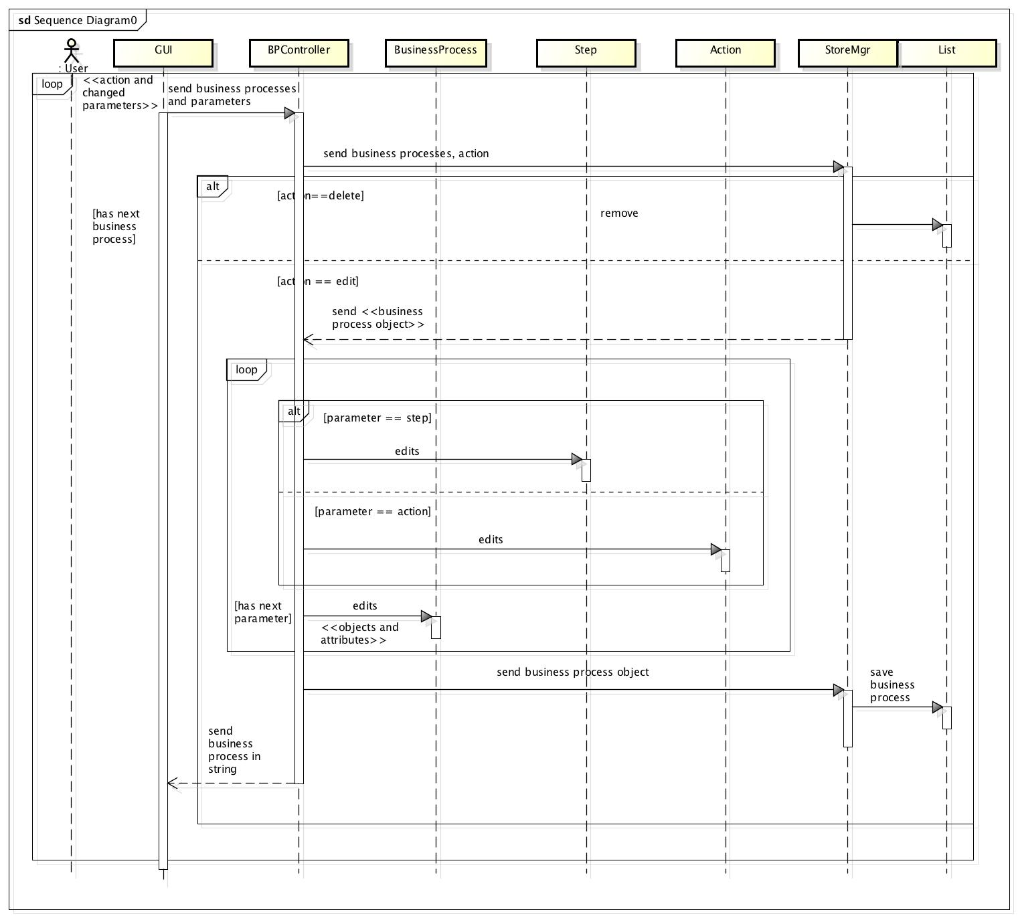

**2 formal:**

**Sequence diagram: Formal**

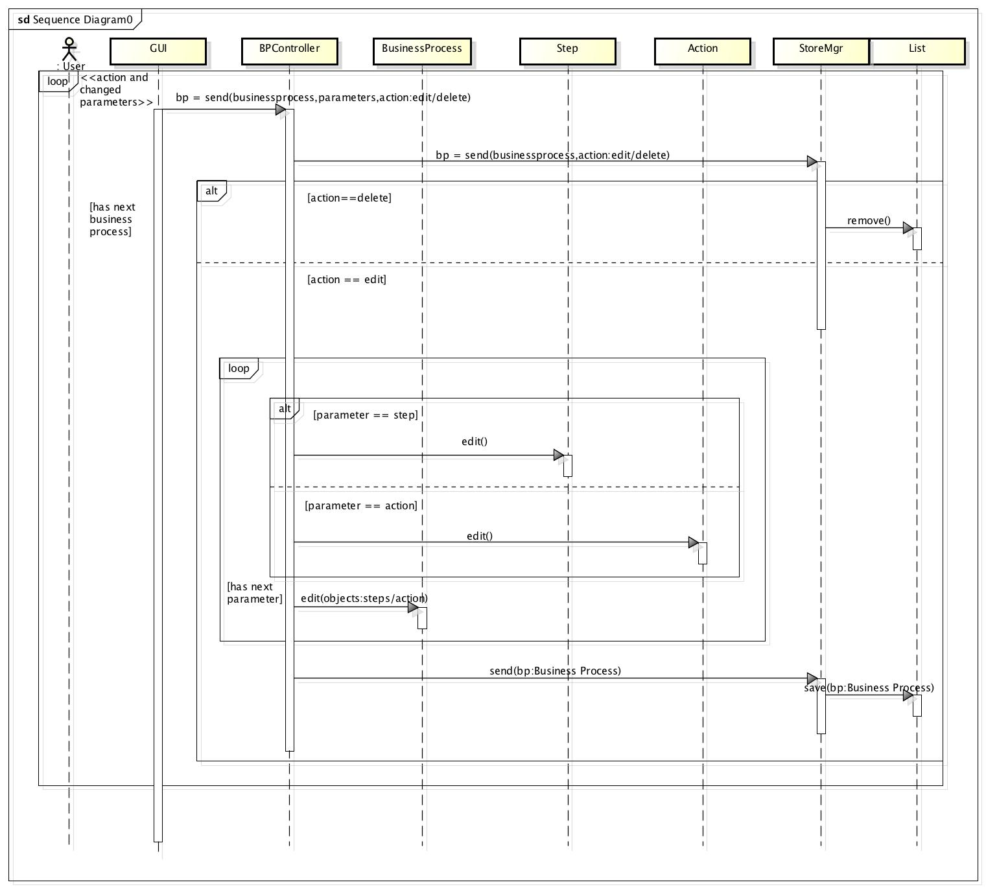

**Design Class Diagram**

