4/7/2017, 3/1/2020  
**Picoblaze Demo**  
  
1. If you have not created a Xilinx_project folder under C:\, please create one.  
C:\Xilinx_projects\   
  
This folder path should not contain spaces. Though Windows has the bad habit of creating folder and file names with spaces, no CAD tool designer likes or supports such names.   
  
If you are using VDI, do not create your directory under the VDI-suggested Documents folder (or the desktop) as it has a weird network folder path and you get an error like the one below.  
  
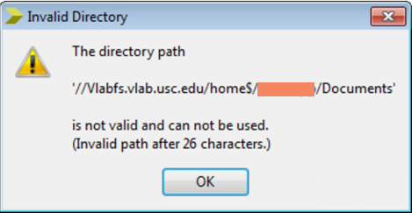   
  
2. Create a demo folder with three subfolders under this   
C:\Xilinx_projects\Picoblaze_Design_Steps_Demo  
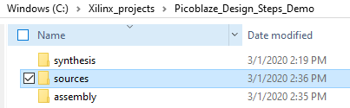  
  
3. Gather the assembler executable (kcpsm6.exe) and the assembler format file given to you (ROM_form.v) under the assembly subdirectory.

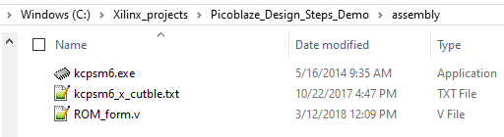

3.1 Create your assembly program (.psm file ) by editing a similar file given to you. Keep a copy under sources subdirectory and also under the assembly subdirectory.  
The sources directory also consists of the top file.

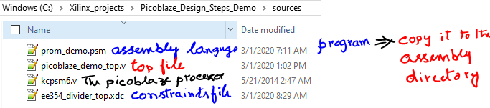

4. Go to the “assembly” subdirectory and invoke (double-click) the assembler executable (kcpsm6.exe) and provide to it your .psm file and the format file.

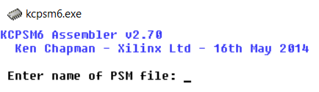

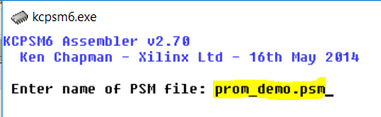

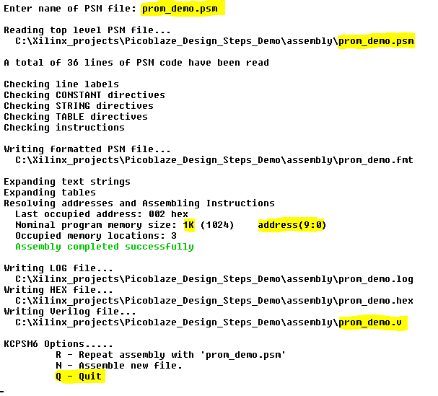  
Type “Q” to quit and look at the contents of your directory.

5. Note the highlighted parts. Since our programs are small, it assembles into a BRAM of 1K location (1K instructions) . It has produced an output file of prom_demo.v (name based on the fact that our assembly language program is named as prom_demo.psm.

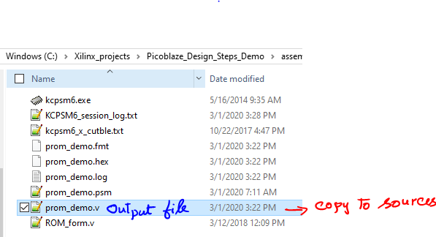

6. copy prom_demo.v to source directory   
  
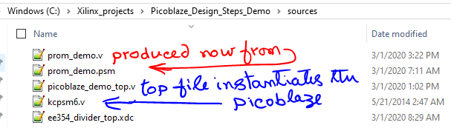

7. Create or use the given top file picoblaze_demo_top.v. Add the .xdc file with the needed pin definitions. Add the kcpsm6.v file (the picoblaze processor file) provided by Xilinx (which is provided by us to you via the demo zip file to the source subdirectory

The top file (here picoblaze_demo_top.v) contains the picoblaze soft processor instantiation.

“7s” stands for the Xilinx 7-series FPGAs. Artix-7 is a 7-series FPGA.  
  
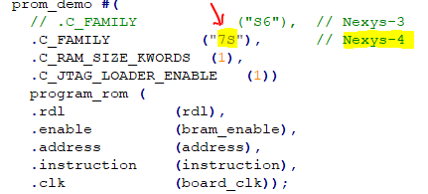

8. Invoke Vivado  
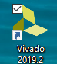

9. Setup the project (project properties, etc.)  
  
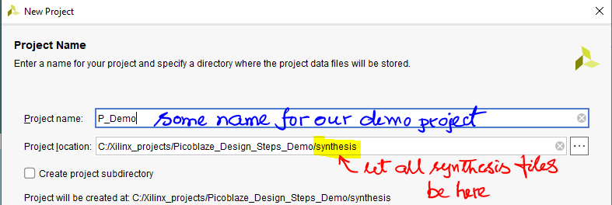

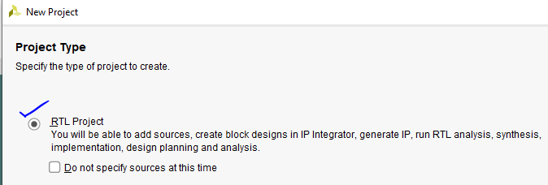

**Add Sources** => Add Files   
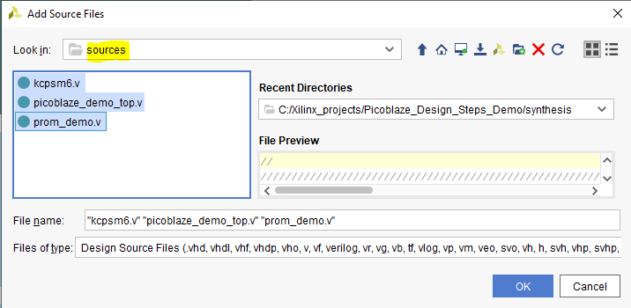

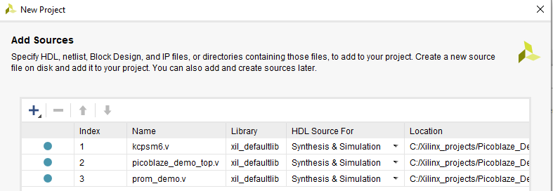



Next  
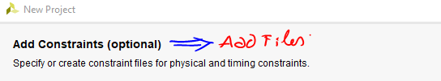

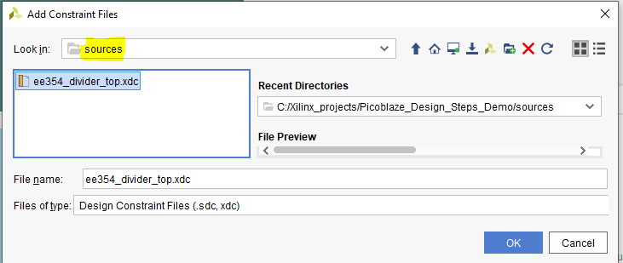

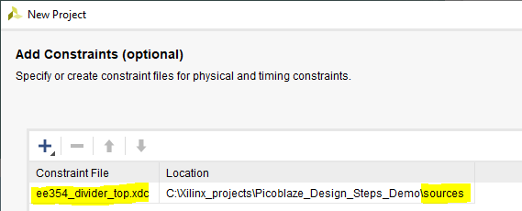

**Next**

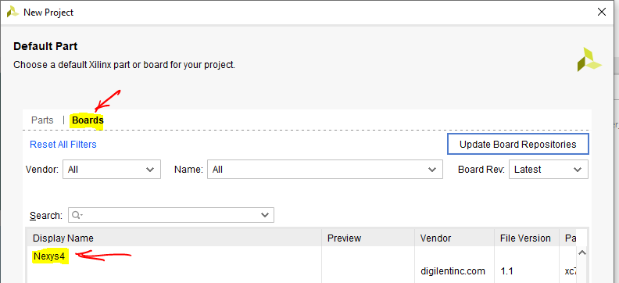

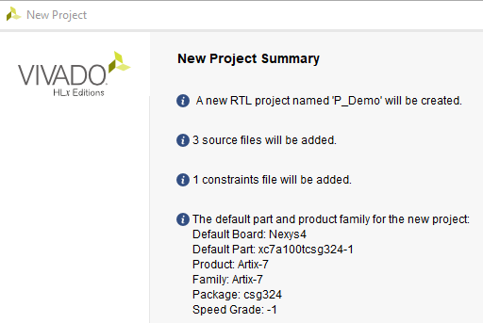

**Finish**

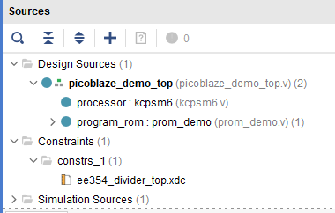

10. **Run Synthesis   
Run Implementation   
Generate Bit stream   
Open Hardware Manager   
Open Target => Auto-connect   
Program Device =>**

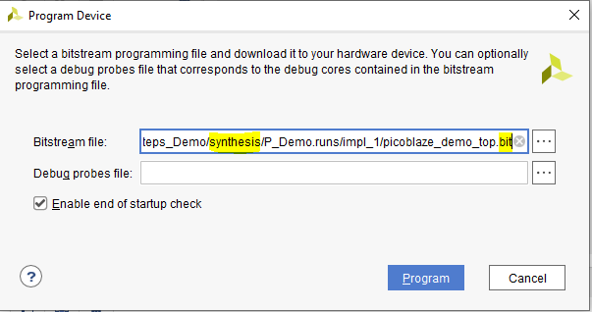

**Program**

Verify on the board, that the 8 LEDs   
{Ld7, Ld6, Ld5, Ld4, Ld3, Ld2, Ld1, Ld0}   
follow the 8 switches   
{Sw7, Sw6, Sw5, Sw4, Sw3, Sw2, Sw1, Sw0}

11. Notice directory structure, where we gather the source files under sources subdirectory, assembler related files under assembly subdirectory and synthesis-related files under synthesis subdirectory.

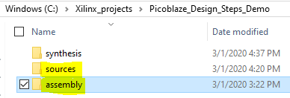

This facilitates carrying the sources files easily to another project. Actually, carry the sources subdirectory and the assembly subdirectory to another project as you need the assembler executable (kcpsm6.exe) and the ROM format file (ROM_form.v) for the next project.

