The PDC export file format
(Peter Neidig, January 25th, 2011)
Update: February 22 nd

Example of a T1 export file in textual format, elements in red indicate changes to former version.

$##1.0

Project: Dynamic method/T1
Date: Tuesday, January 25, 2011 11:09:27 AM
User: neidig
Computer: moertel2
generated by: ProteinCenter 1.1.5 (2011 Jan/25)

SECTION: sample information
sample name: ubiquitine
Description/Title: standard demo sample
Origin: in-house
Date of preparation: 06 / 2005
Solvent: 90% H2O + 10% D2O
pH: 7.0
Sample tube: normal
Tube diameter (mm): 3
Concentration (mM): 10.00
Temperature (K): 308.0
Weight (Daltons): 8900
Correlation time (ns): 12.40
Labelling: 15N
AminoAcid storage: FASTA file
AminoAcid file: E:\data\dynamic\nmr\sample_ber\ubi_fasta_.txt
0 M Q I F V K T L T G
10 K T I T L E V E P S
20 D T I E N V K A K T
30 Q D K E G I P P D Q
40 Q R L I F A G K Q L
50 E D G R T L S D Y N
60 I Q K E S T L H L V
70 L R L R G G

SECTION: relevant parameters
Proton frequency[MHz]: 600.130
X nucleus frequency[MHz]: 60.811

SECTION: used integrals
Mixing time [s]: 0.01000000 0.05000000 …… Peak name I0 I1 ….. Gln [2] 188221907.00000000 170715850.00000000 ….
Ile [3] 181874689.00000000 165473246.00000000 ..

SECTION: used integral errors
Mixing time [s]: 0.01000000 0.05000000 ….
Peak name I0 I1 …. Gln [2] 1608301.59447534 1607613.84326396 …
Ile [3] 1207564.59447534 1206876.84326396 …

SECTION: details
fitted function: f(t) = I0 * e-t/T1 to fit I0 and T1
Random error estimation of data: RMS per spectrum (or trace/plane)
Systematic error estimation of data: worst case per peak scenario
Fit parameter Error estimation method: from fit using arbitray y uncertainties
Confidence level: 95%
Used peaks: peaks from E:\data\dynamic\...\pdata\10\peaklist.xml
Used integrals: peak intensities
Used Mixing time: all non-zero integrals used

SECTION: results
Peak name F1 [ppm] F2 [ppm] T1 [s] error errorScale
Gln [2] 122.508 8.898 0.4560 0.0055642 2.22814
Ile [3] 114.800 8.280 0.4289 0.0040993 2.22814

Explanations:
- The first token in the file is used as an ID, here: $##1.0. It allows other software to do a version control.
- The file is intended to be parsed by other software. Information is either stored as keyword: \tab value (per line) or as tables like
value1 \tab value2 \tab value3 … value could be a number or string.
- The specified keywords are preserved, i.e. not changed in spelling. Some (if not really relevant) may however be omitted or others may be added in future. Other software that wants to read relevant information should just parse and look up relevant keywords.
- To make the file more easy to parse, sections have been added with the keyword SECTION: A section ends if a blank line or another section is found.
- The first group of keywords (Project:, Date:, …) is used as header.
Usually not relevant.
- SECTION: sample information is used to provide some sample info, usually not relevant.
- SECTION: relevant parameters contains a subset of parameters that are relevant for the analysis, currently only the resonance frequencies.
- SECTION: used integrals contains the table of used peak integrals/intensities. The table contains a preceeding line starting with the keyword Mixing time [s]: followed by \tab separated values and a title line with \tab separated column names Peak name I0 I1 …
This title line (which is regarded as not relevant) may contain some additional spaces for better readability by the human. The first column contains peak names as strings all other entries are floating point numbers.
- SECTION: used integral errors is built like the previous table but contain integral errors.
- SECTION: details provides details, all regarded as relevant
- SECTION: results provides a result table. It is preceeded by a title line with \tab separated column names
Peak name F1 [ppm] F2 [ppm] T1 [s] error errorScale
The first column contains peak names as strings, all other entries are floating point numbers. Error is the error of the fitted parameters, errorScale is an additional scaling factor that has been multiplied to the error. This scaling factor depends on the specified confidence level.

Recommended PDC options:
Data/Peaks

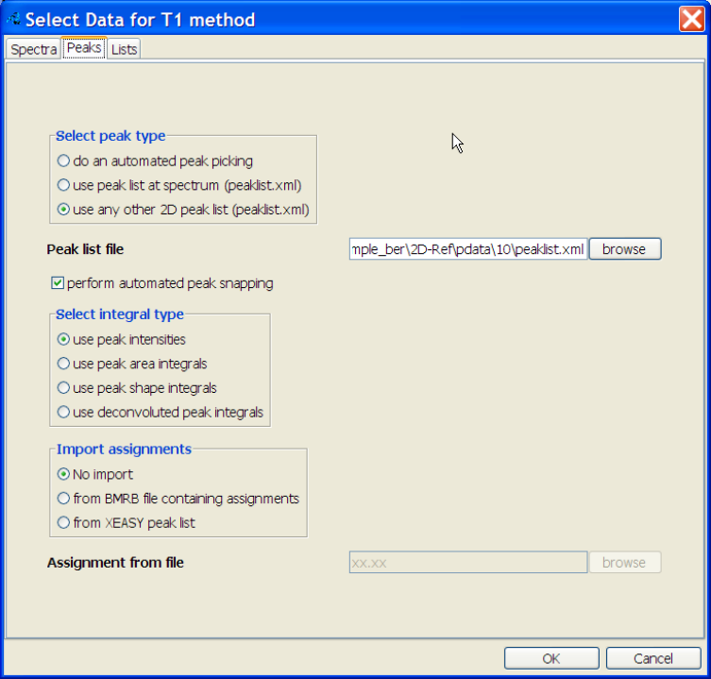

Data/Lists

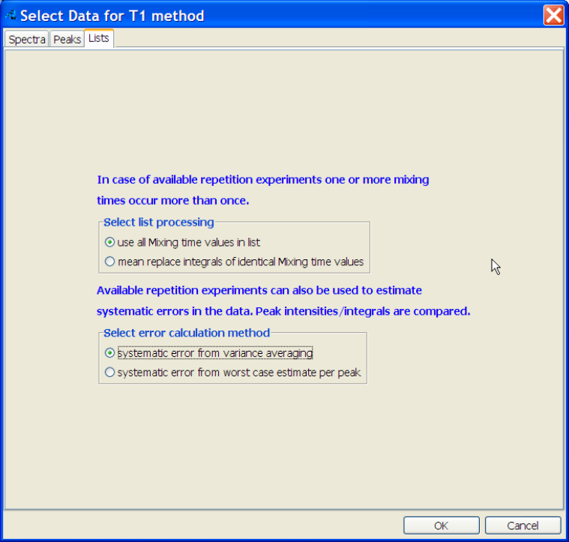

Analysis

