# General

## Introduction and Intended Use (Informative)

This Tech Note is intended to provide information and guidance to end users for wiring your model railroad for analog DC or Digital Command Control (DCC) which will render good performance and reliable operation. Some of this document is related to both and some is specific to DCC. There exist on the internet at several websites and in various books information on wiring your model railroad. This Tech Note has been written by assembling the best practices based on experience and has been reviewed and approved by several manufacturers of DCC equipment.

## References

This standard should be interpreted in the context of the following NMRA Standards, Technical Notes, and Technical Information.

### Normative

### S-9.1 Electrical Standards for Digital Command Control, which specifies signal voltages.

### Informative

* None

## Terminology

|  |  |
| --- | --- |
| **Term** | **Definition** |
| Track Bus | Pair of wires carrying DCC signal and power from the power station to the track. Hereinafter referred to as bus. |
| Feeder Drop | Smaller wires making a connection from the track or accessory to the bus. |
| Power Station | A device that amplifies the low current DCC electrical signals transmitted by a Command Station for the purpose of providing high current DCC signals with sufficient power to operate model trains and any accessory decoders that are connected to the track. The power station may be a separate device or may be combined with the command station and/or throttle. |
| Decoder (mobile) | DCC receiver for controlling vehicle animation. |
| Accessory Decoder | DCC receiver for controlling accessories. |
| Vehicle | Mobile model railroad device. This includes locomotives and other rolling stock. |
| Accessories | Fixed model railroad device. This includes turnouts, lights, signals and other devices not on the rails. |

# Electrical Properties

With DC operation the power supply usually drives one or a few locomotives at any given time. With DCC, many vehicles (locomotives) and accessories may be driven from one power station. Although in some cases a model railroad previously wired for DC may work just fine on DCC, updating the wiring may be necessary to obtain acceptable performance. The combination of increased power requirement and signal distortion may dictate updating the wiring for DCC.

DCC decoders have a minimum voltage at which they will operate reliably. In addition, a minimal voltage is required to properly drive the motor in the vehicle. Good wiring practices and following these guidelines will assure that at any point on the model railroad, sufficient voltage is present as well as a clear DCC signal with minimal distortion.

## Voltage loss

All electrical conductors have some resistance. Because rail has more resistance than the copper wire that is typically used in the bus, one should not depend on long stretches of rail to conduct power and DCC signals.

### Bus Wire Size

The bus wire conducts the power and DCC signal from the power station to the track. Both the length of run and current draw must be considered. As the length of run increases the bus resistance increases. As the current draw increases the voltage drop increases. V = I x R.[1] Wire size and material will also affect voltage loss. It is recommended copper wire be used. The wire may be stranded or solid; the wire gauge accounts for the conductive cross sectional area be it stranded or solid.

A solid wire of a given gauge will fit in a smaller terminal slot than the same gauge of stranded wire. If the bus used wire will not fit a power station or circuit breaker terminal, using a solid wire of the same gauge may resolve the issue. It is permissible to use a short section of smaller gauge wire that will fit into the terminal and connect that to the larger bus wire with a secure connection such as a butt connector, terminal strip, split bolt connector or wire nut. The added resistance of a very short section of wire is negligible.

The maximum voltage rating for decoders is different for each scale. Refer to S-9.1. For best performance the bus size in American Wire Gauge (AWG) shall be such that there is no more than a 5% voltage loss at the furthest point from the power station at the maximum current of the power station. The Charts 2.1 – 2.4 below gives recommended wire size for length of run and at various currents.

As a matter of safety, voltage drop is important because the booster must be able to fully drive its rated current for the overload protection to trip. Too much voltage drop (inline resistance) may limit the drive current of the booster during a short condition leading to excessive heat built up and damage to equipment. A good method to check that the circuit breaker in the power station or external circuit breaker is working properly is to place a metal object across the rails at the further most point from the power station or breaker to verify that the breaker trips. This is commonly referred to as the quarter test, as a quarter is placed across the rails to create a short. In larger scales a larger coin or other large metal object would be required to cross both rails.

The maximum current for the power station varies between scales. For N scale a power station limit of 3-5 amps is typical, for HO 5 amps, for O scale and larger power stations of 10 amps are common. However, this will vary by the size of the model railroad, amount and type of equipment (vehicles) used. The graphs below shows the voltage loss for common wire sizes at various distances. Each graph is for different currents that are common ratings for power stations.

**Table 2.1 Coper Wire Resistance**

|  |  |  |
| --- | --- | --- |
| **Gauge** | **Ohms per 1000 feet** | **Diameter inches** |
| #10 AWG | 0.9989 | 0.1019 |
| #12 AWG | 1.5880 | 0.0808 |
| #14 AWG | 2.5250 | 0.0640 |
| #16 AWG | 4.0160 | 0.0508 |
| #18 AWG | 6.3850 | 0.0403 |
| #20 AWG | 10.15 | 0.0320 |
| #22 AWG | 16.14 | 0.0254 |
| #24 AWG | 25.67 | 0.0201 |

**Table 2.2 Nickle Silver Rail Resistance**

|  |  |
| --- | --- |
| **Rail Size** | **Ohms per (unit length)** |
| 0.125” |  |
| 0.100” |  |
| 0.083” |  |
| 0.070” |  |
| 0.055” |  |

**Chart 2.1**

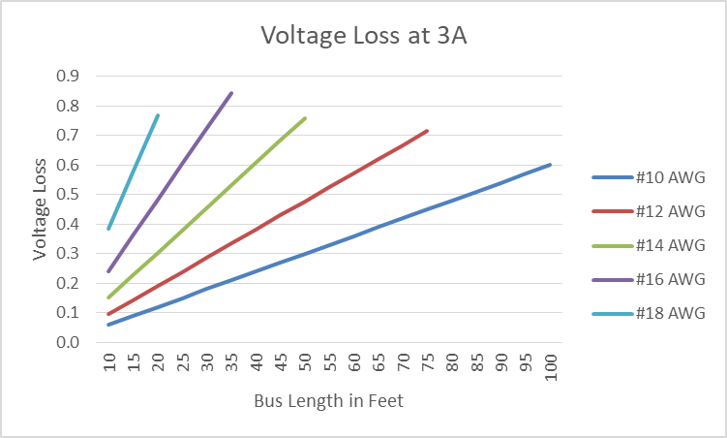

**Chart 2.2**

**Chart 2.3**

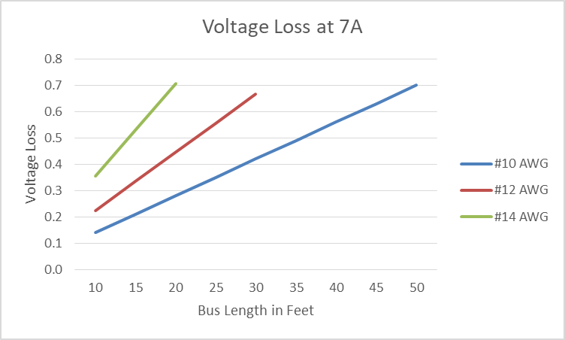

**Chart 2.4**

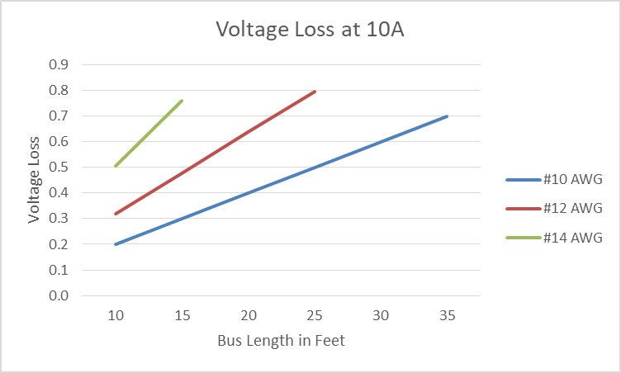

Should sections of track exceed the length of run supported by a given wire size, the power station may need to be located closer to the track section, or the center of the section of track to feed in both directions, or break up the track into power districts and use multiple power stations one supplying each power district.

### Feeder Drops

The feeder drop attached to each rail or accessory is typically smaller than the bus wire to accommodate connecting the feeder to the rail or accessory. The feeder drop should be securely attached to the rail. The feeder drop may be either a solid or stranded wire.

In smaller scales soldering the feeder drop to the rail is a good method for attachment. The feeder drop may be soldered to the side of the rail (field side) or to the bottom between ties. With a little practice one can solder to the bottom of track with plastic ties without melting them. Once the track is painted and ballasted the connections nearly disappear.

For large scale track (G & F) the mass of the rail makes getting enough heat to make a good solder connection difficult. For large scale track, mechanical connectors with screw terminals make a good method to connect the feeder drops to the track.

Never rely on a friction connection such as a slide on rail joiner. The connection should be by means of soldering or tight screw terminals.

Each section of rail should have a feeder drop wire attached. In no case should an unsoldered rail joiner be relied on to conduct the power and signal. Feeder drops should be spaced at no more than 3 feet or 1 meter apart. For very short sections of rail, less than 6 inches (15cm); a soldered rail joiner may be used to connect that short rail section to an adjacent rail with a feeder drop.

Each accessory should have a pair of feeders attached unless the accessory decoder takes its power directly from the rail. Some accessories such as turnouts come with an accessory decoder integrated which draw current from the rails.

Feeder drops should be sized based on the maximum current capacity of the power station. In a short circuit condition the full current capacity of a power station could flow through a single feeder drop. Therefore, feeder drops should be sized for the worst condition that could be encountered.

**Table 2.2 Typical Feeder Drop Size**

|  |  |
| --- | --- |
| **Power Station** | **Feeder Drop Min wire size** |
| 3A | 22 AWG |
| 5A | 20 AWG |
| 7A | 18 AWG |
| 10A | 16 AWG |

The feeder drop may be attached to the bus wire by various means including; stripping each wire wrapping and soldering, displacement connectors, or other suitable means for a secure connection. Bare connections should be covered by heat shrink tubing, electrical tape or other suitable means of insulation. Feeder drop wires should be kept as short as possible, never exceeding 12 inches/30cm.

## Signal Distortion

### Twisted bus pairs

To reduce induction and high frequency interference the pair of bus wires should be as close as possible. For smaller wires a zip cord is one solution. For heavier wire they may be available only as individual wires. Twisting the wires at a rate of at least 4 turns per foot (30cm) will put them in close proximity, yet will allow enough room to attach feeder drops. Where there is a run where no feeder drops are to be attached the number of twist per unit length may be increased.

Twisting the bus reduces inductance which reduces ringing. It also increases capacitance which reduces ringing. It also reduces susceptibility to common mode noise (interference).

Be aware that this increased capacitance downstream from a current sensing occupancy detector can cause false occupancy indications. Wire downstream from the detector generally should not be twisted to avoid false occupancy indications.

### Bus terminations

The DCC bus may be fitted with a resistor capacitor (RC) filter using a 150Ω resistor of adequate wattage in series with a 0.1µf 50V capacitor across the bus. See Table 2.3 below. Such a filter is best located near the end of the bus but additional filters may be placed at points along the bus if needed.

The purpose of such filters are to reduce ringing and to shunt any voltage spikes created when there is a short circuit created by a derailment or equipment running into a turnout set against it. Results will vary for each situation depending on the length of the bus, load on the bus and the power station. Although different power stations conform to NMRA Standards the outputs will behave somewhat differently. If the power station output is driven hard there will be more ringing in the signal. The less load there is on the bus the more ringing will be observed. Adding an RC snubber will reduce this ringing.

Such RC filters will draw a small amount of current and should not be placed down line from any current sensing occupancy detector.

**Table 2.3 Termination Resistors 150Ω**

|  |  |  |
| --- | --- | --- |
| **Scale** | **Max Voltage** | **Wattage** |
| Z & N | 14V | 1W |
| HO | 17V | 1W |
| S & O | 19V | 2W |
| G & F | 22V | 2W |

### Routing of Bus

In wiring for DCC, the bus should be laid out linearly. It should never loop back on itself, nor should there be a loop that goes out to a branch and comes back to connect to the main. The reason for this is to prevent reflection in the DCC signal timing as it reaches the decoder.

The bus should not be run parallel for long distances to other data busses such as Computer Model Railroad Interface (C/MRI) or Layout Command Control (LCC). Coupling and induction of signal is possible. Given that most railroads and models are linear it is not always possible to avoid running various wiring parallel. The DCC bus should be separated from other busses by at least 3 inches (7.6cm) for long distances.

## Short Circuit Protection

### DC Short Circuit Protection

Given that in DC the power pack usually controls one train (one or more locomotives) per output the short circuit protection is usually built in each output by the manufacturer according to the rating of the power pack.

### DCC Power Stations

A power station is defined as a DCC device that supplies a DCC signal with adequate power to drive a vehicle or accessory. The command station generates the DCC wave form which is imposed on the power supplied by a booster. Within any system there can be only one command station but there may be many boosters. A power station may be a combination command station and booster in one enclosure or it may be a booster with a DCC signal from a command station outside of that enclosure.

### DCC Power Districts

Depending on the size of the model railroad, how much track, how many vehicles (locomotives), accessories and operators are in use at any given time; it may be beneficial to divide the track into power districts. Should a short circuit occur in one location, the circuit breaker for that section would protect it without interrupting the power to other power districts.

Although in the past some have used 12VDC automotive tail light bulbs to protect against short circuits, today there are circuit breakers that are much faster and can be set for various trip currents and response times. It is no longer recommended to use tail light bulbs for short circuit protection.

Should the number of vehicles (locomotives) in use exceed the power capacity of the initial power station, power stations (boosters) may be added to supply additional power. Each Power Station should be in separate power district. Sub-districts may be divided, each protected by individual circuit breakers.

### Common Rail Wiring

Where one rail or the bus wire for that rail is continuous through the model railroad is called common rail. Although this can be implemented in DC powered model railroads where each power pack (controller) has its own transformer; could also be used in DCC model railroads there is a risk. Should two adjacent power district or sub districts use common rail wiring and the adjacent districts be out of phase because one pair of bus wires be flipped a voltage that exceeds the maximum voltage rating of the decoder could be present. Essentially this puts double the voltage of the power station at the single gap between the two districts. This can destroy a decoder.

It is recommended to gap both rails (and both sets of bus wire). Should the two sides be out of phase, the decoder will not be damaged. The locos will stop at the gap and not proceed. The issue is easily corrected by flipping one of the bus pairs.

# Document History

|  |  |
| --- | --- |
| **Date** | **Description** |
| 17-Jan-2021 | First Release |
|  |  |
|  |  |
|  |  |

**Important Notices and Disclaimers Concerning NMRA Standards Documents**

The Standards (S), Recommended Practices (RP), Technical Note (TN), and Technical Information (TI) documents of the National Model Railroad Association (“NMRA Standards documents”) are made available for use subject to important notices and legal disclaimers. These notices and disclaimers, or a reference to this page, appear in all standards and may be found under the heading "Important Notices and Disclaimers Concerning NMRA Standards Documents."

**Notice and Disclaimer of Liability Concerning the Use of NMRA Standards Documents**

NMRA Standards documents are developed within the Standards and Conformance Department of the NMRA in association with certain Working Groups, members, and representatives of manufacturers and sellers. NMRA develops its standards through a consensus development process, which brings together volunteers representing varied viewpoints and interests to achieve the final product. NMRA Standards documents are developed by volunteers with modeling, railroading, engineering, and industry-based expertise. Volunteers are not necessarily members of NMRA, and participate without compensation from NMRA.

NMRA does not warrant or represent the accuracy or completeness of the material contained in NMRA Standards documents, and expressly disclaims all warranties (express, implied and statutory) not included in this or any other document relating to the standard or recommended practice, including, but not limited to, the warranties of: merchantability; fitness for a particular purpose; non-infringement; and quality, accuracy, effectiveness, currency, or completeness of material. In addition, NMRA disclaims any and all conditions relating to results and workmanlike effort. In addition, NMRA does not warrant or represent that the use of the material contained in NMRA Standards documents is free from patent infringement. NMRA Standards documents are supplied “AS IS” and “WITH ALL FAULTS.”

Use of NMRA Standards documents is wholly voluntary. The existence of an NMRA Standard or Recommended Practice does not imply that there are no other ways to produce, test, measure, purchase, market, or provide other goods and services related to the scope of the NMRA Standards documents. Furthermore, the viewpoint expressed at the time that NMRA approves or issues a Standard or Recommended Practice is subject to change brought about through developments in the state of the art and comments received from users of NMRA Standards documents.

In publishing and making its standards available, NMRA is not suggesting or rendering professional or other services for, or on behalf of, any person or entity, nor is NMRA undertaking to perform any duty owed by any other person or entity to another. Any person utilizing any NMRA Standards document, should rely upon their own independent judgment in the exercise of reasonable care in any given circumstances or, as appropriate, seek the advice of a competent professional in determining the appropriateness of a given NMRA Standards documents.

IN NO EVENT SHALL NMRA BE LIABLE FOR ANY DIRECT, INDIRECT, INCIDENTAL, SPECIAL, EXEMPLARY, OR CONSEQUENTIAL DAMAGES (INCLUDING, BUT NOT LIMITED TO: THE NEED TO PROCURE SUBSTITUTE GOODS OR SERVICES; LOSS OF USE, DATA, OR PROFITS; OR BUSINESS INTERRUPTION) HOWEVER CAUSED AND ON ANY THEORY OF LIABILITY, WHETHER IN CONTRACT, STRICT LIABILITY, OR TORT (INCLUDING NEGLIGENCE OR OTHERWISE) ARISING IN ANY WAY OUT OF THE PUBLICATION, USE OF, OR RELIANCE UPON ANY STANDARD OR RECOMMENDED PRACTICE, EVEN IF ADVISED OF THE POSSIBILITY OF SUCH DAMAGE AND REGARDLESS OF WHETHER SUCH DAMAGE WAS FORESEEABLE.

**Translations**

NMRA’s development of NMRA Standards documents involves the review of documents in English only. In the event that an NMRA Standards document is translated, only the English version published by NMRA is the approved NMRA Standards document.

**Official Statements**

A statement, written or oral, that is not processed in accordance with NMRA policies for distribution of NMRA communications, or approved by the Board of Directors, an officer or committee chairperson, shall not be considered or inferred to be the official position of NMRA or any of its committees and shall not be considered to be, nor be relied upon as, a formal position of NMRA.

**Comments on Standards**

Comments for revision of NMRA Standards documents are welcome from any interested party, regardless of membership. However, **NMRA does not provide interpretations, consulting information, or advice pertaining to NMRA Standards documents.**

Suggestions for changes in documents should be in the form of a proposed change of text, together with appropriate supporting comments. Since NMRA standards represent a consensus of concerned interests, it is important that any responses to comments and questions also receive the concurrence of a balance of interests. For this reason, NMRA, its departments, Working Groups or committees cannot provide an instant response to comments, or questions except in those cases where the matter has previously been addressed. For the same reason, NMRA does not respond to interpretation requests. Any person who would like to participate in evaluating comments or in revisions to NMRA Standards documents may request participation in the relevant NMRA working group.

**Laws & Regulations**

Users of NMRA Standards documents should consult all applicable laws and regulations. Compliance with the provisions of any NMRA Standards document does not constitute compliance to any applicable regulatory requirements. Implementers of the standard are responsible for observing or referring to the applicable regulatory requirements. NMRA does not, by the publication of NMRA Standards documents, intend to urge action that is not in compliance with applicable laws, and NMRA Standards documents may not be construed as doing so.

**Copyrights**

NMRA Standards documents are copyrighted by NMRA under US and international copyright laws. They are made available by NMRA and are adopted for a wide variety of both public and private uses. These include both use, by reference, in laws and regulations, and use in private self-regulation, standardization, and the promotion of modeling, structural and engineering practices and methods. By making NMRA Standards documents available for use and adoption by public authorities and private users, NMRA does not waive any rights in copyright to the NMRA Standards documents.

**IMPORTANT NOTICE**

NMRA Standards documents do not guarantee or ensure safety, security, health, or environmental protection, or ensure against interference with or from other systems, devices or networks. NMRA Standards documents development activities consider research and information presented to the standards development group in developing any safety recommendations. Other information about safety practices, changes in technology or technology implementation, or impact by peripheral systems also may be pertinent to safety considerations during implementation of the standard. Implementers and users of NMRA Standards documents are responsible for determining and complying with all appropriate safety, security, environmental, health, and interference protection practices and all applicable laws and regulations.

1. V = voltage I = current R = resistance in ohms