**Philippine Air Force Finance Center**

The Office of the Finance, Philippine Air Force was activated as a Special staff of the Commanding General, PAF on October 03, 1948. The office was responsible in monitoring all financial activities of the entire Command.Their mission is to provide financial management and services to the Philippine Air Force.

**PAFFC Functions**

1. Disburse funds of the PAF strictly in accordance with laws and regulations and render reports required under existing regulations;
2. Provides financial services to personnel and units including those detailed outside PAF based on sites and other client agencies served by the PAF;
3. Provide the cash required by regular and special disbursing officer and personnel going on official mission or schooling/training;
4. Draws, prepares and signs checks, warrants for the CS, AFP under sec616 RAC, as amended, chargeable against the appropriation of the PAF;
5. Administers the current accounts of the PAF with Authorized Government Depository Bank;
6. Maintains centralized pay records of both military and civilian personnel;
7. Operates and maintains the PAF payroll system for military and civilian personnel;
8. Provides technical training and motivation to personnel charged with custody, handling and disbursements of funds both appropriated and non-appropriated.

**Officers-In-Charge**

**Commanding Officer:** Col Romeo N Dela Cruz (GSC)

**Executive Officer:** LTC Florentino I Ariola PAF

**Sgt Major:** Msgt Alicia M Valdez WAC (PAF)

**First Sgt:** Msgt Justo E Ballinan PAF

**Organizational Chart and their Departments**

**Description of Each Department**

1. Finance Operations Department

This department performs the financial operations in support to the accomplishment of Unit mission.

1. Administration Department

To provide administrative and security support to the Center. This department also controls on enlisted personnel and civilian employees and logistic needs of the Center.

1. Fiscal Department

This department supervises all matters pertaining to fiscal operations, meaning they provide financial information requirements to support proper financial resources, fiscalizes and recommends adjustment on the utilization of PAF financial resources available to ensure its efficient use.

1. Head Supply and Support Department

This department advises and assists the Commanding Officer, Air Force Finance Center in the management of all supplies and equipments and serves as the support services of the Center.

**Project Statement Form**

|  |  |  |
| --- | --- | --- |
| **Name** |  | **Contact Information** |
| Domalanta, Kemp A. | Project Manager | domalantakemp@yahoo.com, kadomalanta@apc.edu.ph |
| Dumandal, Krisa Joy O. | Junior Developer / Documenter | krisadumandal@yahoo.com, kodumandal@apc.edu.ph |
| Bugais, Lady Kim M. | Creative Designer / Documenter | lady.kim05@yahoo.com, lmbugais@apc.edu.ph |

**Stake Holders**

**Team PAFFC**

Domalanta, Kemp A.

**Project Manager**

Dumandal, Krisa Joy O.

**Junior Developer / Documenter**

Bugais, Lady Kim M.

**Creative Designer / Documenter**

Mr. Jose Eugenio Quesada

**Professor / Adviser**

**Asia Pacific College**

**Email:** [jlquesada@apc.edu.ph](mailto:jlquesada@apc.edu.ph)

**Users**

Target users are those personnel in Philippine Air Force. It will serve as their account in viewing their financial data. The personnel in the Philippine Air Force Finance Center have the privilege to be an administrator of the system which can edit the financial data depending on their assigned department.

**Project Objectives**

**Short Term**

1. **Access the system easily**

Provide a system through internet that can be accessible in any Philippine Air Force Headquarters.

1. **Secured data storage**

The system is password-protected so that all the data is secured. It is also uses cloud-computing technology that supports online data storage and minimize complications when it comes to losing data.

1. **Easy report generation**

The users can easily see the summary of his/her financial claims.

1. **Increase data availability**

All users’ data can be access anytime and anywhere.

**Long Term**

1. **Nationwide availability**

Have an easy way of communicating to different employees of the Philippine Air Force through web-based system by being discernible with their financial accounts.

1. **Generates sufficient information**

It provides more detailed information regarding the personal data of the employees.

1. **Satisfies the employees**

The system will provide all of the needed data of the employees and have an easier way to track their records.

1. **System Maintenance**

For the system to be still reliable in the future the company must have the developers, maintain the system to be still working and still useful for the company. It will be under the maintenance of these developers and the system will be upgraded also by these people. The system must be under this maintenance or else the system will not last long and might be not a good program to be used by the company.

**Success Factors**

**Short Term**

We can say that our project is successful if we meet all of the following requirements:

1. If the administrator could store data in the system.
2. If the system computes the data correctly.
3. If all of the PAF personnel can access the system.

**Long Term**

We can say that our project is successful if we meet all of the following requirements:

1. If the project will continuously provide accurate information to the users.
2. If the system is still being used by the company for a long time through the upgrade and maintenance of the developers.

**Strategic and Background Information**

|  |  |  |
| --- | --- | --- |
| Please answer the following questions by marking “Yes” or “No.” | Yes | No |
| Is the project is consistent with the state organization Business Plan? If not, why? | X |  |
| Is the project identified in the state organization IT strategic plan? If not, why not? | X |  |

**Business Area or IT Area Impacted**

* Payroll
* Financial

**Type of Technology**

The Type of Technology that the Philippine Air Force Finance Center have for now are the MySQL Database which serves as their database and they also have a client-server architecture for their system which is they said it’s hard, costs money for transportation, and takes time to install to different Philippine Air Force Headquarters.

## Vision and Scope Document

### 1. Business Requirements

#### 1.1 Background, Business Opportunity, and Customer Needs

Handling a thousand of employees of Philippine Air Force (PAF) is a hard task. There is a widespread agreement that the transaction at the Finance office in PAF is very complicated, take – time, and inconvenient to both personnel of PAF and the office. This is due to the fact that when the time a personnel goes to the Finance office, they encounter a lot of problems. In a normal day, about 30 minutes were consumed for a transaction to be completed. When personnel come in a busy day, they spend almost an hour to complete the transaction.

The finance office has an existing system that is available only for the admin. The system itself is not internet based so it is only for the office. They also have some problem in limited storage of data because there is no server. Papers are seen on the office so they want to lessen the use of papers.

To give a solution for these problems experience by the company, the best approach that can be made is by the use of the technology. Changing and developing the old procedure and system will provide the finance office staffs have an easy job. A system that can display all the financial summary of a personnel, so that it will not cost them time. Then, provide an accessible system which can be use anywhere and anytime. By using the desire system it will make the transaction of the finance center be convenient.

#### 1.2 Business Objectives and Success Criteria

|  |  |
| --- | --- |
| BO-1: | Reduce time wastage by 60% in every transaction made by the personnel within 2 month following the initial release. |
| BO-2: | Minimize the work of the employees in the Finance office. |
| BO-3: | Maintain an accurate and secured transaction of personnel. |
| SC-1: | To have 70% of the personnel going to the Finance office will use the online Finance Monitoring System within 4 months. |
| SC-2: | To have 90% of the transaction be automated within 5 months. |
|  | |

#### 1.3 Business Risks

|  |  |
| --- | --- |
| RI-1: | The Finance office might need a server where the information of the personnel will be store. Buying a server might cost them a lot of money. |
| RI-2: | Few personnel that are not familiar with using computer might not agree on using the system, but rather to use their traditional procedure. |
| RI-3: | The Finance office might need an IT expert to maintain the system. |

### 2. Vision of the Solution

#### 2.1 Vision Statement

For all the personnel of PAF who wish to have very fast transaction, the Financial Claim Monitoring System is a web-based application that will help them for making a quick and accurate transaction. Staffs and employees of the finance office who are having hard time will have a lessen work. The new system will allow all personnel of PAF to access the system all the time and everywhere via a computer with an internet. The system provides a better solution for the problem of the office. It reduces much time and resources required in processing in every transaction of a personnel.

#### 2.2 Major Features

|  |  |
| --- | --- |
| FE-1 | Transaction approval of financial claims per personnel. |
| FE-2 | Summary of collateral and variable claims of the personnel. |
| FE-3 | Searching of the personnel records including all their financial claims. |
| FE-4 | Adding financial records of a personnel, if needed |
| FE-5 | Update financial claims of a personnel, if needed |
| FE-6 | Viewing of financial claim status |
| FE-7 | Deleting financial claims of a personnel, if necessary |

#### 2.3 Assumptions and Dependencies

|  |  |
| --- | --- |
| AS-1: | The availability of the employee’s information will be accessible anytime. |
| AS-2: | Using the system will make the transactions be more convenient for the employees and office personnel. |
| AS-3: | It is assumed that the Financial Claim Monitoring System will be able to handle any data. |
| DE-1: | Before the Financial Claim Monitoring System can be access, an Internet connection is required. |

### 3. Scope and Limitations

#### 3.1 Limitations and Exclusions

|  |  |
| --- | --- |
| LI-1: | The Financial Claim Monitoring System will work for computer which has Internet connection. |
| LI-2: | The Financial Claim Monitoring System will be available only for all of the Philippine Air Force employees. |

### 4. Business Context

#### 4.1 Stakeholder Profiles

| Stakeholder  Office of the Commanding Officer | Major Value  Convenience; Reliable System; Time Saving | Attitudes  Worried about the security of the data | Major Interests  Security of data, Reliability of data | Constraints  Have a system but didn’t work well as expected |
| --- | --- | --- | --- | --- |
| Office of the Executive Officer | automation of all the process; | quite happy to the current system | Simplicity of use, | Doesn’t have enough knowledge about computer |
| Office of the Head, Finance Operations Department | Minimal work;  Accessible data | receptive but cautious | Cost savings from the new technology, | Not enough funds to pursue |
| Office of the Head, Administration Department | More efficient use of staff time throughout the day; | Troubled about handling personnel | Lessen work and hassle | Worry about job preservation |
| Office of the Head, Fiscal Department | Easy procedure to input data; | contented in the existing system | Availability of data, | No resources available |

|  |  |  |  |  |  |
| --- | --- | --- | --- | --- | --- |
| **EVENT** | **TRIGGER** | **SOURCE** | **USE CASE** | **RESPONSE** | **DESTINATION** |
| Adding a new personnel | New Personnel Record | Air Force Main | Create new personnel profile record | New Personnel details | Admin |
| Edit Personnel profile | Update Profile Information | Personnel | Update personnel profile information |  |  |
| Admin wants  to add payroll record | New payroll record | Payroll System Head | Create payroll record | New payroll added every month | Admin |
| Add new claim record to the personnel | New claim record | Admin | Create claim record | New financial claim record and details | Personnel |
| Add amount of claim to the personnel | Adding amount in the personnel’s claim | Admin | New personnel claim amount | New personnel claim amount | Personnel |
| Update the claim status of each personnel | “for approval” |  | Update claim status | Approved, processing, or denial claim status | Accounting |
| Edit the date of the claim status | Update the date of the claim status report | Admin | Update claim status date | Update the date of the claim status | Admin |
| The admin wants to compute the total net amount of the personnel | Summary report of the net amount of the personnel | Admin | Summary report of the financial claim | Net amount total summary | Personnel |
| Personnel wants to view his financial claim record summary | Request financial claim record summary | Personnel | Look up financial claim record summary | Financial claim record summary | Personnel |
| Personnel wants to view his financial claim status | Request financial claim status | Personnel | View financial claim status | Display financial claim status | Personnel |

**Brief Use Case:**

**Create new personnel profile record:** The main headquarters of the Philippine Air Force submits new personnel to Finance Center Administrator. The Finance Center Administrator will create new record of the personnel. The following record that must encode is the Name, rank, assigned unit and their serial number, including their username and password. Then, the personnel will now be able to access his/her account.

**Update personnel profile information:** The administrator has the capability to update the personnel’s profile information. If there were sudden changes about it and/or if the finance department will have an update in the personnel’s profile like the additional or the deduction gross amount of one of the personnel or changing of ranks and units.

**Create payroll record:** Every month, there is a new payroll record coming from the Payroll System Department Head. If that comes, the admin request to the system to create automatically a payroll record.

**Create claim record:** The admin of the system will add a claim to a certain personnel. The new claim will be included to the information and data of the personnel. The claim will be available for the personnel.

**New personnel claim amount:** If the admin wants to add amount to an existing claim of the personnel, the system will allow him/her to enter a value. The amount entered will be saved to the existing claim record of the personnel.

**Update claim status:** An update for the claim of each personnel is requested by the admin, the system will allow the admin to update the department location of the claim or the status of the claim of each personnel. Each department will now be visible if the updated claim of the personnel entered is approved or not. This approval will now be accredited by the bank if all the departments approved the said claim.

**Update claim status date:** If there was a sudden change or need to edit the date of the claim status report, the admin will change the date of the claim status report.

**Summary report of the financial account:** The admin wants to summarize the whole financial summary the total net amount of each personnel because the admin will check if the whole summary report was updated correctly. The system will display the whole financial claim summary of each personnel.

**Look up financial claim record summary:** A personnel wants to view summary of his / her financial claim status. The personnel logs in to the system and the system will automatically search for the account of the personnel who is logged in at that moment. The system will display the financial claim record summary of the personnel.

**View financial claim status:** If the personnel request to view the claim status information. The system will display the request of the personnel. He will now be able to view his status if it is approved or still processing.

**CASUAL USE CASES**

**Brief format:**

**Update personnel profile information:** The administrator has the capability to update the personnel’s profile information. If there were sudden changes about it and/or if the finance department will have an update in the personnel’s profile like the additional or the deduction gross amount of one of the personnel or changing of ranks and units.

**Casual format:**

**Main Success Scenario:**

The admin wants to update the personnel’s profile information. The system will display the profile information of the personnel

**Alternate Scenario:**

If nothing is displayed in the screen (perhaps it is corrupted), try refreshing the page and repeat the process. If nothing happens, contact or inform the admin and ask for assistance.

If the items that are displayed in the screen are incomplete, try refreshing the page and repeat the process. If nothing happens notify or contact the admin for help.

**Brief format:**

**Look up financial claim record summary:** A personnel wants to view summary of his / her financial claim accounts. The personnel use the CMS (Claim Monitoring System) and click the Financial Claim Account Inquiry, the system will automatically search for the account of the personnel. The system will display their claim summary of the personnel. The system also will display a drop-down list for identifying a type of claims to be displayed.

**Casual format:**

**Main Success Scenario:**

The personnel want to view summary of his / her financial claim accounts. The personnel use the CMS system and click the Financial Claim Account Inquiry, the system will automatically search for the account of the personnel who is logged in at that time. The system will display the summary financial claims and net amount of the personnel. The system also will display a drop-down list for identifying a type of claims to be displayed.

**Alternate Scenarios:**

If nothing is displayed in the screen (perhaps it is corrupted), try refreshing the page and repeat the process. If nothing happens, contact or inform the admin and ask for assistance.

If the items that are displayed in the screen are incomplete, try refreshing the page and repeat the process. If nothing happens notify or contact the admin for help.   
  
If the table displayed is empty, consult the admin to check if the data is corrupted or the data are not entered in the system.

If the browser tells that the system displayed that it is unavailable, check the internet connection and refresh the page to redirect in the system. If nothing happens, try to connect in the different computer.

If the information in the drop-down list were blank, consult the admin to check if the personnel has an existing claim o none.

If the system displayed incomplete information, refresh the page or consult to the admin to find if the information were entered in the system successfully.

**Brief format:**

**Adding New Personnel:** Air Force submits new personnel to Finance Center Administrator. The Finance Center Administrator will create new record of the personnel. The following record that must encode is the Name, rank, assigned unit and their serial number, including their username and password. Then, the personnel will now be able to access his/her account.

**Casual format:**

**Main Success Scenario:**

Air Force submits new personnel to Finance Center Administrator. The Finance Center Administrator will create new record of the personnel. The following record that must encode is the Name, rank, assigned unit and their serial number, including their username and password. Then, the personnel will now be able to access his/her account.

**Alternate Scenarios:**

If the system displayed “Incomplete data”, check the following blank requirements and enter the required information.  
  
If the system displayed “Duplicate record”, check if the personnel were been included to the system. If not, contact the assigned personnel for assistance and help.

If the system displayed “Username not available”, enter a valid username that is unique and easy to remember.

If the system displayed “Unsafe password”, enter a six unique character long valid password.

If the system displayed nothing after saving the information of the personnel, click the back button and save the information again.

If the browser tells that the system displayed that it is unavailable, check the internet connection and refresh the page to redirect in the system. If nothing happens, try to check the proxy settings or contact the network administrator.

**Brief format:**

**Update claim status date:** If there was a sudden change or need to edit the date of the claim status report, the admin will change the date of the claim status report.

**Casual format:**

**Main Success Scenario:**

If there was a sudden change or need to edit the date of the claim status report, the admin will change the date of the claim status report in the system.

**Alternate Scenarios:**

If nothing is displayed in the screen(perhaps it is corrupted), try refreshing the page and repeat the process. If nothing happens, contact or inform the admin and ask for assistance.

If the edited status report is not saved, try saving it again. If it still not saved contact the admin

If the system displayed “Incomplete data”, check the following blank requirements and enter the required information.

**Brief format:**

**Update claim status date:** If there was a sudden change or need to edit the date of the claim status report, the admin will change the date of the claim status report.

**Main Success Scenario:**

If there was a sudden change or need to edit the date of the claim status report and the admin will change the date of the claim status report, the system will display the input box that has information and need to be edited.

**Alternate Scenarios:**

If nothing is displayed in the screen(perhaps it is corrupted), try refreshing the page and repeat the process. If nothing happens, contact or inform the admin and ask for assistance.

If the edited status report is not saved, try saving it again. If it still not saved contact the admin

If the system displayed “Incomplete data”, check the following blank requirements and enter the required information.

**Brief format:**

**View financial claim status:** If the personnel request to view the claim status information. The system will display the request of the personnel. He will now be able to view his status if it is approved or still processing.

**Casual format:**

**Main Success Scenario:**

If the personnel request to view their claim status information, the system will display the request of the personnel.

**Alternate Scenarios:**

If nothing is displayed in the screen (perhaps it is corrupted), try refreshing the page and repeat the process. If nothing happens, contact or inform the admin and ask for assistance.

**Brief Format:**

**Create payroll record:** Every month, there is a new payroll record coming from the Payroll System Department Head. If that comes, the admin request to the system to create automatically a payroll number.

**Casual format:**

**Main Success Scenario:**

If the admin wants to create or generate a new payroll number, the system will automatically create a new payroll number

**Alternate Scenarios:**

If the system said that there is an error, try to refresh and request again a new payroll number. There may be some error in the internet connection or in the computer itself. If nothing happens and no payroll number added, contact the administrator to report the error.

**Brief format:**

**Create claim record:** The admin of the system will add a claim to a certain personnel. The new claim will be included to the information and data of the personnel. The claim will be available for the personnel.

**Casual format:**

**Main Success Scenario:**

If the administrator wants to create another claim record of the personnel, the system will be display the information needed to be inputted.

**Alternate Scenarios:**

If nothing is displayed in the screen (perhaps it is corrupted), try refreshing the page and repeat the process. If nothing happens, contact or inform the admin and ask for assistance.

If the claim record is not saved, try saving it again. If it still not saved try refreshing the page and repeat all the process.

**Brief format:**

**New personnel claim amount:** If the admin wants to add amount to an existing claim of the personnel, the system will allow him/her to enter a value. The amount entered will be saved to the existing claim record of the personnel.

**Casual format:**

**Main Success Scenario:**

If the admin wants to add an amount in the existing claim of the personnel, the system will be displayed an input box for the admin to enter the amount of the claim.

**Alternate Scenarios:**

If nothing is displayed in the screen, try refreshing the page and repeat the process. There may be some error in the internet connection or in the computer itself. If nothing happens and no payroll number added, contact the administrator to report the error. If nothing happens, contact or inform the admin and ask for assistance.

**Brief format:**

**Update claim status:** An update for the claim of each personnel is requested by the admin, the system will allow the admin to update the department location of the claim or the status of the claim of each personnel. Each department will now be visible if the updated claim of the personnel entered is approved or not. This approval will now be accredited by the bank if all the departments approved the said claim.

**Casual format:**

**Main Success Scenario:**

If the administrators want to update the location or the status of the claim, the system will display a dropdown list where it contain the choices of the stage location of the claim.

**Alternate Scenarios:**

If the items that are displayed in the screen are incomplete, try refreshing the page and repeat the process. If nothing happens notify or contact the admin for help.   
  
If the table displayed is empty, consult the admin to check if the data is corrupted or the data are not entered in the system.

If the browser tells that the system displayed that it is unavailable, check the internet connection and refresh the page to redirect in the system. If nothing happens, try to connect in the different computer.

If the textbox list is still disabled, consult the admin to check if the personnel has an existing claim o none.

If the system displayed incomplete information, refresh the page or consult to the admin to find if the information were entered in the system successfully.

**FULLY DRESSED USE CASES**

**Adding New Personnel**

Primary Actor:  
Admin

Stakeholders and Interest:  
Admin: Wants a fast entry of data  
Personnel: Wants a detailed summary  
Company: Wants an accurate record of data

Main Scenarios:  
Actor Intention System Responsibility

1. Air Force Main wants to add a new

personnel to the system.

1. Admin login to the system
2. Admin requests the system to add

a personnel

4. Accepts the request, display a form-like page.

5. Admin enters the required data.  
 6. Admin tells the personnel to enter   
 his / her username and password.

7. The system validates and

checks the entered data.

8. The system asks for   
 confirmation for adding the

new personnel.

9. Admin confirms the request.   
 10. The system displays a  
 message.  
 11. The system records all the   
 entered data and saves it to  
 the database.

**Look up financial claim record summary:**

Primary Actor:  
Personnel

Stakeholders and Interest:  
Personnel: Wants a fast and reliable detailed summary  
Admin: Wants a errorless system   
Company: Wants a reliable system and satisfies personnel

Main Scenarios:  
Actor Intention System Responsibility

1. Personnel want to view his/her  
   summary of his financial account.
2. Personnel login to the system.
3. Personnel ask for a financial  
   inquiry.

4. The system approves the  
 request.  
5. The system displays the   
 personnel account including his payroll numbers, claims.  
6. The system displays a drop-   
 down list box to identify the  
 type of claims.

7. Personnel choose a type of   
 claim.  
 8. The system displays the data  
 according to the claim type  
 chosen.  
 9. Personnel see a detailed of   
 his/her claim record summary

including the net amount.

**ACTIVITY DIAGRAMS**

|  |  |  |
| --- | --- | --- |
| **Air Force Main** | **Admin** | **System** |
| Request for adding a personnel | Enter the data  Do the request | Checks and validates the entered data |

|  |  |  |
| --- | --- | --- |
| **Air Force Main** | **Admin** | **System** |
|  | Changes required?  Review the data entered | Save the data to the database |

|  |  |
| --- | --- |
| **Personnel** | **System** |
| Request for the summary  Wants to view his/her financial account summary | Displays a drop down list box for the type of claim  Displays the request |
| Personnel | System |
| Views the request  Chooses a type | Response to the chosen type |

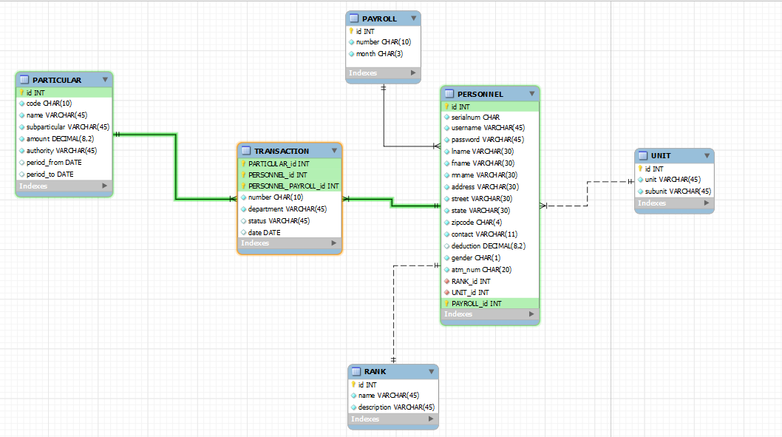**Entity Relationship Diagram**

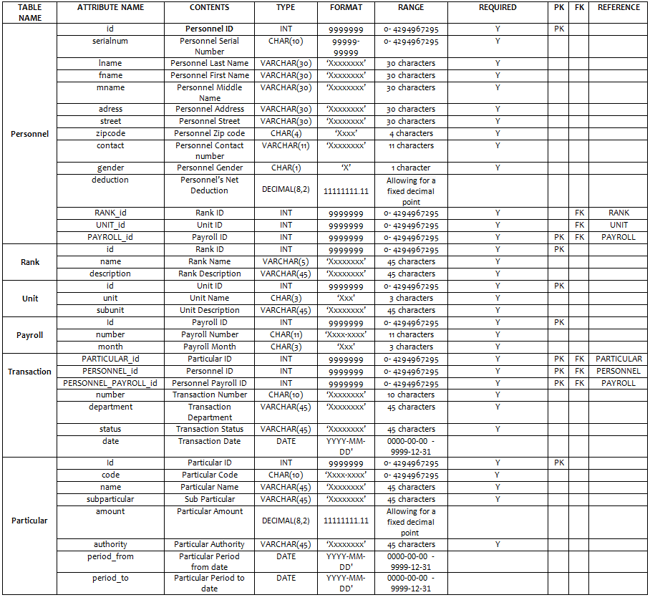**DATA DICTIONARY**

**Screen Designs**

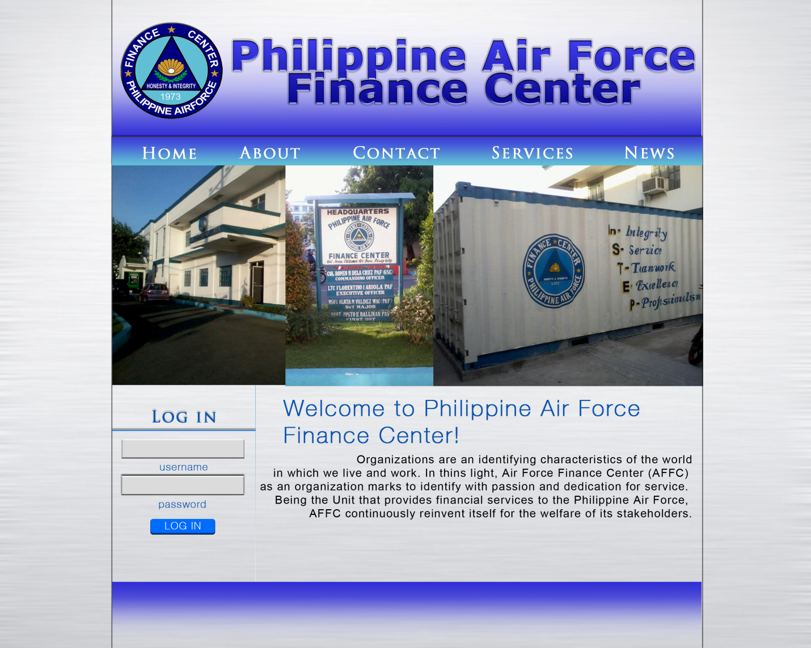

The home page and the default design of the site

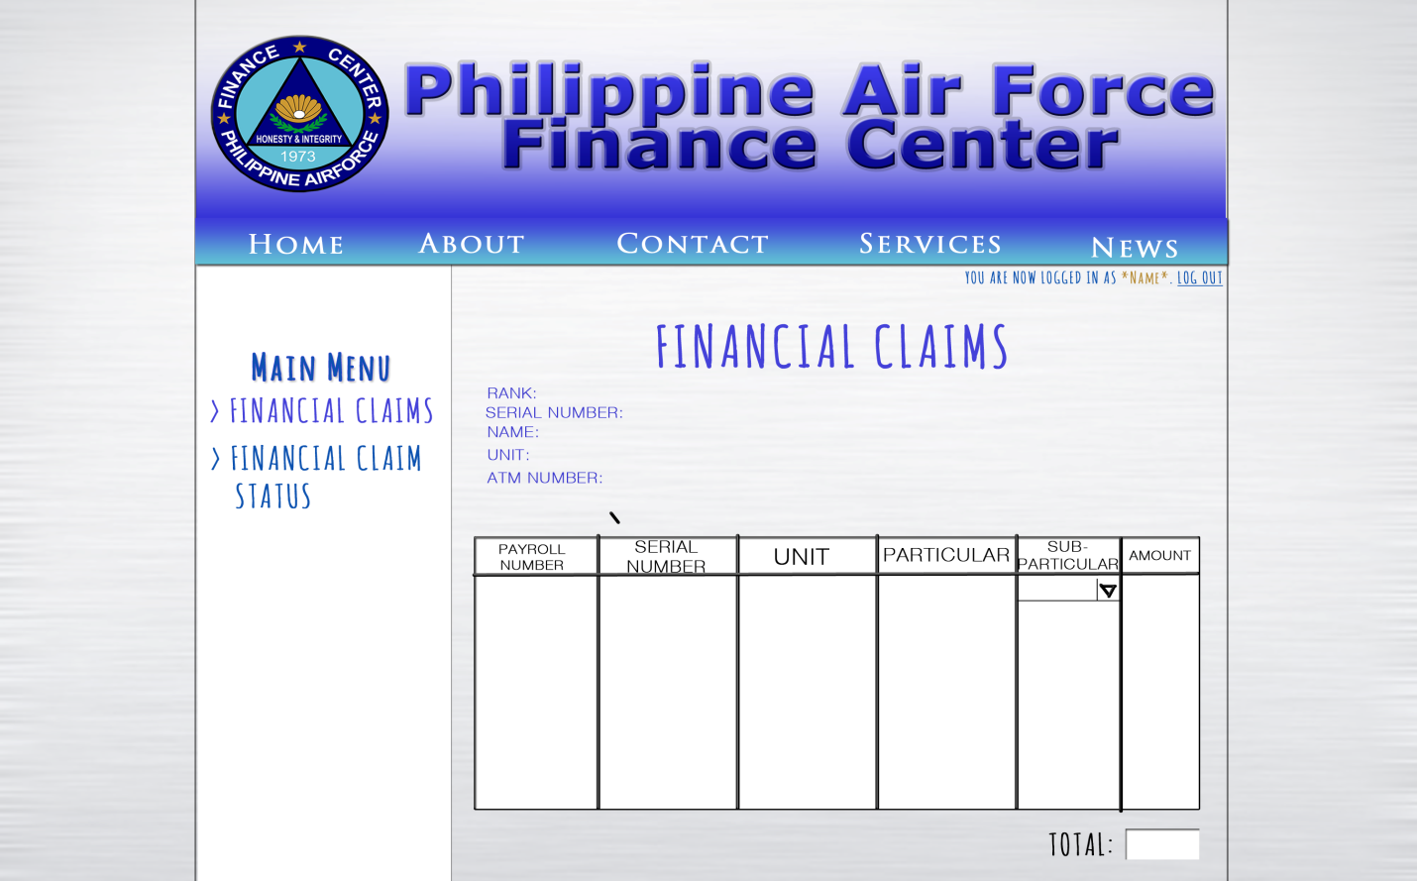

Interface of the financial claim when it is viewed by the personnel.

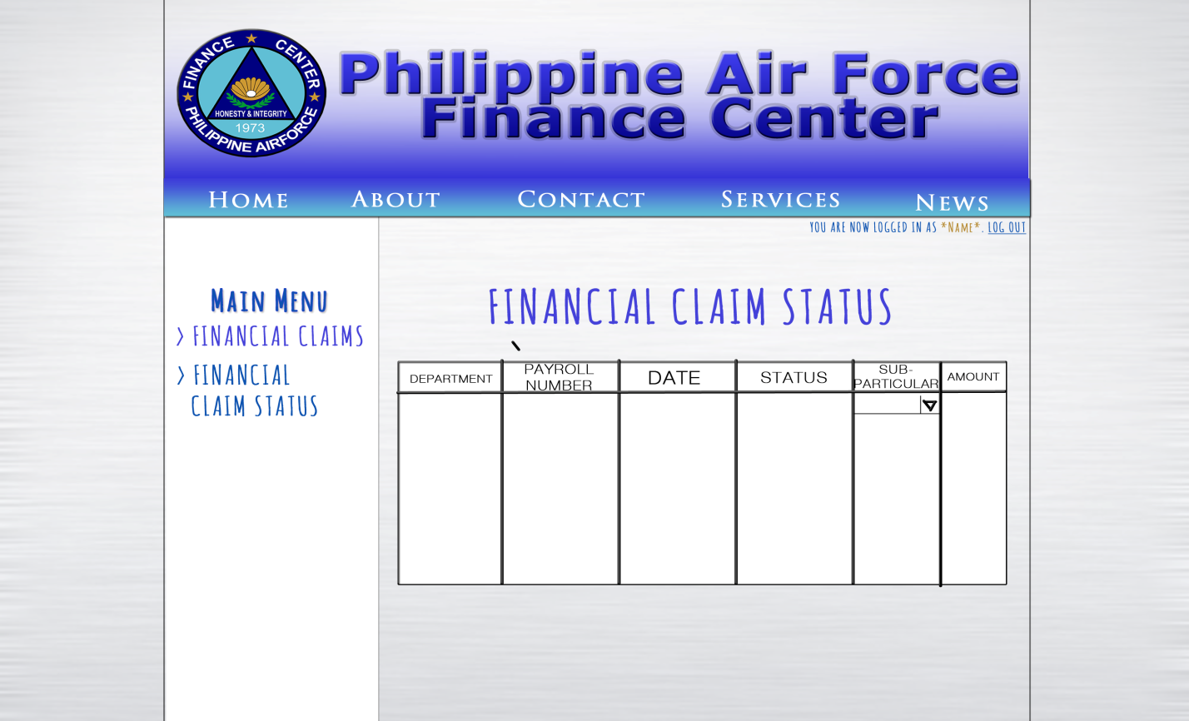

This interface is for the personnel’s perspective. They can only view the status of the claims.

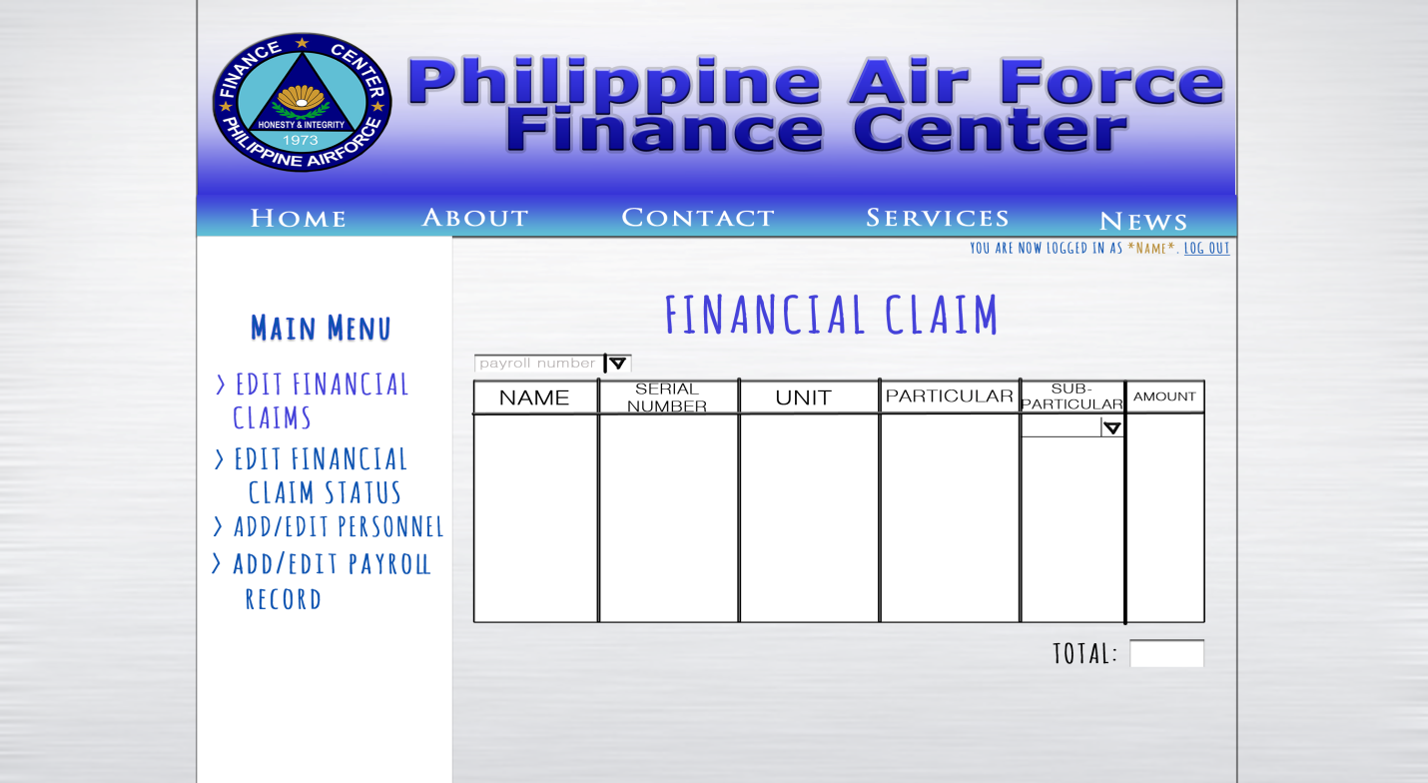

This interface is for the administrator’s perspective. They can update the data here, if necessary.

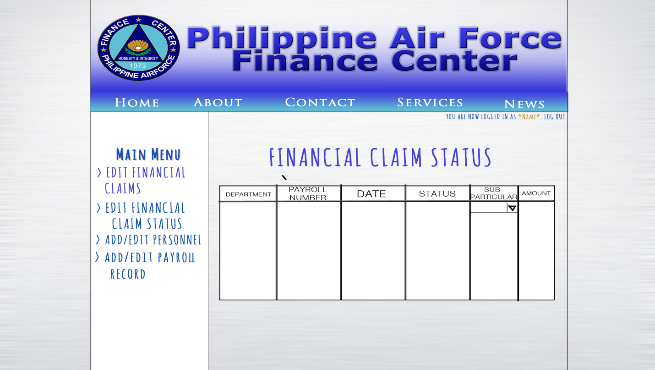

This interface is for the administrator’s perspective. Here, different department heads can edit the status of the claims. If one department already approved the claim, it will be processed by another department and can never be updated.

**School Project: Weekly Status Report: Week 1**

**A. Tasks accomplished**   
On the first week of our school project, we had a meeting in our client to ask for the approval of our proposal for them. We took a picture with the Head of their company. We talked about on how we will work with them like the requirements they need before they will allow us to access their data and also, suggests for other projects that they want for us to do.  
  
**B. Problems encountered**   
We had our appointment for the first client which is the AFP Commissary exchange but unfortunately, they disapproved our proposal because according to them, for security purposes.  
  
**C. Possible solutions**   
We immediately look for another client which is already the approved one, the AFP Finance Center.  
  
**D. Next steps to accomplish**   
The next step for this project is to submit the requirements they need for them to allow us to access the company's data/information and also, the schedule on how often we will work for them and updates for our work.

**School Project: Weekly Status Report: Week 2**

**A. Tasks accomplished**  
We finished the documents needed, but not all, which is a way to get to know our client more.  
  
**B. Problems encountered**  
Because of the investigation clearance that is still being processed, we were unable to go to the company's location to know the information we need for our project. With that, we weren't able to pass some of the documents needed in this subject.  
  
**C. Possible solutions**  
In solution, we can interview Mr. Rolando B. Dumandal to know some of their company's information so even if we can't go to their company's location, we could still get some information for us to proceed with what we are doing prior to this project.  
  
**D. Next steps to accomplish**  
Interview with the client about their business process and we have to know what are their requirements for us to do their web-based system.