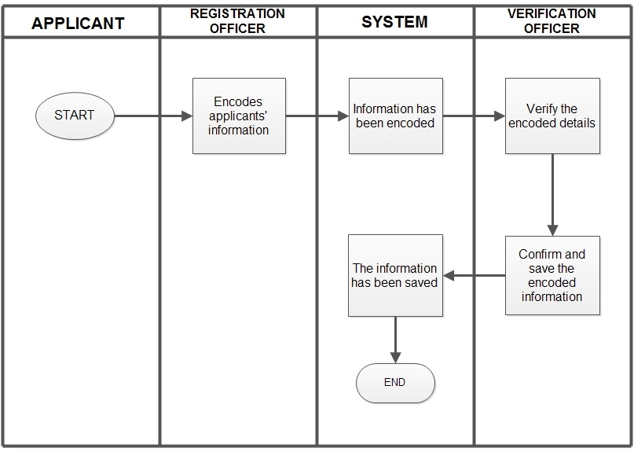

***Registration Process***

*Primary Actor:*

Applicant, Registration Officer and Verification Officer

Stakeholders and Interest:

*Applicant:* fast and easy process to register

*Registration Officer*: want to have an automated registration with a friendly user interface, wants to have well-organized information of the applicants.

*Verification Officer*: wants to have easy and fast way of checking the submitted requirements

*Pre-conditions*: Newly applied applicants

*Success Guarantee (post conditions):* The applicant is registered.

Main Success Scenario (or Basic Flow):

|  |  |
| --- | --- |
| **Actor Intention** | **System Responsibility** |
| 1. Choose to Register |  |
|  | 2. A step by step procedure will be shown that starts with filling up applicant’s personal information |
| 3. The user encodes the applicant’s personal details |  |
| 4. The user clicks “Next” | 5. A dropdown list of Type of Insurance will be shown. |
| 6. The user chooses the type of insurance |  |
|  | 7. A form about the specified insurance will be shown |
|  |  |
| 8. The user encodes the details |  |
| 9. The user clicks “Next” |  |
|  | 10. A review of the applicant’s information and his/her insurance application will be shown. |
| 11.The user clicks “Confirm” |  |
|  | 12. A dialog box will appear, “The Insurance Application was successfully saved.” |

Extensions (or Alternative Flows):

1. An applicant’s information has been already exist in the database

* The Registration Officer can edit the details of the applicant

1. Incomplete submission of details in the application form

* The Registration Officer can encode the incomplete details.

1. Information cannot saved into the database

* Displays an error message, “"Information has not been saved!"

1. Incomplete data

* A tool tip will appear beside the text input tab. “This field is required!”

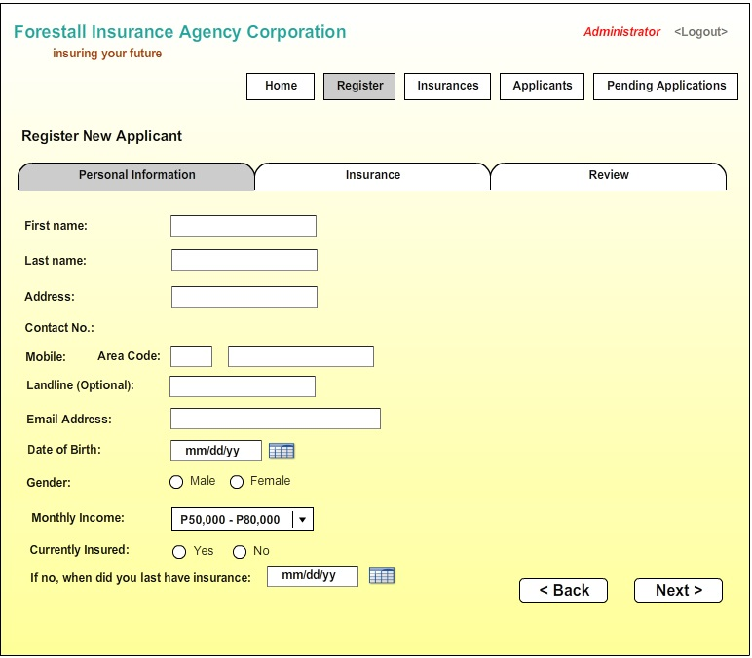

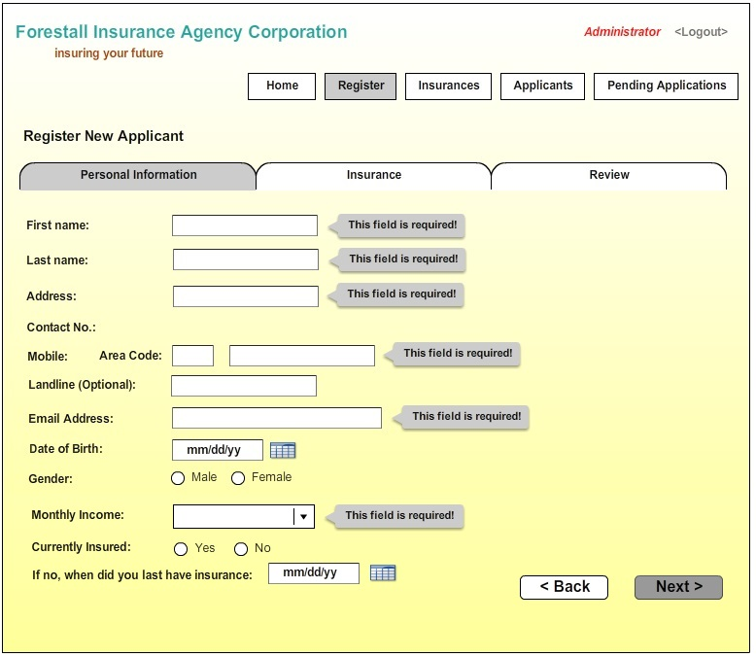

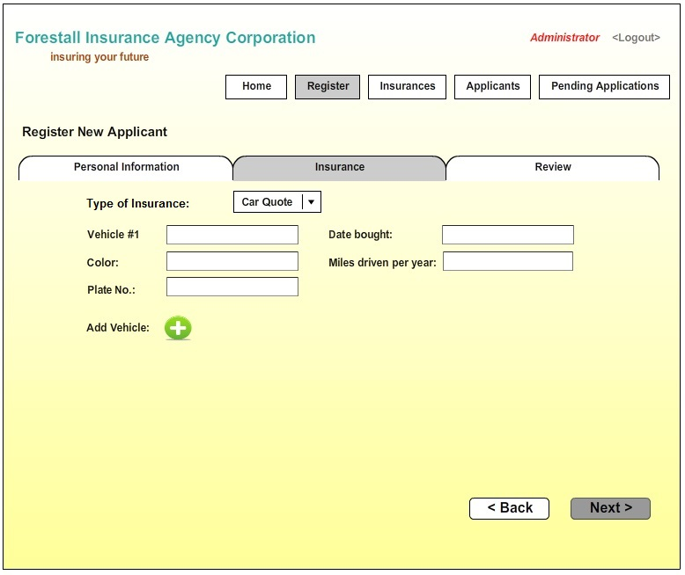

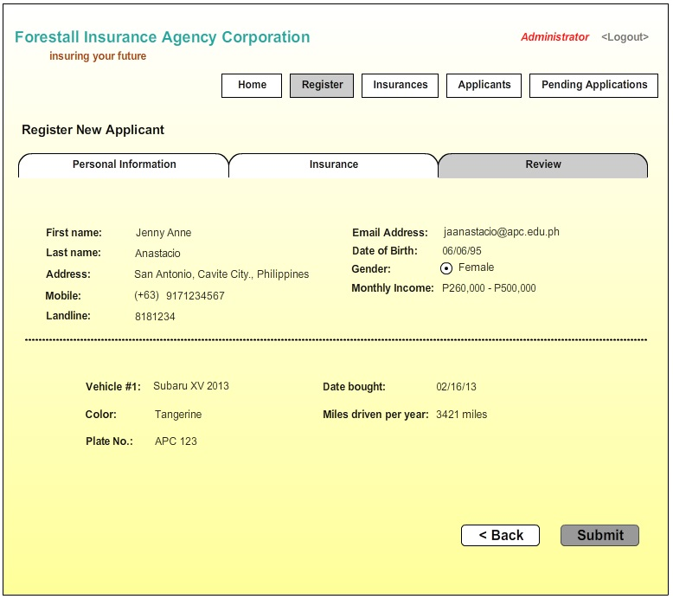

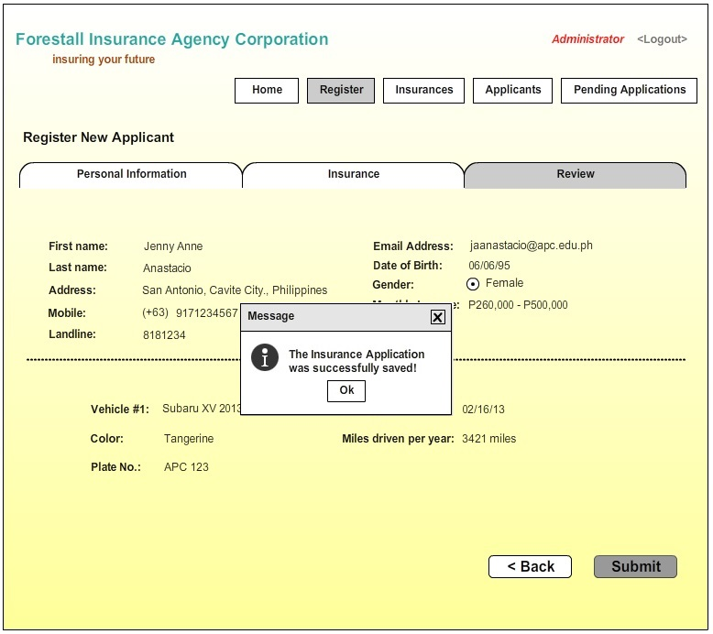

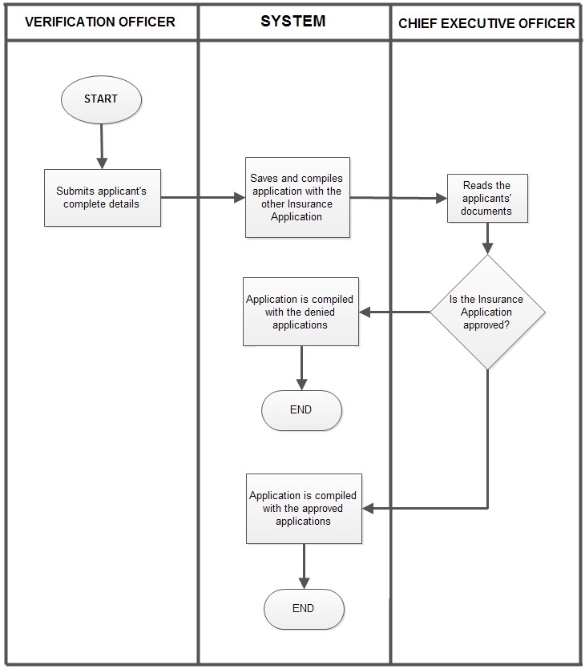

***Approving and Denying of Insurance Applications***

*Primary Actor:*

Chief Executive Officer

*Stakeholders and Interest:*

Chief Executive Officer: wants to have an easy and faster way of approving and denying of Insurance applications

*Pre-conditions*: Reviewing the pending applicants

*Success Guarantee (post conditions):*Applicants are approved or denied.

|  |  |
| --- | --- |
| Actor Intention | System Responsibility |
| 1. Clicks “Pending Applications” |  |
|  | 1. Pending applicants will be shown. |
| 1. Clicks every applicant’s name |  |
|  | 1. The details of the applicant will be shown. |
|  | 1. Two radio buttons will be shown. (Approved, Denied) |
| 1. The CEO clicks “Approve” and “Submit” |  |
|  | 1. A dialog box will appear, “The Application was approved and was successfully submitted.” |
| 1. Clicks “OK” |  |
|  | 1. The system will compile all approved applications from denied applications. |

Extensions (or Alternative Flows):

1. The CEO clicks incorrect radio button, she clicked “APPROVE”

* The CEO can change it by searching the applicants name in the APPROVED APPLICATIONS.

1. The CEO didn’t click APPROVE nor DENY.

* Displays a message, “You did not click APPROVE nor DENY. Please try again.”

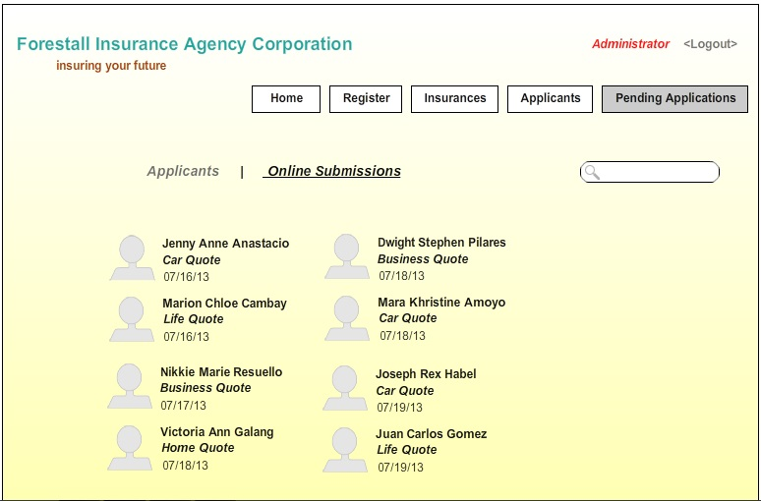

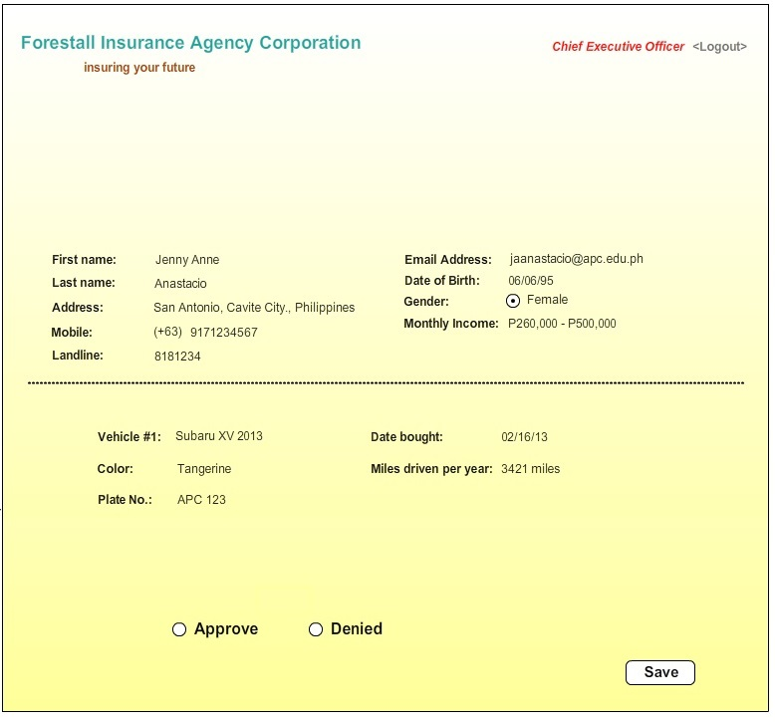

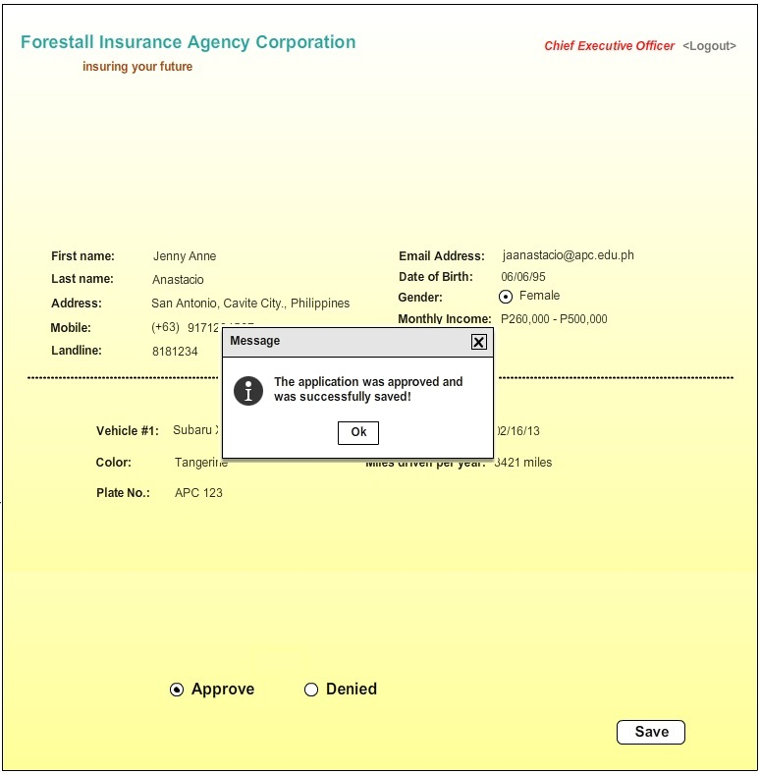

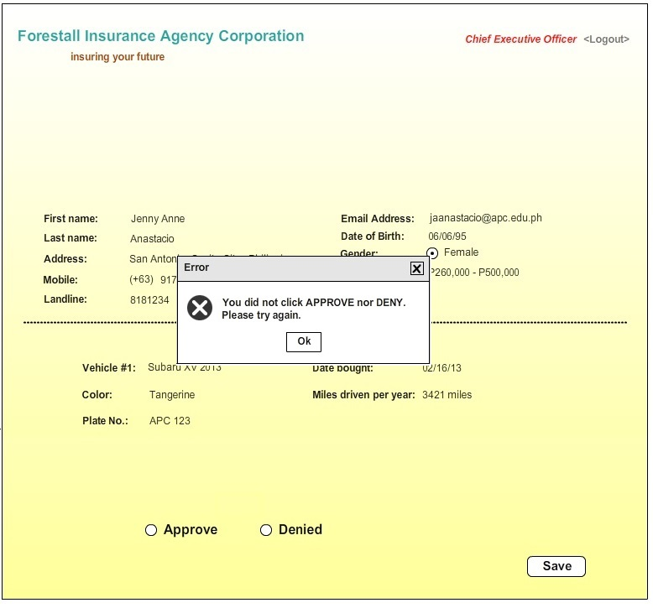

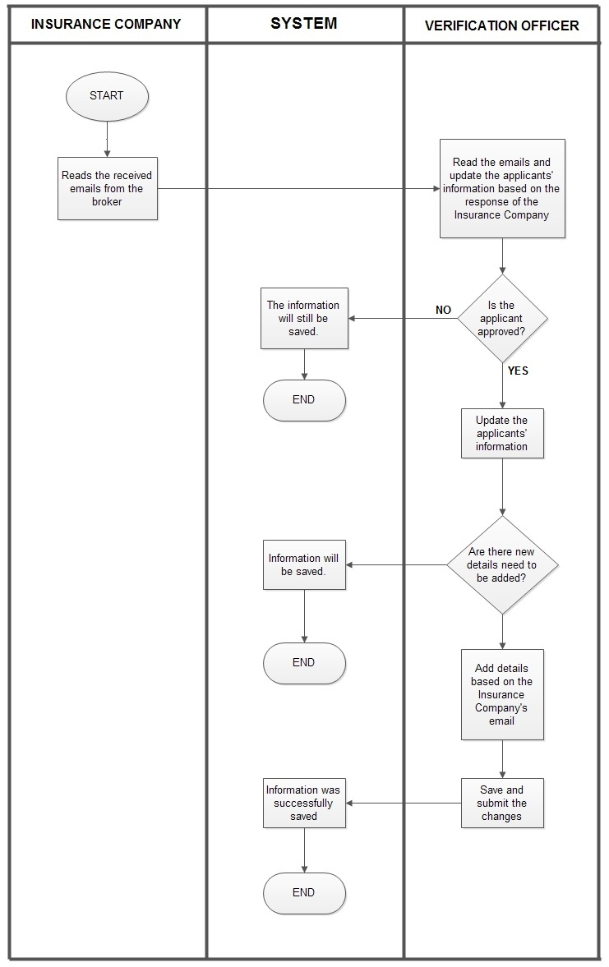

**Update Applicant’s Information**

*Primary Actor:*

Verification Officer

Stakeholders and Interest:

*Verification Officer:* wants to have an easy way to separate granted applications from denied ones with the help of the user-friendly system

*Pre-conditions*: Applicants that are approved

*Success Guarantee (post conditions:* Applicants are successfully updated.

|  |  |
| --- | --- |
| Actor Intention | System Responsibility |
| 1. The monitoring officer will click “Applicants” from the main page. |  |
|  | 2. Displays all applicants |
| 3. The actor will type the applicants’ ID or the applicant’s name. |  |
|  | 4. The searched applicant will be shown. |
| 5. The actor will click “edit icon” |  |
|  | 6. Displays the applicant’s details |
|  | 7. Two radio buttoned choices will be shown. (Approved or Denied) |
| 8. The actor clicks the radio button depending on the documents if the applicant was approved or denied. |  |
| 9. If needed, the user adds another field in the applicant’s database. The user will click “Add a new field icon” |  |
|  | 10. The system will let the user type the name of the field |
| 11. The actor will type in the text box “Insurance Code” |  |
|  | 12. Displays the typed field name |
| 13. The actor will type in the textbox,  “Car54312” |  |
|  | 14. The typed information was encoded. |
| 15. The actor will click “Save” |  |
|  | 16. A dialog box will appear. “The Insurance Application was successfully saved!” |
| 17. The monitoring officer clicks “OK” |  |

Extensions (or Alternative Flows):

1. Invalid Code

* A dialog box will appear, “Invalid Code, please try again.”

1. Incorrect Name

* A dialog box will appear, “Name cannot be searched. Please try again.”

1. The user encoded incorrect field name.

* The user can click “edit” to change the field name.

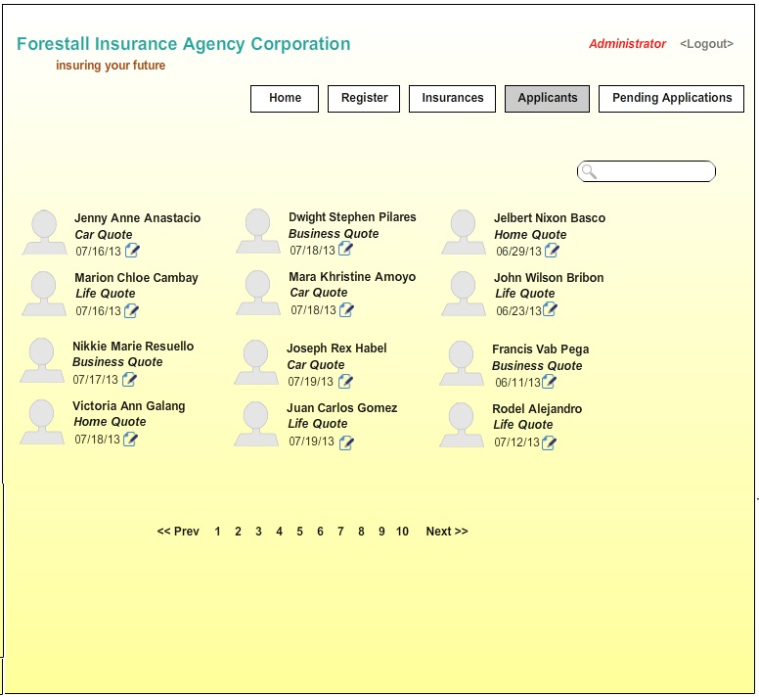

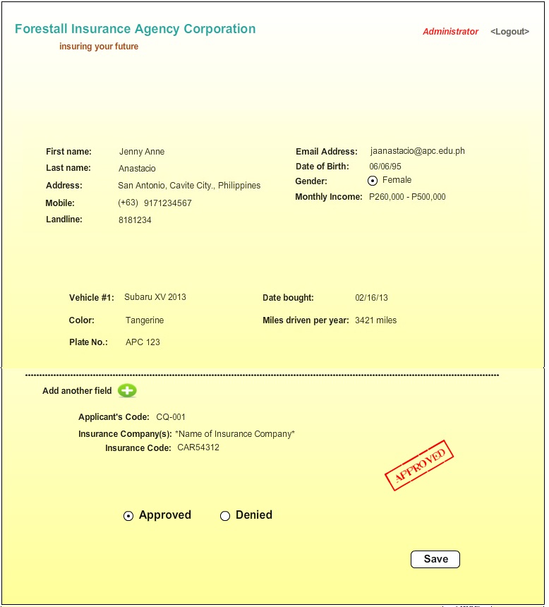

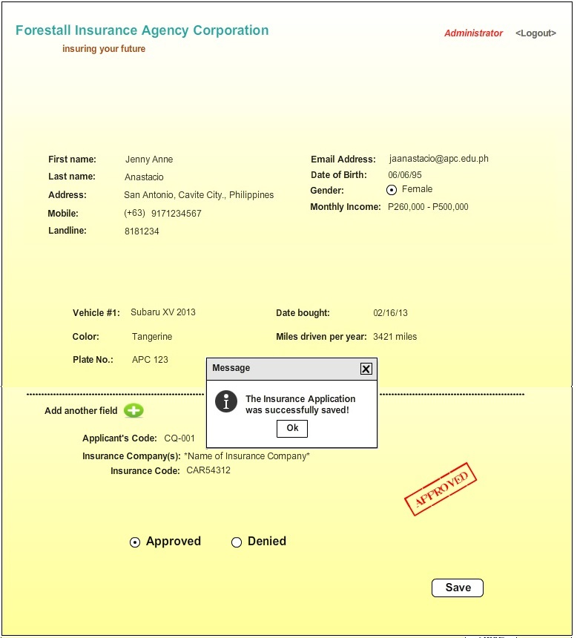

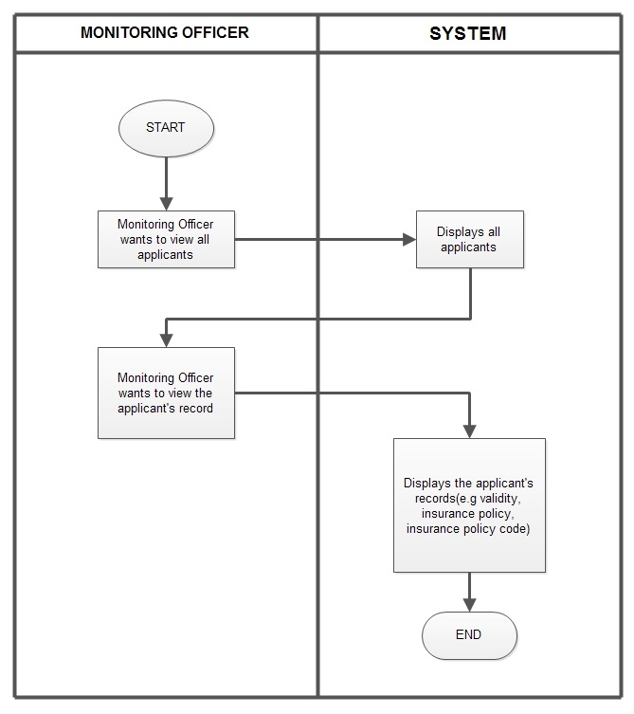

**Tracking**

*Monitor whose insurances are going to expired in that specific month.*

*Primary Actor:*

Monitoring Officer

Stakeholders and Interest:

*Monitoring Officer:* wants to have easy way to monitor the availability of all the insurances.

*Pre-conditions*: Applicants that approved

*Success Guarantee (post conditions:* Applicants are now being monitored

|  |  |
| --- | --- |
| Actor Intention | System Responsibility |
| 1. Click “Insurances” |  |
|  | 2. Displays all granted Applicant’s Insurances and their information |
| 3. The monitoring officer would like to view whose insurance will expire in this particular month. He will choose a particular month in the dropdown list. |  |
|  | 4. Insurances that will be expired on that particular month will be shown. |
| 5. The monitoring officer will click “Done” after viewing the insurances. |  |
|  | 5. Back to the main page of the system |

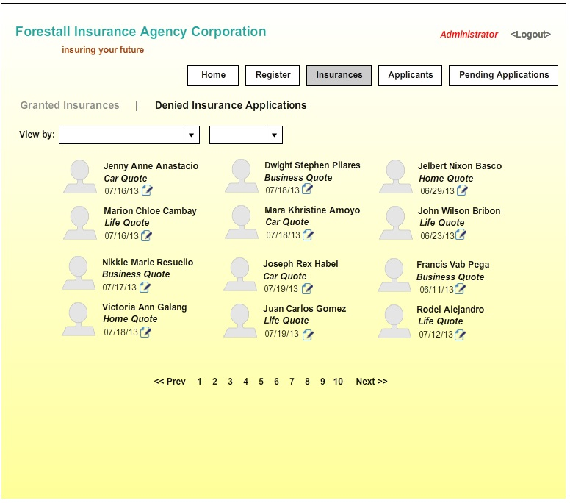

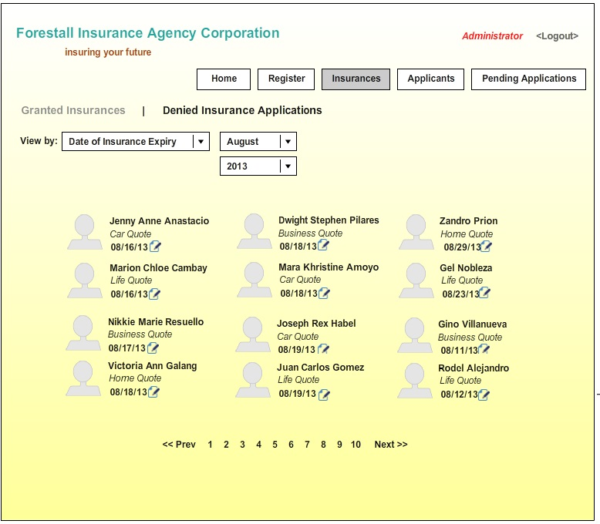

**Tracking**

*Viewing of Applicants*

*Primary Actor:*

Monitoring Officer

Stakeholders and Interest:

*Monitoring Officer:* wants to have easy and faster of checking the applicants

*Pre-conditions*: Applicants that are approved

*Success Guarantee (post conditions:* Applicants are now being monitored

|  |  |
| --- | --- |
| Actor Intention | System Responsibility |
| 1. Choose “Insurances” |  |
|  | 2. Displays all granted applicants |
| 3. The user chooses “Type of Insurance” in the first dropdown. |  |
| 4. The user chooses the “Car Quote” in the second dropdown list. |  |
|  | 5. Displays all applicants who applied for Car Insurance |

