Nombre y apellido:
Instructor’s name:

Reading Comprehension: /22
Written Proficiency: /78
Total: /100

I. READING COMPREHENSION: Interpretive Assessment (22 points)
You and your new friend Jorge are planning to study abroad in México. You have heard great things about México and are anxious to see what its most important sites are. You plan to live with a Mexican family while abroad, so you decide to go over a webpage about different types of foods. You find the following text that discusses two drinks. Check how much you understand by answering in English the questions that follow.

Café y chocolate: dos sanos alimentos para empezar el día
El café es una de las bebidas más populares en todo el mundo. Existen nada menos que ochocientas especies de café, pero sólo se cultivan unas diez. Y, de éstas, las más habituales son dos: la variedad arábica y la robusta. La primera es la de más calidad, y tiene un sabor suave y un agradable aroma. Se cultiva en América Central, Sudamérica y países africanos como Etiopía, Tanzania y Kenia. La otra variedad, como su nombre indica, produce unos granos menos sabrosos y aromáticos, y se suele utilizar para elaborar cafés instantáneos y baratos.
Tomar una taza de café es para muchos la única forma de despertarse por las mañanas. El motivo es el efecto vigorizante de la cafeína, que estimula la actividad intelectual y física, ayuda a hacer la digestión y combate la migraña. Además, apenas tiene calorías. Pero, como ya sabes, si se consume en exceso provoca nerviosismo e insomnio.
El chocolate
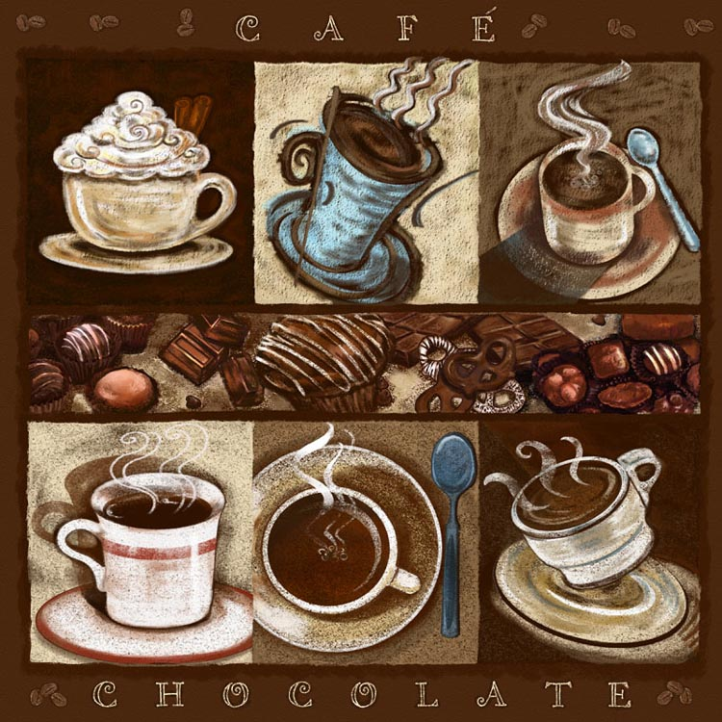
Muchos eligen para desayunar una taza de leche con chocolate. Aunque, en realidad, a los aficionados al chocolate les encanta consumirlo en todas sus variedades: a la taza, en tableta, barritas, bombones, pasteles... ¿Qué tiene el chocolate para ser tan irresistible? Básicamente, un sabor delicioso, ya que es rico en grasas, que proceden de la manteca de cacao. También tiene propiedades calmantes. Y, aunque es una bomba calórica, proporciona muchas ventajas al organismo: es un excelente aporte energético para prácticas físicas intensas; las grasas que contienen no aumentan el colesterol en la sangre; y, además, aporta vitaminas y minerales.
Historia
Cristóbal Colón y su tripulación son los primeros occidentales en probar el chocolate, cuando los habitantes de la isla de Guanja, en las costas de Honduras, les regalaron unas pequeñas nueces con las que elaboraban una bebida llamada xocolatl. Pero este alimento se populariza entre los españoles a raíz de la llegada de Hernán Cortés a México.
El chocolate llega a Europa en el siglo XVII. Se suaviza su sabor mezclándolo con miel o azúcar y se convierte en una bebida muy popular. Las infantas españolas lo introdujeron en Francia, y poco a poco se extendió su consumo por toda Europa.

http://aula2.el-mundo.es/aula/noticia.php/2003/02/17/aula1045241446.html

1. According to the reading, there are species of coffee plants (2 pts.)
a) 80 b) 88 c) 800 d) 880

2. Mention at least one characteristic of each kind of drink according to the reading (6
pts., 3 pts. each)
a) Arábica:
b) Chocolate in the 17th Century:

3. List one advantage and one disadvantage of drinking coffee according to the reading (6 pts., 3 pts. each)
Advantage:

Disadvantage:

4, True or False (8 pts., 2 pts. each)
a) Chocolate aficionados like to consume chocolate in different ways. TRUE FALSE
b) The first Europeans to try chocolate were Christopher Columbus and his crew. TRUE FALSE
c) Chocolate arrives in Europe after Hernán Cortés goes to France. TRUE FALSE
d) Robusta is only cultivated in Central and South America. TRUE FALSE

II. WRITTEN PROFICIENCY: Presentational Assessment (78 points)
A. Interpersonal communication (30 point)

1. Jorge, your friend, is coming to your apartment for lunch and is bringing his picky sister, Carmen. According to the clues given below, plan a menu for lunch that will be agreeable to everyone. Include drinks, the meal itself, and dessert. You must provide at least ten items. WRITE YOUR ANSWER IN SPANISH. (10 points)

Carmen doesn’t drink alcohol. She doesn’t like milk. She doesn’t like neither hot nor fried foods. She likes lettuce and tomatoes. She prefers fresh ingredients and likes dessert.

To drink:
______________________________________________________________________________

______________________________________________________________________________

To eat:
_____________________________________________________________________________

______________________________________________________________________________

For dessert:
_____________________________________________________________________________

______________________________________________________________________________

2. Jorge will send this email to his Mexican friend, Ana, because he wants to practice Spanish as much as he can. Again, he needs your help to complete it with the appropriate form of the word in parenthesis. (8 points)

Querida Ana:
¿Cómo estás? Yo estoy muy contento en Rutgers. Tengo dos amigos que son Carrie y John. Ellos son muy ______________₁ (trabajador) y muy _________________₂ (idealista). Carrie es un poco ________________₃ (tonto) a veces y John es muy ________________₄ (serio). ¡Ah! Creo que Carrie va a ser mi novia. ¿Qué piensas tú?
Jorge

3. Jorge y Carmen tienen problemas. Review the messages that Jorge and Carmen wrote asking for advice to solve their problems, and complete with the correct present tense form of the appropriate verb. Use each verb only once. (12 pts)

Dormir | poder | ser
querer | ir | practicar

Yo (1) _____________ mucho deporte, nado, juego al tenis dos veces por semana y todos los días camino media hora. Pero mi alimentación no (2) _____________ muy buena. ¿Qué (3) _______________hacer? Jorge R.

Mi problema es el estrés. (4) _____________ a clases todos los días, trabajo 10 horas al día, (5) _____________ mal y fumo 30 cigarrillos al día. El médico me dice que tengo que hacer ejercicios, pero yo no (6)_______________. Carmen R.

B. Presentational Communication (48 points)
You decided to write an email in SPANISH to your future Mexican host family to tell them about your family and life as a Rutgers student. Your email must include the following information:

[] Describe yourself and one member of your family in detail: name, age, and where this family member lives
[] Talk about your and his/her personality in detail (at least 5 negative characteristics and 5 positive ones)
[] Talk about where your family member is (location) and how s/he is (busy, worried, etc.)
[] Explain briefly the reason why your family member is in the state described above.
[] Talk about things you and your family member like (4) and things you don’t like (2)
[] Talk about your diet at Rutgers, food you like and dislike and what students eat to have a balanced diet
[] Ask your host family two questions
[] Linking words to connect your sentences

To: famliamexicana@mexico.org
From: yo@rutgers.edu
Re: Mi familia y yo

Presentational Rubric

 | 4 | 3 | 2 | 1
A. CONTENT  Score: ____________ | You fulfilled all the requirements of the task in detail. | You fulfilled most of the requirements of the task with some detail. | You fulfilled some of the requirements of the task with few details. | You fulfilled few of the requirements of the task. Your task completion and details were inadequate.
B. COMPREHENSIBILITY Score: ____________ | Reader was able to understand all of what you were trying to communicate. | Reader was able to understand most of what you were trying to communicate. | Reader was able to understand less than half of what you were trying to communicate. | Reader was able to understand little of what you were trying to communicate.
C. ACCURACY  Score: ____________ | You used language correctly almost all the time, including grammar (agreement, gustar, present tense, etc) spelling and word order. | You have few problems with grammar (agreement, gustar, present tense, etc), spelling, word order, and punctuation. | You have some basic problems with grammar (agreement, gustar, present tense, etc), spelling, word order, and punctuation. | You have a significant number of grammar (agreement, gustar, present tense, etc), spelling, word order, and punctuation errors.
D. VOCABULARY Score: ____________ | You have used a wide range of vocabulary from chapters 1-4. | You have used a good range of vocabulary from chapters 1-4. | You have used less than the vocabulary expected from chapters 1-4. | You have used an inadequate amount of vocabulary. Fail to incorporate new vocabulary or included very few new words
E. ORGANIZATION Score: ____________ | Your presentation is logical and effective. | Your presentation is generally logical and effective with a few minor problems. | Your presentation is somewhat illogical and confusing in places. | Your presentation lacks logical order and organization.
F. TEXT TYPE  Score: ____________ | You wrote a fairly coherent paragraph. | You have created with the language by using strings of sentences. | You have created with language by using simple sentences and some strings of sentences. | You have used simple sentences, isolated words, and memorized phrases.
TOTAL: (A+B+C+D+E+F) ________ X 2=__________/48

Comments:
STRENGTHS | OPPORTUNITIES

