Nombre y apellido:
Instructor:

Reading Comprehension: /22
Written Proficiency: /78
Total: /100

Context: You want to spend a semester studying abroad and need to find an apartment.

- Reading Comprehension: interpretive assessment (22 points)
You are going to Valencia, Spain to study abroad for a semester and you are considering renting an apartment just for yourself. Read the following article about living alone while in college and then answer IN ENGLISH the questions that follow.

Estudiantes que viven solos: los quehaceres domésticos


Alquilaste un departamento pequeño pero cómodo, que queda cerca de la universidad. Conseguiste ayuda de unos amigos para hacer la mudanza. ¿Y ahora? ¿Cómo organizar la nueva rutina en tu vida independiente?

Finalmente, has concretado la decisión de irte a vivir solo. Ya estás en tu nuevo hogar, con tus libros y apuntes de clase metidos en cajas de cartón, un colchón en el piso, sin televisión y sin microondas. Y no podrías sentirte más feliz. Una vez superado el primer entusiasmo de la
recién independencia, caes en la cuenta de que debes hacerte cargo de una casa ahora, y que las responsabilidades que conlleva el vivir solo aumentan tanto como las satisfacciones. No te preocupes: aquí te damos algunas ideas sobre cómo organizar las tareas de la casa.

¿Qué comemos hoy?
Si eres de aquellos que llegaba a la noche tarde después de ir a clases, sabiendo que en el horno lo esperaba una porción más que abundante del pollo al horno de mamá, al principio te resultará duro acostumbrarte a tu nuevo régimen. Como estudiantes, no siempre sabemos cocinar, y aún cuando sabemos, pareciera que el tiempo nunca alcanza y vives a hamburguesas y a pastas.

Para no consumir todo tu presupuesto de la semana en comprar comida hecha, una buena recomendación es planificar por adelantado tu menú de la semana. Si tienes congelador puedes dejarte los platos ya preparados, guardados en recipientes herméticos y calentarlos en pocos minutos. Y si no, algunas cosas de todos modos se pueden dejar hechas: arroz, albóndigas, lentejas, salsas, tartas… de esta manera, no tendrás que ponerte a cocinar cuando llegues tarde.

Día de limpieza
Si bien es cierto que “tu casa, tus reglas”, tampoco puedes vivir entre el desorden y la suciedad. Debes organizarte para periódicamente limpiar el departamento, tirar papeles viejos, llevar la ropa al lavadero y acomodar las pilas de papeles que suelen proliferar en los apartamentos estudiantiles. Lo mejor es proponerte un día fijo para dedicárselo a la limpieza, pero procurar además mantener todo lo más limpio posible: pasa un trapo por la mesada después de lavar, barre el piso a diario, dobla la ropa y guárdala en el armario en lugar de amontonarla en el sofá. De esta manera, todo se mantendrá más prolijo y la limpieza general te llevará menos tiempo.
http://www.estudiante.org/estudiantes-que-viven-solos-los-quehaceres-domesticos/

1. True or False? Circle the correct answer based on the information provided in the reading. (8 pts., 2pts. each)

1. The apartments is fully furnished, including necessary appliances. T F
2. When living alone, one has more responsibilities and needs better organization. T F
3. The weekly menu should be planned ahead of time and
you should have pre-prepared meals. T F
4. Students should know how to cook burgers and pasta. T F

2. According to the context, what does “presupuesto” mean? (2 pts)

a. allowance b savings c. budget d. credit

3. Complete the following table with information from the reading. (8 pts., 2 pts. each)

 | Recommendations
Food/Cooking | - ______________________________________________________  ______________________________________________________
Cleaning | 1. ______________________________________________________  2. ______________________________________________________  3. ______________________________________________________

4. In your opinion, what other chores not mentioned in the reading can be effective in order to keep your apartment neat and organized? Mention two chores and explain why. Use the reading to support your opinion. Do not translate. (4 pts.)

______________________________________________________________________________

______________________________________________________________________________

______________________________________________________________________________

______________________________________________________________________________

______________________________________________________________________________

______________________________________________________________________________

- WRITTEN PROFICIENCY (78 pts.)
- Interpersonal Communication (30 pts.)
- Buscando apartamento. You are now in Valencia looking for a rental apartment. You text your parents about different aspects that you are taking into account when choosing an apartment and some apartments that you are interested in. Use comparisons to talk about the apartments you like. (10 pts)

habitaciones precio localización piscina

Localización | PRECIO | DESCRIPCIÓN FÍSICA
#1:  Barrio Cuatro Calles, Calle Poniente 5a, Valencia | 750 EUROS | Cerca del centro de la ciudad. Sala, comedor y cocina unida, 1 habitación, 1 baño y jardín delante, totalmente amueblado.
#2:  Barrio Cuatro Calles, Avenida Norte 77, Valencia | 800 EUROS | Cerca del centro de la ciudad. Sala, comedor y cocina separada; garaje detrás del edificio, 2 baños, 2 habitaciones, sala, piscina pública en frente al edificio. Parcialmente amueblado
#3:  Barrio El Carmen, Residencia San Luís 5, Valencia | 750 EUROS | A 20 minutos del centro de la ciudad. Sala, comedor y cocina separada, 2 habitaciones, 2 baños y balcón. Totalmente amueblado.

(+) _______________________________________________________________________
________________________________________________________________________

(-) _______________________________________________________________________
________________________________________________________________________

(=)______________________________________________________________________
________________________________________________________________________

(=)______________________________________________________________________
________________________________________________________________________

2. Mi nuevo apartamento en Valencia. You ended up renting an apartment with a friend. Your friend sent you the description of the apartment, but his/her Spanish is not that good and he/she forgot a few important words. Complete the description with the missing vocabulary words. (20 pts.)

El apartamento en Valencia

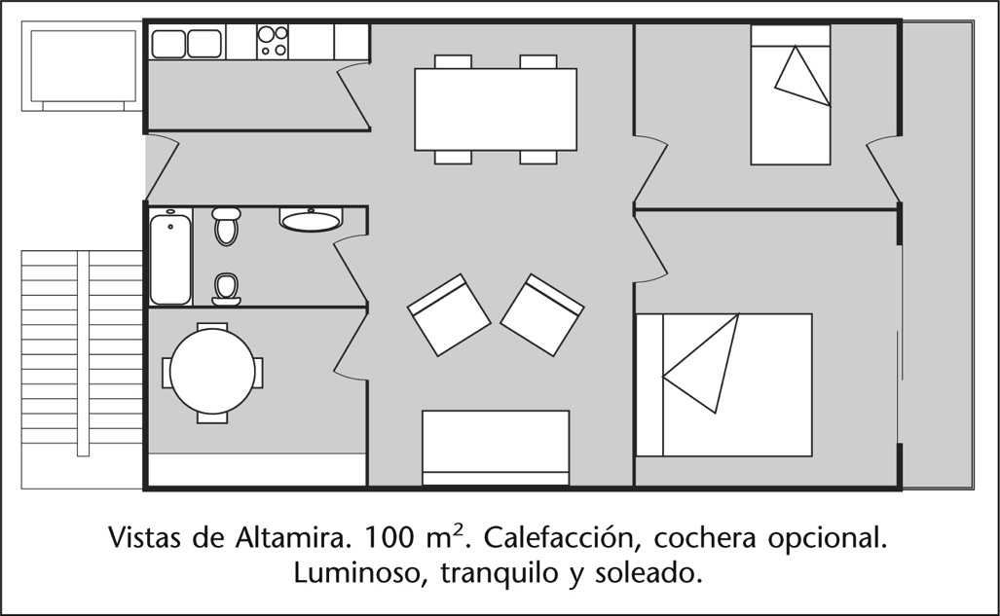
ENTRADA
El apartamento tiene dos (1) _________________: uno grande y otro pequeño. En el grande se puede poner una (2) _________________ grande o dos pequeñas. En el centro hay una (3) _________________ grande con comedor. La (4) ________________ tiene un refrigerador muy grande. El apartamento no tiene (5) para tomar el sol o hacer barcacoa y tampoco tiene un (6) para escuchar la música. Solamente hay un (7) ________________ con ducha, y al lado hay una habitación pequeña con una (8) ________________ redonda y cuatro (9) . El apartamento no tiene (10) para la ropa, por lo tanto tenemos que comprar uno.

- Presentational Communication (48 points)
You realized that you need one more roommate in Valencia. The service at the university requires you to write a profile in order to help you find roommates. Write an e-mail (9-12 sentences) in SPANISH and include the following:
[ ] Your name, description of personality and preferences (hobbies)
[ ] Include what you have done or accomplished so far.
[ ] A description of your life and what you did, have done in your childhood or adolescence
[ ] What responsibilities the ideal roommate will have to take on, regarding household chores
[ ] Ask one question to the potential candidates
[ ] Give two instructions on how to contact you

Remember to incorporate vocabulary, communicative functions, linking words from review and Chapter 10
To: e-amigosvalencia@pp.es
From: yo@rutgers.edu
Re: Compañero o compañera de cuarto

Presentational Rubric

 | 4 | 3 |  | 2 | 1
A. CONTENT  Score ________ | You fulfilled all the requirements of the task in detail. | You fulfilled most of the requirements of the task with some detail. |  | You fulfilled some of the requirements of the task with few details. | You fulfilled few of the requirements of the task. Your task completion and details were inadequate.
B. COMPREHENSIBILITY  Score: __________ | Reader was able to understand all of what you were trying to communicate. | Reader was able to understand most of what you were trying to communicate. |  | Reader was able to understand less than half of what you were trying to communicate. | Reader was able to understand little of what you were trying to communicate.
C. ACCURACY  Score:___________ | You have used grammar (conditional agreement, etc.), spelling, word order, and punctuation correctly with minor problems. | You have few problems with grammar (conditional agreement, etc.), spelling, word order, and punctuation. |  | You have some basic problems with grammar (conditional agreement, etc.), spelling, word order, and punctuation. | You have a significant number of grammar (conditional agreement, etc.), spelling, word order, and punctuation errors.
D. VOCABULARY  Score_____________ | You have used a wide range of vocabulary from chapter 10, review and beyond. | You have used a good range of vocabulary from chapters 10 & review. |  | You have used less than the vocabulary expected from chapters 10 & review | You have used an inadequate amount of vocabulary from chapters 10 & review. Fail to incorporate new vocabulary or included very few new words
E. ORGANIZATION  Score: ___________ | Your presentation is logical and effective. | Your presentation is generally logical and effective with a few minor problems. |  | Your presentation is somewhat illogical and confusing in places. | Your presentation lacks logical order and organization.
F. TEXT TYPE  Score: | You wrote a fairly coherent paragraph with some complex linking words. | You have created with the language by using strings of sentences. With a combination of complex and basic linking words |  | You have created with language by using simple sentences and some strings of sentences and linking words | You have used simple sentences, isolated words, and memorized phrases. Used very few basic linking words.
TOTAL: (A+B+C+D+E+F) ____________X 2 = _________ /48
STRENGTHS |  |  | OPPORTUNITIES

