Nombre y apellido:
Instructor:
Listening Comprehension /20
Oral Proficiency: /30

/ 50
- Listening Comprehension: interpretative assessment (20 points)
You are organizing materials to do a presentation on the university’s summer programs. You decide to focus on Caribbean and Spanish culture. Answer the following questions according to the information provided in the video. You will watch the video three times.

A. LA HABANA.
1. True or False (2 pts. each)
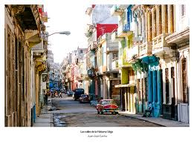
a. Buildings in Havana have changed little since the sixties. T F

b. If you drink Cuban spirits such as Rum, some people will
have a negative impression of you. T F

c. A Cuban person may walk you to a place if you are lost
and ask for directions. T F

d. You must avoid getting in touch with Cubans in Havana T F

2. Completa en ESPAÑOL con la información adecuada (2 pts. each)

 | Menciona y describe detalladamente datos importantes
Chevrolets | 1. ________________________________________________________
El Malecón: | 1. _________________________________________________________  2._________________________________________________________
Music & food | 1. ________________________________________________________

3. ¿Qué es La Habana Vieja? ¿Cómo es? Responde en ESPAÑOL, usando información del vídeo y dando al menos cuatro detalles sobre el lugar (4 puntos)

Space for notes:

Nombre y apellido:
Instructor:
Oral Production /30
- ORAL PROFICIENCY: Presentational (30 points)

You decided to make a presentation for the Spanish and Portuguese Department.

  - Select a Region: [ ] Spain [ ] The Caribbean
  - Present a brief description about the selected region and its culture using expressions and linguistic functions studied so far.
  - Select one site of the selected region and say why you prefer that place. (You can use the images as reference)

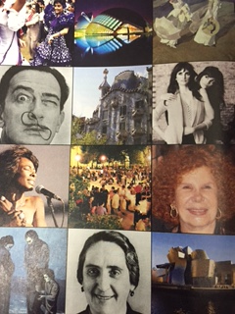
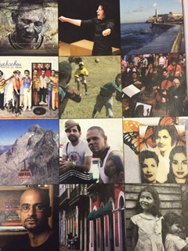
Spain The Caribbean

  - Compare and contrast the different sites of the region or regions. Take into consideration at least two of the following aspects. Mention important information and describe in detail:

[ ] CULTURE [ ] PEOPLE [ ] ART [ ] MUSIC [ ] CELEBRATIONS

You have a few minutes to organize your thoughts. You may jot down notes on this page if you wish.

DO NOT WRITE A SCRIPT. DO NOT READ.
Space for notes:

PRESENTATIONAL RUBRIC for oral production: 30 points

 | 5 | 4-3 | 2 | 1
A. TASK COMPLETION  Score: ______ | You have completed all tasks assigned in a thorough manner with accurate and appropriate information. | You have completed most of the tasks assigned with mostly accurate and appropriate information. | You have completed some of the tasks assigned with somewhat accurate and appropriate information. | You have completed very few of the tasks assigned with very little or inaccurate and inappropriate information.
B. ORGANIZATION  Score: ______ | Your presentation was very well organized, logical and effective. | Your presentation was organized, generally logical and effective with a few minor problems. | Your presentation is somewhat organized, illogical and confusing in places. | Your presentation lacks logical order and organization.
C. COMPREHENSIBILITY  Score: ______ | You understood all of what you were trying to communicate. Errors are rare and do not impact comprehensibility. | You understood most of what you were trying to communicate. Errors do not impact comprehensibility. | You understood less than half of what you were trying to communicate. Errors usually impact comprehensibility. | You understood little of what you were trying to communicate. Errors impact comprehensibility.
D. VOCABULARY  Score: ______ | You have used a wide range of vocabulary from chapters 1 & 2, linking words and beyond. | You have used a good range of vocabulary from Chapters 1 & 2 and some linking words | You have used less than the vocabulary expected. Incorporated some new vocabulary from chapters 1 & 2 and used basic linking words. | You have used an inadequate amount of vocabulary. Fail to incorporate new vocabulary or included very few new words and/or linking words
E. ACCURACY  Score: ______ | You used language correctly most of the time. General grammar was used adequately and when necessary. In particular, very good command of ser and estar, agreement, comparisons, and preterit and imperfect tenses, and word order and other grammar needed. | You have used language correctly most of the time,  In particular, good command of ser and estar, agreement, comparisons, and preterit and imperfect tenses, and word order and other grammar needed. | You have sometimes used language correctly, In particular, showed some command of ser and estar, agreement, comparisons, and preterit and imperfect tenses, and word order and other grammar needed. | You seldom used language correctly specially of ser and estar, agreement, comparisons, and preterit and imperfect tenses, and word order and other grammar needed..
F. FLUENCY  Score: ______ | You spoke clearly and without hesitation. Pronunciation and intonation seemed natural. | You hesitated a little, and had a few problems with pronunciation and intonation. | You hesitated and had some problems with pronunciation and intonation. | You hesitated frequently and struggled with pronunciation and intonation.  You read.
Comments:
STRENGTHS | OPPORTUNITIES

