**PBS Export Tool User Guide**

**Changelog Version 2301.02**

1. Fix bug *Data source rejected establishment of connection, message from server: "Too many connections*"
2. Enhance processing feedback
3. Enhanced export performance
4. Fix application freeze on a single thread
5. Flexibility to configure database parameters
6. Launch this documentation from the user interface by clicking  button.

**How-To**

**Step 1:** Edit the **app.properties** with the parameters for your host server.

**Step 2:** Launch the **PBSexport.jar** application

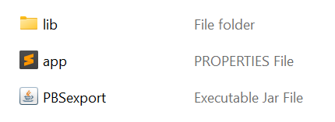

**button

**Step 4:** Browse to the folder location where the PBS exported file(s) is and click **Select Folder** on the folder dialog box.

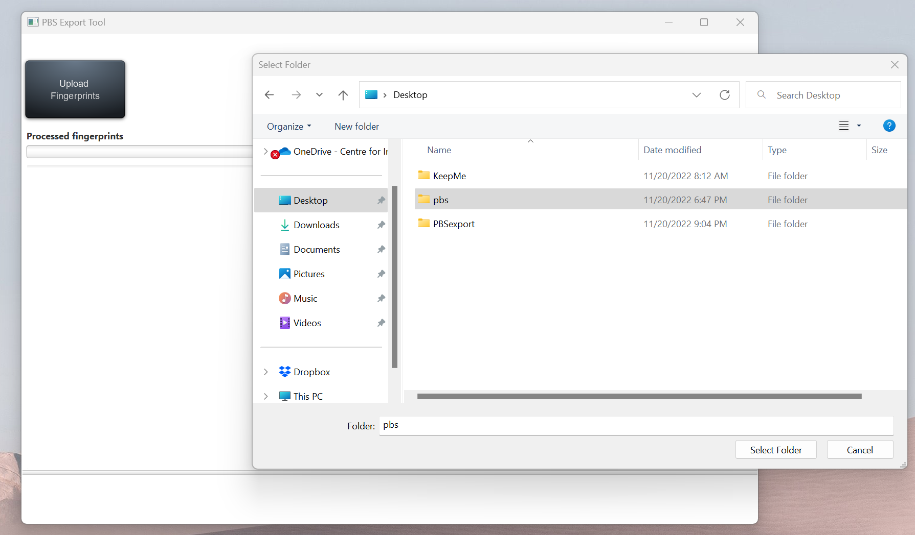

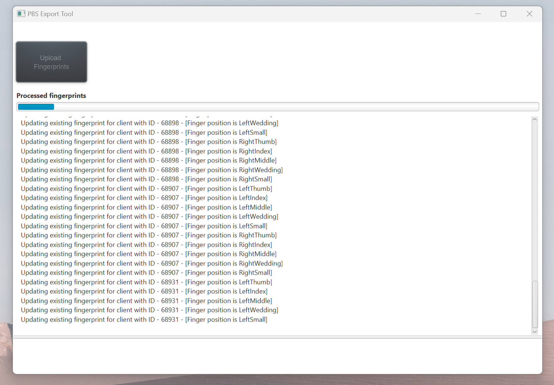

File processing start

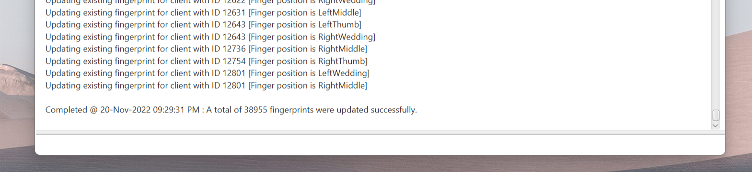

Processing end