**Patient Biometrics System (PBS) Processor User Guide**

**Changelog Version 2301.02**

1. Fix the bug: *Data source rejected establishment of connection, message from server: "Too many connections*".
2. Enhance fingerprints processing feedback.
3. Enhanced export performance.
4. Fix application freeze on a single thread.
5. Flexibility to configure database parameters.
6. Launch this documentation from the user interface by clicking  button.

**How-To**

**Step 1:** Edit the **app.properties** with the parameters to match your NigeriaMRS host server.

*Figure 1: app.properties configuration file*

**Step 2:** Launch the **PBSprocessor.jar** application

*Figure 2 : PBS processor application launcher*

**button to browse the exported PBS file and start processing the fingerprints.

**Step 4:** Browse to the folder location where the **.json** PBS exported file(s) is/are and click **Select Folder** from the folder dialog box as shown in figure 3.

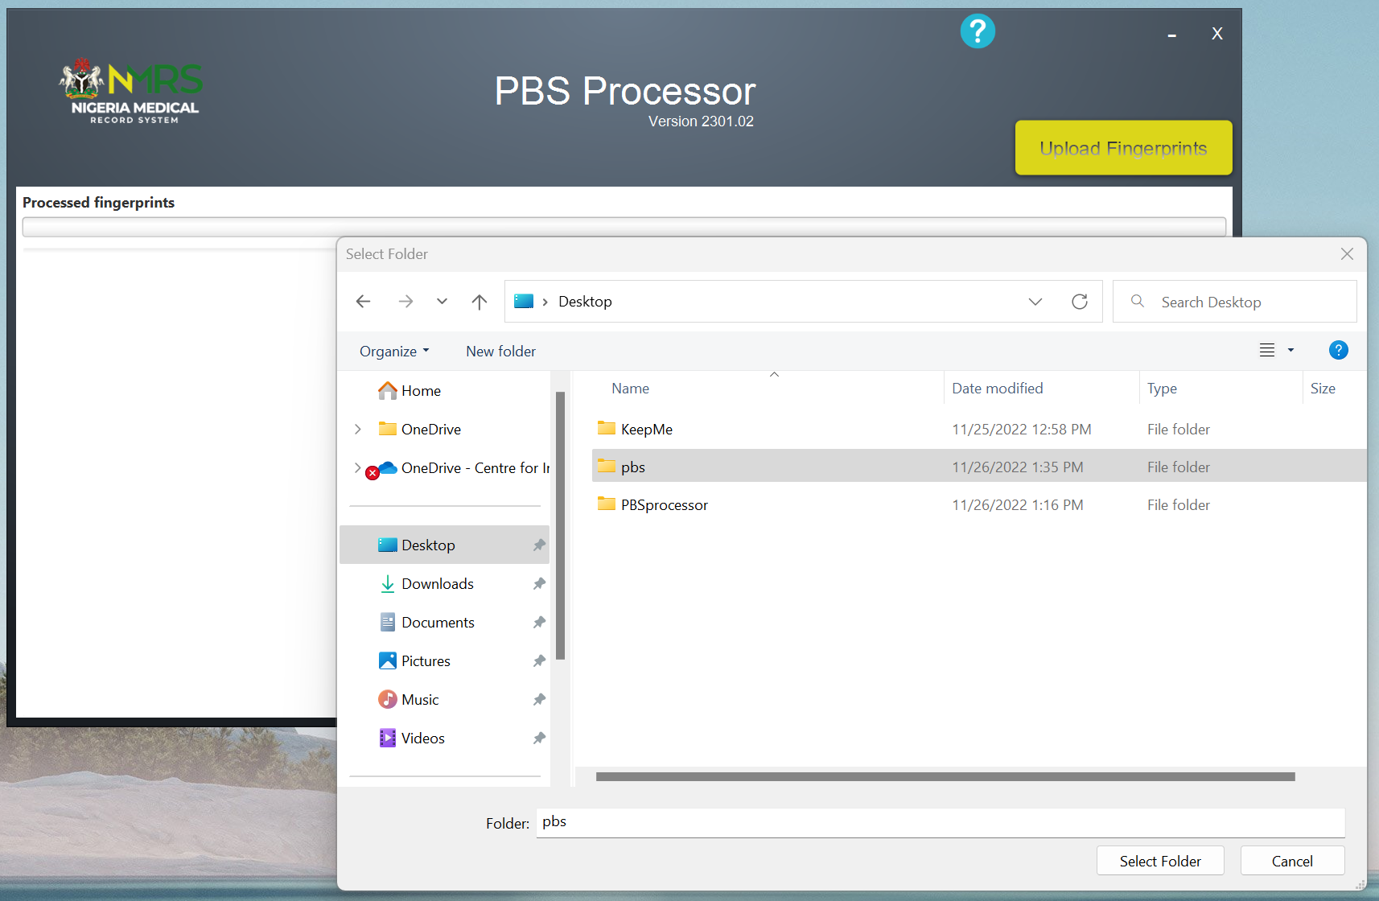

*Figure 3: PBS files browser*

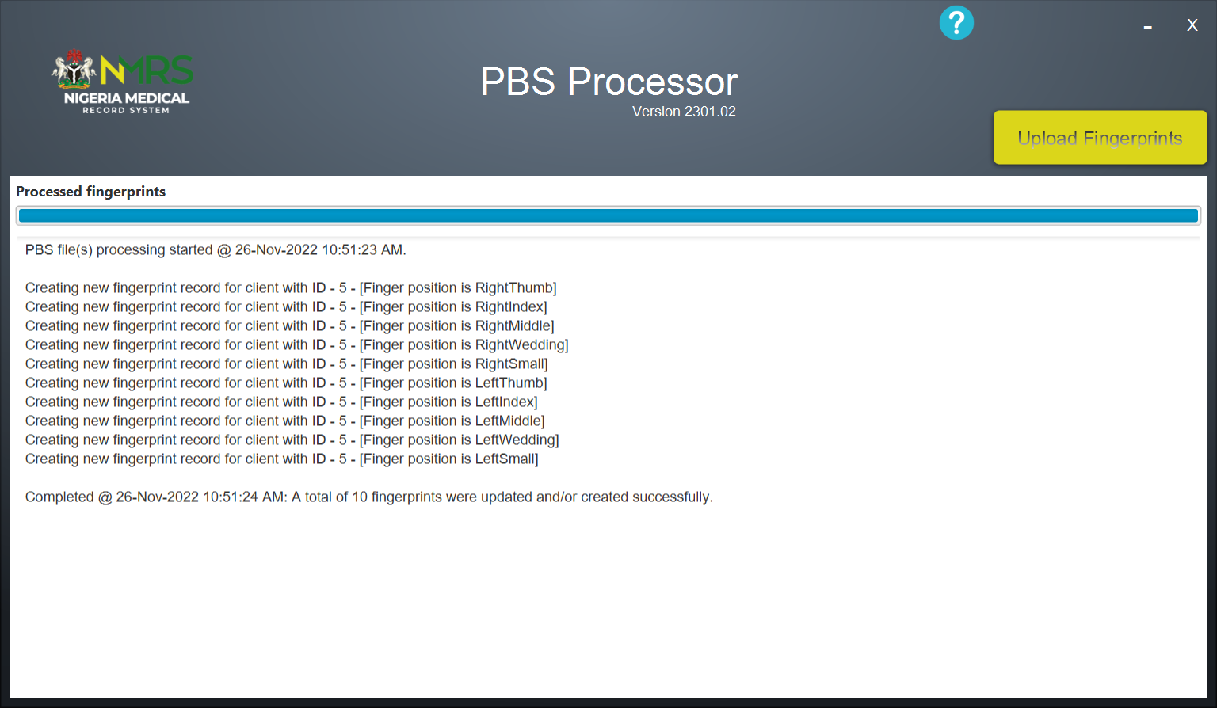

*Figure 4: Fingerprints processed*