How to install ?

- Extract file glassfish-3.0.1.zip
- Move folder from glassfishv3/glassfish to /opt/
- This folder contains default domain [domain1]
- Default domain is located in /opt/glassfish/domains/domain1
- To change port number edit domain.xml file in /opt/glassfish/domains/domain1/config/

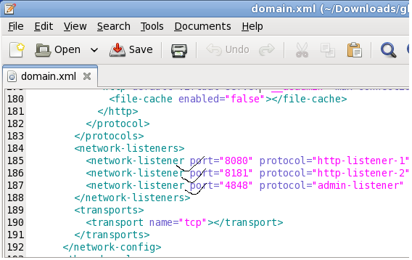

- To start glassfish use command “/opt/glassfish/bin/asadmin start-domain domain1”
- To stop glassfish use command “/opt/glassfish/bin/asadmin stop-domain domain1”

- To add project in glassfish
- --> Go to glassfish admin panal using http://host:4848/
- --> Go to Applications
- --> Deploy
- --> Local Packaged File or Directory
- --> Select Project to deploy

- To add ACLFilter in glassfish edit default-web.xml file in /opt/glassfish/domains/domain1/config/

- To add connection pooling setting
- -->Resources
- -->JDBC
- -->Connection Pools
- -->New
- -->Add all parameters like username,password,URL
- -
- To make available glassfish connection to WFMS in OLD fashion
- Enter following entry in WFMS/WEB-INF/web.xml
- <resource-ref>
- <res-ref-name>jdbc/oracle</res-ref-name>
- <res-type>javax.sql.DataSource</res-type>
- <res-auth>Container</res-auth>
- </resource-ref>

- To create domain use command “/opt/glassfish/bin/asadmin create-domain --adminport 4849 domain2”
- -->Go to new admin panal and change default ports for this domain
- -->Alternatively you can change in “domain2/config/domain.xml

- To create common library
- -->Go to Configuration
- -->JVM Settings
- -->Path Setting
- -->Enter path of library in “Native Library Path Prefix”

Disadvantages :

- In glassfis we have to map all servlets in web.xml
- In glassfish tag-lib library could not locate spring-*.jar in library path so we have to put them in project lib

