Client Side

Go To Your Netbeans 6.7 => Team => Versioning => Checkout
OR
Go To Your Netbeans 6.8 => Team => Versioning => Checkout

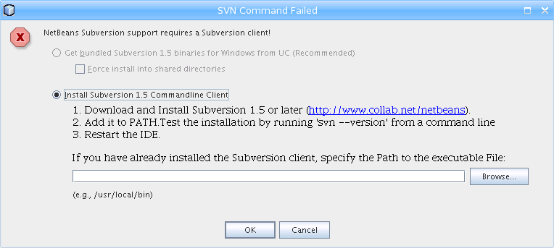

Browse or insert following path in above text box

/usr/local/bin/svn

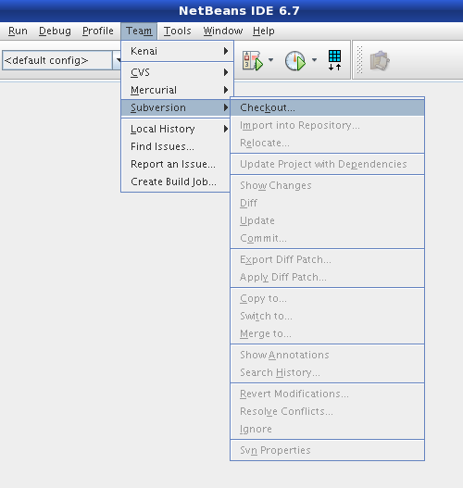

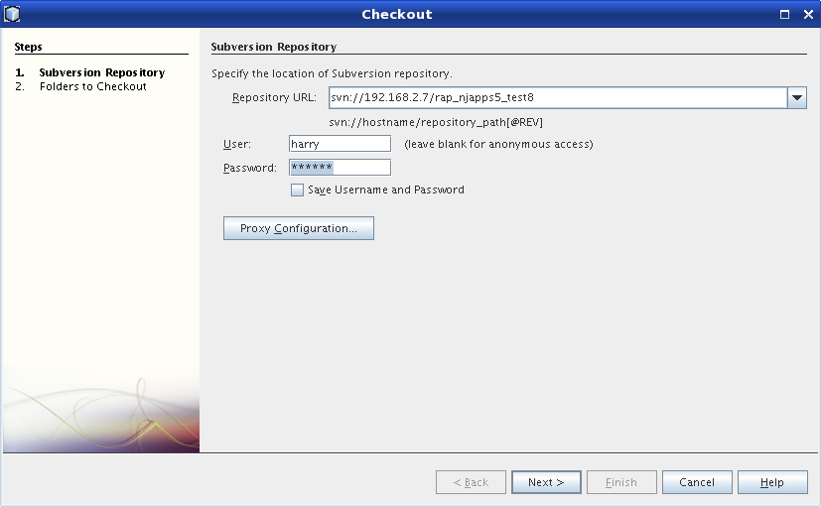

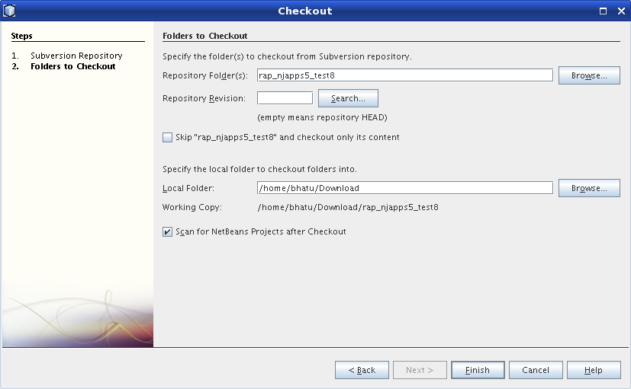

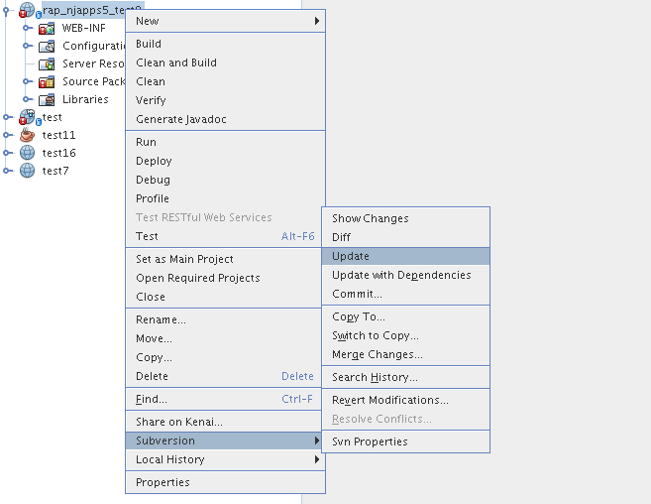
To Get changes from server

Versioned File

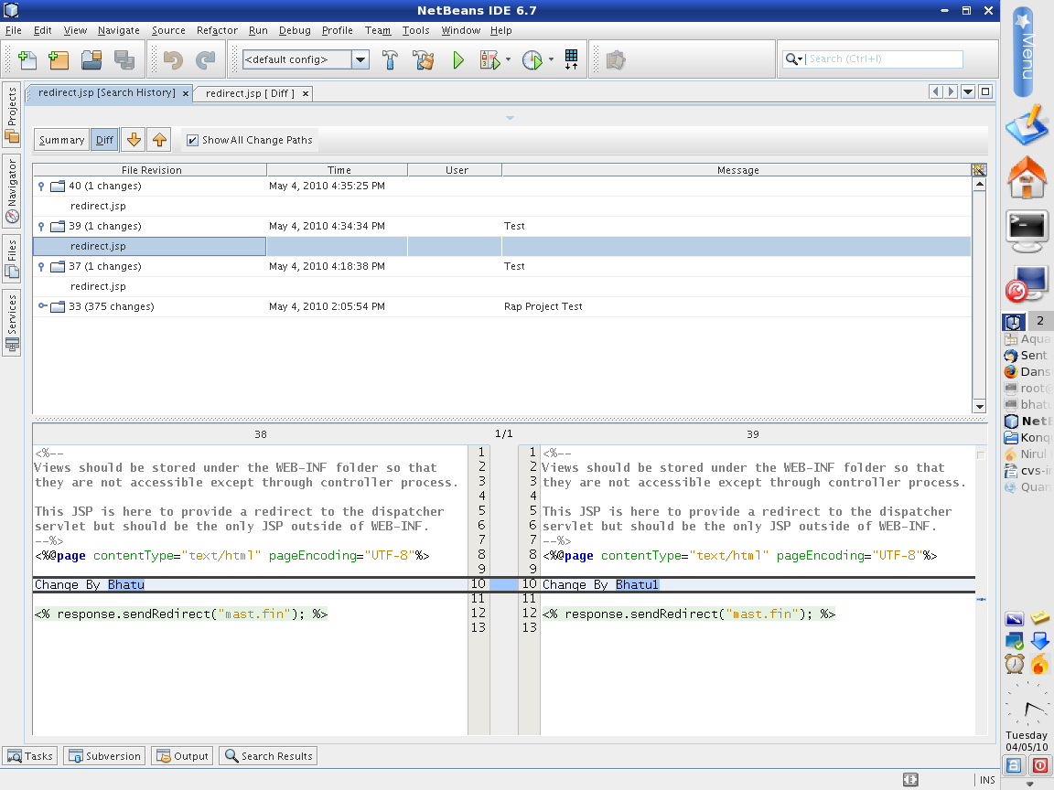

Current File Compare With Server

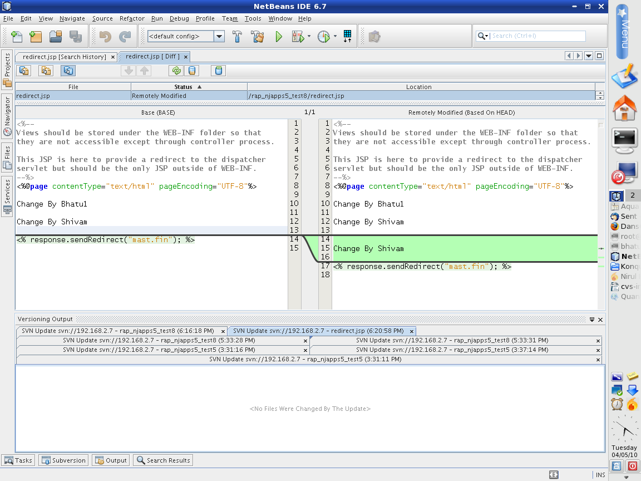

To save changes in server

