Enterprise Architecture

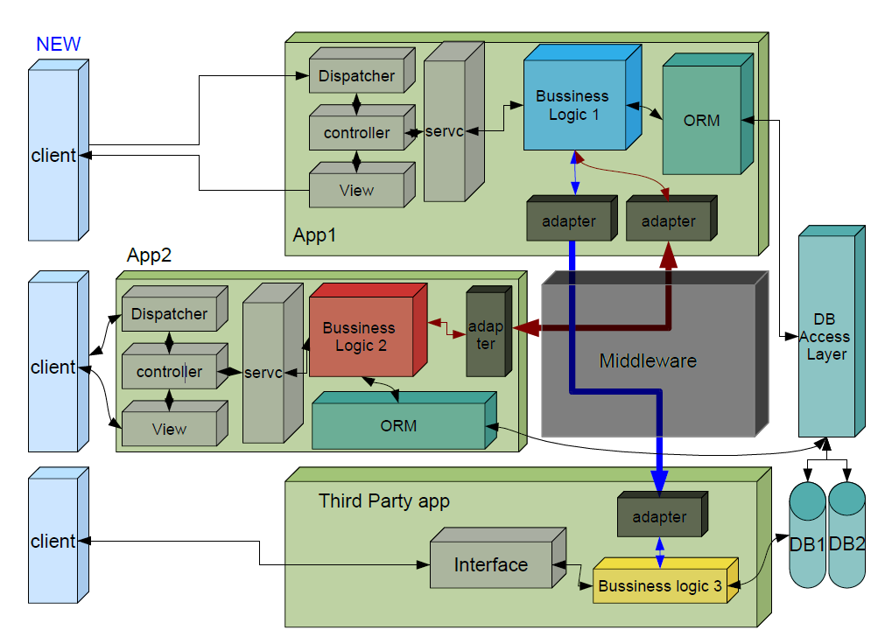
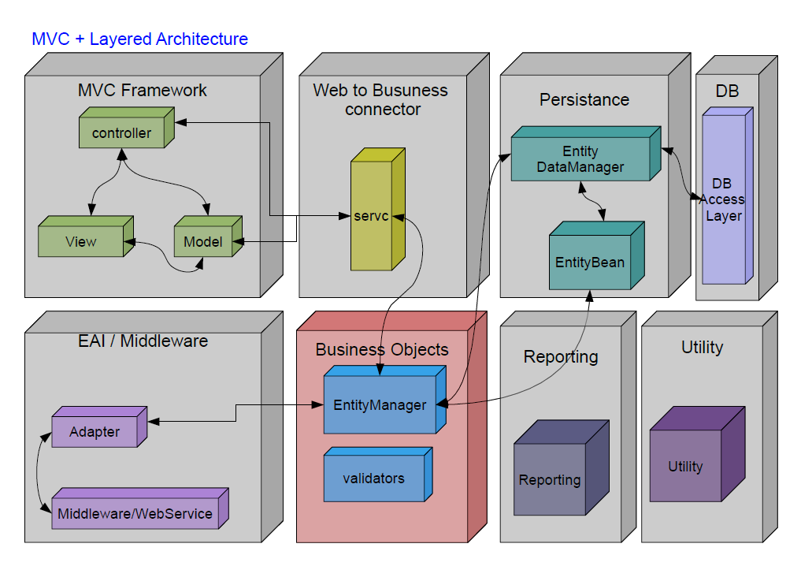

MVC Framework – Controller

Use Spring Controllers for Controller in MVC Framework.

MVC Framework – View

Use JSP, JSTL for view in MVC Framework.

MVC Framework – Model

Model can further categorized in following components as shown in above figures.

Web to Business Connector – Service Classes

This portion provides connection logic between business logic and web application. Controllers and FormBeans must not have direct access to the business logic and utilities; rather they can call service classes and service classes will make them available for them indirectly. Service class is also responsible to convert data from one form to another; for example from List to JSON etc. To convert this data service class can make use of utility classes.

Business Layer

This portion contains business logic, server side validations, business rule validation etc.

Persistence Layer

This portion contains database operations. Only this part should have SQL queries, usage of entity beans, access to Database Utilities like Service Classes and Transaction Management (excluding Reporting Layer).

Reporting Layer

This part covers reporting in web applications in which we can have SQL queries directly written in Reporting Classes where joins in more than one tables is mandatory.

Utility Layer

This part contains utility parts such as Mail Sending, JSON Parser, Properties Readers etc

EAI / Middleware

This part contains intermediatory classes like webservice calling, Message Queue etc.

