Global System for Mobile Communication (GSM)

2. GSM
Throughout the evolution of cellular telecommunications, various systems have been developed without the benefit of standardized specifications. This presented many problems directly related to compatibility, especially with the development of digital radio technology. The GSM standard is intended to address these problems.
From 1982 to 1985 discussions were held to decide between building an analog or digital system. After multiple field tests, a digital system was adopted for GSM. The next task was to decide between a narrow or broadband solution. In May 1987, the narrowband time division multiple access (TDMA) solution was chosen. A summary of GSM milestones is given in Table 2.
Year | Milestone
1982 | GSM formed
1986 | field test
1987 | TDMA chosen as access method
1988 | memorandum of understanding signed
1989 | validation of GSM system
1990 | preoperation system
1991 | commercial system start-up
1992 | coverage of larger cities/airports
1993 | coverage of main roads
1995 | coverage of rural areas

3. The GSM Network
GSM provides recommendations, not requirements. The GSM specifications define the functions and interface requirements in detail but do not address the hardware. The reason for this is to limit the designers as little as possible but still to make it possible for the operators to buy equipment from different suppliers. The GSM network is divided into three major systems: the switching system (SS), the base station system (BSS), and the operation and support system (OSS). The basic GSM network elements are shown in Figure 2.
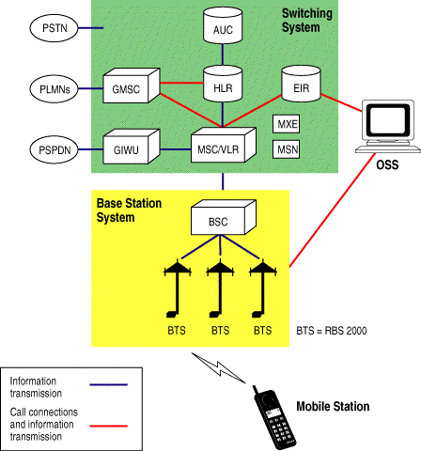
Figure 2. GSM Network Elements

The Switching System
The switching system (SS) is responsible for performing call processing and subscriber-related functions. The switching system includes the following functional units.
- home location register (HLR)—The HLR is a database used for storage and management of subscriptions. The HLR is considered the most important database, as it stores permanent data about subscribers, including a subscriber's service profile, location information, and activity status. When an individual buys a subscription from one of the PCS operators, he or she is registered in the HLR of that operator.
- mobile services switching center (MSC)—The MSC performs the telephony switching functions of the system. It controls calls to and from other telephone and data systems. It also performs such functions as toll ticketing, network interfacing, common channel signaling, and others.
- visitor location register (VLR)—The VLR is a database that contains temporary information about subscribers that is needed by the MSC in order to service visiting subscribers. The VLR is always integrated with the MSC. When a mobile station roams into a new MSC area, the VLR connected to that MSC will request data about the mobile station from the HLR. Later, if the mobile station makes a call, the VLR will have the information needed for call setup without having to interrogate the HLR each time.
- authentication center (AUC)—A unit called the AUC provides authentication and encryption parameters that verify the user's identity and ensure the confidentiality of each call. The AUC protects network operators from different types of fraud found in today's cellular world.
- equipment identity register (EIR)—The EIR is a database that contains information about the identity of mobile equipment that prevents calls from stolen, unauthorized, or defective mobile stations. The AUC and EIR are implemented as stand-alone nodes or as a combined AUC/EIR node.

The Base Station System (BSS)
All radio-related functions are performed in the BSS, which consists of base station controllers (BSCs) and the base transceiver stations (BTSs).
- BSC—The BSC provides all the control functions and physical links between the MSC and BTS. It is a high-capacity switch that provides functions such as handover, cell configuration data, and control of radio frequency (RF) power levels in base transceiver stations. A number of BSCs are served by an MSC.
- BTS—The BTS handles the radio interface to the mobile station. The BTS is the radio equipment (transceivers and antennas) needed to service each cell in the network. A group of BTSs are controlled by a BSC.

The Operation and Support System
The operations and maintenance center (OMC) is connected to all equipment in the switching system and to the BSC. The implementation of OMC is called the operation and support system (OSS). The OSS is the functional entity from which the network operator monitors and controls the system. The purpose of OSS is to offer the customer cost-effective support for centralized, regional, and local operational and maintenance activities that are required for a GSM network. An important function of OSS is to provide a network overview and support the maintenance activities of different operation and maintenance organizations.

Additional Functional Elements
Other functional elements shown in Figure 2 are as follows:
- message center (MXE)—The MXE is a node that provides integrated voice, fax, and data messaging. Specifically, the MXE handles short message service, cell broadcast, voice mail, fax mail, e-mail, and notification.
- mobile service node (MSN)—The MSN is the node that handles the mobile intelligent network (IN) services.
- gateway mobile services switching center (GMSC)—A gateway is a node used to interconnect two networks. The gateway is often implemented in an MSC. The MSC is then referred to as the GMSC.
- GSM interworking unit (GIWU)—The GIWU consists of both hardware and software that provides an interface to various networks for data communications. Through the GIWU, users can alternate between speech and data during the same call. The GIWU hardware equipment is physically located at the MSC/VLR.

4. GSM Network Areas
The GSM network is made up of geographic areas. As shown in Figure 3, these areas include cells, location areas (LAs), MSC/VLR service areas, and public land mobile network (PLMN) areas.
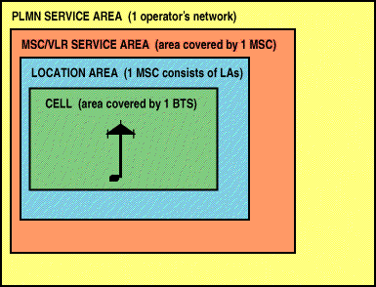
Figure 3. Network Areas
The cell is the area given radio coverage by one base transceiver station. The GSM network identifies each cell via the cell global identity (CGI) number assigned to each cell. The location area is a group of cells. It is the area in which the subscriber is paged. Each LA is served by one or more base station controllers, yet only by a single MSC (see Figure 4). Each LA is assigned a location area identity (LAI) number.
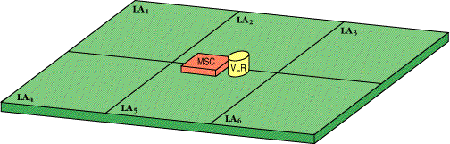
Figure 4. Location Areas
An MSC/VLR service area represents the part of the GSM network that is covered by one MSC and which is reachable, as it is registered in the VLR of the MSC (see Figure 5).
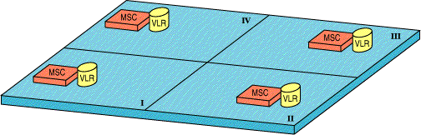
Figure 5. MSC/VLR Service Areas
The PLMN service area is an area served by one network operator (see Figure 6).
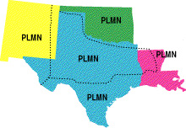
Figure 6. PLMN Network Areas

5. GSM Specifications
Before looking at the GSM specifications, it is important to understand the following basic terms:
- bandwidth—the range of a channel's limits; the broader the bandwidth, the faster data can be sent
- bits per second (bps)—a single on-off pulse of data; eight bits are equivalent to one byte
- frequency—the number of cycles per unit of time; frequency is measured in hertz (Hz)
- kilo (k)—kilo is the designation for 1,000; the abbreviation kbps represents 1,000 bits per second
- megahertz (MHz)—1,000,000 hertz (cycles per second)
- milliseconds (ms)—one-thousandth of a second
- watt (W)—a measure of power of a transmitter
Specifications for different personal communication services (PCS) systems vary among the different PCS networks. Listed below is a description of the specifications and characteristics for GSM.
- frequency band—The frequency range specified for GSM is 1,850 to 1,990 MHz (mobile station to base station).
- duplex distance—The duplex distance is 80 MHz. Duplex distance is the distance between the uplink and downlink frequencies. A channel has two frequencies, 80 MHz apart.
- channel separation—The separation between adjacent carrier frequencies. In GSM, this is 200 kHz.
- modulation—Modulation is the process of sending a signal by changing the characteristics of a carrier frequency. This is done in GSM via Gaussian minimum shift keying (GMSK).
- transmission rate—GSM is a digital system with an over-the-air bit rate of 270 kbps.
- access method—GSM utilizes the time division multiple access (TDMA) concept. TDMA is a technique in which several different calls may share the same carrier. Each call is assigned a particular time slot.
- speech coder—GSM uses linear predictive coding (LPC). The purpose of LPC is to reduce the bit rate. The LPC provides parameters for a filter that mimics the vocal tract. The signal passes through this filter, leaving behind a residual signal. Speech is encoded at 13 kbps.

