SOA

The benefits provided by ESB’ are
Loose Coupling
You might have heard that web services provide you with loose coupling between systems. This is only partially true. Web services, by the very nature of Web Services Description Language (WSDL) and XML Schema Definition (XSD) document, can provide some loose coupling because they formalize a contract between the service consumer and the service provider. This is a “design-by-contract” model, and it does provide tangible benefits. If you’re careful, you can create a schema that’s platform-neutral and highly reusable.

However, if you take a look at any WSDL, you’ll see that the service endpoints are written
into the WSDL, as you can see in Listing 1-1.
Listing 1-1. HelloWorld Service Definition
<service name="HelloWorldService">
<port binding="s1:HelloWorldServiceSoapBinding"
name="HelloWorldPortSoapPort">
<s2:address location="http://www.bea.com:7001/esb/Hello_World" />
</port>
</service>

By specifying a specific machine and port (or a set of machines and ports), you’re tightly
coupling this service to its physical expression on a specific computer. You can use a Domain Name Server (DNS) to substitute portions of the URL, and therefore direct clients into multiple machines in a server farm. However, DNS servers are woefully inadequate for this, due to their inability to understand and manage the status of the services running on these servers.

So, loose coupling isn’t achieved by WSDL or web services alone. A more robust solution is to provide some mediation layer between service clients and service producers. Such a mediation layer should also be capable of bridging transport, message formats, and security technologies. For example, a service might be invoked through a traditional HTTP transport mechanism, but it can then invoke lower-level services through Java Message Service (JMS), e-mail, File Transfer Protocol (FTP), and so on. This approach is often effectively used to “wrap” older services and their transports from the newer service clients.

Location Transparency
Location transparency is a strategy to hide the physical locations of service endpoints from the service clients. Ideally, a service client should have to know about a single, logical machine and port name for each service. The client shouldn’t know the actual service endpoints. This allows for greater flexibility when managing your services. You can add, move, and remove service endpoints as needed, without needing to recompile your service clients.

Mediation
An ESB is an intermediary layer, residing between the service client and the service providers. This layer provides a great place for adding value to the architecture without changing the applications on either end. An ESB is a service provider to the service clients. When clients use a service on the service bus, the service bus has the ability to perform multiple operations: it can transform the data or the schema of the messages it sends and receives, and it can intelligently route messages to various service endpoints, depending on the content of those messages.

Schema Transformation
The web service published by the service bus might use a different schema from the schema of the business service it represents. This is a vital capability, especially when used in conjunction with a canonical taxonomy or when aggregating or orchestrating other web services. It’s quite common that a service client will need to receive its data using a schema that’s significantly different from that of the service provider. The ability to transform data from one schema to another is critical for the success of any ESB.

Service Aggregation
The service bus can act as a façade and make a series of web service calls appear as a single service. Service aggregation follows this pattern, making multiple web service calls on behalf of the proxy service and returning a single result. Service orchestration is similar to service aggregation, but includes some conditional logic that defines which of the lower-level web services are called and the order in which they are invoked.

Load Balancing
Due to their position in any architecture, ESBs are well suited to perform load balancing of service requests across multiple service endpoints. When you register a business web service with Oracle Service Bus (OSB), you can specify the list of service endpoints where that business service is running. You can change this list, adding or removing service endpoints without needing to restart the OSB server.

Enforcing Security
You should enforce security in a centralized manner whenever possible. This allows for
a greater level of standardization and control of security issues. Furthermore, security is best enforced through a policy-driven framework. Using security policies means that the creation and application of security standards happen outside the creation of the individual web services.

Monitoring
An ESB plays a vital role in an SOA. As such, you must have a robust way to monitor the status of your ESB, in both proactive and reactive manners. The ability to proactively view the performance of the service bus allows you to help performance-tune the service bus for better performance. Tracking the performance over time can help you plan for increasing the capacity of your ESB.

Reactive monitoring allows you to define alerts for specific conditions. For example, if
a specific service doesn’t complete within a given timeframe, the ESB should be able to send an alert so that a technician can investigate the problem.

Configuration vs. Coding
A modern service bus should be configuration-based, not code-based. For many engineers, the importance of that statement isn’t immediately obvious. It took us some time before we appreciated the configuration-oriented capability of OSB. Most software systems in use today are code-based. Java EE 5 applications are a great example of this. In a Java EE 5 application, you write source code, compile it into an EAR or WAR file, copy that EAR or WAR file onto one or more Java EE 5 application servers, and then deploy those applications. Sometimes it’s necessary to restart the Java server, depending on the nature of your deployment.

Configuration-based systems work differently. There’s nothing to compile or deploy. You simply change the configuration and activate those changes. We would argue that your telephone is configuration-based; you configure the telephone number you want to call, and your call is placed. There’s no need to restart your phone. Similarly, network routers and switches are configuration-based. As you make changes to their configuration, those changes take effect. There’s no need for a longer software development life cycle to take place. Configuration and coding are two different strategies. Neither is superior to the other in all situations. There are times when the Java EE 5 approach is the most appropriate, and other times when the configuration-based approach is best.

OSB is entirely standards-based. You configure OSB through the use of XQuery, XPath, XSLT, and WSDLs. The only aspect of OSB that might be deemed “proprietary” is the implementation of the message flows.

Annotations used while writing a web service

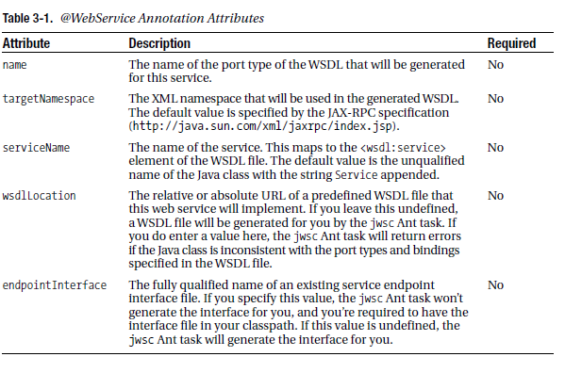

@SoapBinding
The @SoapBinding annotation allows you to specify the information that’s contained in the <wsdlsoap:binding> section of a WSDL file. Its attributes are shown in Table 3-2. In general, we recommend specifying all these attributes explicitly to communicate your intention clerly for how the code will operate. To use this annotation, you need to import javax.jws.SOAPBinding in your Javasource code.

