WebServices

In common usage the term refers to clients and servers that communicate over the Hypertext Transfer Protocol (HTTP) protocol used on the web. Such services tend to fall into one of two camps: Big Web Services^{[1]} and RESTful Web Services.

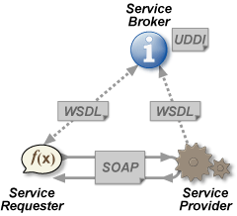
Big Web Services" use Extensible Markup Language (XML) messages that follow the Simple Object Access Protocol (SOAP) standard and have been popular with traditional enterprise. In such systems, there is often a machine-readable description of the operations offered by the service written in the Web Services Description Language (WSDL).

More recently, REpresentational State Transfer (RESTful) web services have been regaining popularity, particularly with Internet companies. By using the PUT, GET and DELETE HTTP methods, alongside POST, these are often better integrated with HTTP and web browsers than SOAP-based services. They do not require XML messages or WSDL service-API definitions

Web API is a development in web services (in a movement called Web 2.0) where emphasis has been moving away from Simple Object Access Protocol (SOAP) based services towards more direct Representational State Transfer (REST) style communications.^{[2]} Web APIs allow the combination of multiple web services into new applications known as mashups.^{[3]}
The user has no control over these services. Also the web services themselves are not reliable; the service provider may remove, change or update their services without giving notice to users. The reliability and fault tolerance is not well supported; faults may happen during the execution. Exception handling in the context of web services is still an open research issue.

Advantages of web services
- Web services provide interoperability between various software applications running on disparate platforms.
- Web services use open standards and protocols. Protocols and data formats are text-based where possible, making it easy for developers to comprehend.
- By utilizing HTTP, web services can work through many common firewall security measures without requiring changes to the firewall filtering rules.
- Web services easily allow software and services from different companies and locations to be combined easily to provide an integrated service.
- Web services allow the reuse of services and components within an infrastructure.
Although JAX-RPC and its name are based on the RPC model, it offers features that go beyond basic RPC. It is possible to develop web services that pass complete documents and also document fragments.

Design methodologies
Web services can be written in two ways:
- A developer using the "bottom up method" first writes the implementing class in a programming language, and then uses a WSDL generating tool to expose its methods as a web service[1]. This is often the simpler approach.
- A developer using the "top down method" first writes the WSDL document and then uses a code generating tool to produce the class skeleton, which he later completes. This way is generally considered more difficult but can produce cleaner designs[2]

Some issues that comes to mind:

The user has no control over these services. Also the web services themselves are not reliable; the service provider may remove, change or update their services without giving notice to users. The reliability and fault tolerance is not well supported; faults may happen during the execution. Exception handling in the context of web services is still an open research issue.
For some data you may be able to call live rather than sending the data around at night. Actually I think you should if the performance is enough. Often the caller need data one piece at a time.
With web services you can wrap systems built with different technology and they will all look the same from the outside.
It seems to me that you will have redundant data in the different systems. It should be avoided if possible. It is better to call "on demand" then relying on nightwise batch jobs. If the data changes a lot it will most certainly differ between systems in certain situations and may cause errors in the business. Data that users base important desicions on should never be possibly outdated.
If you stick with redundant data for performance reasons I dont think web services helps much. The important thing is to have a nice data format that is as easily read as it is written. Ftp will certainly be faster than web services for this kind of transaction.
Is web services secure nowadays? Some of the wizards around may have the answer.
A web services solution bids for a much more complex environment. Setting up a web-services-enabled and secure web server would probably cost you a couple of manweeks. Or are you building it in the existing systems? In one of my recent projects (a year ago) we built an XML solution in an IBM mainframe that served data on demand to weblogic web/ejb servers using Tuxedo as middleware. The only place where performance was an issue was in WebLogic. When tuned it worked fine too. We never thought about web services in that project.

JAX-WS
JAX-WS stands for Java API for XML Web Services. JAX-WS is a technology for building web
services and clients that communicate using XML. JAX-WS allows developers to write
message-oriented as well as RPC-oriented web services.

Figure 16–1 illustrates how JAX-WS technology manages communication between a web
service and client.

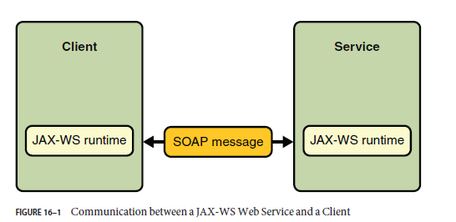

The starting point for developing a JAX-WS web service is a Java class annotated with the
javax.jws.WebService annotation. The @WebService annotation defines the class as a web
service endpoint.

A service endpoint interface or service endpoint implementation (SEI) is a Java interface or class,
respectively, that declares the methods that a client can invoke on the service. An interface is not
required when building a JAX-WS endpoint. The web service implementation class implicitly
defines an SEI.

These are the basic steps for creating the web service and client:
1. Code the implementation class.
2. Compile the implementation class.
3. Use wsgen to generate the artifacts required to deploy the service.
4. Package the files into aWARfile.
5. Deploy theWARfile. The web service artifacts (which are used to communicate with
clients) are generated by the Application Server during deployment.
6. Code the client class.
7. Use wsimport to generate and compile the web service artifacts needed to connect to the
service.
8. Compile the client

Additional specifications, WS

WS-Security
WS-Reliability
WS-Transaction
WS-Addressing

A list of web service frameworks:

Name | Platform | Messaging Model (Destination) | Specifications | Protocols
ActionWebService | Ruby (on Rails) | Client/Server | ? | SOAP, XML-RPC, WSDL
Apache Axis | Java/C++ | Client/Server | WS-ReliableMessaging, WS-Coordination, WS-Security, WS-AtomicTransaction, WS-Addressing | SOAP, WSDL
Apache Axis2 | Java/C | Client/Server/ Asyn Support | WS-ReliableMessaging,WS-Security, WS-AtomicTransaction, WS-Addressing ,MTOM ,WS-Policy, WS-MetadataExchange | SOAP,MTOM, WSDL 2.0, WSDL
Apache CXF | Java | Client/Server/ Asyn Support | WS-Addressing, WS-Policy, WS-ReliableMessaging, WS-Security, WS-SecureConversation, WS-SecurityPolicy, WS-Trust, MTOM | SOAP1.1, SOAP1.2,MTOM, WSDL 2.0, WSDL
AlchemySOAP | C++ | Client/Server | WS-Addressing | SOAP
csoap | C | Client/Server | ? | SOAP
Halcyon | Ruby | Client/Server | N/A | JSON
HED Hosting Environment Daemon | C++ with Python and Java bindings | Client/Server | Selected parts of WSRF, WS-Security, WS-Addressing, SAML | SOAP
Hessian | Java, Ruby, Python, Erlang, PHP, others | Client/Server | Hessian 1.0.1 | Hessian
JSON-RPC-Java | Java | Server | ??? | JSON-RPC
JSON-RPC-Lua | Lua | Server | ??? | JSON-RPC
Java Web Services Development Pack / GlassFish | Java | Client/Server | WS-Addressing, WS-Security, ??? | SOAP, WSDL, ???
.NET Framework | C#, VB .NET | Client/Server | WS-Addressing, WS-Security, | SOAP, WSDL, ???
NuSOAP | PHP | Client/Server | Object Oriented, Creates Users Help document, ? | SOAP, WSDL
Rogue Wave® Hydra Eclipse Based Development | C++, Java | Client/Server | WS-Security, SCA, SDO, Transport/Protocol neutral (JMS/SOAP, raw socket/binary, etc.) | SOAP, WSDL
SOAP Lite | Perl | Client/Server | ??? | SOAP, WSDL, ???
Simple Remoting | Java / JavaScript | Client/Server |  | JSON/HTTP, HTTP GET/POST
Web Services Interoperability Technology | Java | Client/Server | WS-Addressing, WS-ReliableMessaging, WS-Coordination, WS-AtomicTransaction, WS-Security, WS-Security Policy, WS-Trust, WS-SecureConversation, WS-Policy, WS-MetadataExchange | SOAP, WSDL, MTOM
Web Services Invocation Framework | Java | Client | ??? | SOAP, WSDL
Windows Communication Foundation | .Net | Client/Server ? | WS-Addressing, WS-ReliableMessaging, WS-Security | SOAP, WSDL
WSO2 WSF/PHP | PHP | Client/Server | SOAP MTOM, WS-Addressing, WS-Security, WS-SecurityPolicy, WS-Secure Conversation, WS-ReliableMessaging | SOAP, WSDL
XFire became Apache CXF | Java | Client/Server | WS-Addressing, WS-Security | SOAP, WSDL
XML Interface for Network Services | Java | Server ? | ?? | SOAP, XML-RPC, WSDL, JSON-RPC, JSON
gSOAP | C/C++ | Client/Server | WS-Addressing, WS-Discovery, WS-Enumeration, WS-Security | SOAP, XML-RPC, WSDL
Staff | C++/AJAX | Client/Server | All of Apache Axis2/C | SOAP, WSDL

Web services are developed using Java Technology APIs and tools provided by an integrated Web Services Stack called Metro. The Metro stack consisting of JAX-WS, JAXB, and WSIT, enable you to create and deploy secure, reliable, transactional, interoperable Web services and clients.

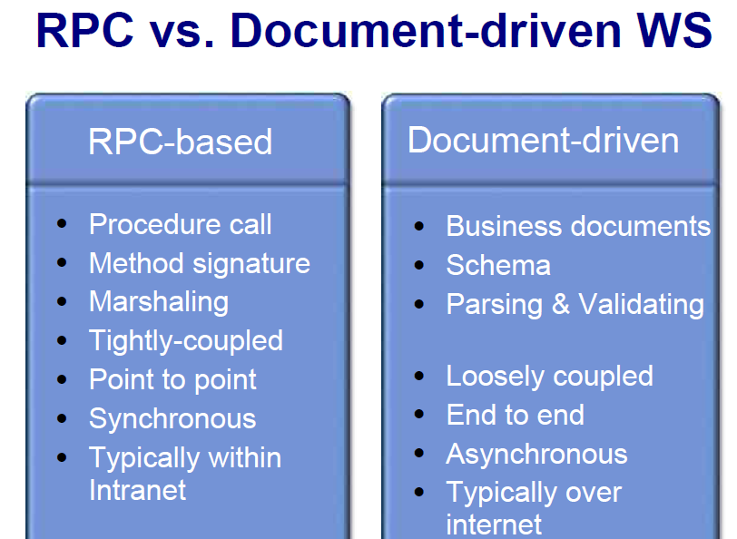

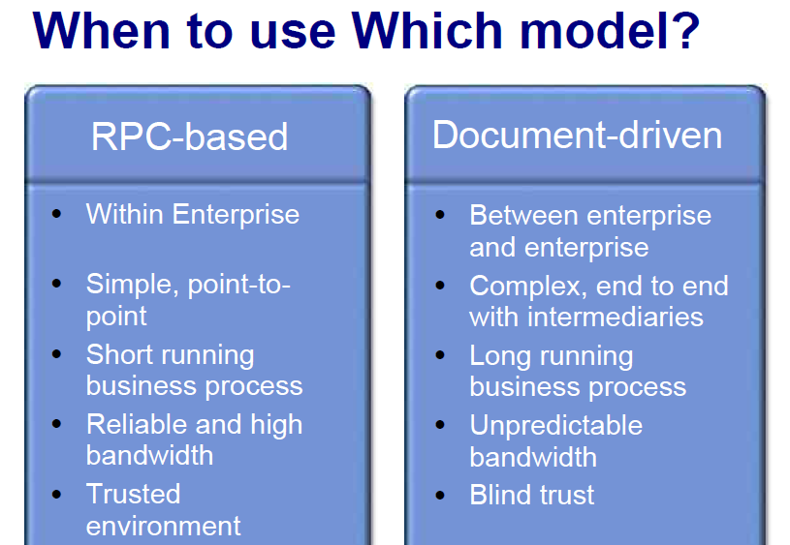

In the RPC-based interaction, the web service is viewed by the consumer as a single logical application or component with encapsulated data, where the WSDL described by the publicly-exposed interface and the XML in the SOAP messages exchanged is formatted to map to the discrete operations exposed by that application. In fact, the messages directly map onto input and output parameters of the procedure calls or operations. Typically, such invocations occur over a synchronous transport protocol like HTTP, where the SOAP request and response is piggybacked on the protocol-level request-and-response, respectively, to form synchronous request-response interaction patterns. For example, see Figure 1, which illustrates a payment service that accepts payments and returns a status, or a stock quote service that accepts a ticker symbol and returns the current quote in the HTTP response.

For example, consider a transporter's web service that accepts bid requests from a shipping company and replies back with an appropriate bid (see Figure 2). Such document-based interactions are typically long-lived in nature; the transport company may need to execute a long-running business process in order to respond appropriately to the request. Because the response cannot be returned immediately over the underlying transport protocol's response (like in the RPC invocation described earlier), document-based message exchanges are more common to asynchronous communication architectures. Also, the effort and complexity involved in building a document-oriented web service is usually more than the effort involved in using an RPC-based architecture. This is because it involves extra steps, such as designing the schema for the documents that will be exchanged, negotiating and arriving at an agreement with business partners on that design, and validating the document against the schema.

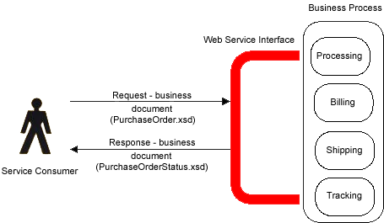

There are four combinations of binding style and data encoding. These are:
- RPC-Encoded
- RPC-Literal
- Document-Literal
- Document-Encoded

Some of the decision points that developers can consider when making a decision on the formatting style for the web service to use are:
- State maintenance: If the stubs generated by a toolkit cannot maintain state, then document style can be used to pass the contents of an entire transaction as an XML document. The service implementation can then ensure the processing sequence and maintain state in the execution of that sequence.
- Industry standard schemas: If the service consumer is only requesting information or persisting information in a pre-defined format, such as those defined by industry standards bodies (eg STAR standards), a document style message makes more sense because it is not constrained by the RPC-oriented encoding.
- Validate business documents: With document style, a web service endpoint can use the capabilities of a validating parser and the runtime to perform syntactic validation on business documents against their schema definitions. In order to enforce similar validation with RPC, a message must include an XML document as a string parameter or attachment and implement the validation in the service. This can often lead to invocations that are not detected until the entire structure has been processed. In short, if the service is accepting or returning a complex XML structure, a document style is better suited, since the XML can be validated against the schema prior to calling the service.
- Performance and memory limitations: Marshalling and un-marshalling parameters to XML in memory can be an intensive process. Typically, the RPC-encoded scheme is the least performing because of the extra processing overhead in encoding the payloads. Also, the SOAP model inherently requires DOM-based processing of the envelope, which can lead to large DOM trees in memory if the XML representation is complex. However, document style services can choose alternate parsing technologies like SAX and StAX to optimize and improve performance, which can be a critical factor for services that handle many simultaneous requests.
- Interoperability: There is a natural tendency to expose the programming language object structures through the WSDL when using RPC style and this causes interoperability issues across platforms. To facilitate interoperability, the WS-I Basic Profile limits the use of the encoding (RPC-encoded or document-encoded) and encourages a literal formatting (document-literal or RPC-literal style). Of the two literal styles, some toolkits today like .NET only support document-literal, and if the web service wants to interoperate with service consumers that use such toolkits, document-literal is the natural choice
Document style combined with literal encoding allows validation; changing that to RPC-literal takes that benefit away because the surrounding RPC element does not appear in the schemas. A possible example where RPC-literal may be used instead of document-literal is when multiple RPC operations return XML documents using the same schema. Document-encoded takes away the benefits of RPC-encoded but does not add anything in return.

Strategy#1 XML In SOAP Body
● Top down approach
– Start with WSDL
– Separately define abstract, concrete WSDL & XML
documents
– Use tools to generate Java SEI and write
implementation
● E.g wscompile
● Bottom up approach
– Start with Java code, write SEI and implementation
– Generate WSDL with tools
– Pass formatting options to tool, typically
document/literal
● Eg wscompile –f:documentliteral

What is Spring Web Services?
Spring Web Services is a product of the Spring community focused on creating document-driven Web services. Spring Web Services aims to facilitate contract-first SOAP service development, allowing for the creation of flexible web services using one of the many ways to manipulate XML payloads

Key Features
- Makes the Best Practice an Easy Practice: Spring Web Services makes enforcing best practices easier. This includes practices such as the WS-I basic profile, Contract-First development, and having a loose coupling between contract and implementation.
- Powerful mappings: You can distribute incoming XML request to any object, depending on message payload, SOAP Action header, or an XPath expression.
- XML API support: Incoming XML messages can be handled in standard JAXP APIs such as DOM, SAX, and StAX, but also JDOM, dom4j, XOM, or even marshalling technologies.
- Flexible XML Marshalling: The Object/XML Mapping module in the Spring Web Services distribution supports JAXB 1 and 2, Castor, XMLBeans, JiBX, and XStream. And because it is a separate module, you can use it in non-Web services code as well.
- Reuses your Spring expertise: Spring-WS uses Spring application contexts for all configuration, which should help Spring developers get up-to-speed nice and quickly. Also, the architecture of Spring-WS resembles that of Spring-MVC.
- Supports WS-Security: WS-Security allows you to sign SOAP messages, encrypt and decrypt them, or authenticate against them.
- Integrates with Acegi Security: The WS-Security implementation of Spring Web Services provides integration with Spring Security. This means you can use your existing configuration for your SOAP service as well.
- Built by Maven: This assists you in effectively reusing the Spring Web Services artifacts in your own Maven-based projects.
- Apache license. You can confidently use Spring-WS in your project.

SOAP with Attachments API for Java (SAAJ)

SOAP with Attachments API for Java (SAAJ) is used mainly for the SOAP messaging that goes on behind the scenes in JAX-WS handlers and JAXR implementations. Secondarily, it is an API that developers can use when they choose to write SOAP messaging applications directly rather than use JAX-WS. The SAAJ API allows you to do XML messaging from the Java platform: By simply making method calls using the SAAJ API, you can read and write SOAP-based XML messages, and you can optionally send and receive such messages over the Internet (some implementations may not support sending and receiving). This chapter will help you learn how to use the SAAJ API

WS-Security describes three main mechanisms:
- How to sign SOAP messages to assure integrity. Signed messages provide also non-repudiation.
- How to encrypt SOAP messages to assure confidentiality.
- How to attach security tokens.

REST

The HTTP methods such as GET and POST are the verbs that the developer can use to describe the necessary create, read, update, and delete (CRUD) actions to be performed. Some may see an analogy to operations in SQL, which also relies on a few common verbs, as shown in Table 1. However, the REST style and HTTP protocol are mutually exclusive, and REST does not require HTTP.
Table 1: Relationships Between SQL and HTTP Verbs

Action | SQL | HTTP
Create | Insert | PUT
Read | Select | GET
Update | Update | POST
Delete | Delete | DELETE

When to Use REST
Architects and developers need to decide when this particular style is an appropriate choice for their applications. A RESTFul design may be appropriate when
- The web services are completely stateless. A good test is to consider whether the interaction can survive a restart of the server.
- A caching infrastructure can be leveraged for performance. If the data that the web service returns is not dynamically generated and can be cached, then the caching infrastructure that web servers and other intermediaries inherently provide can be leveraged to improve performance. However, the developer must take care because such caches are limited to the HTTP GET method for most servers.
- The service producer and service consumer have a mutual understanding of the context and content being passed along. Because there is no formal way to describe the web services interface, both parties must agree out of band on the schemas that describe the data being exchanged and on ways to process it meaningfully. In the real world, most commercial applications that expose services as RESTful implementations also distribute so-called value-added toolkits that describe the interfaces to developers in popular programming languages.
- Bandwidth is particularly important and needs to be limited. REST is particularly useful for limited-profile devices such as PDAs and mobile phones, for which the overhead of headers and additional layers of SOAP elements on the XML payload must be restricted.
- Web service delivery or aggregation into existing web sites can be enabled easily with a RESTful style. Developers can use technologies such as Asynchronous JavaScript with XML (AJAX) and toolkits such as Direct Web Remoting (DWR) to consume the services in their web applications. Rather than starting from scratch, services can be exposed with XML and consumed by HTML pages without significantly refactoring the existing web site architecture. Existing developers will be more productive because they are adding to something they are already familiar with, rather than having to start from scratch with new technology.
A SOAP-based design may be appropriate when
- A formal contract must be established to describe the interface that the web service offers. The Web Services Description Language (WSDL) describes the details such as messages, operations, bindings, and location of the web service.
- The architecture must address complex nonfunctional requirements. Many web services specifications address such requirements and establish a common vocabulary for them. Examples include Transactions, Security, Addressing, Trust, Coordination, and so on. Most real-world applications go beyond simple CRUD operations and require contextual information and conversational state to be maintained. With the RESTful approach, developers must build this plumbing into the application layer themselves.
- The architecture needs to handle asynchronous processing and invocation. In such cases, the infrastructure provided by standards such as WSRM and APIs such as JAX-WS with their client-side asynchronous invocation support can be leveraged out of the box.

Describing RESTful Endpoints

If you are developing RESTful web services, the following general guidelines provide a good starting point:
- Make the XML schemas available to service consumers and package them with the WAR file.
- Clearly document the expected input, output, and error conditions that may arise as result of invocation.

