Hibernate (Version 4.3)

Connecting to database:
- Stand-alone built-in connection pool
- javax.sql.DataSource
- Connection pools, including support for two different third-party opensource JDBC connection pools:
  - c3p0
  - proxool
- Application-supplied JDBC connections. This is not a recommended approach and exists for legacy reasons

Hibernate configurations:

Example 1.1. hibernate.properties for a c3p0 connection pool
hibernate.connection.driver_class = org.postgresql.Driver
hibernate.connection.url = jdbc:postgresql://localhost/mydatabase
hibernate.connection.username = myuser
hibernate.connection.password = secret
hibernate.c3p0.min_size=5
hibernate.c3p0.max_size=20
hibernate.c3p0.timeout=1800
hibernate.c3p0.max_statements=50
hibernate.dialect = org.hibernate.dialect.PostgreSQL82Dialect

Example 1.2. hibernate.cfg.xml for a connection to the bundled HSQL database

<?xml version='1.0' encoding='utf-8'?>

<hibernate-configuration
xmlns="http://www.hibernate.org/xsd/hibernate-configuration"
xsi:schemaLocation="http://www.hibernate.org/xsd/hibernate-configuration hibernate-configuration-4.0.xsd"
xmlns:xsi="http://www.w3.org/2001/XMLSchema-instance">
<session-factory>
<!-- Database connection settings -->
<property name="connection.driver_class">org.hsqldb.jdbcDriver</property>
<property name="connection.url">jdbc:hsqldb:hsql://localhost</property>
<property name="connection.username">sa</property>
<property name="connection.password"></property>

<!-- JDBC connection pool (use the built-in) -->
<property name="connection.pool_size">1</property>

<!-- SQL dialect -->
<property name="dialect">org.hibernate.dialect.HSQLDialect</property>

<!-- Enable Hibernate's automatic session context management -->
<property name="current_session_context_class">thread</property>

<!-- Disable the second-level cache -->
<property name="cache.provider_class">org.hibernate.cache.internal.NoCacheProvider</property>

<!-- Echo all executed SQL to stdout -->
<property name="show_sql">true</property>

<!-- Drop and re-create the database schema on startup -->
<property name="hbm2ddl.auto">update</property>
<mapping resource="org/hibernate/tutorial/domain/Event.hbm.xml"/>
</session-factory>
</hibernate-configuration>

Programatic configuration

Example 1.3. Specifying the mapping files directly
You can obtain a org.hibernate.cfg.Configuration instance by instantiating it directly and specifying XML mapping documents. If the mapping files are in the classpath, use method addResource().
Configuration cfg = new Configuration()
.addResource("Item.hbm.xml")
.addResource("Bid.hbm.xml");

Example 1.4. Letting Hibernate find the mapping files for you
The addClass() method directs Hibernate to search the CLASSPATH for the mapping files, eliminating hard-coded file names. In the following example, it searches for org/hibernate/auction/Item.hbm.xml andorg/hibernate/auction/Bid.hbm.xml.
Configuration cfg = new Configuration()
.addClass(org.hibernate.auction.Item.class)
.addClass(org.hibernate.auction.Bid.class)
.setProperty("hibernate.dialect", "org.hibernate.dialect.MySQLInnoDBDialect")
.setProperty("hibernate.connection.datasource", "java:comp/env/jdbc/test")
.setProperty("hibernate.order_updates", "true");

1.1.2. Obtaining a JDBC connection
you can use method openSession of classorg.hibernate.SessionFactory to open sessions. Sessions will obtain JDBC connections as needed
Session session = sessions.openSession();

A surrogate key is a primary key column with no meaning to the user.
Ex: user_id column in the table which is autogenerated.

If you wish to represent a many-to-many association in a relational database, you
must introduce a new table, called a link table.

Difference between Entity Bean and Hibernate

1)In Entity Bean at a time we can interact with only one data Base. Where as in Hibernate we can able to establishes the connections to more than One Data Base. Only thing we need to write one more configuration file.
2) EJB need container like Weblogic, WebSphare but hibernate don't nned. It can be run on tomcat.
3) Entity Beans does not support OOPS concepts where as Hibernate does.
4) Hibernate supports multi level cacheing, where as Entity Beans doesn't.
5) In Hibernate C3P0 can be used as a connection pool.
6) Hibernate is container independent. EJB not.

ORM (Object Relational Mapping)
In a nutshell, object/relational mapping is the automated (and transparent) persistence
of objects in a Java application to the tables in a relational database,
using metadata that describes the mapping between the objects and the database.

“Hello World” with Hibernate
package hello;
public class Message {
private Long id;
private String text;
private Message nextMessage;
private Message() {}
public Message(String text) {
this.text = text;
}
public Long getId() {
return id;
}
private void setId(Long id) {
this.id = id;
}
public String getText() {
return text;
}
public void setText(String text) {
this.text = text;
}
public Message getNextMessage() {
return nextMessage;
}
public void setNextMessage(Message nextMessage) {
this.nextMessage = nextMessage;
}
}

Hibernate mapping XML

<!DOCTYPE hibernate-mapping PUBLIC
"-//Hibernate/Hibernate Mapping DTD//EN"
"http://hibernate.sourceforge.net/hibernate-mapping-2.0.dtd">
<hibernate-mapping>
<class
name="hello.Message"
table="MESSAGES">
<id
name="id"
column="MESSAGE_ID">
<generator class="increment"/>
</id>
<property
name="text"
column="MESSAGE_TEXT"/>
<many-to-one
name="nextMessage"
cascade="all"
column="NEXT_MESSAGE_ID"/>
</class>
</hibernate-mapping>

Creating record

Session session = getSessionFactory().openSession();
Transaction tx = session.beginTransaction();
Message message = new Message("Hello World");
session.save(message);
tx.commit();
session.close();

Retrieving records

Session newSession = getSessionFactory().openSession();
Transaction newTransaction = newSession.beginTransaction();
List messages =
newSession.find("from Message as m order by m.text asc");
System.out.println( messages.size() + " message(s) found:" );
for ( Iterator iter = messages.iterator(); iter.hasNext(); ) {
Message message = (Message) iter.next();
System.out.println( message.getText() );
}
newTransaction.commit();
newSession.close();

Updating a record

Session session = getSessionFactory().openSession();
Transaction tx = session.beginTransaction();
// 1 is the generated id of the first message
Message message =
(Message) session.load( Message.class, new Long(1) );
message.setText("Greetings Earthling");
Message nextMessage = new Message("Take me to your leader (please)");
message.setNextMessage( nextMessage );
tx.commit();
session.close();

Hibernate Architecture

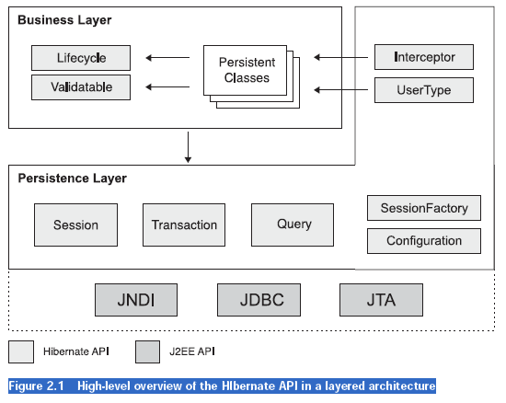

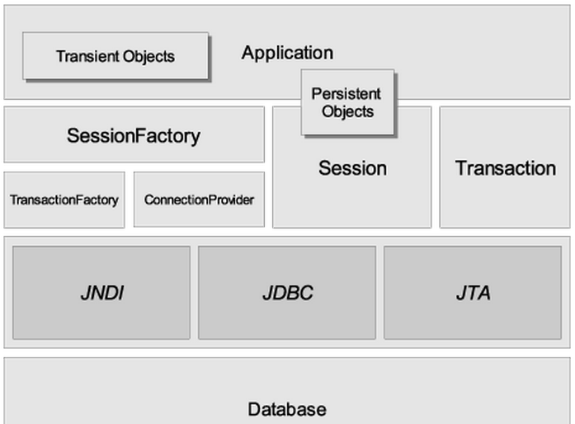

1.The core interfaces

- Session
A single-threaded, short-lived object representing a conversation between the application and the persistent store. Wraps a JDBC java.sql.Connection. Factory for org.hibernate.Transaction. Maintains afirst level cache of persistent the application's persistent objects and collections; this cache is used when navigating the object graph or looking up objects by identifier.

The Hibernate notion of a session is something between connection and transaction.
It may be easier to think of a session as a cache or collection of loaded objects relating to a single unit of work.

sesssionFactory.openSession();

- SessionFactory
The application obtains ‘Session’ from ‘SessionFactory’. This is not light weight and is intended to be shared among many application Threads. There is typically a single SessionFactory for the
whole application—created during application initialization.

The session factory caches generated sql statements and other mapping metadata that Hibernate uses at run time. It also holds cached data that has been read in one unit of work and may be reused in a future unit of work (only if class and collection mappings specify that this second-level cache is desirable).
Configuration cfg = new Configuration();
cfg.addResource("hello/Message.hbm.xml");
cfg.setProperties( System.getProperties() );
SessionFactory sessions = cfg.buildSessionFactory();

SessionFactory sessions = new Configuration()
.configure("/hibernate-config/auction.cfg.xml")
.buildSessionFactory();

- Persistent objects and collections
Short-lived, single threaded objects containing persistent state and business function. These can be ordinary JavaBeans/POJOs. They are associated with exactly one org.hibernate.Session. Once theorg.hibernate.Session is closed, they will be detached and free to use in any application layer
- Transient and detached objects and collections
Instances of persistent classes that are not currently associated with a org.hibernate.Session. They may have been instantiated by the application and not yet persisted, or they may have been instantiated by a closed org.hibernate.Session.

- Configuration
The Configuration object is used to configure and bootstrap Hibernate. The application uses a Configuration instance to specify the location of mapping documents and Hibernate-specific properties and then create the SessionFactory.

- Transaction
The Transaction interface is an optional API. Hibernate applications may choose not to use this interface, instead managing transactions in their own infrastructure code. A Transaction abstracts application code from the underlying transaction implementation—which might be a JDBC transaction, a JTA UserTransaction, or even a Common Object Request Broker Architecture (CORBA) transaction—allowing the application to control transaction boundaries via a consistent API.
This helps to keep Hibernate applications portable between different kinds of execution environments and containers.

- Query and Criteria
Query interface allows us to query the database and control as how the queries are executed.

Criteria is also similar and allows us to execute object oriented criteria queries.

A Query instance is light weight and cannot be used outside the session that created it.

4.1.3. Prefer non-final classes (semi-optional)
A central feature of Hibernate, proxies (lazy loading), depends upon the persistent class being
either non-final, or the implementation of an interface that declares all public methods. You can
persist final classes that do not implement an interface with Hibernate; you will not, however,
be able to use proxies for lazy association fetching which will ultimately limit your options for
performance tuning. To persist a final class which does not implement a "full" interface you must disable proxy generation.

If the final class does implement a proper interface, you could alternatively tell Hibernate to use
the interface instead when generating the proxies

<class name="Cat" proxy="ICat"...>...</class>

4.3. Implementing equals() and hashCode()
You have to override the equals() and hashCode() methods if you:
• intend to put instances of persistent classes in a Set (the recommended way to represent many valued associations); and
• intend to use reattachment of detached instances

Hibernate guarantees equivalence of persistent identity (database row) and Java identity only
inside a particular session scope. When you mix instances retrieved in different sessions, you
must implement equals() and hashCode() if you wish to have meaningful semantics for Sets

4.4. Dynamic models
Persistent entities do not necessarily have to be represented as POJO classes or as JavaBean
objects at runtime. Hibernate also supports dynamic models (using Maps of Maps at runtime) and
the representation of entities as DOM4J trees. With this approach, you do not write persistent
classes, only mapping files.

By default, Hibernate works in normal POJO mode. You can set a default entity representation
mode for a particular SessionFactory using the default_entity_mode configuration option

Ex:
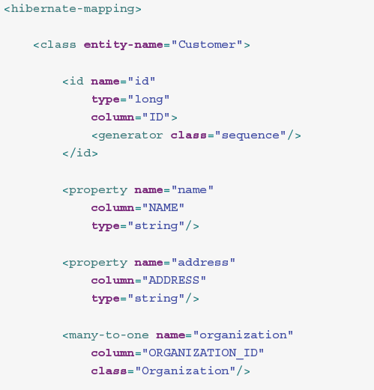
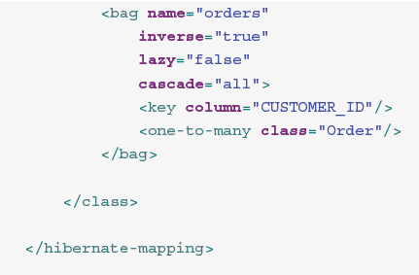

After setting the default entity mode to dynamic-map for the SessionFactory, you can, at runtime, work with Maps of Maps:

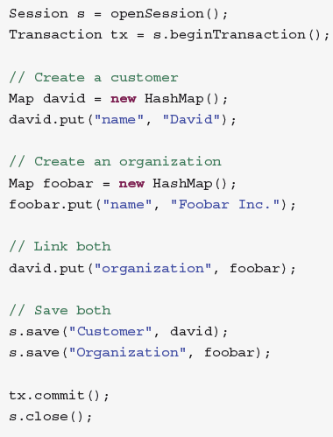

One of the main advantages of dynamic mapping is quick turnaround time for prototyping, without
the need for entity class implementation. However, you lose compile-time type checking and
will likely deal with many exceptions at runtime. As a result of the Hibernate mapping, the
database schema can easily be normalized and sound, allowing to add a proper domain model
implementation on top later on.

Entity representation modes can also be set on a per Session basis:

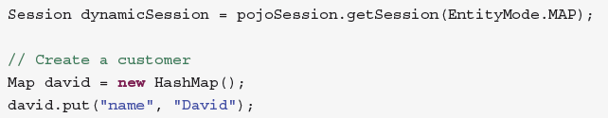
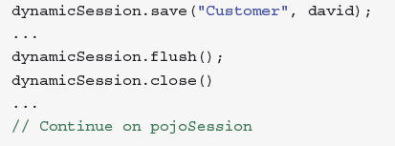

4.5. Tuplizers

If a given piece of data is thought of as a data structure, then a
tuplizer is the thing that knows how to create such a data structure, how to extract values from such a data structure and how to inject values into such a data structure. For example, for the POJO entity mode, the corresponding tuplizer knows how create the POJO through its constructor. It also knows how to access the POJO properties using the defined property accessors. There are two (high-level) types of Tuplizers:
• org.hibernate.tuple.entity.EntityTuplizer which is responsible for managing the above
mentioned contracts in regards to entities
• org.hibernate.tuple.component.ComponentTuplizer which does the same for
components

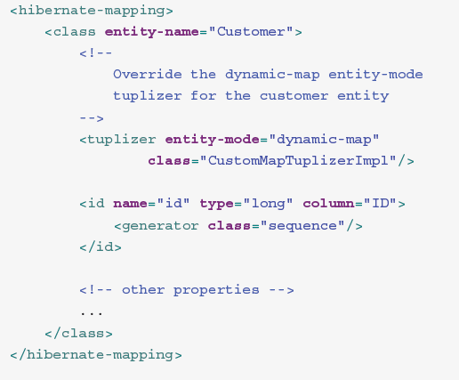
4.6. EntityNameResolvers
org.hibernate.EntityNameResolver is a contract for resolving the entity name of a given
entity instance. The interface defines a single method resolveEntityName which is passed
the entity instance and is expected to return the appropriate entity name

Entity

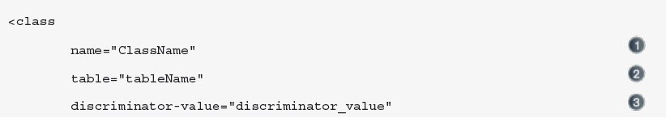
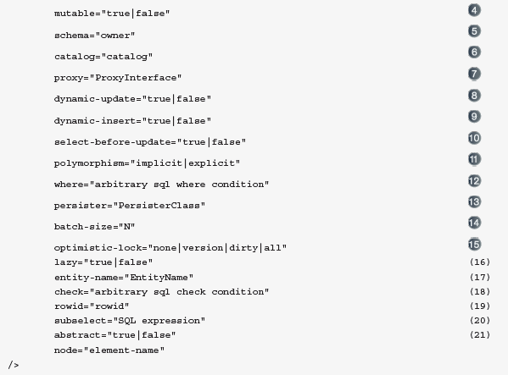

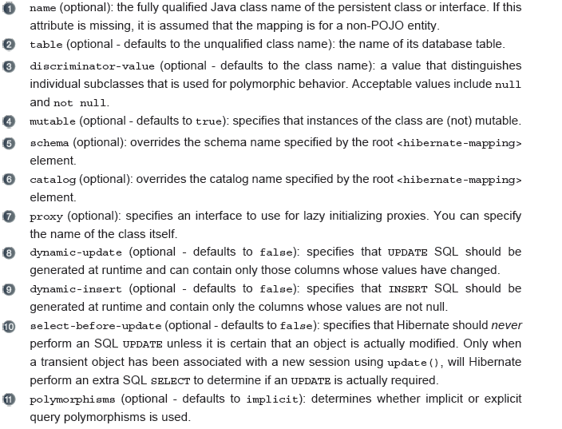

5.1.2. Identifiers
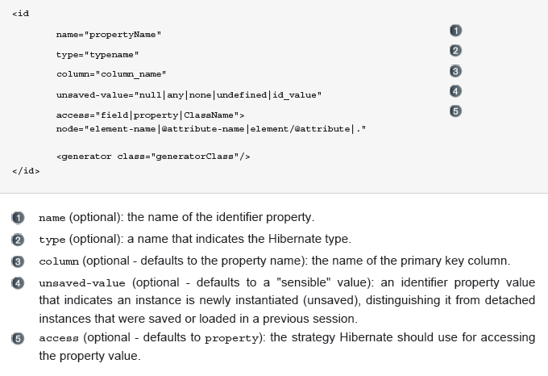
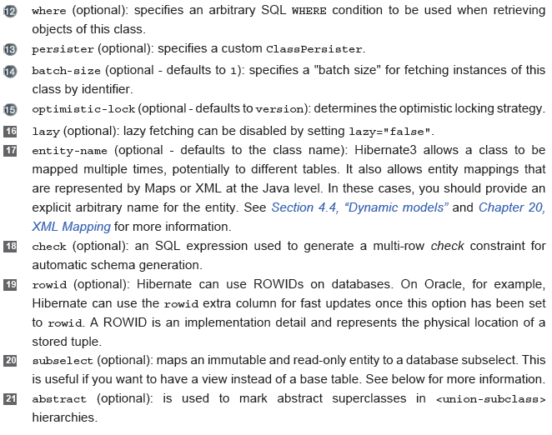

5.1.2.1. Composite identifier
You can define a composite primary key through several syntaxes:
• use a component type to represent the identifier and map it as a property in the entity: you then
annotated the property as @EmbeddedId. The component type has to be Serializable.
• map multiple properties as @Id properties: the identifier type is then the entity class itself and
needs to be Serializable. This approach is unfortunately not standard and only supported
by Hibernate.
• map multiple properties as @Id properties and declare an external class to be the identifier
type. This class, which needs to be Serializable, is declared on the entity via the @IdClass
annotation. The identifier type must contain the same properties as the identifier properties of
the entity: each property name must be the same, its type must be the same as well if the entity
property is of a basic type, its type must be the type of the primary key of the associated entity
if the entity property is an association (either a @OneToOne or a @ManyToOne).

First a simple example:
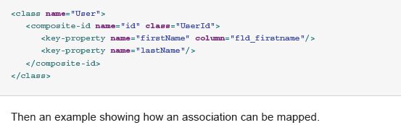

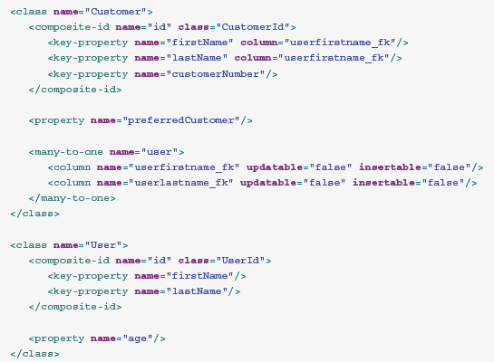
The last example shows how to map association directly in the embedded id component

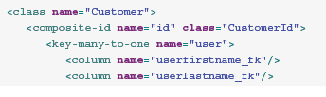
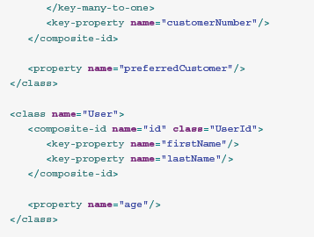

2. Callback Interfaces
Callback interfaces allow the application to receive a notification when something
interesting happens to an object—for example, when an object is loaded, saved,
or deleted.
- Lifecycle interface
- Validatable interface
Both allow persistent objects to react to events relating to their own persistent state.
- Interceptor
interface was introduced to allow the application to process callbacks without forcing the persistent classes to implement Hibernate-specific APIs. Implementations of the Interceptor interface are passed to the persistent instances as parameters.

3.Types

Hibernate Type object maps java object type to a database column type.
Ex: java.util.Currency, java.util.Calendar, byte[], and java.io.Serializable.

Hibernate also support user defined custom types. The interfaces UserType and CompositeUserType are provided to allow the developers to add their custom object types.

4. Extension Interfaces
Much of the functionality that hibernate provides is configurable. The external interfaces provided by hibernate allows us to use different strategies for the following.

a. Primary key generateion: IdentifierGenerator interface
b SQL Dialect support Dialect abstract class
c. Caching Cache and CacheProvider interfaces
d. JDBC connection mgmt ConnectionProvider interface
e. Transaction Mgmt TransactionFactory, Transaction, TransactionManagerLookup
f. ORM strategies ClassPersister interface
g. Property Access strategy PropertyAccessor interface
h. Proxy creation ProxyFactory interface

Configuring Hibernate using XML
Use “hibernate.cfg.xml” to define configuration. Here you can specify the location of mapping documents.

?xml version='1.0'encoding='utf-8'?>
<!DOCTYPE hibernate-configuration
PUBLIC "-//Hibernate/Hibernate Configuration DTD//EN"
"http://hibernate.sourceforge.net/hibernate-configuration-2.0.dtd">
<hibernate-configuration>
<session-factory name="java:/hibernate/HibernateFactory">
<property name="show_sql">true</property>
<property name="connection.datasource">
java:/comp/env/jdbc/AuctionDB
</property>
<property name="dialect">
net.sf.hibernate.dialect.PostgreSQLDialect
</propert
<property name="transaction.manager_lookup_class">
net.sf.hibernate.transaction.JBossTransactionManagerLookup
</property>
<mapping resource="auction/Item.hbm.xml"/>
<mapping resource="auction/Category.hbm.xml"/>
<mapping resource="auction/Bid.hbm.xml"/>
</session-factory>
</hibernate-configuration

Contextual sessions
as of version 3.1, the processing behind SessionFactory.getCurrentSession() is now pluggable. To that end, a new extension interface, org.hibernate.context.spi.CurrentSessionContext, and a new configuration parameter, hibernate.current_session_context_class, have been added to allow pluggability of the scope and context of defining current sessions.

Hibernate comes with three implementations of this interface:
- org.hibernate.context.internal.JTASessionContext: current sessions are tracked and scoped by a JTAtransaction. The processing here is exactly the same as in the older JTA-only approach. See the Javadocs for details.
- org.hibernate.context.internal.ThreadLocalSessionContext:current sessions are tracked by thread of execution. See the Javadocs for details.
- org.hibernate.context.internal.ManagedSessionContext: current sessions are tracked by thread of execution. However, you are responsible to bind and unbind a Session instance with static methods on this class: it does not open, flush, or close a Session.

Table 3.3. Hibernate Configuration Properties
Property name | Purpose
hibernate.dialect | The classname of a Hibernate  org.hibernate.dialect.Dialect which allows Hibernate to  generate SQL optimized for a particular relational database.  e.g. full.classname.of.Dialect  In most cases Hibernate will actually be able to choose the correct  org.hibernate.dialect.Dialect implementation based on  theJDBC metadata returned by the JDBC driver.
hibernate.show_sql | Write all SQL statements to console. This is an alternative to  setting the log category org.hibernate.SQL to debug.  e.g. true | false
hibernate.format_sql | Pretty print the SQL in the log and console.  e.g. true | false
hibernate.default_schema | Qualify unqualified table names with the given schema/  tablespace in generated SQL.  e.g. SCHEMA_NAME
hibernate.default_catalog | Qualifies unqualified table names with the given catalog in  generated SQL.  e.g. CATALOG_NAME
hibernate.session_factory_name | The org.hibernate.SessionFactory will be automatically  bound to this name in JNDI after it has been created.  e.g. jndi/composite/name
hibernate.max_fetch_depth | Sets a maximum "depth" for the outer join fetch tree for  single-ended associations (one-to-one, many-to-one).  A 0 disables default outer join fetching.  e.g. recommended values between 0 and 3
hibernate.default_batch_fetch_size | Sets a default size for Hibernate batch fetching of associations.  e.g. recommended values 4, 8, 16
hibernate.default_entity_mode | Sets a default mode for entity representation for all sessions  opened from this SessionFactory, defaults to pojo.  e.g. dynamic-map | pojo
hibernate.order_updates | Forces Hibernate to order SQL updates by the primary key value  of the items being updated. This will result in fewer transaction  deadlocks in highly concurrent systems.  e.g. true | false
hibernate.generate_statistics | If enabled, Hibernate will collect statistics useful for performance  tuning.  e.g. true | false
hibernate.use_identifier_rollback | If enabled, generated identifier properties will be reset to default  values when objects are deleted.  e.g. true | false
hibernate.use_sql_comments | If turned on, Hibernate will generate comments inside the SQL,  for easier debugging, defaults to false.  e.g. true | false
hibernate.id.new_generator_mappings | Setting is relevant when using @GeneratedValue. It indicates whether or not the new IdentifierGenerator implementations  are used for javax.persistence.GenerationType.AUTO,javax.  persistence.GenerationType.TABLE andjavax.  persistence.GenerationType.SEQUENCE. Default to false to keep backward compatibility.  e.g. true | false

Java Management Extensions (JMX)

Hibernate may be packaged and administered as a JMX MBean. The Hibernate JMX service allows Hibernate to be initialized at application server startup and controlled (configured) via a JMX client. However, JMX components aren’t automatically integrated with container-managed transactions.

Sometimes we would prefer that this validation not occur when Hibernate is initializing a newly loaded object. In that case, it might make sense to tell Hibernate to directly access the instance
variables (we map the property with access="field" in Hibernate metadata),forcing Hibernate to bypass the setter method and access the instance variable directly.

Property access strategies
Hibernate doesn’t require property accessor methods
on POJO classes, if you define a new property access strategy.

<property name="name"
column="NAME"
type="string"
access="field"/>

Controlling insertion and updates

For properties that map to columns, you can control whether they appear in the INSERT statement by using the insert attribute and whether they appear in the UPDATE statement by using the update attribute. The following property never has its state written to the database:
<property name="name"
column="NAME"
type="string"
insert="false"
update="false"/>
The property name of the JavaBean is therefore immutable and can be read from the database but not modified in any way. If the complete class is immutable, set the immutable="false" in the class mapping.

In addition, the dynamic-insert attribute tells Hibernate whether to include
unmodified property values in an SQL INSERT, and the dynamic-update attribute
tells Hibernate whether to include unmodified properties in the SQL UPDATE:
<class name="org.hibernate.auction.model.User"
dynamic-insert="true"
dynamic-update="true">
...
</class>

These are both class-level settings. Enabling either of these settings will cause
Hibernate to generate some SQL at runtime, instead of using the SQL cached at
startup time. The performance cost is usually small. Furthermore, leaving out
columns in an insert (and especially in an update) can occasionally improve
performance if your tables define many columns.

Naming conventions

Hibernate provides a feature that allows you to enforce naming standards automatically.
Suppose that all table names in CaveatEmptor should follow the pattern
CE_<table name>.
One solution is to manually specify a table attribute on all <class> and collection elements in our mapping files. This approach is time-consuming and easily forgotten. Instead, we can implement Hibernate’s NamingStrategy interface.

However, a better way to handle this kind of requirement is to use the concept
of an SQL schema (a kind of namespace).

SQL schemas
You can specify a default schema using the hibernate.default_schema configuration
option. Alternatively, you can specify a schema in the mapping document. A
schema may be specified for a particular class or collection mapping:
<hibernate-mapping>
<class
name="org.hibernate.auction.model.Category"
table="CATEGORY"
schema="AUCTION">
...
</class>
</hibernate-mapping>
It can even be declared for the whole document:
<hibernate-mapping
default-schema="AUCTION">
..
</hibernate-mapping>

Object identity—Objects are identical if they occupy the same memory location in the JVM. This can be checked by using the == operator.
■ Object equality—Objects are equal if they have the same value, as defined by the equals(Object o) method. Classes that don’t explicitly override this method inherit the implementation defined by java.lang.Object, which compares object identity.
■ Database identity—Objects stored in a relational database are identical if they represent the same row or, equivalently, share the same table and primary key value.

Hibernate’s built-in identifier generator modules

5.1.2.2. Identifier generator
Hibernate offers various generation strategies, let's explore the most common ones first that
happens to be standardized by JPA:
• IDENTITY: supports identity columns in DB2, MySQL, MS SQL Server, Sybase and
HypersonicSQL. The returned identifier is of type long, short or int.
• SEQUENCE (called seqhilo in Hibernate): uses a hi/lo algorithm to efficiently generate
identifiers of type long, short or int, given a named database sequence.
TABLE (called MultipleHiLoPerTableGenerator in Hibernate) : uses a hi/lo algorithm to
efficiently generate identifiers of type long, short or int, given a table and column as a
source of hi values. The hi/lo algorithm generates identifiers that are unique only for a particular
database.
• AUTO: selects IDENTITY, SEQUENCE or TABLE depending upon the capabilities of the underlying database.

Various additional id generators.
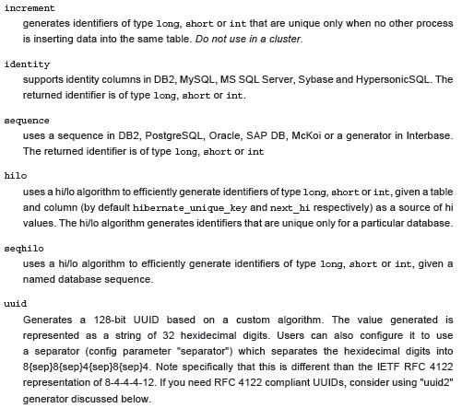
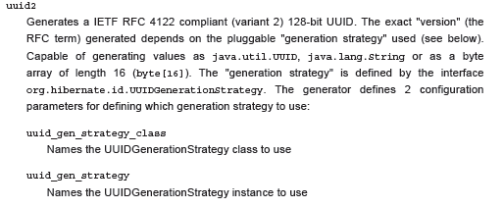
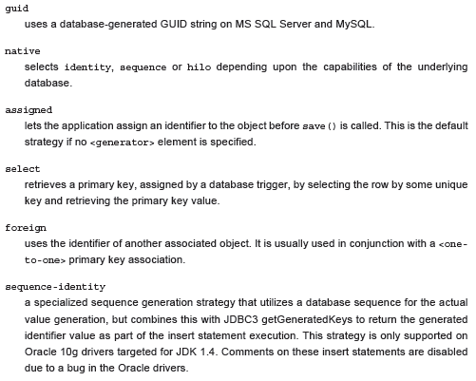
5.1.2.2.2. Hi/lo algorithm

Ex:
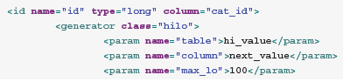
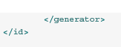

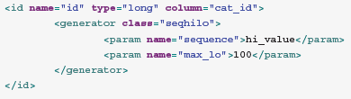

5.1.4.2. Property mapping with hbm.xml

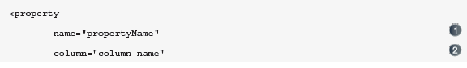
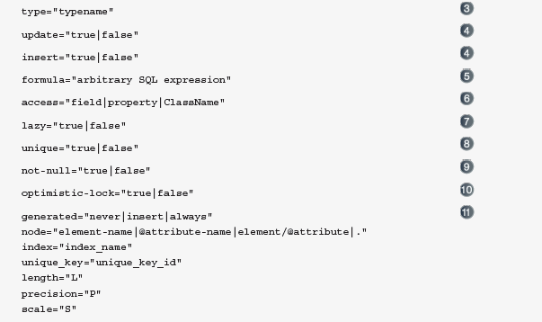

5.1.5. Embedded objects (aka components)
Embeddable objects (or components) are objects whose properties are mapped to the same table as the owning entity's table. Components can, in turn, declare their own properties, components or collections.

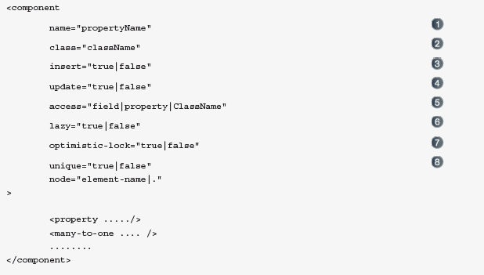
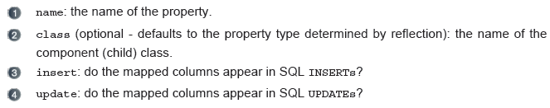
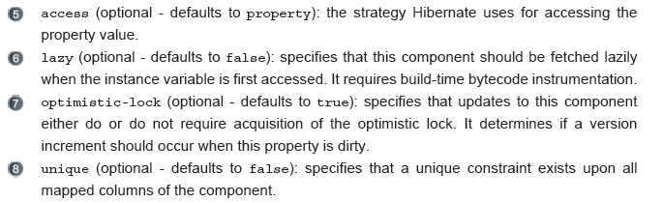

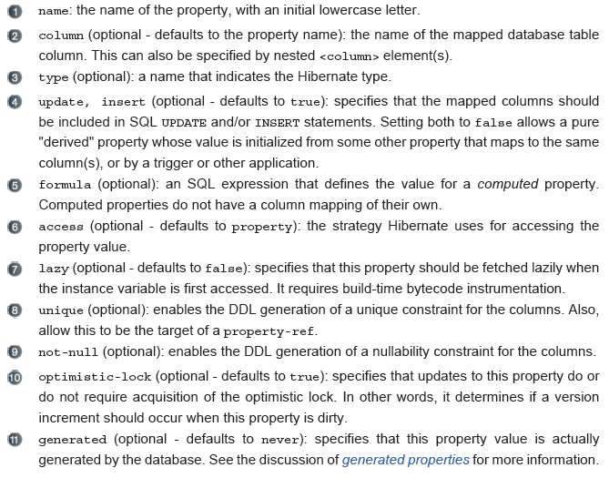

Fine-grained object models
In crude terms, fine-grained means “more classes than tables.” For example, a user might have both a billing address and a home address. In the database, we might have a single USER table with the columns BILLING_STREET, BILLING_CITY, and BILLING_ZIPCODE along with HOME_STREET, HOME_CITY, and HOME_ZIPCODE. There are good reasons to use this somewhat denormalized relational model (performance, for one).

In our object model, we could use the same approach, representing the two
addresses as six string-valued properties of the User class. But we would much
rather model this using an Address class, where User has the billingAddress and
homeAddress properties.
This object model achieves improved cohesion and greater code reuse and is
more understandable.

Using components
<class
name="User"
table="USER">
<id
name="id"
column="USER_ID"
type="long">
<generator class="native"/>
</id>
<property
Listing 3.7 Mapping the User class with a component Address
name="username"
column="USERNAME"
type="string"/>
<component
name="homeAddress"
class="Address">
<property name="street"
type="string"
column="HOME_STREET"
notnull="true"/>
<property name="city"
type="string"
column="HOME_CITY"
not-null="true"/>
<property name="zipcode"
type="short"
column="HOME_ZIPCODE"
not-null="true"/>
</component>
<component
name="billingAddress"
class="Address">
<property name="street"
type="string"
column="BILLING_STREET"
notnull="true"/>
<property name="city"
type="string"
column="BILLING_CITY"
not-null="true"/>
<property name="zipcode"
type="short"
column="BILLING_ZIPCODE"
not-null="true"/>
</component>
...
</class>

Mapping Inheritance

5.1.6. Inheritance strategy

- Table per CLASS hierarchy

The concrete subclass represented by a particular row is identified by the value of a type iscriminator column. This approach is shown in figure 3.8.

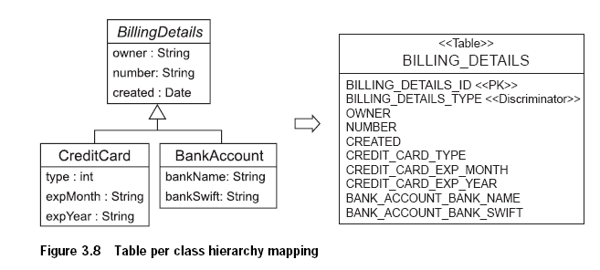

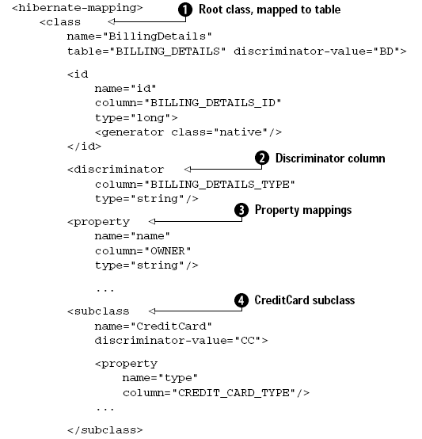

- Table per SubClass

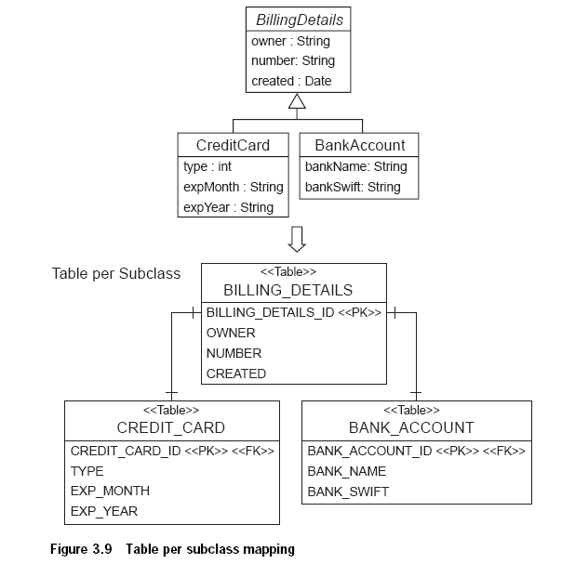

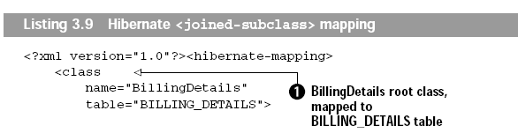

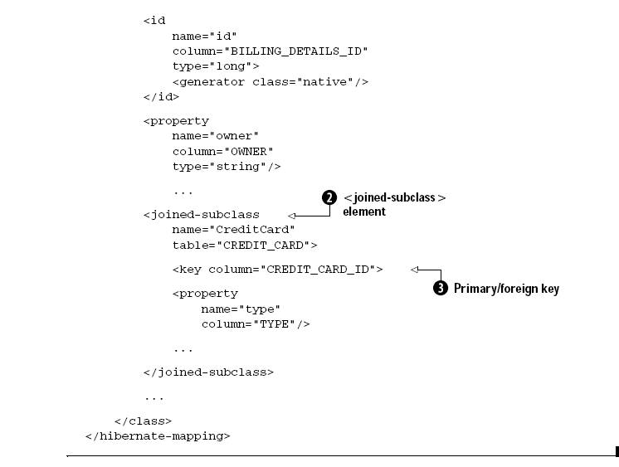

Hibernate associations are all inherently unidirectional. As far as Hibernate is concerned, the association from Bid to Item is a different association than the association from Item to Bid.

- Table per concrete class with implicit polymorphism

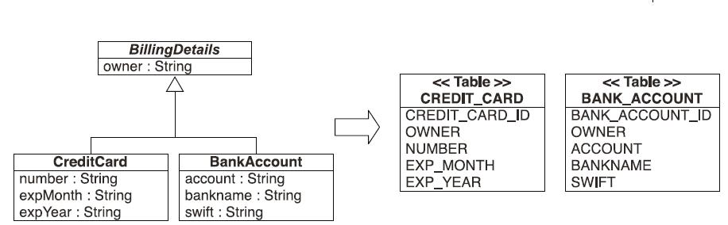
<class name="CreditCardPayment" table="CREDIT_PAYMENT">
<id name="id" type="long" column="CREDIT_PAYMENT_ID">
<generator class="native"/>
</id>
<property name="amount" column="CREDIT_AMOUNT"/>
...
</class>

<class name="CashPayment" table="CASH_PAYMENT">
<id name="id" type="long" column="CASH_PAYMENT_ID">
<generator class="native"/>
</id>
<property name="amount" column="CASH_AMOUNT"/>
...
</class>

<class name="ChequePayment" table="CHEQUE_PAYMENT">
<id name="id" type="long" column="CHEQUE_PAYMENT_ID">
<generator class="native"/>
</id>
<property name="amount" column="CHEQUE_AMOUNT"/>
...
</class>

- Table per concrete class with unions

Table per concrete class with unions
In this situation, we again have two tables and duplicate superclass columns in both: CREDIT_CARD and BANK_ACCOUNT. What’s new is a special Hibernate mapping that includes the superclass.
<hibernate-mapping>
<class name="BillingDetails" abstract="true">
<id name="id" column="BILLING_DETAILS_ID" type="long">
<generator class="native"/>
</id>
<property name="name" column="OWNER" type="string"/>
...
<union-subclass name="CreditCard" table="CREDIT_CARD">
<property name="number" column=”NUMBER”/>
<property name="expMonth" column="EXP_MONTH"/>
<property name="expYear" column="EXP_YEAR"/>
</union-subclass>
<union-subclass name="BankAccount" table="BANK_ACCOUNT">
...
</class>
</hibernate-mapping>

Managing Associations

Many to one association

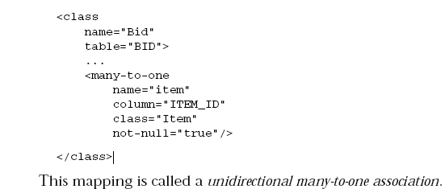

We specified the not-null attribute because we can’t have a bid without an item. The not-null attribute doesn’t affect the runtime behavior of Hibernate;

One to one association

A unidirectional one-to-one association on a foreign key is almost identical. The only difference is the column unique constraint.
<class name="Person">
<id name="id" column="personId">
<generator class="native"/>
</id>
<many-to-one name="address"
column="addressId"
unique="true"
not-null="true"/>
</class>

<class name="Address">
<id name="id" column="addressId">
<generator class="native"/>
</id>
</class>

A unidirectional one-to-one association on a primary key usually uses a special id generator In this example, however, we have reversed the direction of the association:
<class name="Person">
<id name="id" column="personId">
<generator class="native"/>
</id>
</class>

<class name="Address">
<id name="id" column="personId">
<generator class="foreign">
<param name="property">person</param>
</generator>
</id>
<one-to-one name="person" constrained="true"/>
</class>

One to many association

A unidirectional one-to-many association on a foreign key is an unusual case, and is not recommended.
<class name="Person">
<id name="id" column="personId">
<generator class="native"/>
</id>
<set name="addresses">
<key column="personId"
not-null="true"/>
<one-to-many class="Address"/>
</set>
</class>

<class name="Address">
<id name="id" column="addressId">
<generator class="native"/>
</id>
</class>
create table Person ( personId bigint not null primary key )
create table Address ( addressId bigint not null primary key, personId bigint not null )

You should instead use a join table for this kind of association.

One-to-many relationship with join tables:

A unidirectional one-to-many association on a join table is the preferred option. Specifying unique="true", changes the multiplicity from many-to-many to one-to-many.
<class name="Person">
<id name="id" column="personId">
<generator class="native"/>
</id>
<set name="addresses" table="PersonAddress">
<key column="personId"/>
<many-to-many column="addressId"
unique="true"
class="Address"/>
</set>
</class>

<class name="Address">
<id name="id" column="addressId">
<generator class="native"/>
</id>
</class>
create table Person ( personId bigint not null primary key )
create table PersonAddress ( personId not null, addressId bigint not null primary key )
create table Address ( addressId bigint not null primary key )

Many To Many associations
The database schema for this mapping is therefore:
_____________ __________________
| | | | _____________
| EVENTS | | PERSON_EVENT | | |
|_____________| |__________________| | PERSON |
| | | | |_____________|
| *EVENT_ID | <--> | *EVENT_ID | | |
| EVENT_DATE | | *PERSON_ID | <--> | *PERSON_ID |
| TITLE | |__________________| | AGE |
|_____________| | FIRSTNAME |
| LASTNAME |
|_____________|

<class name="Person" table="PERSON">
<id name="id" column="PERSON_ID">
<generator class="native"/>
</id>
<property name="age"/>
<property name="firstname"/>
<property name="lastname"/>

<set name="events" table="PERSON_EVENT">
<key column="PERSON_ID"/>
<many-to-many column="EVENT_ID" class="Event"/>
</set>

</class>

For a many-to-many association, or n:m entity relationship, an association table is required.
private void addPersonToEvent(Long personId, Long eventId) {
Session session = HibernateUtil.getSessionFactory().getCurrentSession();
session.beginTransaction();

Person aPerson = (Person) session.load(Person.class, personId);
Event anEvent = (Event) session.load(Event.class, eventId);
aPerson.getEvents().add(anEvent);

session.getTransaction().commit();
}

After loading a Person and an Event, simply modify the collection using the normal collection methods. There is no explicit call to update() or save(); Hibernate automatically detects that the collection has been modified and needs to be updated. This is called automatic dirty checking.
The process of synchronizing the memory state with the database, usually only at the end of a unit of work, is called flushing
The call to update makes a detached object persistent again by binding it to a new unit of work, so any modifications you made to it while detached can be saved to the database. This includes any modifications (additions/deletions) you made to a collection of that entity object.
<set name="emailAddresses" table="PERSON_EMAIL_ADDR">
<key column="PERSON_ID"/>
<element type="string" column="EMAIL_ADDR"/>
</set>

The difference compared with the earlier mapping is the use of the element part which tells Hibernate that the collection does not contain references to another entity, but is rather a collection whose elements are values types, here specifically of type string
Now map this side of the association in Event.hbm.xml.
<set name="participants" table="PERSON_EVENT" inverse="true">
<key column="EVENT_ID"/>
<many-to-many column="PERSON_ID" class="Person"/>
</set>

The most important addition here is the inverse="true"attribute in the set element of the Event's collection mapping.
What this means is that Hibernate should take the other side, the Person class, when it needs to find out information about the link between the two
What about the inverse mapping attribute? For you, and for Java, a bi-directional link is simply a matter of setting the references on both sides correctly. Hibernate, however, does not have enough information to correctly arrange SQL INSERT and UPDATE statements (to avoid constraint violations). Making one side of the association inverse tells Hibernate to consider it a mirror of the other side. That is all that is necessary for Hibernate to resolve any issues that arise when transforming a directional navigation model to a SQL database schema. The rules are straightforward: all bi-directional associations need one side as inverse. In a one-to-many association it has to be the many-side, and in many-to-many association you can select either side.

Bidirectional association
We need one more thing in our association mapping to tell Hibernate to treat this as a bidirectional association: The inverse attribute tells Hibernate that the collection is a mirror image of the many-to-one association on the other side:

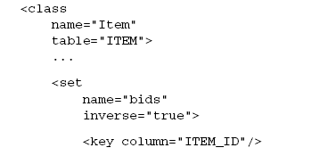
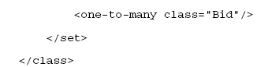

When we instantiate a new Bid and add it to an Item, the bid should become persistent
immediately. We would like to avoid the need to explicitly make a Bid persistent
by calling save() on the Session interface.
We make one final tweak to the mapping document to enable cascading save:

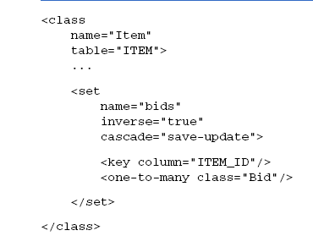

A parent/child relationship

Use ‘cascade=”all-delete-orphan”’ to specify parent child relationship.

We used cascade="all-delete-orphan" to indicate the following:
■ Any newly instantiated Bid becomes persistent if the Bid is referenced by a
persistent Item (as was also the case with cascade="save-update"). Any persistent
Bid should be deleted if it’s referenced by an Item when the item is
deleted.
■ Any persistent Bid should be deleted if it’s removed from the bids collection
of a persistent Item. (Hibernate will assume that it was only referenced
by this item and consider it an orphan.)
We have achieved with the following with this mapping: A Bid is removed from
the database if it’s removed from the collection of Bids of the Item (or it’s
removed if the Item itself is removed).

Lifecycle of Hibernate Persistent objects

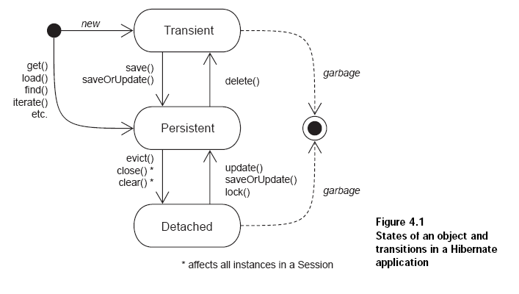

Transient
In Hibernate, objects instantiated using the new operator aren’t immediately persistent.
Their state is transient, which means they aren’t associated with any database
table row, and so their state is lost as soon as they’re dereferenced (no longer referenced
by any other object) by the application.

Hibernate considers all transient instances to be nontransactional; a modification
to the state of a transient instance isn’t made in the context of any transaction.
This means Hibernate doesn’t provide any rollback functionality for transient
objects. (In fact, Hibernate doesn’t roll back any object changes, as you’ll see later.)
Objects that are referenced only by other transient instances are, by default, also
transient. For an instance to transition from transient to persistent state requires
either a save() call to the persistence manager or the creation of a reference from
an already persistent instance.

Persistent
persistent instances are always associated with a Session and are transactional.
Persistent instances participate in transactions—their state is synchronized
with the database at the end of the transaction. When a transaction commits,
state held in memory is propagated to the database by the execution of SQL
INSERT, UPDATE, and DELETE statements.

If you only want to update modified columns, you can enable dynamic
SQL generation by setting dynamic-update="true" in a class mapping.

A persistent instance may be made transient via a delete() call to the persistence
manager API,

Detached
In the case of Hibernate, however, these instances lose their association with the
persistence manager when you close() the Session. We refer to these objects as
detached, indicating that their state is no longer guaranteed to be synchronized with
database state; they’re no longer under the management of Hibernate.

Hibernate lets you reuse these instances in a new transaction by reassociating them with a new persistence manager.

Hibernate also provides an explicit detachment operation: the evict() method
of the Session. However, this method is typically used only for cache management
(a performance consideration). It’s not normal to perform detachment explicitly.
Rather, all objects retrieved in a transaction become detached when the Session is
closed or when they’re serialized (if they’re passed remotely, for example).

A detached object can be made persistent by calling update() or lock() method on the object.

A detached object can be made persistent by Calling delete() method.

Retrieving a persistent object
Session session = sessions.openSession();
Transaction tx = session.beginTransaction();
int userID = 1234;
User user = (User) session.get(User.class, new Long(userID));
tx.commit();
session.close();

Using transitive persistence in Hibernate
Transitive persistence is a technique that allows you to propagate persistence to transient
and detached subgraphs automatically.

Cascading persistence with Hibernate

Cascade=none, all, delete, save-upate, all-delete-orphan, delete-orphan

Distinguishing between transient and detached instances
A range of options is available. Hibernate will assume that an instance is an
unsaved transient instance if:
■ The identifier property (if it exists) is null.
■ The version property (if it exists) is null.
■ You supply an unsaved-value in the mapping document for the class, and
the value of the identifier property matches.
■ You supply an unsaved-value in the mapping document for the version
property, and the value of the version property matches.
■ You supply a Hibernate Interceptor and return Boolean.TRUE from Interceptor.
isUnsaved() after checking the instance in your code.

However, if we had used the primitive type long in our persistent classes, we
would have needed to use the following identifier mapping in all our classes:

<class name="Category" table="CATEGORY">
<id name="id" unsaved-value="0">
<generator class="native"/>
</id>
....
</class>

The unsaved-value attribute tells Hibernate to treat instances of Category with an
identifier value of 0 as newly instantiated transient instances.

Retrieving objects
The objects can be retrieving from database by following methods
1. Navigating the object graph, starting from an already loaded object, by
accessing the associated objects through property accessor methods such as
aUser.getAddress().getCity().
2. Retrieving by identifier,
3. Using the Hibernate Query Language (HQL),
4. Using the, Hibernate Criteria API,
5. Using native SQL queries,

1. Retrieving objects by identifier
User user = (User) session.get(User.class, userID);
User user = (User) session.load(User.class, userID);

If load() can’t find the object in the cache or database, an exception is thrown. The load() method never returns null. The get() method returns null if the object can’t be found.

The load() method may return a proxy instead of a real persistent instance. A proxy is a placeholder that triggers the loading of the real object when it’s accessed for the first time; we discuss proxies later in this section. On the other hand, get() never returns a proxy.

2. Retrieving by HQL
Ex:
Query q = session.createQuery("from User u where u.firstname = :fname");
q.setString("fname", "Max");
List result = q.list();

3. Query by
Criteria criteria = session.createCriteria(User.class);
criteria.add( Expression.like("firstname", "Max") );
List result = criteria.list();

- Query by example

User exampleUser = new User();
exampleUser.setFirstname("Max");
Criteria criteria = session.createCriteria(User.class);
criteria.add( Example.create(exampleUser) );
List result = criteria.list();

The idea behind QBE is that the application supplies an instance of the queried class with
certain property values set (to nondefault values).

Fetching strategies

Immediate fetching
Immediate association fetching occurs when you retrieve an entity from the database
and then immediately retrieve another associated entity or entities in a further
request to the database or cache.

Lazy Fetching
Lazy fetching lets you decide how much of the object graph is loaded in the first
database hit and which associations should be loaded only when they’re first
accessed.

<class name="Item" lazy="true">

Eager (outer join) fetching
Outer join fetching allows a whole graph of objects connected by many-to-one, one-to-many, many-to-many and one-to-one associations to be retrieved in a single SQL SELECT.
Outer join fetching can be disabled globally by setting the property hibernate.max_fetch_depth to 0. A setting of 1 or higher enables outer join fetching for one-to-one and many-to-one associations that have been mapped with fetch="join".

Eager fetching lets you explicitly specify which associated objects should be loaded
together with the referencing object. Hibernate can then return the associated
objects in a single database request, utilizing an SQL OUTER JOIN.

<many-to-one name="item" class="Item" outer-join="true">

outer-join="auto"—The default. When the attribute isn’t specified; Hibernate
fetches the associated object lazily if the associated class has proxying
enabled, or eagerly using an outer join if proxying is disabled (default).

■ outer-join="true"—Hibernate always fetches the association eagerly using
an outer join, even if proxying is enabled. This allows you to choose different
fetching strategies for different associations to the same proxied class.

■ outer-join="false"—Hibernate never fetches the association using an
outer join, even if proxying is disabled. This is useful if you expect the associated
object to exist in the second-level cache (see chapter 5). If it isn’t
available in the second-level cache, the object is fetched immediately using
an extra SQL SELECT.

Batch fetching

Batch fetching isn’t strictly an association fetching strategy; it’s a technique that may
help improve the performance of lazy (or immediate) fetching. Usually, when you
load an object or collection, your SQL WHERE clause specifies the identifier of the
object or object that owns the collection. If batch fetching is enabled, Hibernate
looks to see what other proxied instances or uninitialized collections are referenced
in the current session and tries to load them at the same time by specifying
multiple identifier values in the WHERE clause.

<class name="Item" lazy="true" batch-size="9">

Need to read from page 172

Setting the fetch depth

Hibernate’s outer join fetch behavior is controlled with the global configuration
option hibernate.max_fetch_depth.

Transactions, concurrency, and caching

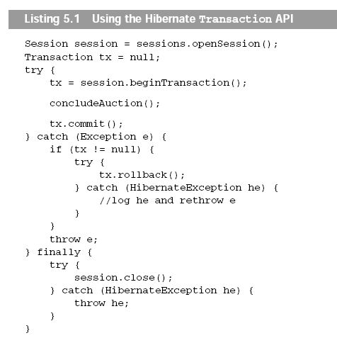

Flushing the Session

Flushing the Session state to the database at the end of a database transaction is
required in order to make the changes durable and is the common case.

You can control this behavior by explicitly setting the Hibernate FlushMode via a
call to session.setFlushMode(). The flush modes are as follows:
■ FlushMode.AUTO—The default. Enables the behavior just described.
■ FlushMode.COMMIT—Specifies that the session won’t be flushed before query
execution (it will be flushed only at the end of the database transaction). Be
aware that this setting may expose you to stale data: modifications you made
to objects only in memory may conflict with the results of the query.
■ FlushMode.NEVER—Lets you specify that only explicit calls to flush() result
in synchronization of session state with the database.

Setting an isolation level

hibernate.connection.isolation = 4

1—Read uncommitted isolation
■ 2—Read committed isolation
■ 4—Repeatable read isolation
■ 8—Serializable isolation

Locking

Using pessimistic locking

Locking is a mechanism that prevents concurrent access to a particular item of data. When one transaction holds a lock on an item, no concurrent transaction can read and/or modify this item. A lock might be just a momentary lock, held while the item is being read, or it might be held until the completion of the transaction. A pessimistic lock is a lock that is acquired when an item of data is read and that is held until transaction completion.

Transaction tx = session.beginTransaction();
Category cat =
(Category) session.get(Category.class, catId, LockMode.UPGRADE);
cat.setName("New Name");
tx.commit();

Hibernate defines several lock modes:
■ LockMode.NONE—Don’t go to the database unless the object isn’t in either
cache.
■ LockMode.READ—Bypass both levels of the cache, and perform a version
check to verify that the object in memory is the same version that currently
exists in the database.
■ LockMode.UPDGRADE—Bypass both levels of the cache, do a version check
(if applicable), and obtain a database-level pessimistic upgrade lock, if
that is supported.
■ LockMode.UPDGRADE_NOWAIT—The same as UPGRADE, but use a SELECT...FOR
UPDATE NOWAIT on Oracle. This disables waiting for concurrent lock releases,
thus throwing a locking exception immediately if the lock can’t be obtained.
LockMode.WRITE—Is obtained automatically when Hibernate has written to
a row in the current transaction (this is an internal mode; you can’t specify
it explicitly).
By default, load() and get() use LockMode.NONE. LockMode.READ is most useful wit

Using managed versioning

Caching strategies and scopes

- Transaction scope
- Process scope
- Cluster scope

The Hibernate cache architecture

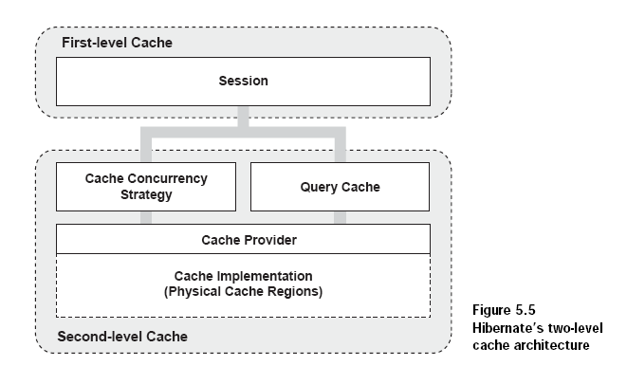

First level cache

The first-level cache is the Session itself.
The session cache ensures that when the application requests the same persistent
object twice in a particular session, it gets back the same (identical) Java instance.

If you insist on using Hibernate even for mass operations, you can immediately
evict() each object after it has been processed (while iterating through a query
result), and thus prevent memory exhaustion.

To completely evict all objects from the session cache, call Session.clear().

Second level cache

The second-level cache in Hibernate is pluggable and might be scoped to the process or cluster.

The Hibernate second-level cache has process or cluster scope;
Persistent instances are stored in the second-level cache in a disassembled form.

So the second-level cache is configurable at the
granularity of an individual class or collection role. This lets you, for example,
enable the second-level cache for reference data classes and disable it for classes
that represent financial records.

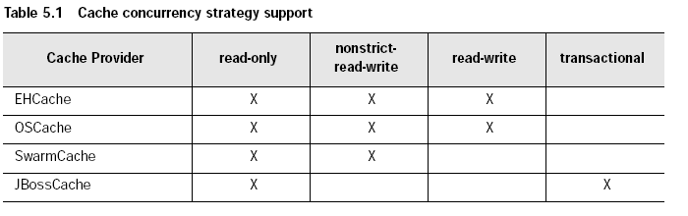

Hibernate Types
an entity is any class whose instances have their own persistent identity. A value type is a class that doesn’t define some kind of persistent identity.

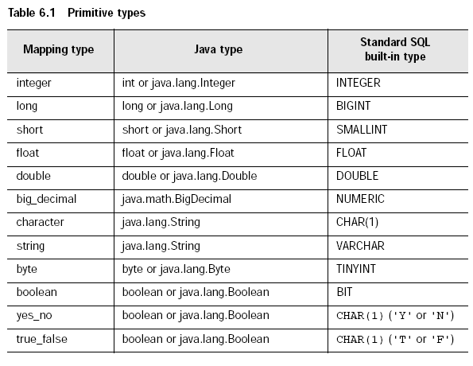

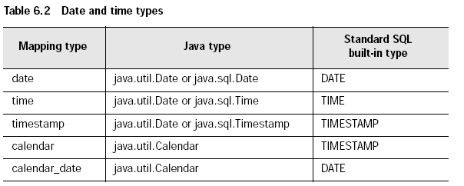

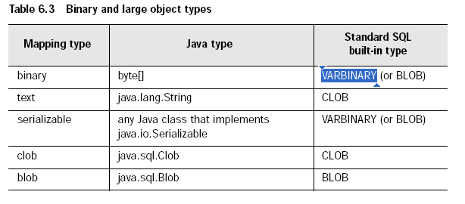

You have to override the equals() and hashCode() methods if you
• intend to put instances of persistent classes in a Set (the recommended way to represent many-valued associations)
and
• intend to use reattachment of detached instances
This is required it we mix up the results of the various sessions.

Basic OR Mapping
UUID algorithm
The UUID contains: IP address, startup time of the JVM (accurate to a quarter second), system time and a
counter value (unique within the JVM).

6.1.5. composite-id
<composite-id
name="propertyName"
class="ClassName"
unsaved-value="undefined|any|none"
access="field|property|ClassName">
node="element-name|."
<key-property name="propertyName" type="typename" column="column_name"/>
<key-many-to-one name="propertyName class="ClassName" column="column_name"/>
......
</composite-id>

6.1.6. discriminator
The discriminator column contains marker values
that tell the persistence layer what subclass to instantiate for a particular row.

Bi-directional association
A bi directional association allows navigation from both ends of the association. It supports

One to many
Set or bag values at one end, single value at other

Many to many
Set or bag value at both ends.

11.1. Hibernate object states
Hibernate defines and supports the following object states:
• Transient - an object is transient if it has just been instantiated using the new operator, and it is not associated with a Hibernate Session. It has no persistent representation in the database and no identifier value has been assigned. Transient instances will be destroyed by the garbage collector if the application doesn't hold a reference anymore. Use the Hibernate Session to make an object persistent (and let Hibernate take care of the SQL statements that need to be executed for this transition).

• Persistent - a persistent instance has a representation in the database and an identifier value. It might just have been saved or loaded, however, it is by definition in the scope of a Session. Hibernate will detect any changes made to an object in persistent state and synchronize the state with the database when the unit of work completes. Developers don't execute manual UPDATE statements, or DELETE statements when an object should be made transient.

• Detached - a detached instance is an object that has been persistent, but its Session has been closed. The reference to the object is still valid, of course, and the detached instance might even be modified in this state. A detached instance can be reattached to a new Session at a later point in time, making it (and all the modifications) persistent again. This feature enables a programming model for long running units of work that require user think-time. We call them application transactions, i.e. a unit of work from the point of view of the user.

To load and object → session.load(object name)
To create persistent object → session.save(object name)

Using Query
List mothers = session.createQuery(
"select mother from Cat as cat join cat.mother as mother where cat.name = ?")
.setString(0, name)
.list();

11.4.3. Criteria queries
HQL is extremely powerful but some developers prefer to build queries dynamically, using an object-oriented API, rather than building query strings. Hibernate provides an intuitive Criteria query API for these cases:

Criteria crit = session.createCriteria(Cat.class);
crit.add( Expression.eq( "color", eg.Color.BLACK ) );
crit.setMaxResults(10);
List cats = crit.list();

Queries in Native SQL
List cats = session.createSQLQuery(
"SELECT {cat.*} FROM CAT {cat} WHERE ROWNUM<10",
"cat",
Cat.class
).list();

Modifiying persistent objects
DomesticCat cat = (DomesticCat) sess.load( Cat.class, new Long(69) );
cat.setName("PK");
sess.flush(); // changes to cat are automatically detected and persisted

11.6. Modifying detached objects
Hibernate supports this model by providing for reattachment of detached instances using the Session.
update() or Session.merge() methods:
// in the first session
Cat cat = (Cat) firstSession.load(Cat.class, catId);
Cat potentialMate = new Cat();
firstSession.save(potentialMate);
// in a higher layer of the application
cat.setMate(potentialMate);
// later, in a new session
secondSession.update(cat); // update cat
secondSession.update(mate); // update mate

Use update() if you are sure that the session does not contain an already persistent instance with the same identifier, and merge() if you want to merge your modifications at any time without consideration of the state of the session. In other words, update() is usually the first method you would call in a fresh session, ensuring that reattachment of your detached instances is the first operation that is executed.

The lock() method also allows an application to reassociate an object with a new session. However, the detached instance has to be unmodified!

11.7. Automatic state detection
saveOrUpdate()
method that either saves a transient instance by generating a
new identifier or updates/reattaches the detached instances associated with its current identifier. The saveOrUpdate()
method implements this functionality.

Usually update() or saveOrUpdate() are used in the following scenario:
• the application loads an object in the first session
• the object is passed up to the UI tier
• some modifications are made to the object
• the object is passed back down to the business logic tier
• the application persists these modifications by calling update() in a second session

saveOrUpdate() does the following:
• if the object is already persistent in this session, do nothing
• if another object associated with the session has the same identifier, throw an exception
• if the object has no identifier property, save() it
• if the object's identifier has the value assigned to a newly instantiated object, save() it
• if the object is versioned (by a <version> or <timestamp>), and the version property value is the same
value assigned to a newly instantiated object, save() it
• otherwise update() the object
and

merge() is very different:
• if there is a persistent instance with the same identifier currently associated with the session, copy the state
of the given object onto the persistent instance
• if there is no persistent instance currently associated with the session, try to load it from the database, or
create a new persistent instance
• the persistent instance is returned
• the given instance does not become associated with the session, it remains detached
11.8. Deleting persistent objects

sess.delete(cat);

11.9. Replicating object between two different datastores
//retrieve a cat from one database
Hibernate 3.0.5 114
Session session1 = factory1.openSession();
Transaction tx1 = session1.beginTransaction();
Cat cat = session1.get(Cat.class, catId);
tx1.commit();
session1.close();
//reconcile with a second database
Session session2 = factory2.openSession();
Transaction tx2 = session2.beginTransaction();
session2.replicate(cat, ReplicationMode.LATEST_VERSION);
tx2.commit();
session2.close();
Working with objects

The ReplicationMode determines how replicate() will deal with conflicts with existing rows in the database.
• ReplicationMode.IGNORE - ignore the object when there is an existing database row with the same identifier
• ReplicationMode.OVERWRITE - overwrite any existing database row with the same identifier
• ReplicationMode.EXCEPTION - throw an exception if there is an existing database row with the same identifier
• ReplicationMode.LATEST_VERSION - overwrite the row if its version number is earlier than the version
number of the object, or ignore the object otherwise

12.1. Session and transaction scopes
A SessionFactory is an expensive-to-create, threadsafe object intended to be shared by all application threads.
It is created once, usually on application startup, from a Configuration instance.
A Session is an inexpensive, non-threadsafe object that should be used once, for a single business process, a
single unit of work, and then discarded.

We recommend to bind the Session to the thread that serves the request, using
a ThreadLocal variable. This allows easy access (like accessing a static variable) in all code that runs in this
thread. Depending on the database transaction demarcation mechanism you chose, you might also keep the
transaction context in a ThreadLocal variable. The implementation patterns for this are known as ThreadLocal
Session and Open Session in View.

12.1.2. Application transactions
• Automatic Versioning - Hibernate can do automatic optimistic concurrency control for you, it can automatically
detect if a concurrent modification occured during user think time.
• Detached Objects - If you decide to use the already discussed session-per-request pattern, all loaded instances
will be in detached state during user think time. Hibernate allows you to reattach the objects and
persist the modifications, the pattern is called session-per-request-with-detached-objects. Automatic versioning
is used to isolate concurrent modifications.
• Long Session - The Hibernate Session may be disconnected from the underlying JDBC connection after the
database transaction has been committed, and reconnected when a new client request occurs.

The Session caches
every object that is in persistent state (watched and checked for dirty state by Hibernate).
This means it grows endlessly until you get an OutOfMemoryException, if you keep it open for a long
time or simply load too much data. One solution for this is to call clear() and evict() to manage the Session
cache, but you most likely should consider a Stored Procedure if you need mass data operations.

12.2.3. Exception handling

JDBCConnectionException - indicates an error with the underlying JDBC communication.
• SQLGrammarException - indicates a grammar or syntax problem with the issued SQL.
• ConstraintViolationException - indicates some form of integrity constraint violation.
• LockAcquisitionException - indicates an error acquiring a lock level necessary to perform the requested
operation.
• GenericJDBCException - a generic exception which did not fall into any of the other categories.

12.3. Optimistic concurrency control
Version checking uses version numbers, or timestamps, to detect conflicting updates (and to prevent lost updates).

You can use two approaches: a dedicated version number or a timestamp.
A version or timestamp property should never be null for a detached instance. Hibernate will detect
any instance with a null version or timestamp as transient, irrespective of what other unsavedvalue
strategies are specified. Declaring a nullable version or timestamp property is an easy way

to avoid problems with transitive reattachment in Hibernate. It is especially useful for people using
assigned identifiers or composite keys

Alternatively, you can use a timestamp. Timestamps are a less safe implementation of optimistic
locking. However, sometimes an application might use the timestamps in other ways as well

12.4. Pessimistic Locking
Advanced users may sometimes wish to obtain exclusive pessimistic locks, or re-obtain locks at the start of a new transaction.

Hibernate will always use the locking mechanism of the database, never lock objects in memory!
The LockMode class defines the different lock levels that may be acquired by Hibernate. A lock is obtained by
the following mechanisms:
• LockMode.WRITE is acquired automatically when Hibernate updates or inserts a row.
• LockMode.UPGRADE may be acquired upon explicit user request using SELECT ... FOR UPDATE on databases
which support that syntax.
• LockMode.UPGRADE_NOWAIT may be acquired upon explicit user request using a SELECT ... FOR UPDATE
NOWAIT under Oracle.
• LockMode.READ is acquired automatically when Hibernate reads data under Repeatable Read or Serializable
isolation level. May be re-acquired by explicit user request.
• LockMode.NONE represents the absence of a lock. All objects switch to this lock mode at the end of a Transaction.
Objects associated with the session via a call to update() or saveOrUpdate() also start out in this
lock mode.

The "explicit user request" is expressed in one of the following ways:
• A call to Session.load(), specifying a LockMode.
• A call to Session.lock().
• A call to Query.setLockMode().

13.1. Interceptors
The Interceptor interface provides callbacks from the session to the application allowing the application to inspect and/or manipulate properties of a persistent object before it is saved, updated, deleted or loaded.

Batch processing
hibernate.jdbc.batch_size 20
hibernate.cache.use_second_level_cache false

Session session = sessionFactory.openSession();
Transaction tx = session.beginTransaction();
for ( int i=0; i<100000; i++ ) {
Customer customer = new Customer(.....);
session.save(customer);
if ( i % 20 == 0 ) { //20, same as the JDBC batch size
//flush a batch of inserts and release memory:
session.flush();
session.clear();
}
}
tx.commit();
session.close();

SQL’s are executed as follows
- Using Hibernate Query Language
- Using Native sql query
- Using Criteria query
- Using Custome sql for insert,delete or update
Ex:
<class name="Person">
<id name="id">
<generator class="increment"/>
</id>
<property name="name" not-null="true"/>
<sql-insert>INSERT INTO PERSON (NAME, ID) VALUES ( UPPER(?), ? )</sql-insert>
<sql-update>UPDATE PERSON SET NAME=UPPER(?) WHERE ID=?</sql-update>
<sql-delete>DELETE FROM PERSON WHERE ID=?</sql-delete>
</class>
- Using Named Queries

Ex:
<hibernate-mapping>
<query name="findStockByStockCode">
<![CDATA[from Stock s where s.stockCode = :stockCode]]>
</query>
</hibernate-mapping>

Query query = session.getNamedQuery("findStockByStockCode")
.setString("stockCode", "7277");

Filtering data
A Hibernate filter is a
global, named, parameterized filter that may be enabled or disabled for a particular Hibernate session.

The Second Level Cache
JVMlevel (SessionFactory-level) cache on a class-by-class and collection-by-collection basis.
Hibernate uses EHCache for JVM-level caching.

To remove an object from first level cache call
Session.evict(class name)

To completely remove all objects from the session cache use
Session.clear()

For removing the second level cache use
Sessionfactory.evict()

The CacheMode controls how a particular session interacts with the second-level cache.
• CacheMode.NORMAL - read items from and write items to the second-level cache
• CacheMode.GET - read items from the second-level cache, but don't write to the second-level cache except
when updating data
• CacheMode.PUT - write items to the second-level cache, but don't read from the second-level cache
• CacheMode.REFRESH - write items to the second-level cache, but don't read from the second-level cache, bypass
the effect of hibernate.cache.use_minimal_puts, forcing a refresh of the second-level cache for all
items read from the database

The Query Cache

Query result sets may also be cached.

hibernate.cache.use_query_cache true

List blogs = sess.createQuery("from Blog blog where blog.blogger = :blogger")
.setEntity("blogger", blogger)
.setMaxResults(15)
.setCacheable(true)
.setCacheRegion("frontpages")
.list();

The SchemaExport tool writes a DDL script to standard out and/or executes the DDL statements.

Difference b/w get() and load()
load() will throw an unrecoverable exception if there is no matching database row.
get() will return null if there is no matching database row.
Cat fritz = (Cat) session.load(Cat.class, "1");
Return the Cat Object with key 1. If there is no Cat Object with key 1 then throw will throw an unrecoverable exception.
If the class is
mapped with a proxy, load() just returns an uninitialized proxy and does not actually hit the database until you
invoke a method of the proxy. This behavior is very useful if you wish to create an association to an object
without actually loading it from the database. It also allows multiple instances to be loaded as a batch if batchsize
is defined for the class mapping.
Cat fritz = (Cat) session.get(Cat.class, "1");
If you are not certain that a matching row exists, you should use the get() method, which hits the database immediately
and returns null if there is no matching row.

Using stored procedures for querying

Hibernate3 provides support for queries via stored procedures and functions. Most of the following documentation is equivalent for both. The stored procedure/function must return a resultset as the first out-parameter to be able to work with Hibernate. An example of such a stored function in Oracle 9 and higher is as follows:
CREATE OR REPLACE FUNCTION selectAllEmployments
RETURN SYS_REFCURSOR
AS
st_cursor SYS_REFCURSOR;
BEGIN
OPEN st_cursor FOR
SELECT EMPLOYEE, EMPLOYER,
STARTDATE, ENDDATE,
REGIONCODE, EID, VALUE, CURRENCY
FROM EMPLOYMENT;
RETURN st_cursor;
END;
To use this query in Hibernate you need to map it via a named query.
<sql-query name="selectAllEmployees_SP" callable="true">
<return alias="emp" class="Employment">
<return-property name="employee" column="EMPLOYEE"/>
<return-property name="employer" column="EMPLOYER"/>
<return-property name="startDate" column="STARTDATE"/>
<return-property name="endDate" column="ENDDATE"/>
<return-property name="regionCode" column="REGIONCODE"/>
<return-property name="id" column="EID"/>
<return-property name="salary">
<return-column name="VALUE"/>
<return-column name="CURRENCY"/>
</return-property>
</return>
{ ? = call selectAllEmployments() }
</sql-query>

List people = sess.getNamedQuery("selectAllEmployees ").list();

Hibernate Pagination

Query and Criteria supports pagination.

Query query = session.createQuery(“from user u order by u.name asc”);
query.setMaxResults(10);
query.setFirstResult(40);

The above query will retrieve 10 records from 40th record.

Simillaryly,
Criteria criteria = session.createCriteria(User.class);
criteria.addOrder(Order.asc(“name”));
criteria.setFirstResult(40);
criteria.setMaxResults(20);

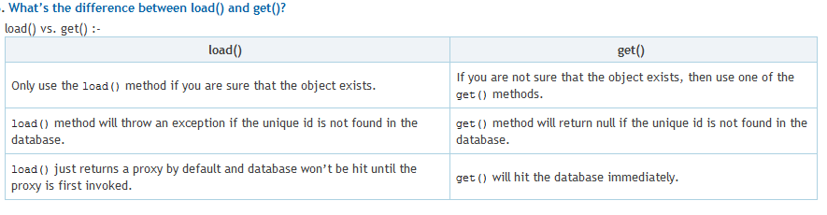

Component mapping in Hibernate
- A component is an object saved as a value, not as a reference
- A component can be saved directly without needing to declare interfaces or identifier properties
- Required to define an empty constructor
- Shared references not supported
Example:
