SOA

Current Status of Business Systems

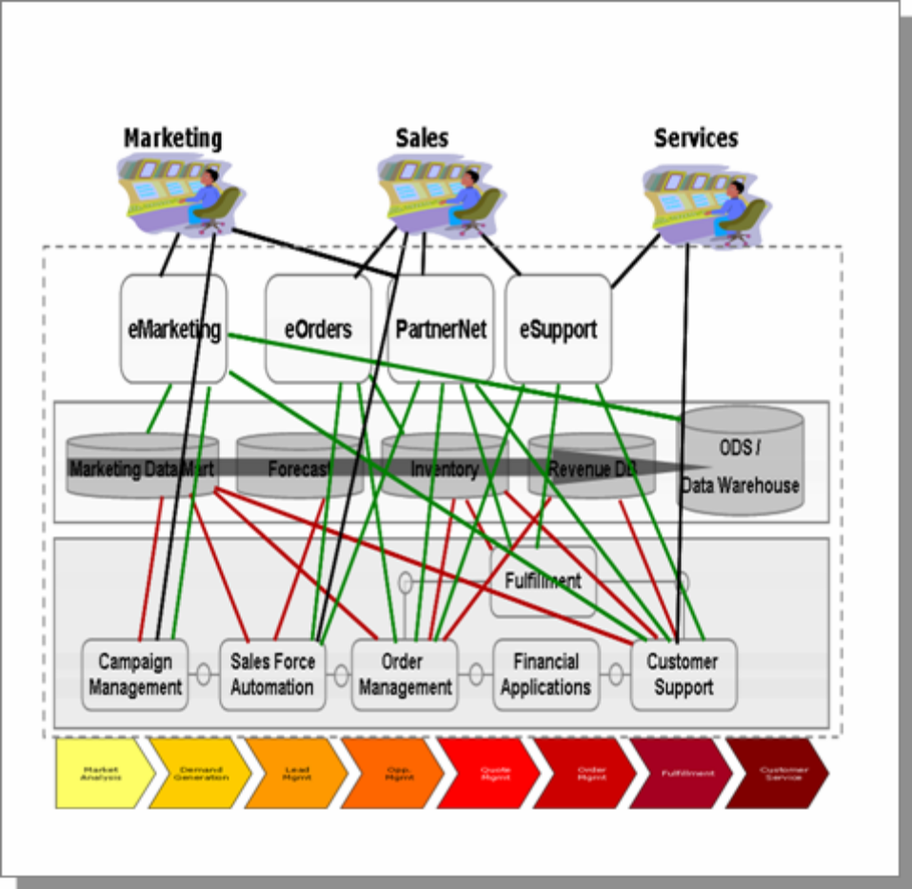

Traditionally, IT works with the business owners, who are influenced by application vendors. This results
in IT strategies that are application or integration-focused. In addition, governance and funding models
have pushed both business and IT stakeholders to do whatever it takes to meet a particular business unit
or department need. This results in many “one-off” applications that may or may not be integrated into the
existing architecture. Mergers and acquisitions introduce new software platforms

What is SOA?
- SOA is a business operations strategy for leveraging information to meet the organization’s objectives, such as increasing overall revenue, boosting customer satisfaction, improving product quality, and enhancing operational agility.

- provide flexible, decoupled functionality that can be reused,

SOA has the following unique capabilities
- Reduced cost. Provides the opportunity to consolidate redundant application functionality and decouple functionality from obsolete and increasingly costly applications while leveraging existing investments.
- Increased flexibility. Structures IT applications based on services in such a way as to facilitate the rapid restructuring and reconfiguration of the business processes and applications that consume them.
- Increased revenue. Provides the opportunity to enter into new markets and leverage existing business capabilities in new and innovative ways using a set of loosely coupled IT services. Helps to increase market share by offering new and better business services.
- Added agility. Delivers business-aligned applications faster.
- Increased consolidation. Integrates IT systems across siloed applications and organizations.

Layers of the SOA solution stack

The layers facilitate separation of concerns. The SOA solution stack defines a blueprint that can be used to define the layers, architectural building blocks within the layers, options available at each layer, and typical architectural decisions that need to be made.

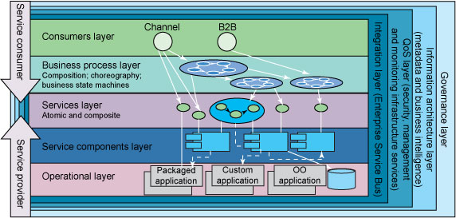
Figure 2. Layers of the SOA reference architecture: Solution stack view
Figure 2 depicts an SOA as a set of logical layers. Note that the SOA solution stack is a partially layered architecture. One layer does not solely depend upon the layer below it; for example, a consumer can access the business process layer as a service or the service layer directly, but not beyond the constraints of the SOA architectural style.

The lower layers (services, service components and operational layer) are concerns for the provider, and the upper ones (services, business processes, and consumers) are concerns for the consumer.

Layer 1. Operational layer
This layer includes all custom or packaged application assets in the application portfolio running in an IT operating environment, supporting business activities. The operational layer is made up of existing application software systems; thereby, it is used to leverage existing IT investments in implementing an SOA solution.
A number of existing software systems are part of this layer. Those systems include:
- Existing monolithic custom applications, including J2EE™ and Microsoft® .NET® applications
- Legacy applications and systems
- Existing transaction processing systems
- Existing databases
- Existing packaged applications and solutions, including enterprise resource planning (ERP) and customer relationship management (CRM) packages (such as SAP and Oracle solutions)
Layer 2. Service component layer
This layer contains software components, each of which provide the implementation for, realization of, or operation on a service, which is why it's called a service component. Service components reflect the definition of a service, both in its functionality and its quality of service.
Each service component:
- Provides an enforcement point for "faithful" service realization to ensure quality of service and adherence to service-level agreements (SLAs).
- Enables business flexibility by supporting the functional implementation of IT flexible services as well as their composition and layering.
- Enables IT flexibility by strengthening decoupling in the system. Decoupling is achieved by hiding volatile implementation details from consumers.
Figure 3 illustrates these concepts and shows service A implemented using a combination of behavior from the third-party Package X and Application Y. Application B, the consumer, is coupled only to the description of the exposed service. The consumer must assume that the realization of the service is faithful to its published description (thereby providing service compliance), and it is the providers' responsibility to ensure that it is. The details of the realization, however, are of no consequence to Application B. Service Component A acts as a service implementation facade, aggregating available system behavior and giving the provider an enforcement point for service compliance.
Figure 3. Service component as a facade
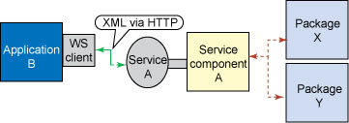

Subsequently, the provider organization may decide to replace Package X with Package M or some other application. Service component A encapsulates the required modifications with the result that there is no impact on any consumers of service A. This example illustrates the value of the service component layer in supporting IT flexibility through encapsulation.

Layer 3. Services layer

This layer consists of all the services defined within the SOA. For the purposes of this reference architecture, a service is considered to be an abstract specification of a collection of (one or more) business-aligned IT functions. The specification provides consumers with sufficient detail to invoke the business functions exposed by a provider of the service; ideally this is done in a platform-independent manner. The service specification includes a description of the abstract functionality offered by the service similar to the abstract stage of a Web Services Definition Language (WSDL) description [5]. This information is not necessarily written using WSDL.

The service specification may also include:
- A policy document
- SOA management descriptions
- Attachments that categorize or show service dependencies
Exposed services reside in this layer; they can be discovered and invoked or possibly choreographed to create a composite service. Services are functions that are accessible across a network through well-defined interfaces of the services layer.

Some of the services in the service layer may be versions of other services, implying that a significant successor-predecessor relationship exists between them

Services are accessible independent of implementation and transport. This capability allows a service to be exposed consistently across multiple customer-facing channels such as the Web, interactive voice response (IVR), Seibel client (used by a customer service rep), and so on.

The services layer can be further divided into sublayers. It includes the services that will be delivered by a given architecture, including both composite and atomic services. Figure 3 shows how to build an SOA solution using the underlying middleware and infrastructure services provided and categorized in Figure 4.

Figure 4. The middleware view of the SOA reference architecture
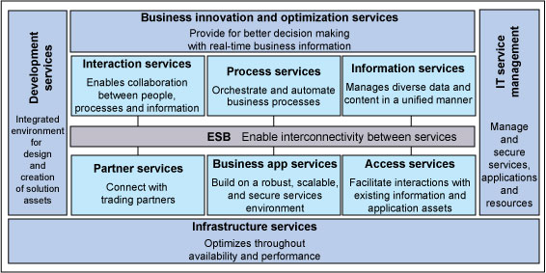

Compositions and choreographies of services exposed in layer 3 are defined in this layer. We use service composition to combine groups of services into flows, or we choreograph services into flows, thereby establishing applications out of services. These applications support specific use cases and business processes. To do this, visual flow composition tools can be used for design of application flows. Figure 5 shows how a business process P can be implemented using services A, B, C, and D from the services layer. Process P contains the logic for the sequence in which the services need to be invoked and executed. The services that are aggregated as a business process, or flow, can be individual services or composite services made up of individual services.

Layer 4. Business process layer
Compositions and choreographies of services exposed in layer 3 are defined in this layer. We use service composition to combine groups of services into flows, or we choreograph services into flows, thereby establishing applications out of services. These applications support specific use cases and business processes. To do this, visual flow composition tools can be used for design of application flows. Figure 5 shows how a business process P can be implemented using services A, B, C, and D from the services layer. Process P contains the logic for the sequence in which the services need to be invoked and executed. The services that are aggregated as a business process, or flow, can be individual services or composite services made up of individual services.

Figure 5. Services orchestration
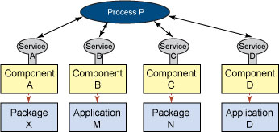

The business process layer covers the process representation, composition methods, and building blocks for aggregating loosely coupled services as a sequencing process aligned with business goals. Data flow and control flow are used to enable interactions between services and business processes. The interaction may exist within an enterprise or across multiple enterprises.

A business process captures the activities needed to accomplish a specific business goal. Typically, an enterprise uses both top-down and bottom-up approaches to assure proper business process definition. Using the top-down approach, business processes are defined by business analysts based on customers' requirements. To optimize the business process for better IT implementation, it is componentized as a reusable service that can be modeled, analyzed, and optimized based on business requirements such as quality of service (QoS) described in layer 7, flow preference, price, time of delivery, and customer preferences. Using a bottom-up approach, after creating a set of assets, we would try to leverage them in a meaningful business context to satisfy customer requirements. The flexibility and extensibility of services composition guided by business requirements and composition rules help make business process into an on demand entity for addressing different types of customer pain points by reusing services assets.

The business process layer communicates with the consumer layer (also called the presentation layer) to communicate inputs and results from the various people who use the system (end users, decision makers, system administrators) through Web portals or business-to-business (B2B) programs. Most of the control-flow messages and data-flow messages of the business process may be routed and transformed through the integration layer. The structure of the messages is most often defined by the information architecture layer. The key performance indicators (KPIs) for each task or process could be defined in the QoS and business intelligence layers. The design of service aggregations is guided by the governance layer. Of course, all the services should be represented and described by the services layer in the SOA solution stack.
Business process layer in the SOA solution stack plays a central coordinating role in connecting business-level requirements and IT-level solution components through collaboration with the integration layer, QoS, and business intelligence layer, as well as the information architecture layer and services layer.

Layer 5. Consumer layer
The consumer layer, or the presentation layer, provides the capabilities required to deliver IT functions and data to end users to meet specific usage preferences. This layer can also provide an interface for application to application communication. The consumer layer of the SOA solution stack provides the capability to quickly create the front end of business processes and composite applications to respond to changes in user needs through channels, portals, rich clients, and other mechanisms. It enables channel-independent access to those business processes supported by various application and platforms. It is important to note that SOA decouples the user interface from the components.

Adopting proven front-end access patterns (for example, portals) and open standards (such as WSRP) can decrease development and deployment cycle times through the use of prebuilt, proven, and reusable front-end building blocks. Use of these patterns also reduces complexity and maintenance costs through use of those common building blocks.

Layer 6. Integration layer
it provides the capability to mediate, route, and transport service requests from the service requester to the correct service provider. This layer enables the integration of services through the introduction of a reliable set of capabilities. These include modest point-to-point capabilities for tightly coupled endpoint integration as well as more intelligent routing, protocol mediation, and other transformation mechanisms often provided by an enterprise service bus (ESB). Web Services Description Language (WSDL) specifies a binding, which implies the location where a service is provided. An ESB, on the other hand, provides a location-independent mechanism for integration.

This is the layer that provides communications, invocation, and quality of service between adjacent layers in an SOA. For example, this layer is where binding of services occurs for process execution, allowing a service to be exposed consistently across multiple customer-facing channels such as Web, IVR, Seibel client, and the like. The transformation of response to HTML (for Web), Voice XML (for IVR), XML string (for Siebel client) can be done using XSLT functionality supported through ESB transformation capability in the integration layer.

Figure 6. Interaction diagram of the integration layer
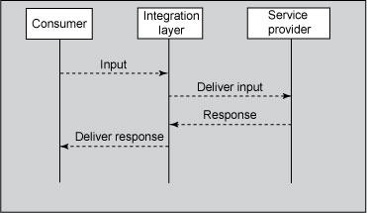

Layer 7. Quality of service layer

Inherent in SOA are characteristics that exacerbate existing QoS concerns in computer systems. Among those characteristics are:
- Increased virtualization
- Loose coupling
- Widespread use of XML
- The composition of federated services
- Heterogeneous computing infrastructures
- Decentralized SLAs
- The need to aggregate IT QoS metrics to produce business metrics

The QoS layer provides an SOA with the capabilities required to realize nonfunctional requirements (NFRs). It must also capture, monitor, log, and signal noncompliance with those requirements relating to the relevant service qualities associated with each SOA layer. This layer serves as an observer of the other layers and can emit signals or events when a noncompliance condition is detected or, preferably, when a noncompliance condition is anticipated.

This layer provides the means of ensuring that an SOA meets its requirements with respect to reliability, availability, manageability, scalability, and security. Finally, it enhances the business value of SOA by enabling businesses to monitor the business processes contained in the SOA with respect to the business KPIs that they influence.

Layer 8. Information architecture and business intelligence layer
The information architecture and business intelligence layer ensures the inclusion of key considerations pertaining to data architecture and information architectures that can also be used as the basis for the creation of business intelligence through data marts and data warehouses. This includes metadata content, which is stored in this layer, as well as information architecture and business intelligence considerations.
Especially applicable to industry-specific SOA solutions, this layer captures cross-industry and industry-specific data structures, XML-based metadata architectures (that is, XML schema), and business protocols of exchanging business data. Some discovery, data mining, and analytic modeling of data is also covered in this layer.
Layer 9. Governance layer

The governance layer covers all aspects of business operational life-cycle management in SOA. It provides guidance and policies for making decisions about an SOA and managing all aspects of an SOA solution, including capacity, performance, security, and monitoring. It enables SOA governance services to be fully integrated by emphasizing the operational life-cycle management aspect of the SOA. This layer can be applied to all the other layers in the SOA solution stack. Since it helps enforce QoS and make appropriate application of performance metrics, it is well connected with layer 7.

Jboss middleware for SOA

IBM middleware for SOA

Recommended Approach

Understand the business services: this is the critical first step towards successful adoption of
SOA
Date: 9/15/2006 SOA Practitioners’ Guide, Part 1: Why Services-Oriented Architecture? Page 10 of 18
• Develop an information strategy that identifies key performance metrics such as “reduce product
defects by x percentage,” or “respond to all mortgage requests within 24 hours”
• Develop an SOA blueprint that articulates the business benefits and includes business principles,
reference architecture, roadmap, and governance and organization guidelines
• Identify “quick wins” to demonstrate that, with SOA, IT can improve on its current average of 15-
18 months to deliver new capabilities.

SOA Lifecycle Approach

SOA Lifecycle Stages
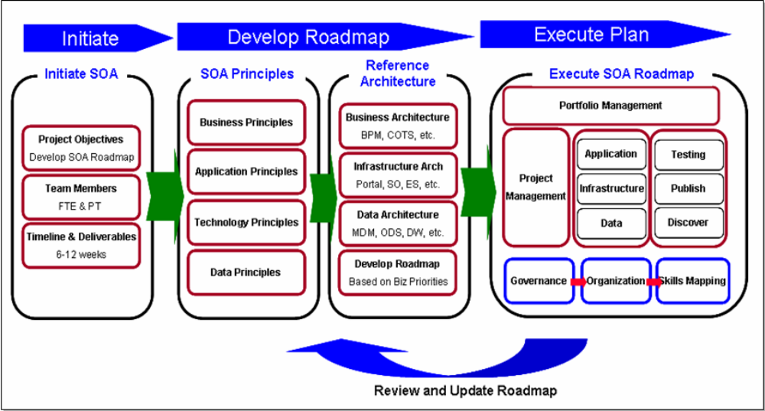

Initiate SOA
At this phase, the company establishes a project team, objectives, and timelines & deliverables. The objective is to create a roadmap that combines business and IT efforts, and that will be approved by an IT Board of Directors.

Develop Roadmap
The team needs to create a roadmap, which spells out the process for conducting an SOA assessment for the organization, developing the SOA principles, defining the reference architecture (future state), and making the transition from the current situation to the future state.

SOA Execution Plan
The execution plan describes how to execute towards the SOA roadmap. Execution has two tracks:
• Projects: teams execute projects in the sequence described in the roadmap and build out the
infrastructure as required to provide the business capability
• Governance and organization: teams implement this in parallel to enable efficient project
execution based on SOA.

SOA Foundation

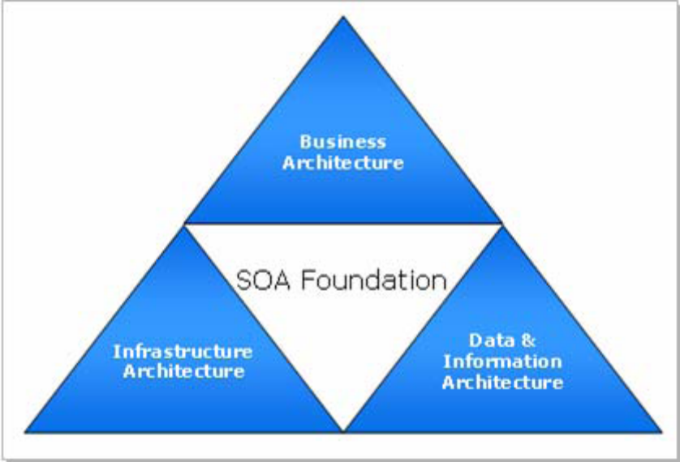

Business Architecture
Business architecture describes the business strategy, objectives, priorities, and processes to be
supported by the SOA.

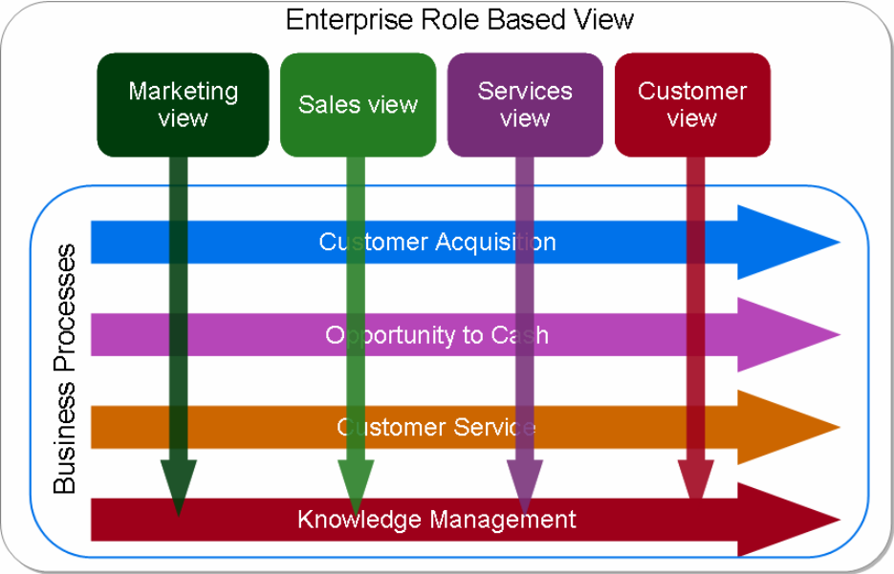
Focus Areas for Business Architecture

Infrastructure Architecture
It should address all the aspects of the scalable infrastructure from networks, enterprise servers, data centers, and firewalls, to application infrastructure, security, monitoring, and middleware.

Data Architecture
Data architecture deals with the logical and physical modeling of the data as well as data manipulation and data quality.

Information Architecture
Information architecture models key concepts and events for a given business process. The business concepts represent any business entities that need to be exchanged by the processes or applications that support the enterprise.

