Cocoon
Cocoon is officially defined as an XML publishing engine, and while technically correct, the description does not do the product justice. The best way to understand Cocoon is to view it as a framework for generating, transforming, processing, and outputting data. Think of Cocoon as a machine that receives data from a wide variety of sources, applies various processing to it, and spits data out in the desired format. Figure 1 helps illustrate this view.
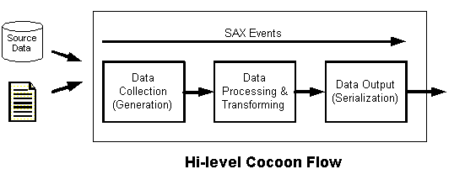

- Cocoon handles all data internally as SAX (Simple API for XML) events; any non-XML input data converts to an XML representation.
- Components called generators—because they generate SAX events—handle data input.
- Components called serializers handle data output—they write the data out to the client (that is, browser, file, and so on).
- The developer combines generators, serializers, and other components to form processing flows called pipelines. All pipelines are defined in a file called the sitemap.
- URI (Uniform Resource Identifier) patterns identify pipelines, but URIs are completely decoupled from physical resources.

