Function Point Analysis

Function Point
Standard unit of measure to represent the functional size of a software application.

Five step counting process

- Determine the type of count
- Determine the scope and boundary of the count
- Determine unadjusted function point
- Determine the value adjustment factor
- Determine the adjusted function point count.

Types of FP count
- Development project FP count
FP can be counted from all phases of development project from requirement to implementation.

- Enhancement project FP count

- Application FP count
Done on existing production application.

Standard functions

Data functions
- Internal logical files
- External interface files

Transaction functions
- External input
- External output
- External inquiries

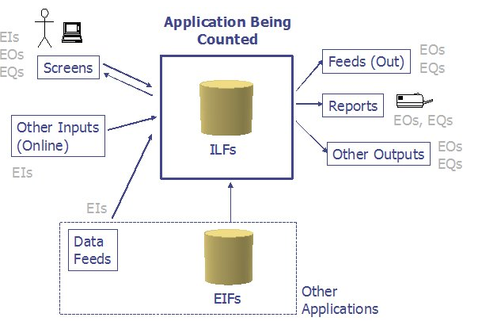

Data Element Type (DET):
A DET is a unique user recognizable, non-recursive (non-repetitive) field. A DET is information that is dynamic and not static. This applied to both data functions and transaction functions.

RET (Record Element Type)
It is a user recognizable sub group of data elements within a ILF or EIF.

Internal Logic files(ILF)
ILF is a user recognizable group of logically related data or control information maintained within the boundary of the application. The primary intent of ILF is to hold data maintained through one or more elementary processes.

RETS | Data Element Types (DETs)
 | 1-19 | 20-50 | 51+
1 | L | L | A
2 to 5 | L | A | H
6 or more | A | H | H

Complexity | Points
Low | 7
Average | 10
High | 15

External interface files (EIF)

EIF is a user recognizable group of logically related data or control information that is maintained within the boundary of reference application. This is the data that application being counted uses but doesn’t maintain.

 | Data Element Types (DETs)
RETS | 1-19 | 20-50 | 51+
1 | L | L | A
2 to 5 | L | A | H
6 or more | A | H | H

Value | No. or Function Points
Low | 5
Average | 7
High | 10

External Input (EI)
Represents the elementary process that processes data or control information that comes from outside the application boundary. It maintains one or more ILF’s and/or alters the behavior of the system.

To arrive at FP for the EI count we refer to DET’s and FTR’s.

File Type Referenced (FTR):
A FTR is a file type referenced by a transaction. An FTR must also be an internal logical file or external interface file.

FTRs | Data Element Types (DETs)
 | 1-4 |  | 5-15 |  | 16+
0-1 | L |  | L |  | A
2 | L |  | A |  | H
3 or more | A |  | H |  | H
Complexity |  | Points/Weight
Low |  | 3
Average |  | 4
High |  | 6

External Outputs (EO)
These are the elementary process that send data or control information out side the application boundary. The processing logic will involve one or more mathematical calculation, create derived data maintain one or more ILF’s or alter behavior of the system.

FTRs | Data Element Types (DETs)
 | 1-5 | 6-19 | 20+
0-1 | L | L | A
2-3 | L | A | H
4 or more | A | H | H

Complexity | Points/Weight
Low | 4
Average | 5
High | 7

External Queries (EQ’s)
Elementary process that sends data or control information outside the application boundary. The primary intent is to present the data retrieved from ILF of EIF. The process logic doesn’t involve any mathematical calculation, doesn’t maintain ILF or EIF and no changes done to the system behavior.
FTRs | Data Element Types (DETs)
 | 1-5 | 6-19 | 20+
0-1 | L | L | A
2-3 | L | A | H
4 or more | A | H | H

Complexity | Points/Weight
Low | 3
Average | 4
High | 6

Ratings

All of the components are rated based upon DET’s, and either RET’s or FTR’s.
Component RET’s FTR’s DET’s

Component | RET’s | FTR’s | DET’s
External Inputs (EI) |  | Yes | Yes
External Outputs (EO) |  | Yes | Yes
External Inquiries (EQ) |  | Yes | Yes
External Interface Files (EIF) | Yes |  | Yes
Internal Logical Files (ILF) | Yes |  | Yes

DET’s for GUI
Radio Buttons
Only one data element type is counted for all the radio buttons contained in the frame.

Check Boxes
Each check box, within a frame, that can be selected should be treated as a data element.

Command Buttons
According to IFPUG counting rules each command button would be counted as a data element

Display of Graphical Images or Icons
A display of a graphical image is simply another data element.

Sound Bytes
Many GUI applications have a sound byte attached. This represents one data element.

Photographic Images
A photographic image is another data element, and is counted as one.

Messages
There are three types of messages that are generated in a GUI application: error messages, confirmation messages and notification messages.

Error messages and confirmation messages

Neither type of message is treated as a unique external output, but each is
treated as a data element for the appropriate transaction.

On the other hand, a notification messages is a business type message.
A notification message is treated as an External Output.

External Inputs
Transactions that brings the data from outside application boundary to inside application boundary.

