JDBC Drivers and their Types
The basic JDBC architecture presented in the preceding section described two broad categories of DBMS interfaces with which JDBC driver implementations may interact. These interfaces were classified according to interface openness as vendor-specific and vendor-independent DBMS interfaces. Sun has in fact come up with a classification scheme for JDBC drivers that is even more specific. Although the distinction by Sun is still made between JDBC drivers that speak to vendor-specific interfaces and those that speak to vendor-independent interfaces, an additional discriminator is employed to offer four distinct types of drivers. This discriminator indicates whether the JDBC driver talks with an interface that has a native platform implementation or with an interface that has a remote network listener with which the JDBC driver communicates. We refer to this additional classification discriminator as interface locality. Table 9.1 shows each JDBC driver type number and name in the context of how they are classified according to interface openness and interface locality. It should be noted that this classification of the four driver types according to interface openness and interface locality is not a formally defined classification scheme but one presented here for you to more rapidly grasp the fundamental and most common distinctions among the four driver types.

Table 9.1. JDBC Driver Types
Interface Openness
 |  | Vendor-Independent | Vendor-Specific
Interface Locality | Client-Side Native | Type 1: JDBC ODBC Bridge | Type 2: Native-API Partly Java Technology-Enabled
Interface Locality | Remote Network Listener | Type 3: Net-Protocol Fully Java Technology-Enabled | Type 4: Native-Protocol Fully Java Technology-Enabled

The J2EE and JDBC Driver Type Selection
Selection of JDBC drivers per the instructions of this section are only relevant to standalone Java enterprise applications. As we'll see in Part VI, "Enterprise Web Enabling," and Part VII, "Enterprise Applications Enabling," J2EE container environments shift JDBC driver type selection from the application developer's concern to the concern of J2EE container providers.

Figure 9.3 illustrates a typical configuration for type 1 JDBC drivers. Type 1 JDBC-ODBC Bridge drivers provide a means for Java applications to make JDBC calls that in turn are mapped to ODBC calls. An ODBC driver thus must be installed on the client side typically as a set of native libraries. Because ODBC is a popular DBMS interface standard for which there exists many ODBC drivers already available to talk with a wide variety of databases, and because JDBC is designed with ODBC in mind, Sun provides a JDBC/ODBC driver implementation with the JDK 1.1 and the J2SE. Sun's implementation of the java.sql.Driver interface for the JDBC-ODBC bridge driver is encapsulated by the sun.jdbc.odbc.JdbcOdbcDriver class. Use of this bridge is typically not recommended in production environments but is useful as a way to perhaps bootstrap your enterprise development efforts.

Figure 9.3. Typical Type 1 JDBC driver configuration.
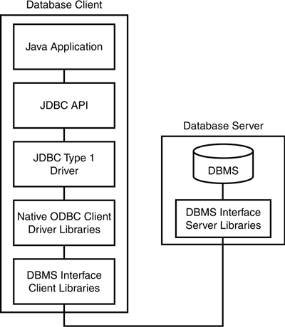

Figure 9.4 illustrates a typical configuration for type 2 JDBC drivers. Type 2 Native-API Partly Java Technology-Enabled drivers provide a mechanism for Java applications to make JDBC calls that are directly mapped to vendor-specific DBMS native library interface calls. Thus the JDBC driver is specifically designed to call native client libraries provided for DBMSs such as Oracle, Sybase, or Informix. Most database vendors now ship JDBC type 2 drivers with their databases. Such type 2 drivers will most typically offer better performance than using a JDBC/ODBC bridge because they bypass the ODBC intermediate layer.

Figure 9.4. Typical Type 2 JDBC driver configuration.
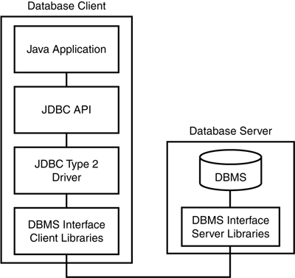

Figure 9.5 illustrates a typical configuration for type 3 JDBC drivers. Type 3 Net-Protocol Fully Java Technology-Enabled drivers provide a mechanism for Java applications to make JDBC calls that are mapped to calls embodied in some DBMS vendor-independent network protocol. These over-the-wire calls are then mapped to a specific DBMS vendor's interface calls. This vendor-independent remote listener is typically implemented by a middleware vendor offering support for connecting to various back-end database types. Thus the Java client application is freed from any dependence on having a set of native libraries installed on the client and has a very flexible means for communicating with various database types. The configuration of vendor-specific DBMS interfaces is thus localized to the middleware database server. Although the choice of network protocol for communicating to the middleware listener is left up to the middleware listener vendor, many vendors have been implementing fairly open solutions that are usable in Internet and intranet environments.

Figure 9.5. Typical Type 3 JDBC driver configuration.
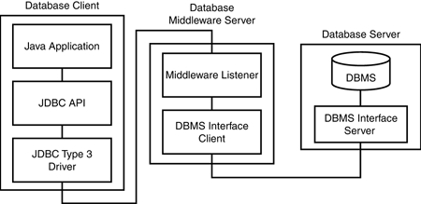

Figure 9.6 illustrates a typical configuration for type 4 JDBC drivers. Type 4 Native-Protocol Fully Java Technology-Enabled drivers provide a mechanism for Java applications to make JDBC calls that are mapped to calls embodied in a DBMS vendor's specific remote network listener protocol, which in turn are used to directly access that vendor's database. As with the type 3 drivers, type 4 drivers also enable a Java client application to be freed from dependence on the loading of a set of native client-side libraries. However, because these drivers are vendor specific, this driver type solution does make for a less-flexible configuration on the client side because clients can now talk only with that vendor's DBMS.

Figure 9.6. Typical type 4 JDBC driver configuration.
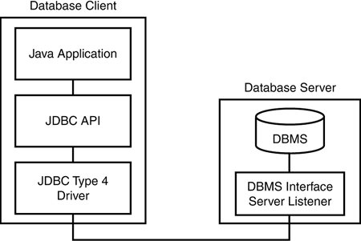

Driver Assessment
Choosing a driver for your enterprise application is an important step that affects performance, reliability, flexibility, and maintainability. Different drivers will have different performance characteristics, but some general assumptions and trade-offs are typically made when considering the various driver classes:
- Client-side native drivers are usually more appropriate in networks in which client-side native libraries can be easily installed and configured or in situations in which a middle tier is assumed to provide intermediate database access on behalf of the client tier.
- Client-side native drivers are difficult to configure for Web clients and usually involve trusted applets and client-side library installs.
- Remote network listener-based drivers result in thinner, pure Java clients.
- Type 1 drivers offer more database vendor independence at the price of lower performance as compared with type 2 drivers.
- Type 2 drivers offer higher performance at the price of database vendor-dependence as compared with type 1 drivers.
- Type 3 drivers offer more database vendor-independence at the potential price of lower performance as compared with type 4 drivers.
- Type 4 drivers offer potentially higher performance at the price of database vendor-dependence as compared with type 3 drivers.
Such driver comparisons based on type are indeed gross comparisons. Evaluations of drivers should be performed on an individual basis because drivers will vary in performance according to specific features, databases in use, and other system environment factors. System environment factors such as client usage, client-side platforms, network bandwidth and usage, and server-side platforms all affect the performance of an application. Because driver implementation details are often not known a priori, information about the performance in a particular environment is not always obvious until it's evaluated in a simulated or actual system environment. Other issues such as security and level of JDBC compliance are also worthwhile attributes of a particular JDBC driver vendor to take into consideration. Of course, as we'll see in Parts VI and VII of this book, the application developer typically does not worry about such issues in J2EE container-based enterprise applications.

JDBC URL formats
Type1
Jdbc:odbc:<dsn name>
Type2
jdbc:db2:database
Type3
(db2java.jar)

Type4
(db2jcc.jar)
jdbc:db2://server1:50000/sample

Java database connectivity(JDBC)
JDBC provides a set of API’s for interacting java applet or application with relational database.

Steps involved
- Load the driver
- get the connection from the DriverManger
- Create a statement object
- Execute the stament object with the query
- Get the result in the resultset

If the result set doesn’t return anything we have to use executeQuery()\

Transaction isolation level can be set on the connection object using setTransactionIsolation() method.
1. Transaction_none 0
2. Transaction_uncommitted_read 1
3. Transaction_committed_read 2
4. Transaction_repeatable_read 4
5. Transaction_serializable 8

Result set meta data is usefull to find the properties of the columns in a resultset.

Statement
Callable statement→ for executing the stored procedures
CallableStament cstmt = conn.prepareCall(,,,,,,,,,,,,,,,,,,,,)
Cstmt.registerOutParameter(,,,,,,,,,,)
Cstmt.setString(,,,,,,,,,)
Int result = cstmt.executeUpdate()
Result is got from callable statement object.

PreparedStatement→ precompiled sql statement, when same sql statements need to be executed many times.

