Java Server Faces
What is JSF?
JavaServer Faces (JSF) is an application framework for creating Web-based user interfaces. If you are familiar with Struts (a popular open source JSP-based Web application framework) and Swing (the standard Java user interface framework for desktop applications), think of JavaServer Faces as a combination of those two frameworks. Like Struts, JSF provides Web application lifecycle management through a controller servlet; and like Swing, JSF provides a rich component model complete with event handling and component rendering.
In a nutshell, JSF eases Web-based application development because it:
- Lets you create user interfaces from a set of standard, reusable server-side components
- Provides a set of JSP tags to access those components
- Transparently saves state information and repopulates forms when they redisplay
- Provides a framework for implementing custom components
- Encapsulates event handling and component rendering so you can use standard JSF components or custom components to support markup languages other than HTML
- Lets tool vendors develop IDEs for a standard Web application framework

Java server faces defines
- A component architecture
- A standard set of UI widgets
- Application infrastructure
- Powerful architecture for displaying component in different ways.
- Automatically keep UI components in synch with Java Objects (Backing beans) which collect user input values and respond to events
- Make web development faster and easier. Developers think in terms of components, events, backing beans and their interaction instead of response, request and markup.
Component:
A software component is a unit of composition with contractually specified interfaces and explicit context dependencies only. It can be deployed independently and subject to composition by third parties.
JSF:
- Framework maintains a tree of the UIComponent for a given page, this component tree is called ‘View’. It is JSF internal representation of the page.
- <f:view> tag encloses all other JSF tags
- UIViewRoot component is the container for all of the other controls on the page.
JSF Request Processing Lifecycle
JSF Request Processing Life cycle
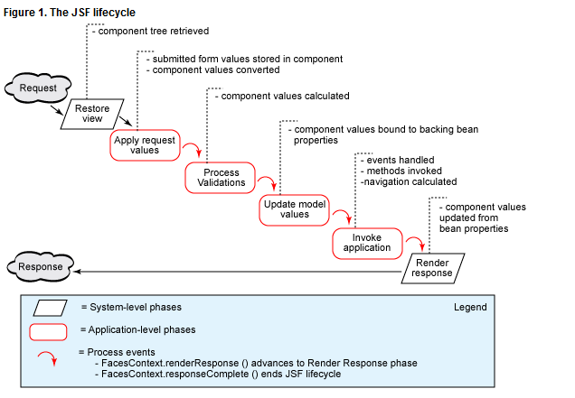

The 6 phases of request process life cycle are
- Restore View
- Apply request values
- Process validations
- Update model values
- Invoke application
- Render response

Phase 1: Restore view
In the first phase of the JSF lifecycle -- restore view -- a request comes through the FacesServlet controller. The controller examines the request and extracts the view ID, which is determined by the name of the JSP page.
The JSF framework controller uses the view ID to look up the components for the current view. If the view doesn't already exist, the JSF controller creates it. If the view already exists, the JSF controller uses it. The view contains all the GUI components.
This phase of the lifecycle presents three view instances: new view, initial view, and postback, with each one being handled differently. In the case of a new view, JSF builds the view of the Faces page and wires the event handlers and validators to the components. The view is saved in a FacesContext object.
The FacesContext object contains all the state information JSF needs to manage the GUI component's state for the current request in the current session. The FacesContext stores the view in its viewRoot property; viewRoot contains all the JSF components for the current view ID.
In the case of an initial view (the first time a page is loaded), JSF creates an empty view. The empty view will be populated as the user causes events to occur. From an initial view, JSF advances directly to the render response phase.
In the case of a postback (the user returns to a page she has previously accessed), the view corresponding to the page already exists, so it needs only to be restored. In this case, JSF uses the existing view's state information to reconstruct its state. The next phase after a postback is apply request values.
This is the phase where the language of the view is set based on the values of the http request sent to the browser.
Phase 2: Apply request values
The purpose of the apply request values phase is for each component to retrieve its current state. The components must first be retrieved or created from the FacesContext object, followed by their values. Component values are typically retrieved from the request parameters, although they can also be retrieved from cookies or headers.
If a component's immediate event handling property is not set to true, the values are just converted. So if the field is bound to an Integer property, the value is converted to an Integer. If the value conversion fails, an error message is generated and queued in the FacesContext, where it will be displayed during the render response phase, along with any validation errors.
If a component's immediate event handling property is set to true, the values are converted to the proper type and validated. The converted value is then stored in the component. If the value conversion or value validation fails, an error message is generated and queued in the FacesContext, where it will be displayed during the render response phase, along with any other validation errors.
Phase 3: Process validation
The first event handling of the lifecycle takes place after the apply request values phase. At this stage, each component will have its values validated against the application's validation rules. The validation rules can be pre-defined (shipped with JSF) or defined by the developer. Values entered by the user are compared to the validation rules. If an entered value is invalid, an error message is added to FacesContext, and the component is marked invalid. If a component is marked invalid, JSF advances to the render response phase, which will display the current view with the validation error messages. If there are no validation errors, JSF advances to the update model values phase.
Phase 4: Update model values
The fourth phase of the JSF application lifecycle -- update model values -- updates the actual values of the server-side model -- namely, by updating the properties of your backing beans (also known as managed beans). Only bean properties that are bound to a component's value will be updated. Notice that this phase happens after validation, so you can be sure that the values copied to your bean's properties are valid (at least at the form-field level; they may still be invalid at the business-rule level).

Phase 5: Invoke application
At the fifth phase of the lifecycle -- invoke application -- the JSF controller invokes the application to handle Form submissions. The component values will have been converted, validated, and applied to the model objects, so you can now use them to execute the application's business logic.
At this phase, you also get to specify the next logical view for a given sequence or number of possible sequences. You do this by defining a specific outcome for a successful form submission and returning that outcome. For example: on successful outcome, move the user to the next page. For this navigation to work, you will have to create a mapping to the successful outcome as a navigation rule in the faces-config.xml file. Once the navigation occurs, you move to the final phase of the lifecycle.
Phase 6: Render response
In the sixth phase of the lifecycle -- render response -- you display the view with all of its components in their current state. Another goal of this phase is to save the state of the view so that it can be restored in the ‘Restore view phase’ if the user requests it again.

Core terms in JSF:
- UIComponent:
A stateful object maintained at the server that provides specific functionality for interacting with end user
- Renderer
Responsible for displaying UI component and translating a user’s input into the component. JSF supports following types
- Direct Implementation model: UIComponent renders self
- Delegated implementation model:UIComponent is rendered by separate classes called ‘renderrers’.
- Validator
Responsible for validating the input. Faces handle validations in 2 ways
At UIComponent level via validator methods in backing beans, or in Validator classes.
- Backing bean
Specialized java beans that collect values from UI component and implement the event listener methods. They perform interaction between UI and the model.

They can be associated with UIComponents in 2 different ways.
- Using Markup
Ex: <h:outputText id=”helloBeanInput” value=”#{helloBean.numcontrols}”/>
- Using ‘binding’ attribte
Ex: <h:outputText id=”controlPanel” binding=”#{helloBean.controlPanel}”/>
This is useful for manipulating the component in backing bean.

- Converter
Converts value to and from string for display. They also handle formatting and localization
- Events and listeners
UIComponents generate events and listener can be associated with them to handle events.
There are 4 standard events
- Value-change events : Fired by input controls
- Action Event: Generated when user activates command component.
- Data model events: Generated when data aware component selects a row for processing. The most common way to trigger this event is through HtmlDataTable component.
- Phase events: Generated before and after each step or phase of JSF request processing life cycle.

Events and Listeners
- Value change events
Fired by input controls
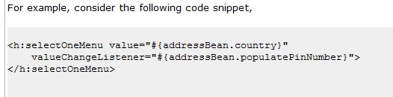

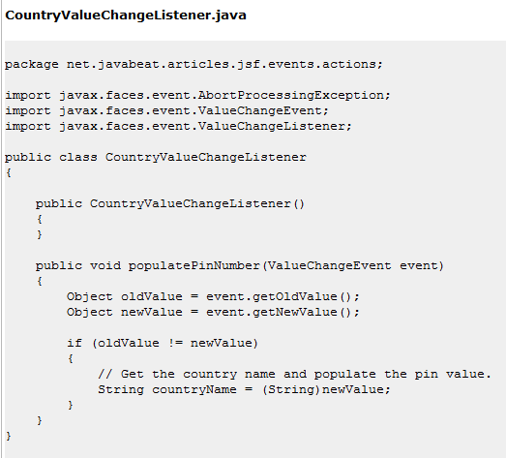
- Action Event
Generated when user activates command component.
Can be handled in 2 ways
- <h:commandButton type=”submit” value=”login” action=”#{loginForm.login”/>
- <h:commandButton type=”submit” value=”login” actionListener=”#{loginForm.login”/>
The difference is that when we use actionListener the backing bean will have access to the commandButton component and can manipulate.
Ex:
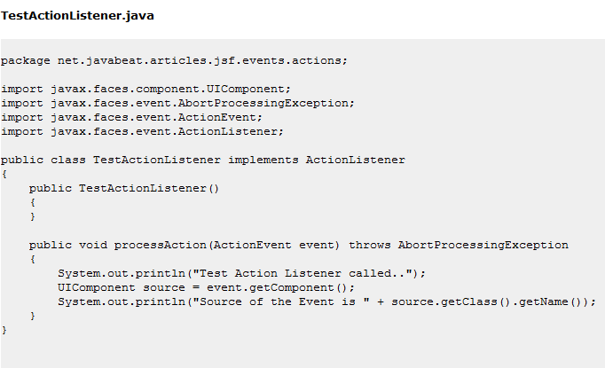
- Data model events:
Generated when data aware component selects a row for processing. The most common way to trigger this event is through HtmlDataTable component.

- Phase events
Phase events: Generated before and after each step or phase of JSF request processing life cycle.
Ex:
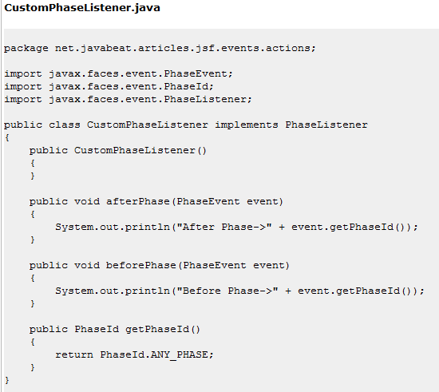
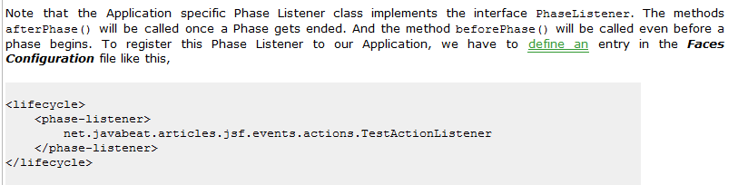
Messages
JSF Messages are used for displaying the application errors and user input errors. A message consists of summary text, detailed text, and severity level.
Ex:
<h:message id=”errors” for=”helloinput” style=”color:red”/>
Navigation
Navigation Handler is responsible for deciding what page to load based on the logical outcome of an action. For any given page, a navigation rule defines what outcomes are under stood and what pages to load based on those outcomes. Each specific mapping between an outcome and page is called ‘Navigation Case’.
Ex:
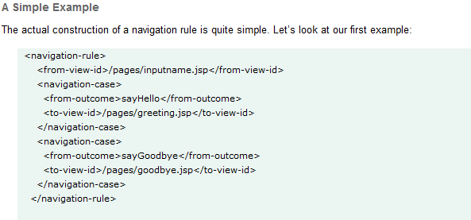

JSF Expression language (EL)
Used in web application pages to access the java bean components in the page bean and other bean associated with the web application.
- The expression delimiters for a value binding expression are #{ and } instead
of ${ and }.
- Value binding expressions do not support JSP expression language functions.
<Include the sample table here>

Scoped Variables
- Application – Variables stored in this scope are available for entire life of the application.
- Session – Variables stored in this scope are available only during a session.
- Request – Variables stored in this scope are available only during current request.
- Page – Variables stored in this scope are available only available in current page

JSF Implicit variables
Implicit Object | Description
applicationScope | Represents a Map of application scope attribute values with attribute names as keys
Cookie | Represents a Map of cookie values for the current request with cookie names as keys
facesContext | Represents the FacesContext instance for the current request
Header | Represents a Map of HTTP header values for the current request with header names as keys
headerValues | Represents a Map of String arrays containing all the header values for HTTP headers in the current request with header names as keys
initParam | Represents a Map of the context initialization parameters
Param | Represents a Map of the request parameters for this request with parameter names as keys
paramValues | Represents a Map of String arrays containing all the parameter values for request parameters in the current request with parameter names as keys
requestScope | Represents a Map of the request attributes for this request with attribute names as keys
sessionScope | Represents a Map of the session attributes for this request with attribute names as keys
View | Represents The root UIComponent in the current component tree stored in the FacesRequest for this request

Application Configuration description
<faces-cong>
<application> - Used for specifying supported languages, location of customized application messages, default render kit and advanced pluggable components.
<managed-bean> - Controls automatic creation of objects in particular scope.
<reference-bean> - Used to tell IDE about other objects may become available.
<navigation-rule> -controls flow of application from one page to another.
<component> -Used to register component with system.
<render-kit> -Used to either add renderer to the default render kit or define entirely new render kit.
<validator> - Used to register validate with the system.
<converter> -Used to register converter with the systems.
<phase-listener> -Registers phase listener to use with the system.
<factory> -Defines classes for the factories that instantiate core JSF classes.
For details on all the elements of the configuration file please see the following file.


Dynamic and static include
Dynamic include is achieved by
- Included pages must be enclosed in JSF <f:subview> core tag.
- All template text and non-jsf tags inside included pages should be included with jsf <f:verbatim> core tag.
For static include there are no such restrictions.

Managed Bean property initialization
Ex:
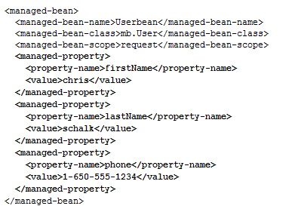
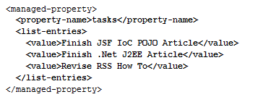

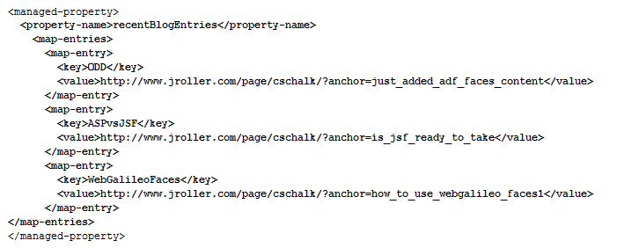
Managed bean life cycle support
- none: A managed bean with this scope is not stored anywhere, it is created "on demand" whenever it is needed.
- request: A bean with a request scope will have it's value stored only for the duration of a single request. Upon subsequent requests on the same object, a new clean version will be instantiated.
- session: A bean with session scope will be stored onto the session meaning that the bean's properties will stay alive during multiple requests. A shopping cart bean would be set to a session scope. Objects stored onto the session are naturally threadsafe and will expire when the session times out if not cleared by the application explicitly. You wouldn't want anyone else looking in your shopping cart!
- application: Objects created with application scope will exist during the entire lifetime of the container. An example of when usage makes sense could be for a JDBC datasource object.

Managed beans registered with scope: | Can only refer to other managed beans with these scopes:
None | none
Request | none, request, session, application
Session | none, session, application
Application | none, application

What are the differences between a Backing Bean and Managed Bean?
Backing Beans are merely a convention, a subtype of JSF Managed Beans which have a very particular purpose. There is nothing special in a Backing Bean that makes it different from any other managed bean apart from its usage.

What makes a Backing Bean is the relationship it has with a JSF page; it acts as a place to put component references and Event code.

Backing Beans | Managed Beans
A backing bean is any bean that is referenced by a form. | A managed bean is a backing bean that has been registered with JSF (in faces-config.xml) and it automatically created (and optionally initialized) by JSF when it is needed.
 | The advantage of managed beans is that the JSF framework will automatically create these beans, optionally initialize them with parameters you specify in faces-config.xml,
Backing Beans should be defined only in the request scope | The managed beans that are created by JSF can be stored within the request, session, or application scopes

Backing Beans should be defined in the request scope, exist in a one-to-one relationship with a particular page and hold all of the page specific event handling code.In a real-world scenario, several pages may need to share the same backing bean behind the scenes.A backing bean not only contains view data, but also behavior related to that data.

Navigation rule

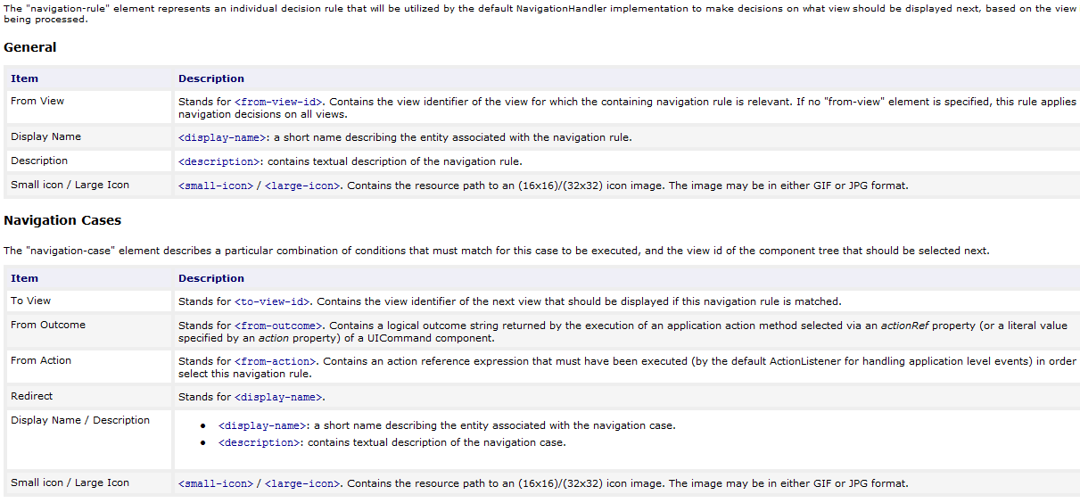

JSF Standard UI Components
All JavaServer Faces UI component classes extend UIComponentBase, which defines the default
state and behavior of aUI component. The following set of UI component classes is included
with JavaServer Faces technology: [Get the table from internet]
- UIColumn: Represents a single column of data in a UIData component.
- UICommand: Represents a control that fires actions when activated.
- UIData: Represents a data binding to a collection of data represented by a DataModel
instance.
- UIForm: Encapsulates a group of controls that submit data to the application. This
component is analogous to the form tag in HTML.
- UIGraphic: Displays an image.
- UIInput: Takes data input from a user. This class is a subclass of UIOutput.
- UIMessage: Displays a localized message.
- UIMessages: Displays a set of localized messages.
- UIOutput: Displays data output on a page.
- UIPanel:Manages the layout of its child components.
- UIParameter: Provides dynamic variable that can be used during the encoding and decoding process.
It is used by the components: HtmlOutputFormat, HtmlOutputLink, HtmlCommandLink
- UISelectBoolean: Allows a user to set a boolean value on a control by selecting or
deselecting it. This class is a subclass of UIInput.
- UISelectItem: Represents a single item in a set of items.
- UISelectItems: Represents an entire set of items.
- UISelectMany: Allows a user to select multiple items from a group of items. This class is a subclass of UIInput.
- UISelectOne: Allows a user to select one item from a group of items. This class is a subclass of UIInput.
- UIViewRoot: Represents the root of the component tree.

JSF Tags
JSF application typically uses JSP pages to represent views. JSF provides useful special tags to enhance these views. Each tag gives rise to an associated component. JSF provides 43 tags in two standard JSF tag libraries:
- JSF Core Tags Library and
- JSF Html Tags Library
Even a very simple page uses tags from both libraries.
<%@ taglib uri=”http://java.sun.com/jsf/core “ prefix=”f” %>
<%@ taglib uri=”http://java.sun.com/jsf/html “ prefix=”h” %>
<f:view>
<h:form>
……………
……………
</h:form>
</f:view>
JSF Html Tags:
HTML tags can be divided into following categories
Inputs (inputText, inputTextarea)
Outputs (outputText, outputLabel)
Commands (commandButton)
Selections (selectOneRadio, selectOneListbox, selectOneMenu for radio buttons, list boxes, menu etc)
Layouts (panelGrid)
Data table (dataTable)
Errors and messages (message, messages)
- All JSF Html Tags :
  - column creates column in a dataTable
  - commandButton creates button
  - commandLink creates link that acts like a pushbutton
  - dataTable creates a table control
  - form creates a form
  - graphicImage displays an image
  - inputHidden creates hidden field
  - inputSecret creates input control for password
  - inputText creates text input control (single line)
  - inputTextarea creates text input control (multiline)
  - message displays the most recent message for a component
  - messages displays all messages
  - outputFormat creates outputText, but formats compound messages
  - outputLabel creates label
  - outputLink creates anchor
  - outputText creates single line text output
  - panelGrid creates html table with specified number of columns
  - panelGroup used to group other components where the specification requires one child element
  - selectBooleanCheckbox creates checkbox
  - selectManyCheckbox creates set of checkboxes
  - selectManyListbox creates multiselect listbox
  - selectManyMenu creates multiselect menu
  - selectOneListbox creates single select listbox
  - selectOneMenu creates single select menu
  - selectOneRadio creates set of radio buttons

JSF Core Tags:
These tags allows you to take advantages of features of JSF framework, like validation, conversion , event handling. Core library is stepchild of Html library. i.e. core library supports the html library.
JSF Core Tags:
- f :view Creates the top-level view
- f:subview Creates a subview of a view
- f:attribute Adds an attribute to a component
- f:param Constructs a parameter component
- f:converter Adds an arbitrary converter to a component
- f:converterDateTime Adds a datetime converter to a component
- f:converterNumber Adds a number converter to a component
- f:actionListener Adds an action listener to a component
- f:valueChangeListener Adds a valuechange listener to a component
- f:validator dds a validator to a component
- f:validateDoubleRange Validates a double range for a component’s value
- f:validateLength Validates the length of a component’s value
- f:validateLongRange Validates a long range for a component’s value
- f:facet Adds a facet to a component
- f:loadBundle Loads a resource bundle, stores properties as a Map
- f:selectitems Specifies items for a select one or select many component
- f:selectitem Specifies an item for a select one or select many component
- f:verbatim Adds markup to a JSF page
[Put example for each from web]
Common component properties
For output components
Id : Component identifier
Value: Components current local value
Rendered: Controls whether the component is visible or not
Converter: Sets the converter used to convert the value to and from string for disply
styleClass: Name of css style class
binding: Value binding expression that associates component with backing bean.
Input and datatable components additionally will have following properties
Validator: A method binding expression for a backing bean method that will be called to validate this component value.
Immediate: Determines whether or not the component should be validated immediately (during apply request values phase) instead of Process validation phase.
Required: Controls whether or not this component is required.
Styleclass: Name of css style class
valueChangeListener: A method binding expression for a value change listener method that will be called when this component value changes.
Binding: Associates this component with backing bean property.
Facet:
They are used to specify subordinate elements like a header or footer.
Ex: HtmlPanelGrid, HtmlDataTable
<h:panelGrid columns="2" border="1" rules="rows" title="This is facet tag demo">
<f:facet name="header">
<h:outputText value="header facet"/>
</f:facet>
<h:outputText value="First Name"/>
<h:inputText/>
<h:outputText value="Last Name"/>
<h:inputText/>
<h:outputText value="Address"/>
<h:inputText/>
<h:commandButton value="submit"/>
<f:facet name="footer">
<h:outputText value="footer facet" />
</f:facet>
</h:panelGrid>

Message Format Elements
Ex:
<h:outputFormat value=”Hey {0}, you were born on {1,date, medium}.”>
<f:param value=”#{user.firstName}”/>
<f:param value=”#{user.dateOfBirth}”/>
</h;outputFormat>
Output: Hey Mark, you were born on Apr20,2004

Ex:
<h:outputFormat value=”You have visited us {0} {0,choice,0 # times|1#time|2#times}.”> <f:param value=”#{user.numberOfVisits}”/>
</h;outputFormat>

Internationalization
Enabling the application to support multiple locales is called internationalization.
The process of modifying an application for specific locale is called localization.

After we have created the localized properties file, we have to convert it to use Unicode characters. This can be done using native2ascii tool included with jdk.

Configure locales
Now we have to tell JSF application which language it should support. We can specify the supported locales with the <local-config> element in the Faces configuration file, inside the <application> element.
<application>
<resource-bundle>
<base-name>bundle.messages</base-name>
<var>msg</var>
</resource-bundle>
<locale-config>
<default-locale>en</default-locale>
<supported-locale>es</supported-locale>
<supported-locale>fr</supported-locale>
</locale-config>
</application>
Using resource bundles with components
<f:loadBundle basename=”LocalizationResources” var=”bundle”/>
<h:outputText value=”#{bundle.halloween}”/>

Validators
JSF provides standard validators like:
DoubleRangeValidator | Value must be numeric type and in range between minimum and/or maximum values.
LongRangeValidator | Value must be numeric type, convertible to long and in range between minimum and/or maximum values.
LengthValidator | Value must be string type and length must be in range between minimum and/or maximum values.

For Example:
1. <f:validateLength /> is used to validate whether the length of the value lies in specified range.
<h:inputText id="name" required="true">
<f:validateLength maximum="10" minimum="1"/>
</h:inputText>
<h:message for="name" />
- <f:validateDoubleRange/> is used to validate whether the double value lies in specified range.
<h:inputText id="no" required="true">
<f:validateDoubleRange minimum="2.0" maximum="10.0"/>
</h:inputText>
<h:message for="no" />
3. <f:validateLongRange"/> is used to validate whether the long value lies in specified range.
<h:inputText id = "lno" required = "true">
<f:validateLongRange minimum = "2" maximum = "10"/>
</h:inputText><br/>
<h:message for="lno" />

Custom validation
If validation for the component value is not supported by the standard validators then you will need to create your own validator. For example, you can create email validator to validate the email text entered by the user i.e. whether the email id is in correct format. Using custom validator you will be able to display your own validation error message.
Steps to create a custom validator:
1. Create a class that implements the javax.faces.validator.Validator interface
2. Implement the validate() method (defined in Validator interface).
package roseindia;
import javax.faces.*;
import javax.faces.validator.*;
import javax.faces.application.*;
import javax.faces.component.*;
import javax.faces.context.*;
import java.util.regex.*;
public class Validation implements Validator{
public Validation(){}
public void validate(FacesContext facesContext, UIComponent uIComponent, Object object) throws ValidatorException{
String enteredEmail = (String)object;
Pattern p = Pattern.compile(".+@.+\\.[a-z]+");
Matcher m = p.matcher(enteredEmail);
boolean matchFound = m.matches();
if (!matchFound) {
FacesMessage message = new FacesMessage();
message.setSummary("Invalid Email ID.");
throw new ValidatorException(message);
}
}
}
3. Register this validator in the configuration file "faces-confix.xml".
<validator>
<validator-id>checkvalidemail</validator-id>
<validator-class>roseindia.Validation</validator-class>
</validator>
4. Use this validator by <f:validator/> tag in the JSP page.
5. Use <h:message> tag in the jsp page to display the error message.
<h:inputText id="email" required="true">
<f:validator validatorId="checkvalidemail" />
</h:inputText>
<h:message for="email" />

Type Conversion and Formatting
This tag is useful converting date and time according to your format. It supports many attributes which can give different styles of presenting date and time like locale attribute formats the date and time according to locale and dateStyle, timeStyle determines how date and time is to be formatted. Date and time can be formatted according to the time zone by setting the timeZone attribute.
The framework has standard converters for all of the basic java types: BigDecimal,BigInteger, Boolean, Byte, Character, Integer, Short, Double, Float and Long.
Standard converters are
- <f:convertDateTime>
Ex:
<h:outputText value="#{MyBean.today}">
<f:convertDateTime type="both" dateStyle="short"/>
</h:outputText>
Output: 5/14/07 12:55:42 PM
This tag contains some attributes:
dateStyle : This is used to set the style of date to be presented to the page. This attribute is applied only if the type attribute is "date" or "both". This attribute can take some values like :
- default May 14, 2007 2:35:45 PM ( Default Value)
- short 5/14/07 12:55:42 PM
- medium May 14, 2007 2:42:36 PM
- long May 14, 2007 2:41:08 PM
- full Monday, May 14, 2007 2:39:56 PM
timeStyle : This is used to set the style of time to be presented to the page. This attribute is applied only if the type attribute is "time" or "both". It also can take values default ( Default Value), short, medium, long, full.
locale : This is used to specify the name of the locale for which we have to format the date and time.
pattern : This is used to set the formatting pattern as defined in java.text.SimpleDateFormat. This is used to determine how the date and time will be formatted.
timeZone : This attribute is used to set the time zone for which the date and time is to be formatted. Its default time zone is GMT time zone.
type : It is used to specify whether date, time or both is to be formatted. Its valid values are "date" (dafault), "time" and "both".
- <f:convertNumber>
This tag is used to register the NumberConverter instance on the enclosing component. This class is responsible to convert String to java.util.Number object and vice-versa.
Ex:
<h:inputText id="number">
<f:convertNumber currencySymbol="$" type="currency" groupingUsed="#{false}"></f:convertNumber>
</h:inputText>
This tag contains some attributes:
currencyCode : In this attribute ISO 4217 currency code is set that will be applied when converting currency values.
currencySymbol : This sets the currency symbol that will be applied when formatting currency values.
groupingUsed : This is the boolean attribute and is used to specify whether the output will contain grouping seperators. Its default value is "true".
integerOnly : This is the boolean attribute and is used to specify whether only the integer part will be parsed.Its default value is "false".
locale : This is used to specify the name of the locale for which we have to format the number.
maxFractionDigits : It is used to specify the maximum no. of digits in the fractional part that will be formated.
maxIntegerDigits : It is used to specify the maximum no. of digits in the integer part that will be formated.
minFractionDigits : It is used to specify the minimum no. of digits in the fractional part that will be formated.
minIntegerDigits : It is used to specify the minimum no. of digits in the integer part that will be formated.
pattern : This is used to set the formatting pattern.
type : It is used to specify the type of formatting. Its valid values are "number" "currency" "percentage". Its default value is "number".

- <f:converter>
This tag is used to register the converter instance on the enclosing component. Many times it is required to convert the input to the appropriate type. In this case this tag can be useful. It takes one required attribute "converterId". In this attribute we specify the name of backing bean class which implements Converter interface. You have to maintain the faces-config file where converter-id and converter-class is specified within the converter element.
Ex:
<h:inputText id="name">
<f:converter converterId="javax.faces.Short"/>
</h:inputText>
This tag contains one attribute :
converterId : This is the required attribute and is used to specify the ID of the converter class which is used in the conversion process (in the case of custom conversion).

Customizing application Messages
Validators and Converters generate error messages when a user’s input is not acceptable. These messages are handled by application message queue and can be displayed with the HtmlMessages and HtmlMessage components.
The default messages can be overridden by specifying a single message bundle in JSF configuration file.
Ex:
<application>
<message-bundle>CustomMessages</message-bundle>
<locale-config>
<default-locale>en</default-locale>
<supported-locale>en</supported-locale>
<supported-locale>es</supported-locale>
</locale-config>
</application>

JSF Environment core classes

Class or Interface | Where to get Reference | Description
Application | FacesContext.getApplication() | Provides access to supported locales, default render kit and factory methods for creating UI components, converters, validations and value binding expression
ValueBinding | Application.createValueBinding(), UIComponentgetValueBinding() | Represents a value binding expression and provides the ability to set or evaluate that expression.
MethodBinding | Application.createMethodBinding() | Represents a method binding expression, and provides the ability to set or equate that expression
FacesContext | FacesContext.getCurrentInstance(); | Represent the state of the current request. You can get the access to the current view, add a new message, control the lifecycle, and so on. This is the main API when you are developing an application.
FacesMessage | FacesContext.getMessages() | Represents messages for the current request.
ExternalContext | FacesContext.getExternalContext(); | Provides access to the hosting environment which is either a servlet or portlet container. From here you can get access to underlying session, request, response objects.

- Application
Ex:
Application ap = facesContext.getApplication();
String bundleName = ap.getMessageBundle();
- ValueBinding
Ex:
User user = (User)app.createValueBinding(“#{sessionScope.user}”).getValue(facesContext);
- MethodBinding
Ex:
MethodBinding mBinding = app.createMethodBinding(“#{myBean.myActionListener}”),new Class[]{ActionEvent.class});
myUICommand.setActionListener(mBinding);

Creating custom component
http://today.java.net/pub/a/today/2004/07/16/jsfcustom.html
Steps involved are
- Subclassing the appropriate classes and or implementing interface (UIComponent/UIComponentBase)
- Adding proper configuration entries to a JSF configuration file.
- Integrating your class with display technology such as jsp. This involves writing a tag handler class and updating a tag library descriptor(TLD).

