Java Server Faces

What is JavaServer Faces?
JavaServer Faces (JSF) is an application framework for creating Web-based user interfaces. If you are familiar with Struts (a popular open source JSP-based Web application framework) and Swing (the standard Java user interface framework for desktop applications), think of JavaServer Faces as a combination of those two frameworks. Like Struts, JSF provides Web application lifecycle management through a controller servlet; and like Swing, JSF provides a rich component model complete with event handling and component rendering.
Java Server Faces is a component oriented and event driven framework for web applications. This makes programming much easier and now the there is no need to write request and response processing logic.
So main purpose of developing JSF was to create a collection of APIs for the UI components with the capacity to manage their states, handle events and validation.
JSF is based on well established Model-View-Controller (MVC) design pattern. Applications developed using JSF frameworks are well designed and easy to maintain then any other applications developed in JSP and Servlets.

JSF Vs Struts
The Top 10 List
#10 There’s only one Struts - Struts is an open-source product, whereas JSF is a specification.
#9 JSF is the standard - JEE 5.0 containers must provide an implementation of JSF, which means that JSF will soon be ubiquitous.
#8 POJO Action Methods - Struts actions are tied to the Struts API, but JSF action methods can be implemented in Plain Old Java Objects.
#7 Managed Beans - Like Spring, JSF uses dependency injection (or inversion of control, if you will), for instantiating and initializing beans. It’s true that Struts creates action beans and form beans for you, but JSF generalizes that concept and adds the ability to initialize managed beans-of any type-created by the framework.
#6 Extensibility - This is huge. JSF has 6 objects that implement much of the framework’s capabilities and you can easily replace those objects by decorating the default implementations. That makes it ridiculously easy, for example, to add your own custom variables to the JSF expression language. It also makes it easy, for example, to plug in your own view handlers, perhaps a view handler that implements Tapestry-like views so you can truly separate components and HTML. In fact, Shale, does both of those things. As if that weren’t enough, JSF gives you numerous hooks into the JSF lifecycle to inject your own voodoo. Shale gives you even more.
#5 Event Model - JSF has an event model that lets you react to value changes, actions, and phase changes in the JSF lifecycle.
#4 Value Bindings - With Struts, you are responsible for ferrying data from your forms to your model objects. You implement an action with an execute method that takes a form bean as an argument. Then you manually pull data out of that form bean and push it to your model. For every form in your application. Ugh.With JSF, you do this:
#{model.property}. That’s all. JSF takes care of the rest.
#3 Renderers - Have you ever looked at the source code for Struts tags? They generate HTML directly. JSF component tags, OTOH, don’t generate anything; instead, they refer to a component-renderer pair on the server. The component maintains state whereas the renderer is in charge of rendering a view. The point here is that renderers are pluggable: you can replace the default renderers with your own implementations; for example, in my Felix talk at NFJS, I illustrate how to implement a custom label renderer that adds asteriks to labels that represent required fields. You plug in that renderer, and JSF will automatically use it throughout your application.Sweet.
#2 Render Kits - I had a Struts consulting job a few years ago where we had to support both a browser-based interface and radio frequency devices, and it was painful.That task would’ve been greatly simplified with JSF because you can create your own render kit-a collection of renderers for a particular display technology-and plug it into JSF.
#1 Components - Components are the number one differentiator between Struts and JSF. Like Swing, JSF provides a rich infrastructure for developing components in addition to a standard set of components. That infrastructure makes it relatively easy to create your own components and share them with others. Already, we’re seeing custom components popping up all over the place, for example with Oracle’s ADF and MyFaces, both of which provide a rich set of components such as JavaScript-powered calendars, trees, etc. Of course, components are only half the story; typically, components delegate rendering to a separate renderer, which provides substantial benefits (see item #3 above). But, as with most things in JSF, you are not forced to adhere to the party line. If you want, you can implement components that render themselves, although if you do so, you will loose the ability to plug a different renderer into your component.

The best advantages of JSF is that it is both a Java Web user-interface standard and a framework that fits well with the Model-View-Controller (MVC) design pattern.
JSF eases the development of web applications based on Java technologies. Here are some of benefits of using JSF:
- JSF provides standard, reusable components for creating user interfaces for web applications.
- JSF provides many tag libraries for accessing and manipulating the components.
- It automatically saves the form data and repopulates the form when it is displayed at client side.
- JSF encapsulates the event handling and component rendering logic from programmers, programmers just use the custom components.
- JSF is a specification and vendors can develop the implementations for JSF.
- There are many GUIs available these days to simplify the development of web based application based on JSF framework.
- Support for multiple devices
- International language suppor.

Steps in the Development Process
Developing a simple JavaServer Faces application usually requires these tasks:
■ Mapping the FacesServlet instance.
■ Creating the pages using the UI component and core tags.
■ Defining page navigation in the application configuration resource file.
■ Developing the backing beans.
■ Adding managed bean declarations to the application configuration resource file

JSF Example

Greeting.jsp
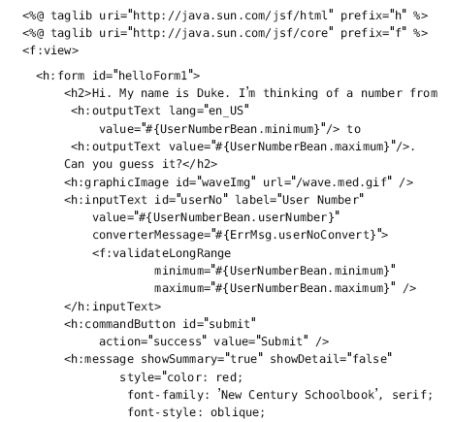
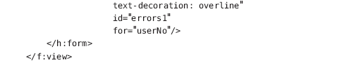

Page Navigation
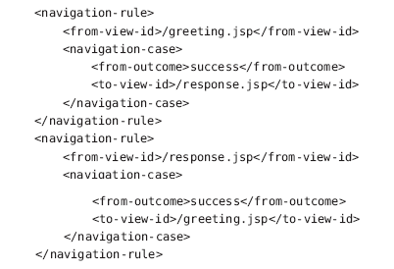
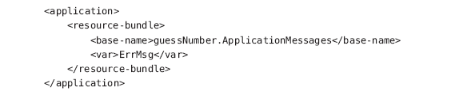
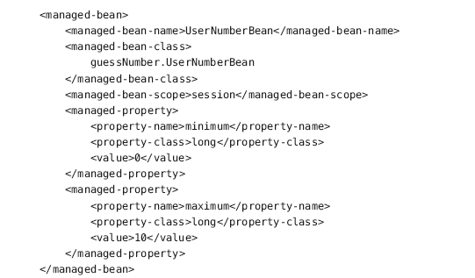

Bean
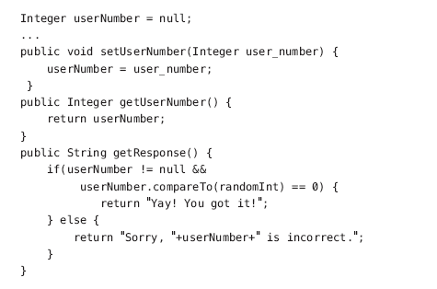

User Interface Component Model
JavaServer Faces technology provides a rich, flexible component architecture that includes the
following:
■ A set of UIComponent classes for specifying the state and behavior of UI components
■ A rendering model that defines how to render the components in various ways
■ An event and listener model that defines how to handle component events
■ A conversion model that defines how to register data converters onto a component
■ A validation model that defines how to register validators onto a component

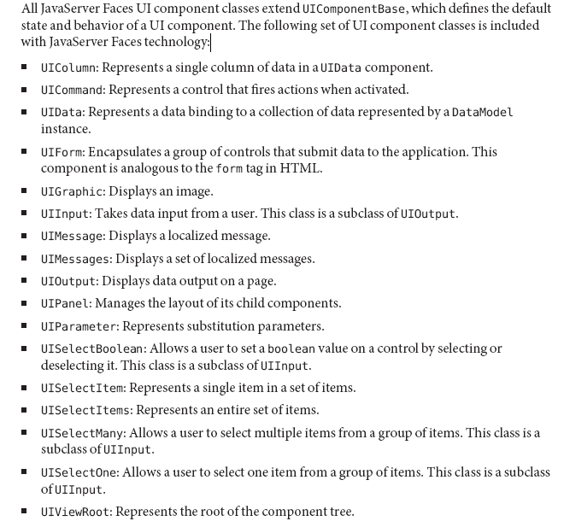

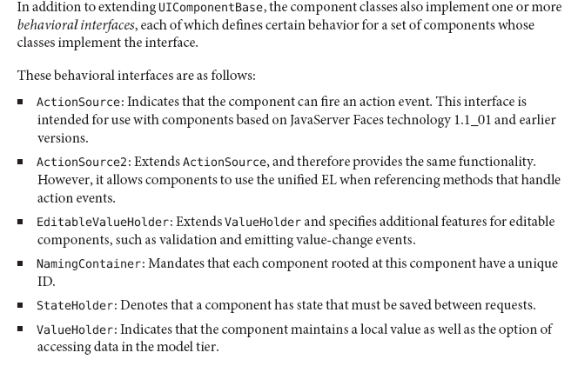
Component Rendering Model
A render kit defines how component classes map to component tags that are appropriate for a
particular client. The JavaServer Faces implementation includes a standard HTML render kit
for rendering to an HTML client.

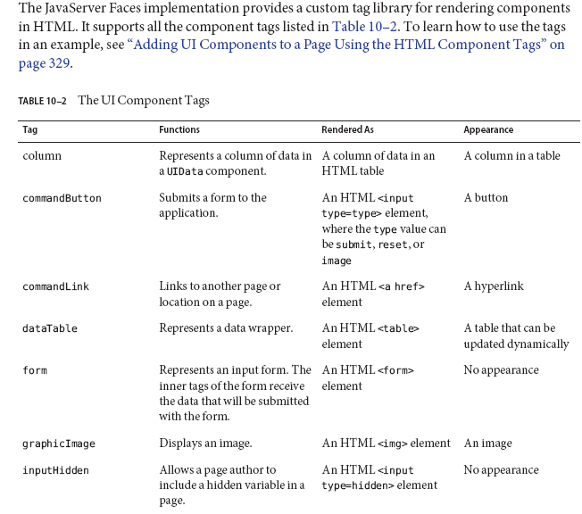
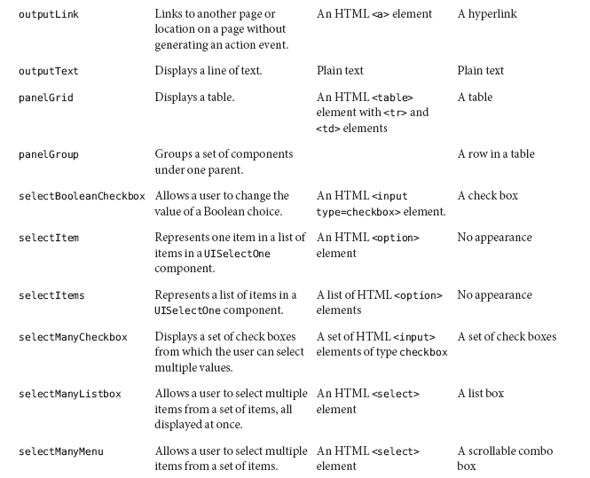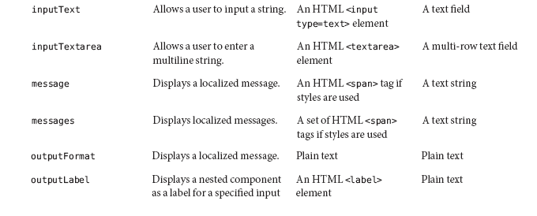
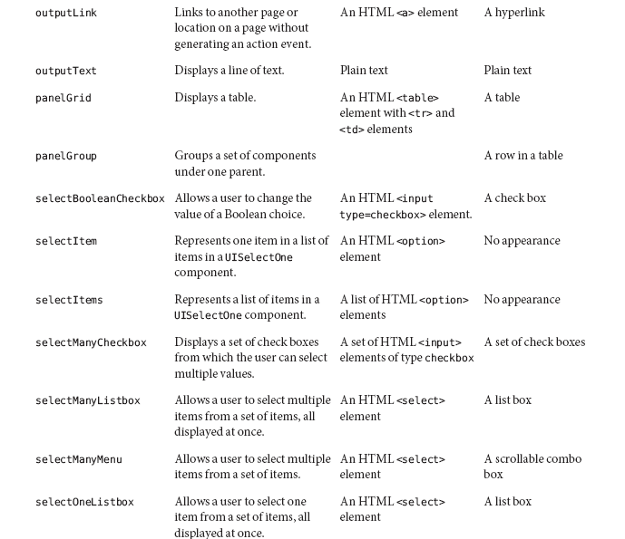
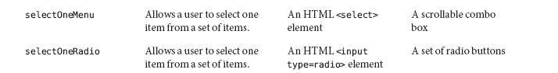

The JavaServer Faces implementation automatically converts component data between these
two views when the bean property associated with the component is of one of the types
supported by the component’s data. For example, if a UISelectBoolean component is
associated with a bean property of type java.lang.Boolean, the JavaServer Faces implementation will automatically convert the component’s data from String to Boolean. In addition, some component data must be bound to properties of a particular type. For example, a UISelectBoolean component must be bound to a property of type boolean or java.lang.Boolean.

Sometimes you might want to convert a component’s data to a type other than a standard type,
or you might want to convert the format of the data. To facilitate this, JavaServer Faces
technology allows you to register a Converter implementation on UIOutput components and
components whose classes subclass UIOutput. If you register the Converter implementation on
a component, the Converter implementation converts the component’s data between the two
views.
To create and use a custom converter in your application, three things must happen:
■ The application developer must implement the Converter class.
■ The application architect must register the Converter with the application.
■ The page author must refer to the Converter object from the tag of the component whose
data must be converted.

The Life Cycle of a JavaServer Faces Page
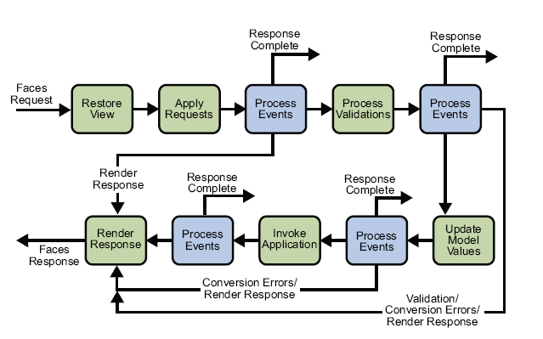
RestoreViewPhase
During this phase, the JavaServer Faces implementation builds the view of the page, wires event
handlers and validators to components in the view, and saves the view in the FacesContext
instance, which contains all the information needed to process a single request. All the
application’s component tags, event handlers, converters, and validators have access to the
FacesContext instance.

Apply RequestValues Phase
After the component tree is restored, each component in the tree extracts its new value from the
request parameters by using its decode method. The value is then stored locally on the
component. If the conversion of the value fails, an error message associated with the
component is generated and queued on FacesContext. This message will be displayed during
the render response phase, along with any validation errors resulting from the process
validations phase.

If some components on the page have their immediate attributes (“The immediate
Attribute”) set to true, then the validation, conversion, and events associated with
these components will be processed during this phase.

ProcessValidations Phase
During this phase, the JavaServer Faces implementation processes all validators registered on
the components in the tree. It examines the component attributes that specify the rules for the
validation and compares these rules to the local value stored for the component.

If the local value is invalid, the JavaServer Faces implementation adds an error message to the
FacesContext instance, and the life cycle advances directly to the render response phase so that
the page is rendered again with the error messages displayed. If there were conversion errors
from the apply request values phase, the messages for these errors are also displayed.

Update ModelValues Phase
After the JavaServer Faces implementation determines that the data is valid, it can walk the
component tree and set the corresponding server-side object properties to the components’
local values. The JavaServer Faces implementation will update only the bean properties pointed
at by an input component’s value attribute. If the local data cannot be converted to the types
specified by the bean properties, the life cycle advances directly to the render response phase so
that the page is re-rendered with errors displayed. This is similar to what happens with
validation errors.

Invoke Application Phase
During this phase, the JavaServer Faces implementation handles
such as submitting a form or linking to another page.

If you want to include a page containing JavaServer Faces tags within another JSP page that
includes JavaServer Faces tags, you must enclose the entire nested page in a subview tag. You
can add the subview tag on the parent page and nest a jsp:include inside it to include the page:
<f:subview id="myNestedPage">
<jsp:include page="theNestedPage.jsp" />
</f:subview

Using the CoreTags
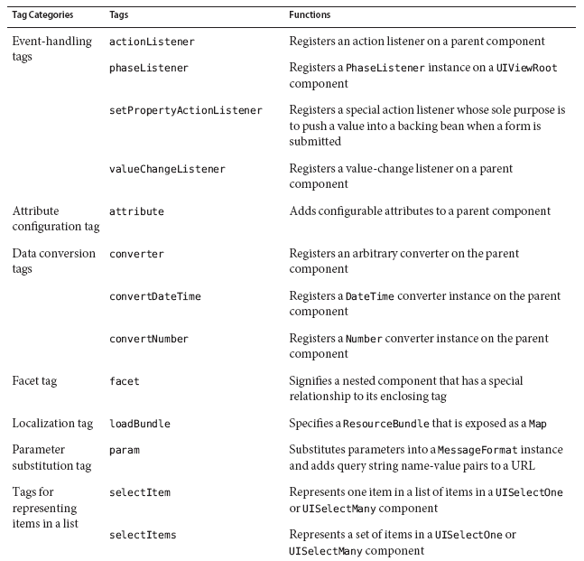
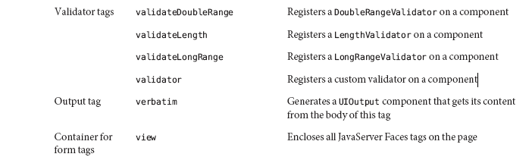

Binding a ComponentValue to an Implicit Object
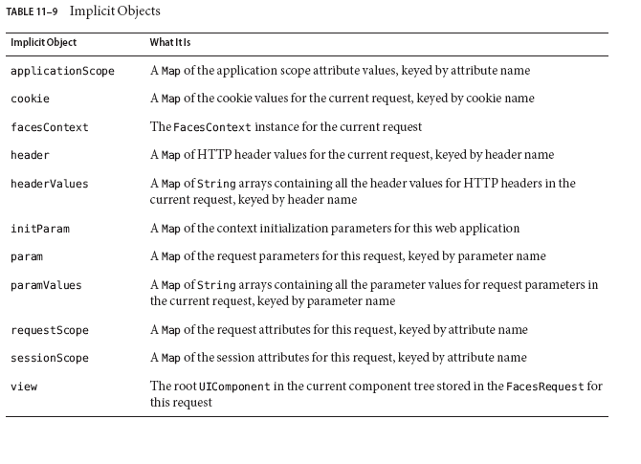

Even a very simple page uses tags from both libraries.
<%@ taglib uri=”http://java.sun.com/jsf/core “ prefix=”f” %>
<%@ taglib uri=”http://java.sun.com/jsf/html “ prefix=”h” %>
<f:view>
<h:form>

In JSF Html Tag Library there are 25 core tags .

All JSF Html Tags :
  - column creates column in a dataTable
  - commandButton creates button
  - commandLink creates link that acts like a pushbutton
  - dataTable creates a table control
  - form creates a form
  - graphicImage displays an image
  - inputHidden creates hidden field
  - inputSecret creates input control for password
  - inputText creates text input control (single line)
  - inputTextarea creates text input control (multiline)
  - message displays the most recent message for a component
  - messages displays all messages
  - outputFormat creates outputText, but formats compound messages
  - outputLabel creates label
  - outputLink creates anchor
  - outputText creates single line text output
  - panelGrid creates html table with specified number of columns
  - panelGroup used to group other components where the specification requires one child element
  - selectBooleanCheckbox creates checkbox
  - selectManyCheckbox creates set of checkboxes
  - selectManyListbox creates multiselect listbox
  - selectManyMenu creates multiselect menu
  - selectOneListbox creates single select listbox
  - selectOneMenu creates single select menu
  - selectOneRadio creates set of radio buttons

JSF Core Tags:
These tags allows you to take advantages of features of JSF framework, like validation, conversion , event handling. Core library is stepchild of Html library. i.e. core library supports the html library. Core tag library also contains tags for views and sub-views , loading resource bundle, adding arbitrary text to a page. Some examples of JSF core tags are:
f: view tag is used to create top level view
f: subview tag is used to create subview of a view.
f: validator tag is used to add a validator to a component.
f: converter tag is used to add an arbitrary converter to a component.
f: actionListener tag is used to add an action listener to a component.
f:valueChangeListener tag is used to add a valuechange listener to a component
Some examples have been given below to understand how to use these tags:
<f:view locale="en">
<h:outputText value="label" />
</f:view>

Ex:
<f:view>
<h1>head</h1>
<p>view</p>
<f:subview id="sub_id">
<c:import url="second.jsp" />
</f:subview>
</f:view>

JSF Renderers
A renderer is a type of class that is responsible for encoding and decoding components.

Encoding:
For example: Suppose we have used h:inputText tag . So the renderer of the component associated with this tag produces the following output:
<input type=”text” name=”ID” value=”current_value”/>
This is called encoding. The encoded page is sent to the browser and displayed.
Decoding:
Now if fields in form are filled by user and page is submitted by clicking the button, the browser sends the form data to the web server as a “POST” request”. POST” request contains form data and URL of the form. This form data is placed in hash table and can be accessed by all components. Each component gets a chance to look that hash table to interpret the form data. This is called decoding.
We typically create renderers for our custom components.In this case we have to register renderers with existing RenderKits in JSF configuration file faces-config.xml

If component uses renderer, then JSF calls encoding methods of the renderer, not the encoding method of the component. Which renderer will be used is determined by getRenderer() method of the component. So rendering of UI components is separated out that makes it pluggable with other possible rendering i.e.if we want a new functionality, like a new look and feel or rendering output to different client types, then its easy to add or plug a new renderer.

Render kit :
Component classes generally transfer the task of generating output to the renderer. All JSF components follow it. Render kit is a set of related renderers. javax.faces.render.RenderKit is the class which represents the render kit.The default render kit contains renderers for html but it’s up to you to make it for other markup languages.Render kit can implement a skin (a look & feel).Render kit can target a specific device like phone, PC or markup language like HTML,WML, SVG. This is one of the best benefit of JSF because JSF doesn't limit to any device or markup.

We typically create renderers for our custom components.In this case we have to register renderers with existing RenderKits in JSF configuration file faces-config.xml.
The renderer class should extend javax.faces.render.Renderer class.
<render-kit>
<renderer>
<renderer-type>........</renderer-type>
<renderer-class>........</renderer-class>
</renderer>
</render-kit>
Facelet
Facelets let’s us create reusable composition components. Being able to take a page (like a JSP) and turn it into a component.

JSF Facelet Tag Reference
  - Facelet component Tag
This tag is used to add a new component into the JSF component tree as children of UI component instance.
  - Facelet composition Tag
This is a templating tag and is used for the wrapping the content that can be included in any other facelet. This tag provides some useful features.
  - Facelet debug Tag
This tag is useful in displaying the component tree and scoped variables. This information will be displayed in a popup window of browser when we press Ctrl+Shift+(a key).
  - Facelet decorate Tag
This tag is like composition tag. Difference between those is that the content outside of the decorate tag is rendered while it is reverse for composition tag i.e. it is not rendered when we use composition tag.
  - Facelet define Tag
This tag is used to define the name of the content. This named content can be included within a template. This tag is used within those tags that allows templating like composition and decorate tags.
  - Facelet fragment Tag
This tag is used to insert the new UIcomponent to the component tree and the content outside of the tag is included to the tree.
  - Facelet include Tag
This tag is used to include the content of a page. This page name is specified by src attribute of include tag. The page that has been included should use composition tag or component tag.
  - Facelet insert Tag
This tag is used to replace the content defined in another facelet to the template. This tag takes one attribute that is not a required attribute and is used in conjunction with define tag.
  - Facelet param Tag
This tag is used to set the parameter to the enclosing component. This tag is helpful in the case of creating the compound message.
  - Facelet remove Tag
This tag is used to remove content within this tag from a facelet at compile time. This tag don't have any attribute. This tag can be used with jsfc attribute which shows that the particular tag will be removed.
  - Facelet repeat Tag
This tag is used to iterate over the list of items. The name of list of items is specified by the EL expression in the value attribute of this tag. This tag contains two attributes "value" "name".

In a nutshell, JSF eases Web-based application development because it:
- Lets you create user interfaces from a set of standard, reusable server-side components
- Provides a set of JSP tags to access those components
- Transparently saves state information and repopulates forms when they redisplay
- Provides a framework for implementing custom components
- Encapsulates event handling and component rendering so you can use standard JSF components or custom components to support markup languages other than HTML
- Lets tool vendors develop IDEs for a standard Web application framework

