Java Swing
Features of the Java Foundation Classes
Feature Description
Swing GUI Components
Includes everything from buttons to split panes to tables.
Pluggable Look-and-Feel Support
Gives any program that uses Swing components a choice of look and feel. For example, the same program can use either the Java or the Windows look and feel. Many more look-and-feel packages are available from various sources. As of v1.4.2, the Java platform supports the GTK+ look and feel, which makes hundreds of existing look and feels available to Swing programs.
Accessibility API
Enables assistive technologies, such as screen readers and Braille displays, to get information from the user interface.
Java 2D API
Enables developers to easily incorporate high-quality 2D graphics, text, and images in applications and applets. Java 2D includes extensive APIs for generating and sending high-quality output to printing devices.
Drag-and-Drop Support
Provides the ability to drag and drop between Java applications and native applications.
Internationalization
Allows developers to build applications that can interact with users worldwide in their own languages and cultural conventions. With the input method framework developers can build applications that accept text in languages that use thousands of different characters, such as Japanese, Chinese, or Korean.
What is Java Web Start and where can you get it?
Answer 2: Java Web Start is a technology that simplifies the distribution of applications. With a click on a Web page link, you can launch full-featured applications without a complicated download and installation process. In v1.4.1 and later releases of the Java platform, Java Web Start is shipped as part of the platform.

And here's the full code for HelloWorldSwing:
import javax.swing.*;

public class HelloWorldSwing {
/**
* Create the GUI and show it. For thread safety,
* this method should be invoked from the
* event-dispatching thread.
*/
private static void createAndShowGUI() {
//Make sure we have nice window decorations.
JFrame.setDefaultLookAndFeelDecorated(true);

//Create and set up the window.
JFrame frame = new JFrame("HelloWorldSwing");
frame.setDefaultCloseOperation(JFrame.EXIT_ON_CLOSE);

//Add the ubiquitous "Hello World" label.
JLabel label = new JLabel("Hello World");
frame.getContentPane().add(label);

//Display the window.
frame.pack();
frame.setVisible(true);
}

public static void main(String[] args) {
//Schedule a job for the event-dispatching thread:
//creating and showing this application's GUI.
javax.swing.SwingUtilities.invokeLater(new Runnable() {
public void run() {
createAndShowGUI();
}
});
}
}

Using Layout Managers
The Java platform supplies six commonly used layout managers: BorderLayout, BoxLayout, FlowLayout, GridLayout, GridBagLayout, and SpringLayout.

As we mentioned before, all JPanel objects use FlowLayout by default. On the other hand, content panes (the main containers in JApplet, JDialog, and JFrame objects) use BorderLayout by default.

Dialogs
In our previous examples, our top-level container has always been a JFrame. Another kind of top-level container is a dialog--a window that is more limited than a frame. To

create simple, standard dialogs, you use the JOptionPane class. The dialogs that JOptionPane provides are modal. When a modal dialog is visible, it blocks user input to all other windows in the program.

Question 1: On what thread should GUIs be created, to guarantee thread safety?
Answer 1: The event-dispatching thread.

Question 4: What is the content pane?
Answer 4: The content pane is the main container in JApplet, JDialog, and JFrame objects.

Top-Level Containers and Containment Hierarchies
Each program that uses Swing components has at least one top-level container. This top-level container is the root of a containment hierarchy — the hierarchy that contains all of the Swing components that appear inside the top-level container.
As a rule, a standalone application with a Swing-based GUI has at least one containment hierarchy with a JFrame as its root. For example, if an application has one main window and two dialogs, then the application has three containment hierarchies, and thus three top-level containers. One containment hierarchy has a JFrame as its root, and each of the other two has a JDialog object as its root.
A Swing-based applet has at least one containment hierarchy, exactly one of which is rooted by a JApplet object. For example, an applet that brings up a dialog has two containment hierarchies. The components in the browser window are in a containment hierarchy rooted by a JApplet object. The dialog has a containment hierarchy rooted by a JDialog object.

The JComponent Class
With the exception of top-level containers, all Swing components whose names begin with "J" descend from the JComponent class. For example, JPanel, JScrollPane, JButton, and JTable all inherit from JComponent. However, JFrame and JDialog don't because they implement top-level containers.
The default layout manager for a Swing applet's content pane is BorderLayout. This differs from the default layout manager for Applet, which is FlowLayout.
Several AWT and Swing classes provide layout managers for general use:
- BorderLayout
- BoxLayout
- CardLayout
- FlowLayout
- GridBagLayout
- GridLayout
- SpringLayout
This section shows example GUIs that use these layout managers, and tells you where to find the how-to page for each layout manager. You can find links for running the examples in the how-to pages and the example index.

BorderLayout
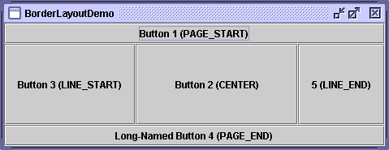
Every content pane is initialized to use a BorderLayout. (As Using Top-Level Containers explains, the content pane is the main container in all frames, applets, and dialogs.) A BorderLayout places components in up to five areas: top, bottom, left, right, and center. All extra space is placed in the center area. For further details, see How to Use BorderLayout.

BoxLayout
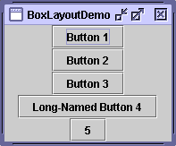
The BoxLayout class puts components in a single row or column. It respects the components' requested maximum sizes and also lets you align components. For further details, see How to Use BoxLayout.

CardLayout
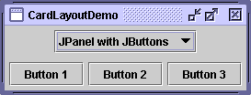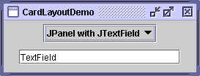
The CardLayout class lets you implement an area that contains different components at different times. A CardLayout is often controlled by a combo box, with the state of the combo box determining which panel (group of components) the CardLayout displays. An alternative to using CardLayout is using a tabbed pane, which provides similar functionality but with a pre-defined GUI. For further details, see How to Use CardLayout.

FlowLayout
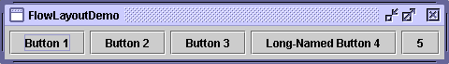
FlowLayout is the default layout manager for every JPanel. It simply lays out components in a single row, starting a new row if its container isn't sufficiently wide. Both panels in CardLayoutDemo, shown previously, use FlowLayout. For further details, see How to Use FlowLayout.

GridBagLayout
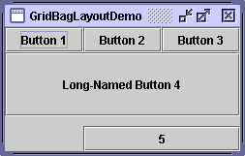
GridBagLayout is a sophisticated, flexible layout manager. It aligns components by placing them within a grid of cells, allowing some components to span more than one cell. The rows in the grid can have different heights, and grid columns can have different widths. For further details, see How to Use GridBagLayout.

GridLayout
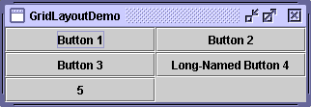
GridLayout simply makes a bunch of components equal in size and displays them in the requested number of rows and columns. For further details, see How to Use GridLayout.

SpringLayout
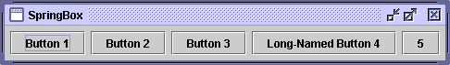
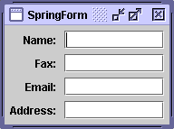
SpringLayout is a flexible layout manager designed for use by GUI builders. It lets you specify precise relationships between the edges of components under its control. For example, you might define that the left edge of one component is a certain distance (which can be dynamically calculated) from the right edge of a second component. For further details, see How to Use SpringLayout.

AWT:
Pros
- Speed: use of native peers speeds component performance.
- Applet Portability: most Web browsers support AWT classes so AWT applets can run without the Java plugin.
- Look and Feel: AWT components more closely reflect the look and feel of the OS they run on.
Cons
- Portability: use of native peers creates platform specific limitations. Some components may not function at all on some platforms.
- Third Party Development: the majority of component makers, including Borland and Sun, base new component development on Swing components. There is a much smaller set of AWT components available, thus placing the burden on the programmer to create his or her own AWT-based components.
- Features: AWT components do not support features like icons and tool-tips.

Swing:
Pros
- Portability: Pure Java design provides for fewer platform specific limitations.
- Behavior: Pure Java design allows for a greater range of behavior for Swing components since they are not limited by the native peers that AWT uses.
- Features: Swing supports a wider range of features like icons and pop-up tool-tips for components.
- Vendor Support: Swing development is more active. Sun puts much more energy into making Swing robust.
- Look and Feel: The pluggable look and feel lets you design a single set of GUI components that can automatically have the look and feel of any OS platform (Microsoft Windows, Solaris, Macintosh, etc.). It also makes it easier to make global changes to your Java programs that provide greater accessibility (like picking a hi-contrast color scheme or changing all the fonts in all dialogs, etc.).
Cons
- Applet Portability: Most Web browsers do not include the Swing classes, so the Java plugin must be used.
- Performance: Swing components are generally slower and buggier than AWT, due to both the fact that they are pure Java and to video issues on various platforms. Since Swing components handle their own painting (rather than using native API's like DirectX on Windows) you may run into graphical glitches.
- Look and Feel: Even when Swing components are set to use the look and feel of the OS they are run on, they may not look like their native counterparts.

Event Adapters
Some listener interfaces contain more than one method. For example, the MouseListener interface contains five methods: mousePressed, mouseReleased, mouseEntered, mouseExited, and mouseClicked. Even if you care only about mouse clicks, if your class directly implements MouseListener, then you must implement all five MouseListener methods. Methods for those events you don't care about can have empty bodies.

Inner Classes and Anonymous Inner Classes
What if you want to use an adapter class, but don't want your public class to inherit from an adapter class? For example, suppose you write an applet, and you want your Applet subclass to contain some code to handle mouse events. Since the Java language doesn't permit multiple inheritance, your class can't extend both the Applet and MouseAdapter classes. A solution is to define an inner class — a class inside of your Applet subclass — that extends the MouseAdapter class.
Inner classes can also be useful for event listeners that implement one or more interfaces directly.
//An example of using an inner class.
public class MyClass extends Applet {
...
someObject.addMouseListener(new MyAdapter());
...
class MyAdapter extends MouseAdapter {
public void mouseClicked(MouseEvent e) {
...//Event listener implementation goes here...
}
}
}
EventHandler class that supports dynamically generating simple, one-statement event listeners

