Java Spring

Spring is a light weight framework for developing enterprise application.

The advantages of Spring are as follows:
- Spring has layered architecture. Use what you need and leave you don't need now.
- Spring Enables POJO Programming. There is no behind the scene magic here. POJO programming enables continuous integration and testability.
- Dependency Injection and Inversion of Control Simplifies JDBC
- Open source and no vendor lock-in.

Spring provides following features.
- Transaction Management: Spring provides a generic abstract transaction management in which the developer can pluggin an transaction manager. Developer don’t need to deal with low level transaction issues. And also this can run on any server without the need of a J2EE container.
- JDBC Exception Handling”
This simplifies the JDBC error handling.
- Integration with Hibernate, JDO and iBatis
- AOP framework.
- Inversion of control (dependency injection).
- MVC framework: Provides MVC framework build on core spring functionality. But we can easily pluggin any other MVC framework in spring.

This is a list of new features for Spring 3.0.

Spring 3.0 New features

- Uses Java5 new features like generics, varargs etc.
- Spring's TaskExecutor abstraction has been updated for close integration with Java 5's java.util.concurrent facilities.
- Spring Expression Language
- IoC enhancements/Java based bean metadata
- IoC enhancements/Java based bean metadata
- General-purpose type conversion system and field formatting system
- Object to XML mapping functionality (OXM) moved from Spring Web Services project
- Comprehensive REST support
- @MVC additions
- Declarative model validation
- Early support for Java EE 6
- Embedded database support
- General-purpose type conversion system and field formatting system
- Spring 3 introduces a core.convert package that provides a general type conversion system

Inversion of control (dependency injection)
The basic concept of the Inversion of Control pattern (also known as dependency injection) is that you do not create your objects but describe how they should be created. You don't directly connect your components and services together in code but describe which services are needed by which components in a configuration file. A container (in the case of the Spring framework, the IOC container) is then responsible for hooking it all up.
i.e., Applying IoC, objects are given their dependencies at creation time by some external entity that coordinates each object in the system. That is, dependencies are injected into objects. So, IoC means an inversion of responsibility with regard to how an object obtains references to collaborating objects.

Benefits of IoC

- Minimizes the amount of code in your application.
- Make your application more testable by not requiring any singletons or JNDI lookup mechanisms in your unit test cases.
- Loose coupling is promoted with minimal effort and least intrusive mechanism. The factory design pattern is more intrusive because components or services need to be requested explicitly whereas in IOC the dependency is injected into requesting piece of code. Also some containers promote the design to interfaces not to implementations design concept by encouraging managed objects to implement a well-defined service interface of your own.
- IOC containers support eager instantiation and lazy loading of services. Containers also provide support for instantiation of managed objects, cyclical dependencies, life cycles management, and dependency resolution between managed objects etc.

Aspect Oriented Programming
Aspect-oriented programming is often defined as a programming technique that
promotes separation of concerns within a software system

Modules in Spring
- Spring AOP: For AOP, replacement for EJB declarative services.
- Spring DAO: Standardizes data acess work.
- Spring Web:
- Spring Web MVC
- Spring Core: Provides dependency injection services.
- Spring Context: adds support for message resources,
- Spring ORM: Provides integration to ORM tools like Hibernate, iBatis etc.

Modules

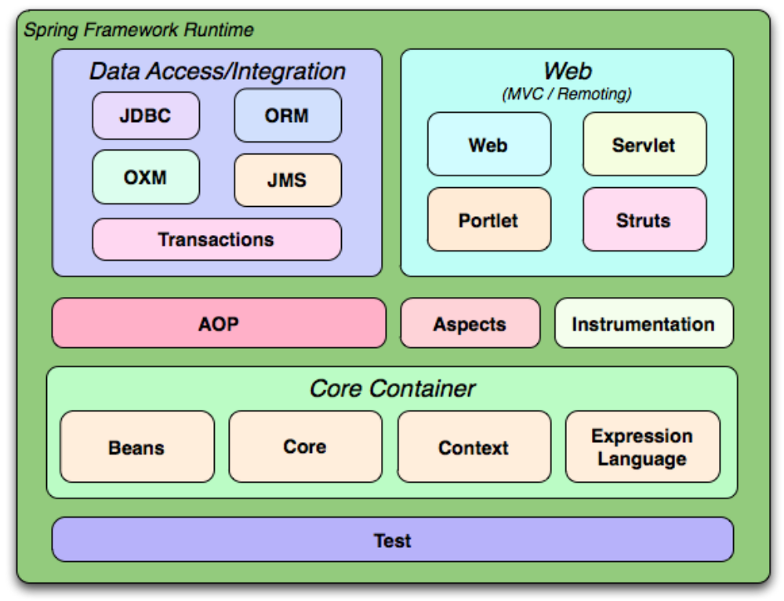

he OSGi framework (OSGi being an acronym for "Open Services Gateway initiative") is a module system and service platform for the Java programming language that implements a complete and dynamic component model, something that as of 2012 does not exist in standalone Java/VM environments. Applications or components (coming in the form of bundles for deployment) can be remotely installed, started, stopped, updated, and uninstalled without requiring a reboot

Difference between EJB and Spring
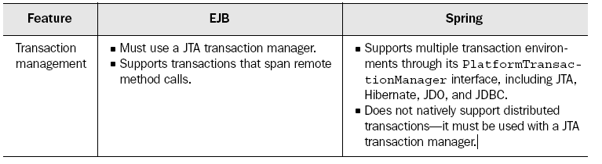
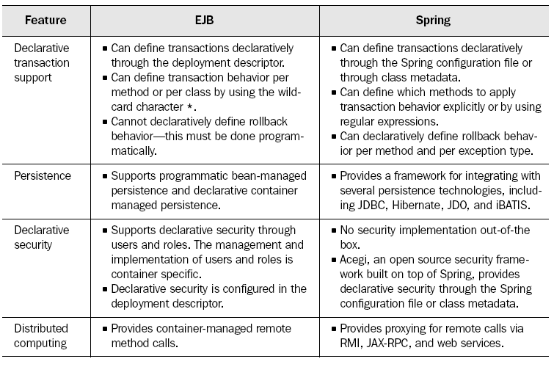

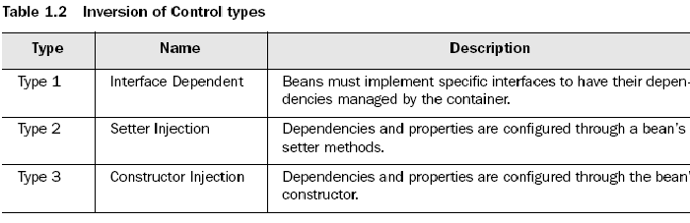

Struts and Spring MVC
- Struts action classes need to sub class ‘Action’ where as in spring they need to implement the controller interface.
- In struts when user is submitting a form the data maps to an actionForm objects which we need to create. But spring allows us to directly map the form submission to an object giving better maintenance.

Spring’s container uses inversion of control (IoC) to manage the components that make up an application.

Spring Bean’s life cycle:

- Instantiation: Spring instantiates the bean.
Populate properties: Spring injects the bean properties
- Set Bean Name : If the bean implements BeanNameAware, spring passes the bean id to the setBeanName();
Set bean factory: If the bean implements BeanFactoryAware, spring passes the bean factory to the setBeanFactory();
- Post process (Before initialization): If there are any bean post processors, spring their postProcessBeforeInitialization() method.
- Initialize bean: If the bean implements InitializingBean, its afterPropertiesSet() method will be called.If the bean has a custom initialization method it will be called.
- Post process (after initialization): If there are any post processors, spring calls the postProcessAfterInitialization() method.
- Bean is ready to use:
- Destroy bean: If the bean implements DisposableBean, its destroy() method will be called. If the bean has a custor destroy method declared, the specified method will be called.

Spring containers
- Bean Factory:
A BeanFactory is like a factory class that contains a collection of beans. The BeanFactory holds Bean Definitions of multiple beans within itself and then instantiates the bean whenever asked for by clients.
- BeanFactory is able to create associations between collaborating objects as they are instantiated. This removes the burden of configuration from bean itself and the beans client.
- BeanFactory also takes part in the life cycle of a bean, making calls to custom initialization and destruction methods.

- Application context: In addition to the functionalities of bean factory the application context does the following.
  - Provides application framework service such as ability to resolve textual messages from properties and publish application events to interested listeners.
  - Application contexts provide a generic way to load file resources, such as images.

BeanFactory factory = new XmlBeanFactory(new FileInputStream("beans.xml"));

Among the many implementations of ApplicationContext are three that are commonly used:

■ ClassPathXmlApplicationContext—Loads a context definition from an XML file located in the class path, treating context definition files as class path resources.

■ FileSystemXmlApplicationContext—Loads a context definition from an XML file in the filesystem.

■ XmlWebApplicationContext—Loads context definitions from an XML file contained within a web application.

ApplicationContext context = new FileSystemXmlApplicationContext("c:/foo.xml");

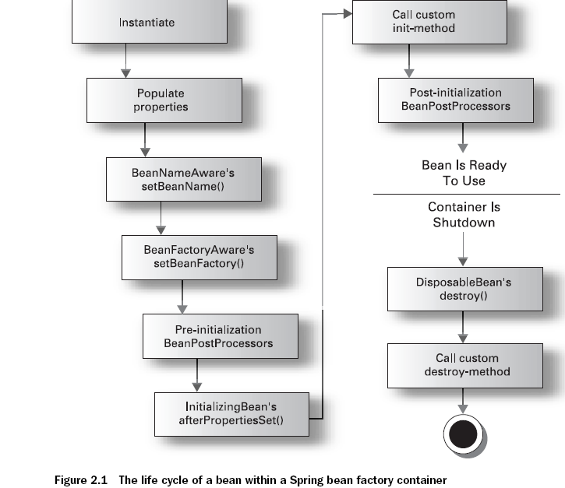

Basic wiring
Piecing together beans within the Spring container is known as wiring. When wiring beans, you tell the container what beans are needed and how the container should use dependency injection to tie them together.

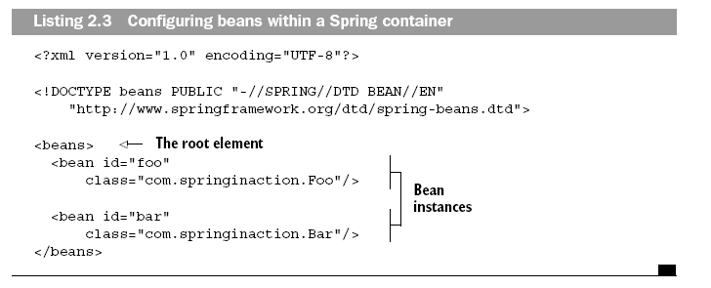

Prototyping Vs. Singleton
By default all spring beans are singleton. If you want to create a new instance of the bean you need to create the prototype of the bean which means instead of defining single bean you define a blueprint. Beans are then created based on blueprint.

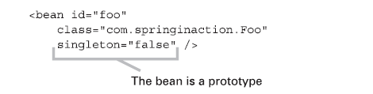

Initialization and destruction

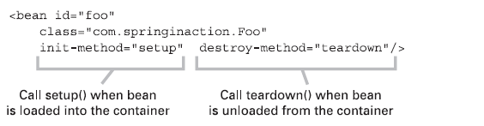

Spring also provides two interfaces that perform the same functionality: InitializingBean
and DisposableBean. The InitializingBean interface provides one method, afterPropertiesSet(), that will be called once all of a bean’s properties have been set. Similarly, DisposableBean’s one method, destroy(), will be called when the bean is removed from the container.

Passing list values

<bean id="sessionFactory" class=
"org.springframework.orm.hibernate.LocalSessionFactoryBean">
<property name="mappingResources">
<list>
<value>/com/springinaction/training/model/Course.hbm.xml</value>
<value>/com/springinaction/training/model/Student.hbm.xml</value>
</list>
</property>
…
</bean>

Wiring maps

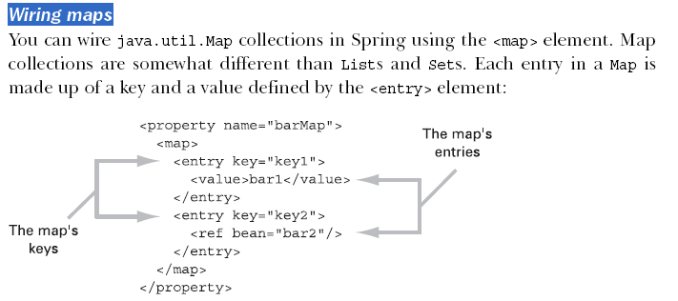

An alternative to setter injection
Setter injection is a straightforward way to configure and wire bean properties. But one shortcoming of setter injection is that assumes that all mutable properties are available via a setter method.

Dependency injection by Constructor

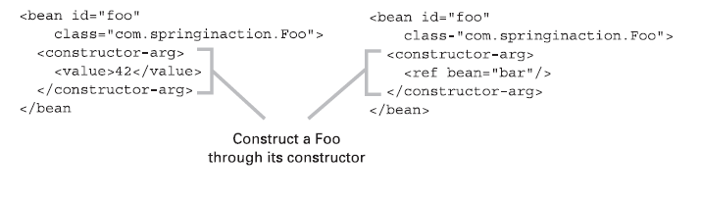

Autowiring

It is possible to automatic resolve collaborators (other beans) for your bean by inspecting the contents of the BeanFactory. In Spring Framework this can be achieved by auto writing modes.

- byname
- byType
- byConstructor
- autodetect

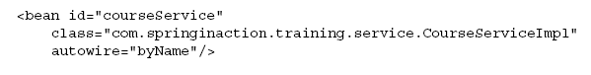

PostProcessing Beans

- BeanPostProcessor :
performs postprocessing on a bean after it has been loaded

- ApplicationContextAwareProcessor
Sets application context on the bean.

- BeanFactoryPostProcessor:
performs postprocessing on a bean factory after the bean factory has loaded its bean definitions but before any of the beans have been instantiated.

Listening for events
1.ContextClosedEvent—Published when the application context is closed
2..ContextRefreshedEvent—Published when the application context is initialized
or refreshed
3. RequestHandledEvent—Published within a web application context when a
request is handled

Knowing about the Beans
Bean-NameAware,
BeanFactoryAware, and

ApplicationContextAware
interfaces. By implementing these three interfaces, beans can be made aware of their name, their
BeanFactory, and their ApplicationContext, respectively.

Aspect Oriented Programming

AOP is used in the Spring Framework to...
• ... provide declarative enterprise services, especially as a replacement for EJB declarative services. The
most important such service is declarative transaction management.
• ... allow users to implement custom aspects, complementing their use of OOP with AOP.

Example:
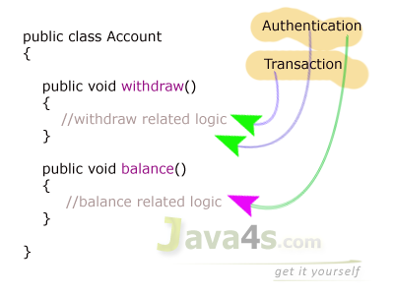

Aspect:
- An aspect represent the cross-cutting functionality name, remember just name only.
- One real time service required for a business logic is called one Aspect.
- Aspect denotes only the cross-cutting functionality name not its implementation and all
- In the above diagram Authentication and Transaction are aspects.
Advice:
Advice is the implementation of Aspect. An Advice provides the code for implementation of the service. As an example consider logging service, logging is an Aspect and Advice denotes the implementation of Log4j.

Types of Advices
- Before Advice
public class beforeAdvice implements MethodBeforeAdvice
{
public void before(Method m,Object args[], Object target)throws Exception
{
//My Before Logic...
}
}
- After Advice
public class afterAdvice implements AfterReturningAdvice
{
public void afterReturning(Object returnValue,Object args[], Object target)throws Exception
{
//My Before Logic...
}
}
- Throws Advice
public class Client implements ThrowsAdvice
{
public void afterThrowing(Method m,Object args[],Object target,Exception e)
{
// our services
}
}
- Around Advice
  - Around Advice is combination of both Before and After Advice.
  - In a single Advice it is possible to implement both Before and After services.
public class Client implements MethodInterceptor
{
public Object invoke(MethodInvocation mi)throws Throwable
{
//Before Logic
Object ob = mi.proceed();
//After logic
return ob;

}
}

Join Point:
While creating the business logic of the method the additional services are needed to be injected (which we saw already) at different places or points, we call such points as join points.
At the join point, an Aspect is injected.

Point Cut:
For what methods what services need to be executed will be taken care by pointcut. A pointcut defines what advices are required at what join points.
We have 2 types of pointcuts in AOP
  - Static Pointcut
    - NameMatchMethodPointcut
<bean id="id1" class="org.spfw.aop.support.NameMatchMethodPointcut">
<property name="mappedNames">
<list>
<value>method1</value>
<value>method2</value>
<value>method3</value>
</list>
</property>
</bean>
    - RegxpMethodPointcut
<bean id="id1" class="org.spfw.aop.support.RegularExpressionMethodPointcut">
<property name="pattern">
<value>get.*N.+[0-9]</value>
</property>
</bean>

  - Dynamic Pointcut
Target object: object being advised by one or more aspects.
AOP proxy: an object created by the AOP framework in order to implement the aspect contracts
Introduction
An introduction allows you to add new methods or attributes to existing classes

Target
A target is the class that is being advised.

Proxy
A proxy is the object created after applying advice to the target object.

Weaving
Weaving is the process of applying aspects to a target object to create a new, proxied
object.

The weaving can take place at several points in the target class’s lifetime:
■ Compile time—Aspects are woven in when the target class is compiled. This
requires a special compiler.
■ Classload time—Aspects are woven in when the target class is loaded into
the JVM. This requires a special ClassLoader that enhances that target
class’s bytecode before the class is introduced into the application.
■ Runtime—Aspects are woven in sometime during the execution of the
application. Typically, an AOP container will dynamically generate a proxy
class that will delegate to the target class while weaving in the aspects.

In spring the weaving is done during runtime.
Spring only supports method joinpoints

Spring generates proxied classes in two ways.
1. If your target object implements
an interface(s) that exposes the required methods, Spring will use the JDK’s
java.lang.reflect.Proxy class.

2. If your target class does not implement an interface, Spring uses the CGLIB1
library to generate a subclass to your target class.

Understanding Spring’s DataAccessException
all exceptions thrown are subclasses of the technology-agnostic org.springframework.dao.DataAccess-Exception

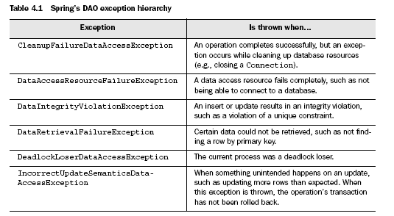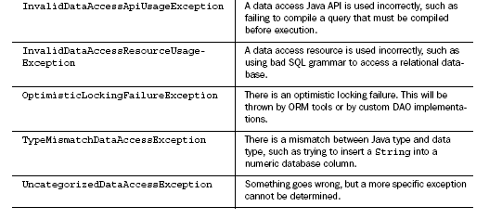

Getting a DataSource from JNDI

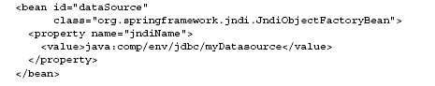

Creating a DataSource connection pool
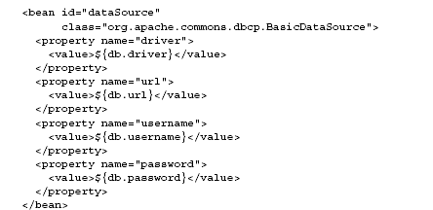

Using a DataSource while testing
DriverManagerDataSource dataSource = new DriverManagerDataSource();
dataSource.setDriverClassName(driver);
dataSource.setUrl(url);
dataSource.setUsername(username);
dataSource.setPassword(password);

Consistent DAO support

Spring separates the fixed and variant parts of the data access process into two distinct classes: templates and callbacks. Templates manage the fixed part of the process while callbacks are where you fill in the implementation details.

Spring’s template classes handle the invariant parts of data access—controlling transactions, managing resources, and handling exceptions. Implementations of the callback interfaces define what is specific to your application—creating statements, binding parameters, and marshalling result sets. In practice, this makes for a very elegant framework because all you have to worry about is your data access logic.

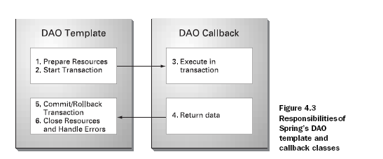

Using JDBC with Spring

Using JdbcTemplate

Spring’s JDBC framework will clean up your JDBC code by shouldering the burden
of resource management and error handling.
JdbcTemplate template = new JdbcTemplate(myDataSource);

Callback interfaces
PreparedStatementCreator.: Creating the prepared stmt
SqlProvider.: getting the sql
PreparedStatementSetter: setting the values in the pstmt statement.
BatchPreparedStatementSetter.: For batch updates.
RowCallbackHandler: For handling the row data of the resultset.
ResultReader.: To retrieve multiple results from db.
RowMapper: For mapping the result set to specific object.
CallableStatementCallback.: For calling stored procedure.

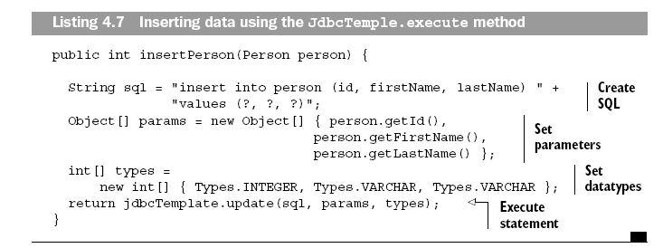

Using RowCallbackHandler

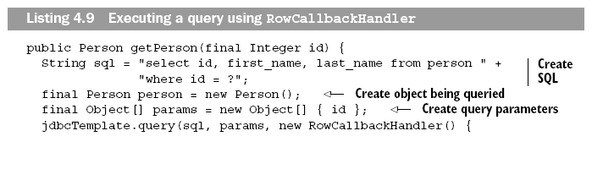
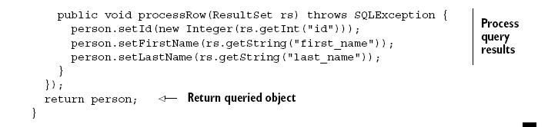

Calling stored procedure.

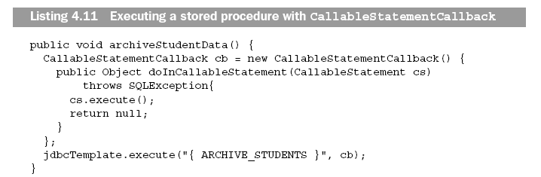

Using Spring with Hibernate
Spring provides integration points to these frameworks, as well as some additional services:
■ Integrated transaction management
■ Exception handling
■ Thread-safe, lightweight template classes
■ Convenience support classes
■ Resource management

Managing Hibernate resources

Sample Hibernate configuration file in spring.

<bean id="sessionFactory"class="org.springframework.
orm.hibernate.LocalSessionFactoryBean">
<property name="dataSource">
<ref bean="dataSource"/>
</property>
<property name="hibernateProperties">
<props>
<prop key="hibernate.dialect">net.sf.hibernate.
dialect.MySQLDialect</prop>
</props>
</property>
<property name="mappingDirectoryLocations">
<list>
<value>classpath:/com/springinaction/training/mod el
</value>
</list>
</property>

<property name="mappingResources">
<list>
<value>Student.hbm.xml</value>
<value>Course.hbm.xml</value>
</list>
</property>
<bean>

<bean id="dataSource"
class="org.springframework.jndi.JndiObjectFactory Bean">
<property name="jndiName">
<value>java:comp/env/jdbc/trainingDatasource</value>
</property>
</bean>

<bean id="hibernateTemplate"
class="org.springframework.orm.hibernate.HibernateTemplate">
<property name="sessionFactory">
<ref bean="sessionFactory"/>
</property>
</bean>
Hibernate Template
HibernateTemplate

Callabak interfaces
HibernateCallback: Defines method doInHibernate()

Using Hibernate template with db
hibernateTemplate.load(Student.class, id);

hibernateTemplate.find("from Student student " + "where student.lastName = ?",
lastName, Hibernate.STRING);

Spring’s transaction management support

- EJB is coupled with JTA where as spring employs call back mechanism that abstract away the actual transaction implementation from the code.

- For application that has transactional requirement spanning multiple data sources spring can support distributed transaction using a third party JTA implementation.

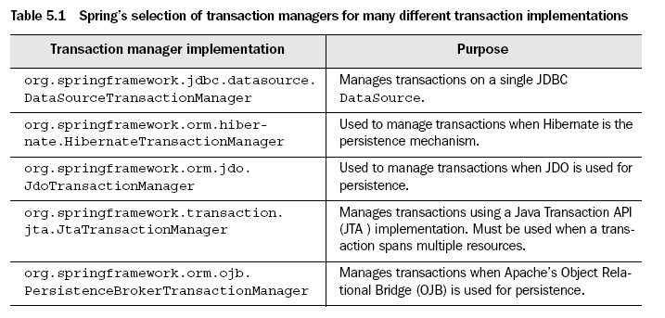
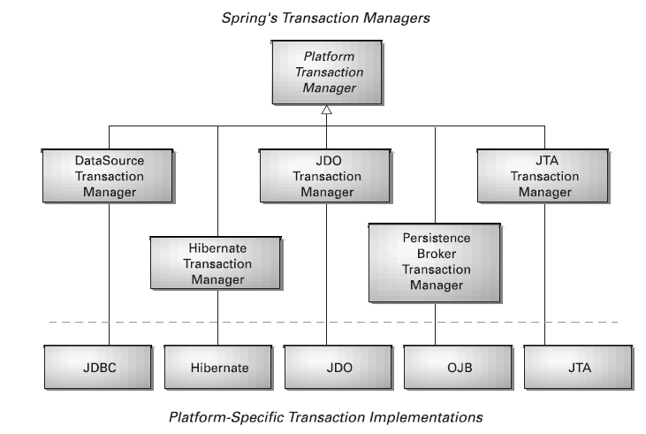

JDBC transactions
<bean id="transactionManager" class="org.springframework.jdbc.datasource.DataSourceT ransactionManager">
<property name="dataSource">
<ref bean="dataSource"/>
</property>
</bean>

Hibernate Transactions
<bean id="transactionManager" class="org.springframework.
orm.hibernate.HibernateTransactionManager">
<property name="sessionFactory">
<ref bean="sessionFactory"/>
</property>
</bean>

Java Transaction API transactions
<bean id="transactionManager" class="org.springframework.
transaction.jta.JtaTransactionManager">
<property name="transactionManagerName">
<value>java:/TransactionManager</value>
</property>
</bean>

Programming transactions in Spring
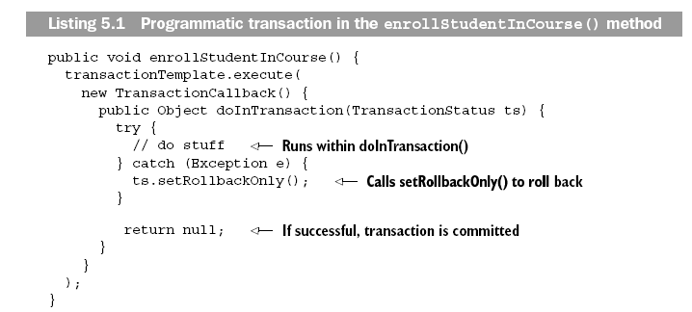

<bean id="transactionTemplate" class="org.springframework.
transaction.support.TransactionTemplate">
<property name="transactionManager">
<ref bean="transactionManager"/>
</property>
</bean>

Declaring transactions

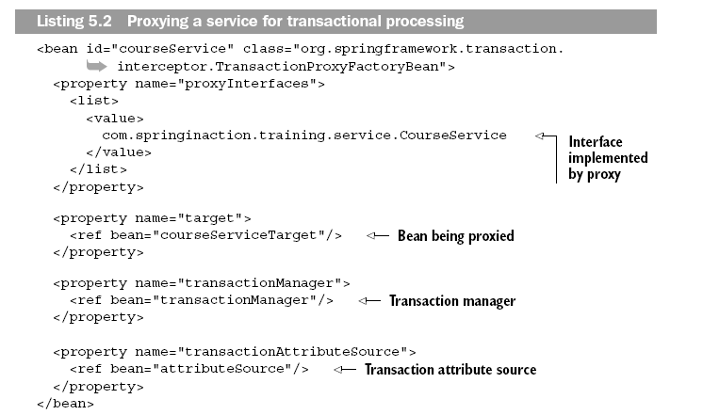

Understanding transaction attributes
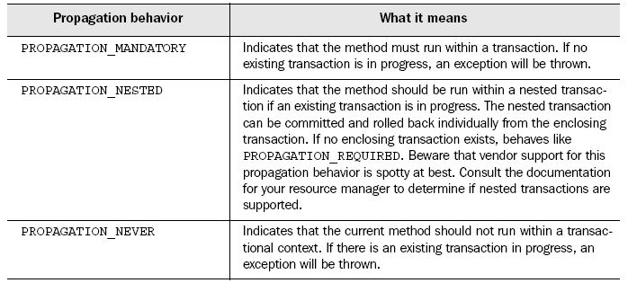
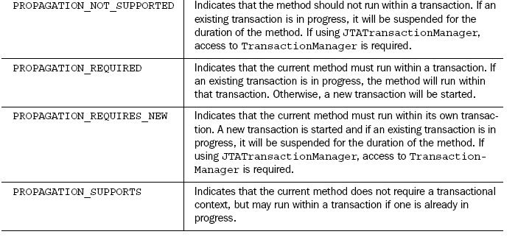

Dirty reads
A dirty read occurs when a transaction is allowed to read data from a row that has been modified by another running transaction and not yet committed.
Dirty reads work similarly to non-repeatable reads; however, the second transaction would not need to be committed for the first query to return a different result. The only thing that may be prevented in the READ UNCOMMITTED isolation level is updates appearing out of order in the results; that is, earlier updates will always appear in a result set before later updates.
In our example, Transaction 2 changes a row, but does not commit the changes. Transaction 1 then reads the uncommitted data. Now if Transaction 2 rolls back his changes (already read by Transaction 1) or updates different changes to the database, then the view of the data may be wrong in the records of Transaction 1.
Transaction 1 | Transaction 2
/* Query 1 */
SELECT * FROM users WHERE id = 1;
/* Query 2 */
UPDATE users SET age = 21 WHERE id = 1;
/* No commit here */
/* Query 1 */
SELECT * FROM users WHERE id = 1;
 | ROLLBACK; /* lock-based DIRTY READ */

Non-repeatable reads
A non-repeatable read occurs, when during the course of a transaction, a row is retrieved twice and the values within the row differ between reads.
Non-repeatable reads phenomenon may occur in a lock-based concurrency control method when read locks are not acquired when performing a SELECT, or when the acquired locks on affected rows are released as soon as the SELECT operation is performed. Under the multiversion concurrency control method, non-repeatable reads may occur when the requirement that a transaction affected by a commit conflict must roll back is relaxed.
Transaction 1 | Transaction 2
/* Query 1 */
SELECT * FROM users WHERE id = 1;
/* Query 2 */
UPDATE users SET age = 21 WHERE id = 1;
COMMIT; /* in multiversion concurrency
control, or lock-based READ COMMITTED */
/* Query 1 */
SELECT * FROM users WHERE id = 1;
COMMIT; /* lock-based REPEATABLE READ */
In this example, Transaction 2 commits successfully, which means that its changes to the row with id 1 should become visible. However, Transaction 1 has already seen a different value for age in that row. At the SERIALIZABLE and REPEATABLE READ isolation levels, the DBMS must return the old value. At READ COMMITTED and READ UNCOMMITTED, the DBMS may return the updated value; this is a non-repeatable read.

Phantom reads
A phantom read occurs when, in the course of a transaction, two identical queries are executed, and the collection of rows returned by the second query is different from the first.
This can occur when range locks are not acquired on performing a SELECT ... WHERE operation. The phantom reads anomaly is a special case of Non-repeatable reads when Transaction 1 repeats a ranged SELECT ... WHERE query and, in the middle of both operations, Transaction 2 creates (i.e. INSERT) new rows (in the target table) fulfilling that WHERE clause.
Transaction 1 | Transaction 2
/* Query 1 */
SELECT * FROM users
WHERE age BETWEEN 10 AND 30;
/* Query 2 */
INSERT INTO users VALUES ( 3, 'Bob', 27 );
COMMIT;
/* Query 1 */
SELECT * FROM users
WHERE age BETWEEN 10 AND 30;

Isolation levels

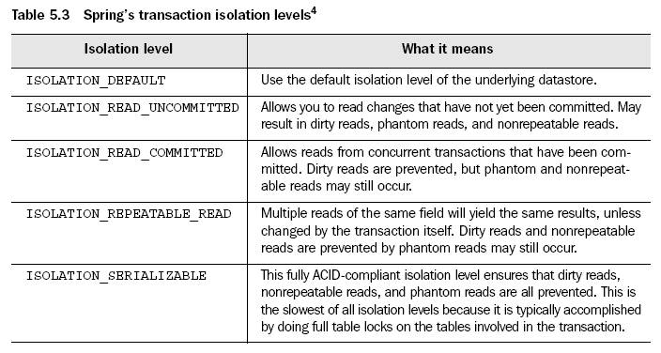

Read-only
If a transaction performs only read operations against the underlying datastore,
the datastore may be able to apply certain optimizations that take advantage of
the read-only nature of the transaction.

it only makes sense to declare a transaction as readonly
on methods with propagation behaviors that may start a new transaction
(PROPAGATION_REQUIRED, PROPAGATION_REQUIRES_NEW, and PROPAGATION_NESTED).

Transaction Timeout
Because the timeout clock begins ticking when a transaction starts, it only makes sense to declare a transaction timeout on methods with propagation behaviors that may start a new transaction (PROPAGATION_REQUIRED, PROPAGATION_REQUIRES_NEW, and PROPAGATION_NESTED).

<bean id="myTransactionAttribute"
class="org.springframework.transaction.interceptor.
DefaultTransactionAttribute">
<property name="propagationBehaviorName">
<value>PROPAGATION_REQUIRES_NEW</value>
</property>
<property name="isolationLevelName">
<value>ISOLATION_REPEATABLE_READ</value>
</property>
</bean>
<bean id="transactionAttributeSource"
class="org.springframework.transaction.interceptor.
MatchAlwaysTransactionAttributeSource">
<property name="transactionAttribute">
<ref bean="myTransactionAttribute"/>
</property>
</bean>

Configuring transaction attributes for specific method

<bean id="transactionAttributeSource"
class="org.springframework.transaction.interceptor. NameMatchTransactionAttributeSource">
<property name="properties">
<props>
<prop key="enrollStudentInCourse">
PROPAGATION_REQUIRES_NEW,ISOLATION_REPEATABLE_READ,
-CourseException

</prop>
</props>
</property>
</bean>

An example for declarative transaction.

A first example
Consider the following interface, and its attendant implementation. (The intent is to convey the concepts, and using the rote Foo and Bar tropes means that you can concentrate on the transaction usage and not have to worry about the domain model.)
// the service interface that we want to make transactional

package x.y.service;

public interface FooService {

Foo getFoo(String fooName);

Foo getFoo(String fooName, String barName);

void insertFoo(Foo foo);

void updateFoo(Foo foo);

}
// an implementation of the above interface

package x.y.service;

public class DefaultFooService implements FooService {

public Foo getFoo(String fooName) {
throw new UnsupportedOperationException();
}

public Foo getFoo(String fooName, String barName) {
throw new UnsupportedOperationException();
}

public void insertFoo(Foo foo) {
throw new UnsupportedOperationException();
}

public void updateFoo(Foo foo) {
throw new UnsupportedOperationException();
}

}
(For the purposes of this example, the fact that the DefaultFooService class throws UnsupportedOperationException instances in the body of each implemented method is good; it will allow us to see transactions being created and then rolled back in response to the UnsupportedOperationException instance being thrown.)
Let's assume that the first two methods of the FooService interface (getFoo(String) and getFoo(String, String)) have to execute in the context of a transaction with read-only semantics, and that the other methods (insertFoo(Foo) and updateFoo(Foo)) have to execute in the context of a transaction with read-write semantics. Don't worry about taking the following configuration in all at once; everything will be explained in detail in the next few paragraphs.
<!-- from the file 'context.xml' -->
<?xml version="1.0" encoding="UTF-8"?>
<beans xmlns="http://www.springframework.org/schema/beans"
xmlns:xsi="http://www.w3.org/2001/XMLSchema-instance"
xmlns:aop="http://www.springframework.org/schema/aop"
xmlns:tx="http://www.springframework.org/schema/tx"
xsi:schemaLocation="
http://www.springframework.org/schema/beans http://www.springframework.org/schema/beans/spring-beans-2.0.xsd
http://www.springframework.org/schema/tx http://www.springframework.org/schema/tx/spring-tx-2.0.xsd
http://www.springframework.org/schema/aop http://www.springframework.org/schema/aop/spring-aop-2.0.xsd">

<!-- this is the service object that we want to make transactional -->
<bean id="fooService" class="x.y.service.DefaultFooService"/>

<!-- the transactional advice (i.e. what 'happens'; see the <aop:advisor/> bean below) -->
<tx:advice id="txAdvice" transaction-manager="txManager">
<!-- the transactional semantics... -->
<tx:attributes>
<!-- all methods starting with 'get' are read-only -->
<tx:method name="get*" read-only="true"/>
<!-- other methods use the default transaction settings (see below) -->
<tx:method name="*"/>
</tx:attributes>
</tx:advice>

<!-- ensure that the above transactional advice runs for any execution
of an operation defined by the FooService interface -->
<aop:config>
<aop:pointcut id="fooServiceOperation" expression="execution(* x.y.service.FooService.*(..))"/>
<aop:advisor advice-ref="txAdvice" pointcut-ref="fooServiceOperation"/>
</aop:config>

<!-- don't forget the DataSource -->
<bean id="dataSource" class="org.apache.commons.dbcp.BasicDataSource" destroy-method="close">
<property name="driverClassName" value="oracle.jdbc.driver.OracleDriver"/>
<property name="url" value="jdbc:oracle:thin:@rj-t42:1521:elvis"/>
<property name="username" value="scott"/>
<property name="password" value="tiger"/>
</bean>

<!-- similarly, don't forget the PlatformTransactionManager -->
<bean id="txManager" class="org.springframework.jdbc.datasource.DataSourceTransactionManager">
<property name="dataSource" ref="dataSource"/>
</bean>

<!-- other <bean/> definitions here -->

</beans>

Need to read chapter 6 remoting, spring MVC

Integrating Struts with Spring
- Registering the Spring plug-in in struts
<plug-in
className="org.springframework.web.struts.ContextLoaderPlugIn">
<set-property property="contextConfigLocation"
value="/WEB-INF/training-servlet.xml,/WEB-INF/…"/>
</plug-in>

2.A Spring comes with org.springframework.web.struts.ActionSupport, an
abstract implementation of the org.apache.struts.action.Action that overrides
the setServlet() method to retrieve the WebApplicationContext from the Context-
LoaderPlugIn.

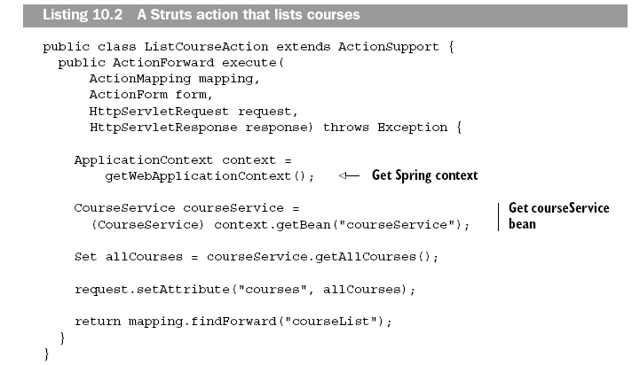

- B Delegating Action
Another approach to Struts-Spring integration is to write a Struts action that is
nothing more than a proxy to the real Struts action that is contained in the Spring
application context. The proxy action will retrieve the application context from
the ContextLoaderPlugIn, look up the real Struts action from the context, then
delegate responsibility to the real Struts action.

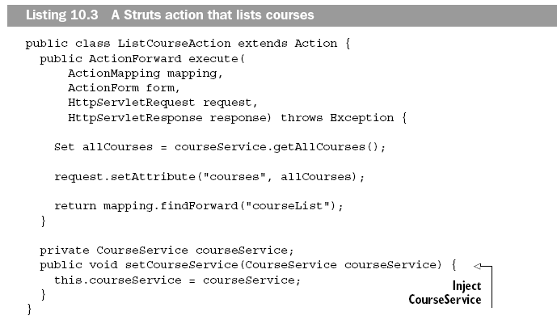

2.B.A
<action path="/listCourses"
type="org.springframework.web.struts.DelegatingActionProxy"/>

<bean name="/listCourses"
class="com.springinaction.training.struts.ListCourseAction">
<property name="courseService">
<ref bean="courseService"/>
</property>
</bean>

2.B.B
To make action delegation slightly more intuitive, Spring provides Delegating-
RequestProcessor, a replacement request processor for Spring. To use it, place
the following in your struts-config.xml:

<controller processorClass=
"org.springframework.web.struts.DelegatingRequestProcessor"/>

<action path="/listCourses"
type="com.springinaction.training.struts.ListCourseAction"/>

Using spring with JSF

JSF and Spring do share some of the same features, most noticeably in the area of IOC services. By declaring JSF managed-beans in the faces-config.xml configuration file, you allow the FacesServlet to instantiate that bean at startup. Your JSF pages have access to these beans and all of their properties.We can integrate JSF and Spring in two ways:
- DelegatingVariableResolver: Spring comes with a JSF variable resolver that lets you use JSF and Spring together.
- <?xml version="1.0" encoding="UTF-8"?>
- <!DOCTYPE beans PUBLIC "-//SPRING//DTD BEAN//EN"
- "http://www.springframework.org/dtd/spring-beans.dtd">

- <faces-config>
- <application>
- <variable-resolver>
- org.springframework.web.jsf.DelegatingVariableResolver
- </variable-resolver>
- </application>
- </faces-config>
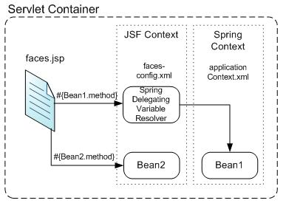
The DelegatingVariableResolver will first delegate value lookups to the default resolver of the underlying JSF implementation, and then to Spring's 'business context' WebApplicationContext. This allows one to easily inject dependencies into one's JSF-managed beans.
- FacesContextUtils:custom VariableResolver works well when mapping one's properties to beans in faces-config.xml, but at times one may need to grab a bean explicitly. The FacesContextUtils class makes this easy. It is similar to WebApplicationContextUtils, except that it takes a FacesContext parameter rather than a ServletContext parameter.
- ApplicationContext ctx = FacesContextUtils.getWebApplicationContext(FacesContext.getCurrentInstance());

Bean scope in Spring

singleton | Scopes a single bean definition to a single object instance per Spring IoC container.
prototype | Scopes a single bean definition to any number of object instances.
request | Scopes a single bean definition to the lifecycle of a single HTTP request; that is each and every HTTP request will have its own instance of a bean created off the back of a single bean definition. Only valid in the context of a web-aware Spring ApplicationContext.
session | Scopes a single bean definition to the lifecycle of a HTTP Session. Only valid in the context of a web-aware Spring ApplicationContext.
global session | Scopes a single bean definition to the lifecycle of a global HTTP Session. Typically only valid when used in a portlet context. Only valid in the context of a web-aware Spring ApplicationContext.

SLF4J is a cleaner dependency and more efficient at runtime than commons-logging because it uses compile-time bindings instead of runtime discovery of the other logging frameworks it integrates.

Thus you can define beans external to your application classes by using Java rather than XML files.
• @Configuration
• @Bean
• @DependsOn
• @Primary
• @Lazy
• @Import
• @ImportResource
@Value

Dependency Injection
IoC is also known as dependency injection (DI). It is a process whereby objects define their dependencies, that is, the other objects they work with, only through constructor arguments, arguments to a factory method, or properties that are set on the object instance after it is constructed or returned from a factory method.

The interface org.springframework.context.ApplicationContext represents the Spring IoC container and is responsible for instantiating, configuring, and assembling the aforementioned beans.

Types:
Constructor-based dependency injection
Setter-based dependency injection
Method1:
<bean id="theTargetBean" class="..."/>
<bean id="theClientBean" class="...">
<property name="targetName">
<idref bean="theTargetBean" />
</property>
</bean>

Method2
<bean id="theTargetBean" class="..." />
<bean id="client" class="...">
<property name="targetName" value="theTargetBean" />
</bean>

The first form is preferable to the second, because using the idref tag allows the container to validate at deployment time that the referenced, named bean actually exists. In the second variation, no validation is Spring Framework 3.1 Reference Documentation 52
performed on the value that is passed to the targetName property of the client bean. Typos are only discovered (with most likely fatal results) when the client bean is actually instantiated.
Using depends-on
If a bean is a dependency of another that usually means that one bean is set as a property of another.Typically you accomplish this with the <ref/> element in XML-based configuration metadata. However, sometimes dependencies between beans are less direct; for example, a static initializer in a class needs to be triggered, such as database driver registration. The depends-on attribute can explicitly force one or more beans to be initialized before the bean using this element is initialized.

Lazy-initialized beans
A lazy-initialized bean tells the IoC container to create a bean instance when it is first requested, rather than at startup.

Annotations:
@Required - This annotation simply indicates that the affected bean property must be populated at configuration time,

@Resource –
@PostConstruct and @PreDestroy

@Repository annotation is a marker for any class that fulfills the role or stereotype (also known as Data Access Object or DAO) of a repository. Among the uses of this marker is
the automatic translation of exceptions as described in the section called “Exception translation”.

@Component is a generic stereotype for any Spring-managed component. @Repository, @Service,and @Controller are specializations of @Component for more specific use cases, for example, in the persistence, service, and presentation layers, respectively. Therefore, you can annotate your component
classes with @Component, but by annotating them with @Repository, @Service, or @Controller instead, your classes are more properly suited for processing by tools or associating with aspects. For example, these stereotype annotations make ideal targets for pointcuts.

Transaction Management

Transaction Management using Spring
Global transactions
Global transactions enable you to work with multiple transactional resources, typically relational
databases and message queues.

Local transactions
Local transactions are resource-specific, such as a transaction associated with a JDBC connection. Local transactions may be easier to use, but have significant disadvantages: they cannot work across multiple transactional resources

The key to the Spring transaction abstraction is the notion of a transaction strategy. A transaction strategy is defined by the org.springframework.transaction.PlatformTransactionManager

public interface PlatformTransactionManager {

TransactionStatus getTransaction(TransactionDefinition definition)
throws TransactionException;

void commit(TransactionStatus status) throws TransactionException;

void rollback(TransactionStatus status) throws TransactionException;
}

The TransactionDefinition interface specifies:
- Isolation: the degree of isolation this transaction has from the work of other transactions. For example, can this transaction see uncommitted writes from other transactions?

JDBC Defined Constant | Description
TRANSACTION_READ_UNCOMMITTED | Allows dirty reads, non-repeatable reads, and phantom reads to occur.
TRANSACTION_READ_COMMITTED | Ensures only committed data can be read.
TRANSACTION_REPEATABLE_READ | Is close to being "serializable," however, "phantom" reads are possible.
TRANSACTION_SERIALIZABLE | Dirty reads, non-repeatable reads, and phantom reads are prevented. Serializable.

- Propagation: normally all code executed within a transaction scope will run in that transaction. However, there are several options specifying behavior if a transactional method is executed when a transaction context already exists: for example, simply continue running in the existing transaction (the common case); or suspending the existing transaction and creating a new transaction. Spring offers all of the transaction propagation options familiar from EJB CMT.

RequiresNew

NotSupported
If the transaction attribute is NotSupported, the transactional context of the calling client is not propagated to the enterprise bean. If a client calls with a transaction context, the container suspends the client's transaction association before invoking the enterprise bean's method. After the method completes, the container resumes the suspended transaction association.

Supports

Mandatory

Never
The transaction attribute Never requires that the enterprise bean method not be called within a transaction context. If the client calls with a transaction context, the container throws the java.rmi.RemoteException. If the client is not associated with any transaction context, the container invokes the method without initiating a transaction.

- Timeout: how long this transaction may run before timing out (and automatically being rolled back by the underlying transaction infrastructure).
- Read-only status: a read-only transaction does not modify any data. Read-only transactions can be a useful optimization in some cases (such as when using Hibernate).

public interface TransactionStatus {

boolean isNewTransaction();

void setRollbackOnly();

boolean isRollbackOnly();
}

PlatformTransactionManager

org.springframework.jdbc.datasource.DataSourceTransactionManager – for JDBC datasource

org.springframework.transaction.jta.JtaTransactionManager – For distributed transactions.

org.springframework.orm.hibernate.HibernateTransactionManager – For hibernate local transactions.

9.4. Resource synchronization with transactions

9.4.1. High-level approach
Generally, the same template approach is used for all persistence APIs, with examples including the JdbcTemplate, HibernateTemplate, and JdoTemplate classes

Low-level approach

At a lower level exist classes such as DataSourceUtils (for JDBC), SessionFactoryUtils (for Hibernate), PersistenceManagerFactoryUtils (for JDO), and so on. When it is preferable for application code to deal directly with the resource types of the native persistence APIs, these classes ensure that proper Spring Framework-managed instances are obtained, transactions are (optionally) synchronized, and exceptions which happen in the process are properly mapped to a consistent API.

9.4.3. TransactionAwareDataSourceProxy
At the very lowest level exists the TransactionAwareDataSourceProxy class. This is a proxy for a target DataSource

Defining transactions

1. Declarative transaction in the xml file.

Example of declarative transaction management.

<?xml version="1.0" encoding="UTF-8"?>
<beans xmlns="http://www.springframework.org/schema/beans"
xmlns:xsi="http://www.w3.org/2001/XMLSchema-instance"
xmlns:aop="http://www.springframework.org/schema/aop"
xmlns:tx="http://www.springframework.org/schema/tx"
xsi:schemaLocation="
http://www.springframework.org/schema/beans http://www.springframework.org/schema/beans/spring-beans-2.0.xsd
http://www.springframework.org/schema/tx http://www.springframework.org/schema/tx/spring-tx-2.0.xsd
http://www.springframework.org/schema/aop http://www.springframework.org/schema/aop/spring-aop-2.0.xsd">

<aop:config>

<aop:pointcut id="defaultServiceOperation"
expression="execution(* x.y.service.*Service.*(..))"/>

<aop:pointcut id="noTxServiceOperation"
expression="execution(* x.y.service.ddl.DefaultDdlManager.*(..))"/>

<aop:advisor pointcut-ref="defaultServiceOperation" advice-ref="defaultTxAdvice"/>

<aop:advisor pointcut-ref="noTxServiceOperation" advice-ref="noTxAdvice"/>

</aop:config>

<!-- this bean will be transactional (see the 'defaultServiceOperation' pointcut) -->
<bean id="fooService" class="x.y.service.DefaultFooService"/>

<!-- this bean will also be transactional, but with totally different transactional settings -->
<bean id="anotherFooService" class="x.y.service.ddl.DefaultDdlManager"/>

<tx:advice id="defaultTxAdvice">
<tx:attributes>
<tx:method name="get*" read-only="true"/>
<tx:method name="*"/>
</tx:attributes>
</tx:advice>

<tx:advice id="noTxAdvice">
<tx:attributes>
<tx:method name="*" propagation="NEVER"/>
</tx:attributes>
</tx:advice>

<!-- other transaction infrastructure beans such as a PlatformTransactionManager omitted... -->

</beans>

Table 9.1. <tx:method/> settings
Attribute | Required? | Default | Description
name | Yes |  | The method name(s) with which the transaction attributes are to be associated. The wildcard (*) character can be used to associate the same transaction attribute settings with a number of methods; for example, 'get*', 'handle*', 'on*Event', etc.
propagation | No | REQUIRED | The transaction propagation behavior
isolation | No | DEFAULT | The transaction isolation level
timeout | No | -1 | The transaction timeout value (in seconds)
read-only | No | false | Is this transaction read-only?
Rollback-for | No |  | The Exception(s) that will trigger rollback; comma-delimited. For example, 'com.foo.MyBusinessException,ServletException'
no-rollback-for | No |  | The Exception(s) that will not trigger rollback; comma-delimited. For example, 'com.foo.MyBusinessException,ServletException'

2. Declarative transaction using annotation.
Use @Transactional annotation in the class and in xml file use
<tx:annotation-driven transaction-manager="txManager"/>

@Transactional(readOnly = true)
public class DefaultFooService implements FooService {

public Foo getFoo(String fooName) {
// do something
}

// these settings have precedence for this method
@Transactional(readOnly = false, propagation = Propagation.REQUIRES_NEW)
public void updateFoo(Foo foo) {
// do something
}
}

3. Using Transaction Templates.

public class SimpleService implements Service {

// single TransactionTemplate shared amongst all methods in this instance
private final TransactionTemplate transactionTemplate;

public SimpleService(PlatformTransactionManager transactionManager) {
Assert.notNull(transactionManager, "The 'transactionManager' argument must not be null.");
this.transactionTemplate = new TransactionTemplate(transactionManager);

// the transaction settings can be set here explicitly if so desired
this.transactionTemplate.setIsolationLevel(TransactionDefinition.ISOLATION_READ_UNCOMMITTED);
this.transactionTemplate.setTimeout(30); // 30 seconds
// and so forth...
}

public Object someServiceMethod() {
return transactionTemplate.execute(new TransactionCallback() {

// the code in this method executes in a transactional context
public Object doInTransaction(TransactionStatus status) {
updateOperation1();
return resultOfUpdateOperation2();
}
});
}

protected void doInTransactionWithoutResult(TransactionStatus status) {
try {
updateOperation1();
updateOperation2();
} catch (SomeBusinessExeption ex) {
status.setRollbackOnly();
}
}

}

DAO support

The best way to guarantee that your Data Access Objects (DAOs) or repositories provide exception
translation is to use the @Repository annotation. This annotation also allows the component scanning
support to find and configure your DAOs and repositories without having to provide XML configuration entries for them.

Type of JdbcTemplates
• JdbcTemplate is the classic Spring JDBC approach and the most popular. This "lowest level"
approach and all others use a JdbcTemplate under the covers, and all are updated with Java 5 support
such as generics and varargs.
• NamedParameterJdbcTemplate wraps a JdbcTemplate to provide named parameters instead of
the traditional JDBC "?" placeholders. This approach provides better documentation and ease of use
when you have multiple parameters for an SQL statement.
• SimpleJdbcTemplate combines the most frequently used operations of JdbcTemplate and
NamedParameterJdbcTemplate.
• SimpleJdbcInsert and SimpleJdbcCall optimize database metadata to limit the amount of necessary
configuration. This approach simplifies coding so that you only need to provide the name of the table
or procedure and provide a map of parameters matching the column names. This only works if the
database provides adequate metadata. If the database doesn't provide this metadata, you will have to
provide explicit configuration of the parameters.

Ex:
List<Actor> actors = this.jdbcTemplate.query(
"select first_name, last_name from t_actor",
new RowMapper<Actor>() {
public Actor mapRow(ResultSet rs, int rowNum) throws SQLException {
Actor actor = new Actor();
actor.setFirstName(rs.getString("first_name"));
actor.setLastName(rs.getString("last_name"));
return actor;

Example of using NamedParameterJdbcTemplate
The NamedParameterJdbcTemplate class adds support for programming JDBC statements using
named parameters, as opposed to programming JDBC statements using only classic placeholder ('?')
arguments.

// some JDBC-backed DAO class...
Private NamedParameterJdbcTemplate namedParameterJdbcTemplate;
public void setDataSource(DataSource dataSource) {
this.namedParameterJdbcTemplate = new NamedParameterJdbcTemplate(dataSource);
}
public int countOfActorsByFirstName(String firstName) {
String sql = "select count(*) from T_ACTOR where first_name = :first_name";
SqlParameterSource namedParameters = new MapSqlParameterSource("first_name", firstName);
return namedParameterJdbcTemplate.queryForInt(sql, namedParameters);
}

SimpleJdbcTemplate
The SimpleJdbcTemplate class wraps the classic JdbcTemplate and leverages Java 5 language features such as varargs and autoboxing.

SQLExceptionTranslator
SQLExceptionTranslator is an interface to be implemented by classes that can translate between SQLExceptions and Spring's own org.springframework.dao.DataAccessException,

Calling a stored procedure with SimpleJdbcCall
public class JdbcActorDao implements ActorDao {
private SimpleJdbcTemplate simpleJdbcTemplate;
private SimpleJdbcCall procReadActor;
public void setDataSource(DataSource dataSource) {
this.simpleJdbcTemplate = new SimpleJdbcTemplate(dataSource);
this.procReadActor =
new SimpleJdbcCall(dataSource)
.withProcedureName("read_actor");
}
public Actor readActor(Long id) {
SqlParameterSource in = new MapSqlParameterSource()
.addValue("in_id", id);
Map out = procReadActor.execute(in);
Actor actor = new Actor();
actor.setId(id);
actor.setFirstName((String) out.get("out_first_name"));
actor.setLastName((String) out.get("out_last_name"));
actor.setBirthDate((Date) out.get("out_birth_date"));
return actor;
}
// ... additional methods
}

Introduction to ORM with Spring

Implementing DAOs based on plain Hibernate 3 API
public class ProductDaoImpl implements ProductDao {
private SessionFactory sessionFactory;
public void setSessionFactory(SessionFactory sessionFactory) {
this.sessionFactory = sessionFactory;
}
public Collection loadProductsByCategory(String category) {
return this.sessionFactory.getCurrentSession()
.createQuery("from test.Product product where product.category=?")
.setParameter(0, category)
.list();
}
}

Marshalling XML using O/X Mappers
Within the field of O/X mapping, a marshaller is responsible for serializing an object (graph) to XML. In similar fashion, an unmarshaller deserializes the XML to an object graph. This XML can take the form of
a DOM document, an input or output stream, or a SAX handler.

Remoting and web services using Spring

Spring features integration classes for remoting support using various technologies.
• Remote Method Invocation (RMI
• Spring's HTTP invoker.
• Hessian.
• Burlap.
• JAX-RPC.
• JAX-WS.
• JMS.

Accessing web services using JAX-RPC
Service:
public class AccountServiceEndpoint extends ServletEndpointSupport implements RemoteAccountService {
private AccountService biz;
protected void onInit() {
this.biz = (AccountService) getWebApplicationContext().getBean("accountService");
}
public void insertAccount(Account acc) throws RemoteException {
biz.insertAccount(acc);
}
public Account[] getAccounts(String name) throws RemoteException {
return biz.getAccounts(name);
}
}

Client:
<bean id="accountWebService" class="org.springframework.remoting.jaxrpc.JaxRpcPortProxyFactoryBean">
<property name="serviceInterface" value="example.RemoteAccountService"/>
<property name="wsdlDocumentUrl" value="http://localhost:8080/account/services/accountService?WSDL"/>
<property name="namespaceUri" value="http://localhost:8080/account/services/accountService"/>
<property name="serviceName" value="AccountService"/>
<property name="portName" value="AccountPort"/>
</bean>

Accessing RESTful services on the Client
RestTemplate
Each method takes URI template arguments in two forms, either as a String variable length argument
or a Map<String,String>.

For example,
String result = restTemplate.getForObject("http://example.com/hotels/{hotel}/bookings/{booking}",
String.class,"42", "21");
using variable length arguments and
Map<String, String> vars = Collections.singletonMap("hotel", "42");
String result =
restTemplate.getForObject("http://example.com/hotels/{hotel}/rooms/{hotel}", String.class, vars);

The UriComponentsBuilder class can be used to build and encode the URI including support for URI templates. For example you can start with a URL String:

UriComponents uriComponents =
UriComponentsBuilder.fromUriString("http://example.com/hotels/{hotel}/bookings/{booking}").build()
.expand("42", "21")
.encode();
URI uri = uriComponents.toUri();
Reference:

http://static.springsource.org/spring/docs/2.0.x/reference/transaction.html

