Extreme Programming (XP) is actually a deliberate and disciplined approach to software development. The first XP project was started March 6, 1996. It has already been proven at many companies of all different sizes and industries world wide.

XP features

XP programmers communicate with their customers and fellow programmers. They keep their design simple and clean. They get feedback by testing their software starting on day one. They deliver the system to the customers as early as possible and implement changes as suggested.

XP is set up for small groups of programmers. Between 2 and 12.
Another requirement is testability. You must be able to create automated unit and functional tests

The Rules and Practices of extreme programming

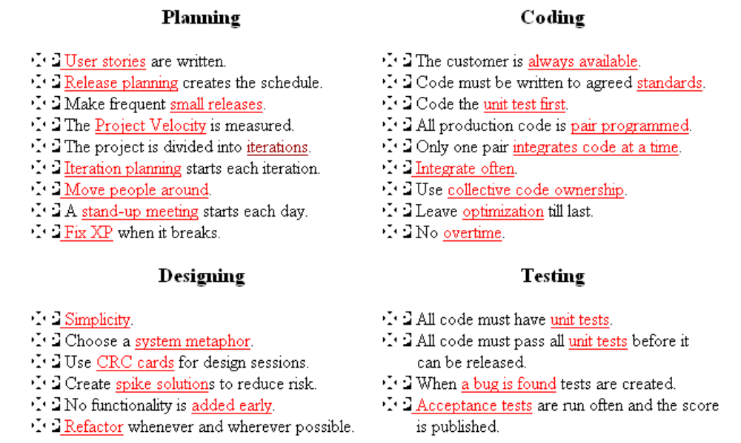

User Stories
The biggest difference is in the level of detail. User stories should only provide enough detail to make a reasonably low risk estimate of how long the story will take to implement.

Developers estimate how long the stories might take to implement. Each story will get a 1, 2 or 3 week estimate in "ideal development time".
Another difference between stories and a requirements document is a focus on user needs. You should try to avoid details of specific technology, data base layout, and algorithms.

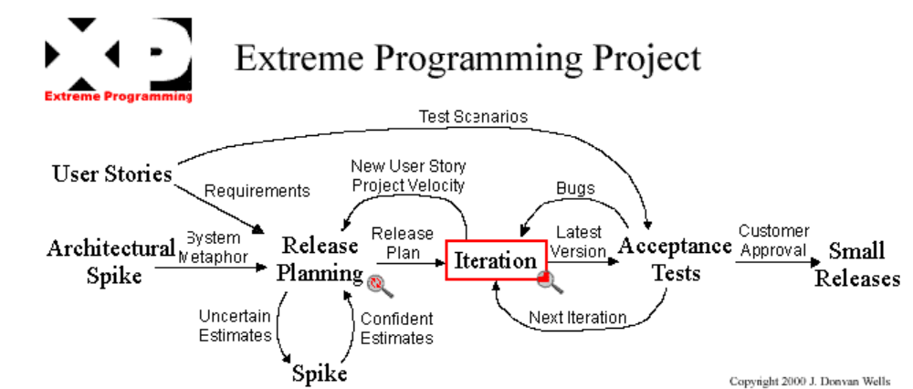

Release Planning

A release planning meeting is used to create a release plan, which lays out the overall project. The release plan is then used to create iteration plans for each individual iteration.
The essence of the release planning meeting is for the development team to estimate each user story in terms of ideal programming weeks. An ideal week is how long you imagine it would take to implement that story if you had absolutely nothing else to do. No dependencies, no extra work, but do include tests. The customer then decides what story is the most important or has the highest priority to be completed
User stories are printed or written on cards. Together developers and customers move the cards around on a large table to create a set of stories to be implemented as the first (or next) release. A useable, testable system that makes good business sense delivered early is desired
You may plan by time or by scope. The project velocity is used to determine either how many stories can be implemented before a given date (time) or how long a set of stories will take to finish (scope). When planning by time multiply the number of iterations by the project velocity to determine how many user stories can be completed. When planning by scope divide the total weeks of estimated user stories by the project velocity to determine how many iterations till the release is ready.
The base philosophy of release planning is that a project may be quantified by four variables; scope, resources, time, and quality.

Make frequent small releases
The development team needs to release iterative versions of the system to the customers often. The release planning meeting is used to discover small units of functionality that make good business sense and can be released into the customer's environment early in the project. This is critical to getting valuable feedback in time to have an impact on the system's development. The longer you wait to introduce an important feature to the system's users the less time you will have to fix it.

Project Velocity
The project velocity (or just velocity) is a measure of how much work is getting done on your project. To measure the project velocity you simply add up the estimates of the user stories that were finished during the iteration. It's just that simple. You also total up the estimates for the tasks finished during the iteration. Both of these measurements are used for iteration planning.
http://www.mayford.ca/xp/velocity.html
Project burn-down chart.
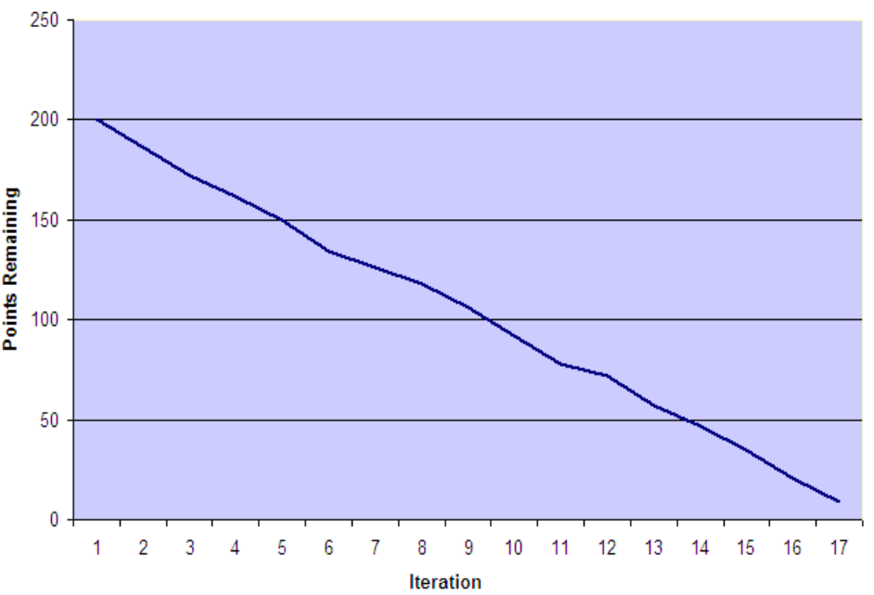

Project Velocity

